Airplane crashes in the US from 1983-2001 – An Analytical study

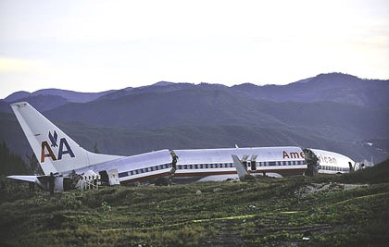

**Kaustubh Ambikesh Padhya CIN: 305861379**

CIS 5270 Project 1: Airplane Crashes in the US 1983-2001

27/10/2016

1. **Dataset URL’s:**

<http://www.ntsb.gov/investigations/data/Documents/datafiles/arc0202.xls>

<http://www.ntsb.gov/investigations/data/Documents/datafiles/2000_GA_Annual_Review_Data.xls>

<http://www.ntsb.gov/investigations/data/Documents/datafiles/2001_GA_Annual_Review_Data.xls>

These URL’s contain the entire data regarding Airplane crashes in the US from 1983-99, 2000 and 2001. It has a total of 42 columns (first dataset) with each column giving meaningful details related to the topic. It contains exciting details like the Date, Location, Aircraft details, Engine details, Weather conditions, Fatalities and injuries to ground staff, crew and passengers, phase of flight and first occurrence. The dataset for the years 2000 and 2001 contains exciting data with respect to the Number of engines and the highest injury caused in addition to the location specific data. The weather condition field has two abbreviations, VMC (Visual meteorological conditions) and IMC (Instrument meteorological conditions).

1. **Data Cleaning:**

|  |  |  |
| --- | --- | --- |
| **Scope/Problem** | **Dirty Data** | **Cleaned Data/ Remarks** |
| 1. **Missing Values** | Contained dummy values/null in the State column. | Removed the values having Null values. |
| 1. **Misspellings** | Typo error in the Number of Engines field. | Corrected such typo errors. |
| 1. **Cryptic values, Abbreviations** |  | Contains Abbreviations for the “Basic Weather conditions” field.  VMC: Visual meteorological conditions.  IMC: Instrument meteorological conditions. |
| 1. **Embedded Values** | The location field had City and State written in the same attribute. | Got the city and state in different columns. |
| 1. **Misfielded values** | State column contained Country names. | Removed those rows. |

1. **Data Visualizations:**
2. **To find out the Trend in Airplane crashes and fatalities from 1983 to 1999 in the US? Also, specifically find the Fatality rate in California.**

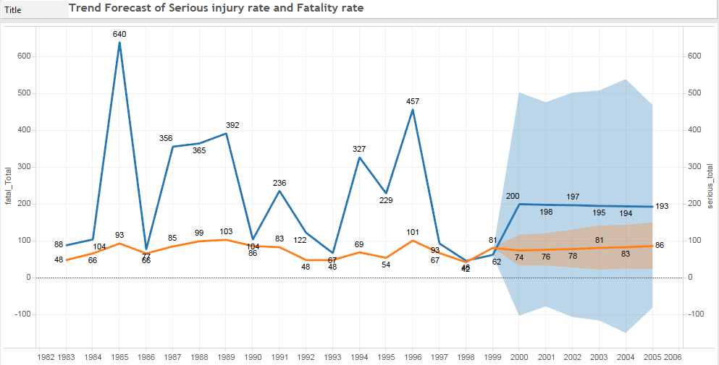

[Tools used: Calculated fields, Dual Axis chart & Forecast Trend lines]

The above Line graph shows the Total Fatalities and Serious injuries occurred due to Airplane accidents from 1983-1999. It can be seen that the year 1985 had accounted for the maximum no. of causalities (640 in numbers) followed by 1996 and 1989. Since the year 1996, the deaths and serious injuries have come down and were at the lowest in the year 1998 (at 46 fatalities). The Multiplicative trend forecast shows the deaths to be at around 200 and serious injuries would be 74 to 86 from 2000-2005.

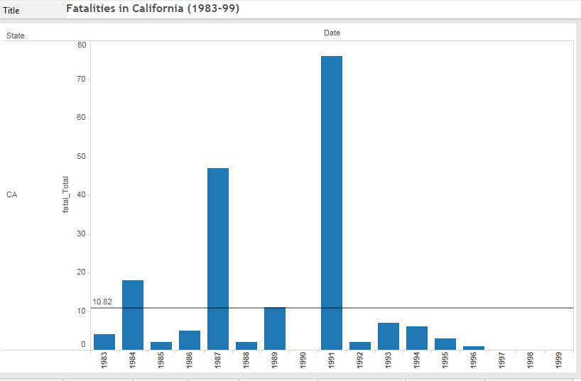

[Tools used: Reference line, Dates and Calculated fields]

In California, the average yearly Fatalities from 1983-99 stand at ~11/year. The year 1991 has been the worst with having a total of 76 deaths reported due to Air accidents. USAir Flight 1493, a Boeing 737-300 with 89 people on board, collides with SkyWest Flight 5569, a Fairchild Metro III carrying 12 people, on a runway at Los Angeles International Airport, in Los Angeles, California, killing 22 people on the USAir plane and everyone aboard the SkyWest aircraft. Thirty people on the USAir plane are injured, 13 of them seriously.

Also, we can see from the graph that the period from 1997-1999 have been the best for Aviation in CA as there have been zero causalities reported during those years.

1. **To derive a relationship between Engine type and weather conditions to find out which type of engine is the most vulnerable to certain weather conditions and results in fatalities? Also, is it safer to have only one engine or more number of engines?**

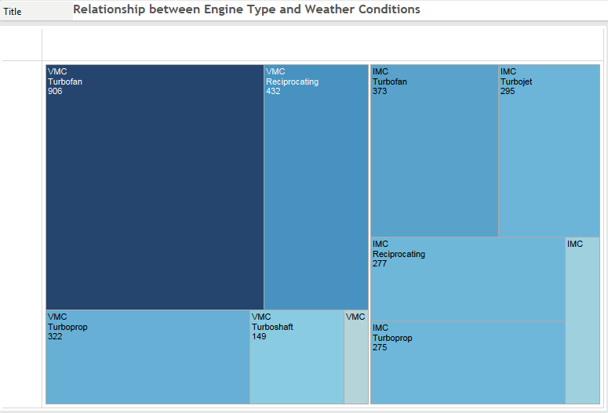

[Tools used: Calculated fields]

In aviation, a visual meteorological condition (or VMC) is an aviation flight category in which visual flight rules (VFR) flight is permitted—that is, conditions in which pilots have sufficient visibility to fly the aircraft maintaining visual separation from terrain and other aircraft. Whereas IMC describes weather conditions that require pilots to fly primarily by reference to instruments, and therefore under Instrument Flight Rules (IFR), rather than by outside visual references under Visual Flight Rules (VFR). [4] From the above visualization we can see that the Turbofan engine is the most vulnerable under VMC and IMC conditions (Though less in IMC), whereas Turbojet engines perform best under VMC conditions. On the other hand, the Turbo shaft engines outshine during IMC weather conditions and account for the least no. of deaths.

 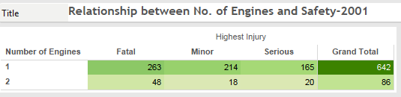

By looking at the above two highlight tables for the years 2000 and 2001, it is clearly evident that it is safer to fly in an aircraft with 2 engines than a one with Single Engine. The number of Accidents reported for Airplanes with Single engine is almost 8 to 10 times more than that with having two engines.

1. **To identify the states where the majority of Air plane accidents have occurred (1983-2001)?**

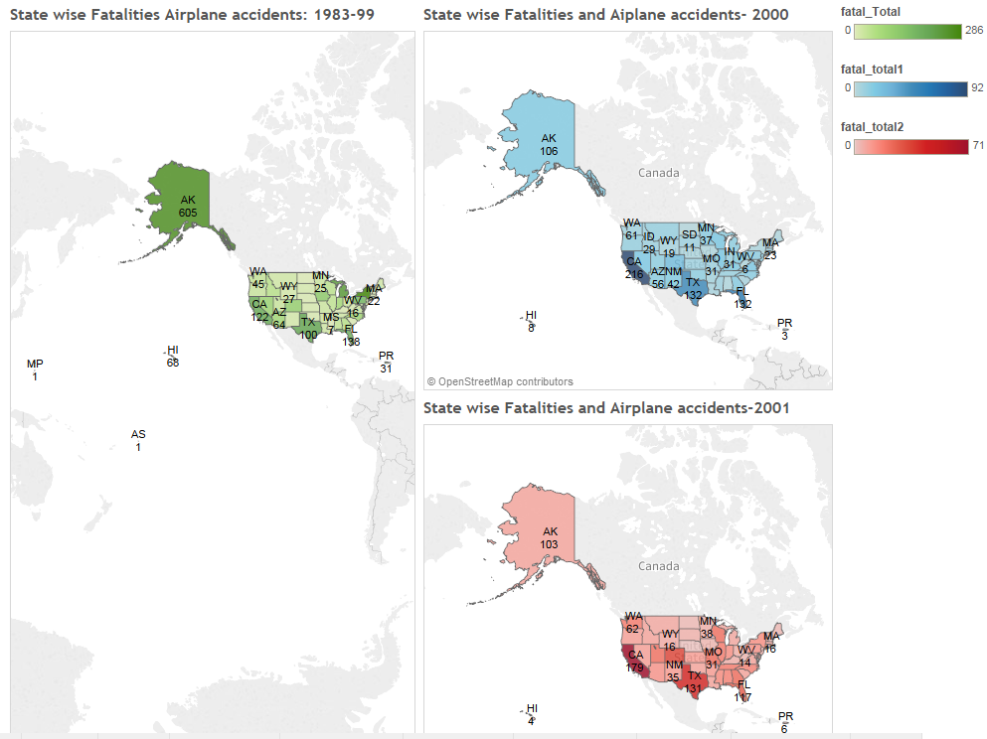

[Tools used: Geographic Maps and Calculated fields]

By carefully observing the above Geographic map it can be clearly seen that the state of Alaska has accounted for maximum no. of Airplane accidents (605 in numbers) from 1983-99. In the year 2000, the state of California topped the list with maximum plane accidents followed by Texas, Florida and Alaska. Major accidents in CA included the Alaska Airlines Flight 261 which went down on January 31, 2000, in the Pacific Ocean about 2.7 miles (4.3 km) north of Anacapa Island, California. The two pilots, three cabin crew members, and 83 passengers on board were killed, and the aircraft was destroyed. [3] The story is the same in 2001 with CA again leading the no. of airplane accidents.

1. **In Which phase of the flight maximum fatal accidents have occurred for Passenger aircrafts from 1983-1999? Also, which are the Top 5 groups of First occurrences resulting in maximum number of deaths?**

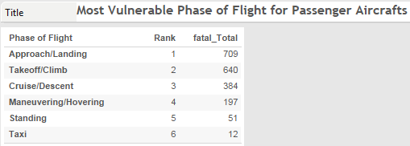

[Tools used: Ranks and calculated fields]

By looking at the above visualization it is clear that the Most Vulnerable phase of the flight for passenger aircrafts is when the Approach/Landing ranked at the First position and followed by Takeoff/Climb at second place. During these phases aircraft are close to the ground and in a more vulnerable configuration than during other flight phases [1]. The safest phase is during Taxi, and rightly so as at that moment the Aircraft is completely moving on Ground.

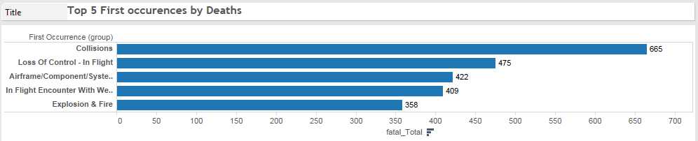

[Tools used: Groups]

The above Bar chart shows the Top five groups of First occurrences (Types of Failures/Reasons) which result in maximum deaths. It can be seen that Collisions (In flight collision with objects, in flight collision with Terrain/water and on ground/water collision) tops the list with having accounted for 665 deaths followed by Loss of Control in flight. Other major issues due to which maximum deaths occur are Airframe/component/system failure, Encounter with Weather and due to Explosions and Fires.

1. **From 1983-99, find out which Aircraft operator has been a Graveyard for Passengers i.e. accounted for maximum deaths of passengers? Provide details of the Crew to passenger fatality rate.**

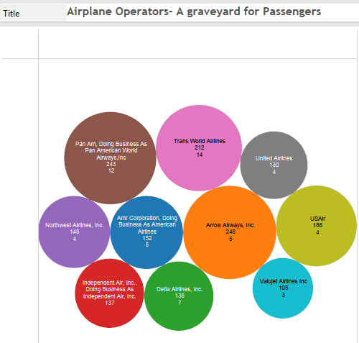

[Tools used: Calculated fields, Packed Bubbles chart]

This Visualization shows the Top ten airline operators which have accounted for maximum number of Passenger fatalities from 1983-99. The details of the visualization represent the no. of Passengers dead, Count of the Airplane accidents, number of Cabin crew Fatal and the Cabin crew to passenger’s fatality rate. By looking at the above displayed chart it can be clearly seen that Pan Am Airways has accounted for the maximum no. of Passenger fatalities i.e. 243 in numbers. But if we see the no. of Airplane accidents reported, then United Airlines tops the list with 39 Accidents. Moreover, it can be seen that Trans world airlines has accounted for maximum fatalities of Crew (14) and has a cabin crew to passengers fatality rate of 0.066 i.e. 6.6%.

1. **Dashboard:**

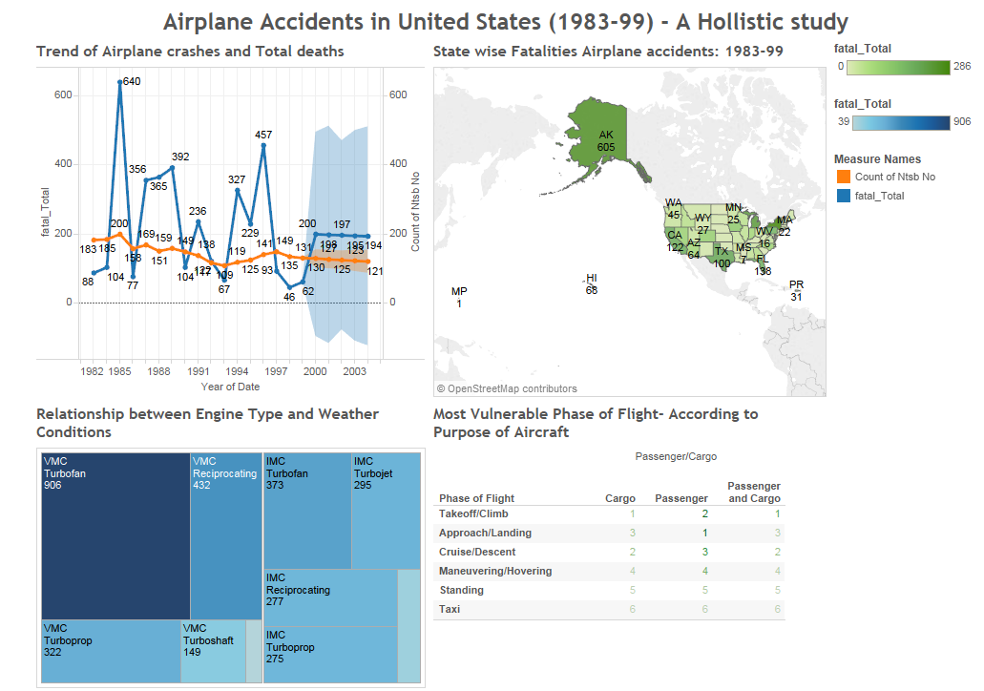

1. **Story telling:**

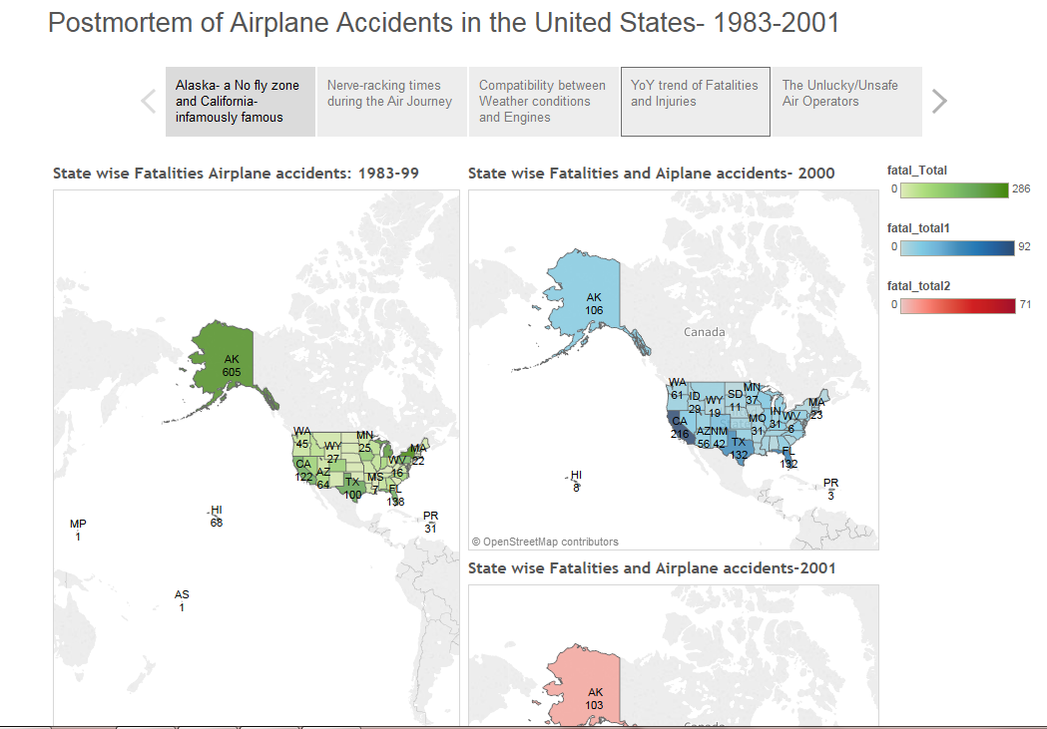

Over the years, the most preferred mode of transport for travelling medium to long distances has been Air Travel. The main reason for that is primarily because it’s the fastest way to reach your destination. Apart from commercial passenger Air liners, the small private jets and the Cargo carriers have had a sharp rise in their numbers from 1983 to 2001. But, looking through the history and the statistics of the Aviation industry in the US it doesn’t seem too great a picture.

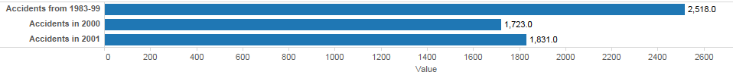

There has been an increase in the number of Airplane accidents in the United States from 2518 reported accidents from 1983-99 to 1831 accidents in the year 2001 itself (NTSB data). By looking at the Geographical map for Accidents occurred in 1983-99, it is clearly visible that flying through Alaska is a nightmare for pilots and passengers. A total of 605 accidents were reported during that period and resulted in 259 deaths. An Article by Christopher Beam lists the reasons why so many planes crash in Alaska. Harsh weather and rough terrain and Storms are especially common in the Aleutian Islands, the Alaska Peninsula, and southern Alaska, with wind speeds of more than 50 miles an hour. Large swaths of the state are also jagged and mountainous, with mountaintops frequently obscured by clouds. And the places with the most treacherous weather and landscape also tend to be most remote, so air travel is the only way to get there. Poor infrastructure doesn't help: Many accidents occur on isolated dirt or gravel air fields, where it's easy for a plane to skid, especially if it's icy or muddy, or on lakes, where it's hard for seaplanes to land unless the water is flat.(About one-third of takeoff/landing accidents in Alaska involve seaplanes) [2]. Also, looking at the number of Accidents reported in the state of California is also something to worry about. From 1983-2001, a total of 517 Airplane accidents have been reported and resulted in 347 deaths.

Talking about an Airplane journey, the entire journey can be put into six phases, namely Taxi, takeoff, climb, cruise, descent and final approach/landing. Almost half of all accidents occur during the final approach and landing stages. These are also the most devastating accidents. Fatal accidents are also likely to occur during the climbing stage. If the aircraft left the gate with undetected faults, these may become apparent during the climb, as the first stage taking place off the ground, and could prove dangerous. Most accidents and fatalities take place during the departure (take off / climb) and arrival (approach/ landing) stages. During these phases aircraft are close to the ground and in a more vulnerable configuration than during other flight phases. For Passenger aircrafts the most nerve-racking time is when the Aircraft is in the Approach or Landing phase. On the other hand, the Cargo planes have a tough time during Takeoff/Climb; which I feel is mainly due to any movement of any heavy cargo. Now, when we look at the Rankings, the safest part of the Air travel is when you are on the ground i.e. Taxi.

Further, when we try to draw a relationship between different types of Engines and their suitability with respect to certain weather conditions, we find that particular engines are best for certain types of Weather. During the VMC weather conditions, the Turbofan engine has proved to be a failure and accounted for 906 casualties from 1983-1999. Also, the Turbofan engine have not fared well under the IMC weather conditions resulting in 373 deaths during the same period. Our Analysis suggests Turbojet engines are more favorable under VMC and the Turbo shaft when there are IMC weather conditions. Also, regarding the Number of Engines, the statistics suggests that it is best to have Two engines than one looking at the number of Accidents with single engine crafts being 8 to 10 times more that those encountered by Dual engine Aircrafts.

Now taking a look at the Fatalities and serious injuries occurred during 1983-99, it is clearly visible that 1985 witnessed more passenger and crew deaths on commercial airlines than any other year (640 in numbers). One of the major contributors to the list was the Crash of Delta Airlines flight 191 at Dallas airport due to a Microburst encountered during Approach/Landing. The reason for this Mishap was found out to be an Encounter with Bad weather which was not handled well by the new pilots. Moreover, Looking at the line chart, there has been a slightly decreasing trend with respect to the Fatalities, which is rightly so because of the continuous research and improvements done to increase for the Air Travelers. The Forecast for the yearly fatalities till 2005 stands at about 200 deaths a year and 80 odd serious injuries.

In the times when the Aviation industry was focusing on making Air travel safer, some Airline operators proved to be unluckily unsafe to travel. The famous players in the Air travel like the Pan Am, Trans world airlines, Arrow airways, Delta airlines, American Airways and the United Airlines proved to be the most unsafe carriers in the United States. Pan Am Airways flight crash resulted in 243 passenger deaths in a single accident. The United Airlines raised serious concerns regarding their focus on Safety procedures due to 39 accidents being reported in the span of 16 years and resulting in 130 passenger casualties. Finally, Looking at these statistics and seeing such big players in this infamous list it raises serious concerns as to whether these big names really take the safety aspect seriously or not. The Aviation industry in the US and across the world needs to step up and take stringent steps to make the comfortable and thrilling Air journey to be the safest mode of travel.

**References:**

1. <http://www.1001crash.com/index-page-statistique-lg-2-numpage-3.html>
2. http://www.slate.com/articles/news_and_politics/explainer/2010/08/nofly_zone.html
3. National Transportation Safety Board (1987). [Aircraft Accident Report: Collision of Aeronaves de Mexico, S.A.; McDonnell Douglas DC-9-32, XA-JED and Piper PA-28-181, N4891F; Cerritos, California; August 31, 1986](http://www.airdisaster.com/reports/ntsb/AAR87-07.pdf)
4. [U.S. Federal Aviation Regulations defining visual meteorological conditions](http://www.ecfr.gov/cgi-bin/text-idx?c=ecfr&sid=4981b2fd2797878ab4bc127f357c3cdb&rgn=div8&view=text&node=14:2.0.1.3.10.2.5.33&idno=14).
5. http://www.ntsb.gov