

**COMPUTER SCIENCES CORPORATION INDIA PVT. LTD.**

**INDORE**

**May, 2016**

**ONLINE DISCUSSION FORUM**

PROJECT REPORT

**Team Members**

Yash Soni

Padmavati Rai

**Project Mentor**

**Kamna Pamnani**

Application Developer   
CSC

# logo.png

**COMPUTER SCIENCES CORPORATION INDIA PVT. LTD.**

**INDORE**

**May, 2016**

**ONLINE DISCUSSION FORUM**

PROJECT REPORT

**Team Members**

Yash Soni

Padmavati Rai

**Project Mentor**

**Kamna Pamnani**

Application Developer   
CSC

**COMPUTER SCIENCES CORPORATION INDIA PVT. LTD.**



Electronics Complex, Pardeshipura,

Indore-452010 (M.P)

Ph: +91-731 - 4430666

**CERTIFICATE**

This is to certify that **Yash Soni and Padmavati Rai , pursuing B.E.(computer science Engineering)**  in Medicaps Institute of Science And Technology have successfully completed their internship project work titled **“Online Discussion Forum”** under the guidance of Mentor Ms. Kamna Pamnani and submitted a satisfactory report on this project

Signature: ___________________

Name: ___________________

**I**

**ACKNOWLEDGMENT**

The most awaited moment of successful completion of an endeavor is always a result of persons involved implicitly or explicitly in it. The successful completion of all the phases of our project is the result of dedicated efforts put in by many people and this report would be incomplete without giving due credits to them. This acknowledgment is but a small token of gratitude in recognition of their help in our endeavor.

we thank **Computer Science Corporation , Indore** Team for providing us golden opportunity to work on this project and increase our knowledge in this field. We express a deep sense of gratitude to our project mentor **Ms. Kamna Pamnani** for her invaluable support and constant encouragement which was of great support to bring this work to present shape.

Lastly I thank all other faculties and friends who were always helpful while making this project and illuminated us with their knowledge and feedbacks.

Yash Soni

Padmavati Rai

**II**

# CONTENT

# Introduction ……………………………………………………………………….1

* 1. Purpose/Aim of Project/Objective………………………………………….…….1

1.2 Scope……………………………………………………………………….….....1

* 1. Problems Domain…………………………………………………………...……2
  2. Solution Domain………………………………………………………..…….….2

1.5 Platform Specification.. ……………………………………………….…...….....2

1. **System Requirement Analysis…………………………………………………………….4**
2. **System Analysis…………………………………………………………………...……….4**
3. **Design………………………………………………………………………………………6**
4. **Database Design…………………………………………………………………………...31**
5. **Implementation……………………………………………………..………………….….38**
6. **Declaration……………………………………………………………….…..…………….48**

# III

**LIST OF FIGURES**

|  |  |  |
| --- | --- | --- |
| Figure No. | Figure Name | Page No. |
| 1 | User Use Case Diagram | 7 |
| 2 | Class Diagram | 9 |
| 3 | Registration Sequence Diagram | 10 |
| 4 | Login Sequence Diagram | 11 |
| 5 | Create Post Sequence Diagram | 12 |
| 6 | Search Post Sequence Diagram | 13 |
| 7 | Bid Sequence Diagram | 14 |
| 8 | Reply Sequence Diagram | 15 |
| 9 | Viewing Notifications Sequence Diagram | 16 |
| 10 | Collaboration Diagram | 17 |
| 11 | Activity Diagram for Login | 18 |
| 12 | Activity Diagram for Registration | 19 |
| 13 | Activity Diagram for create post | 20 |
| 14 | Activity Diagram for Bid | 21 |
| 15 | Activity Diagram for view post | 22 |
| 16 | Activity Diagram for Search Post | 23 |
| 17 | Activity Diagram for reply | 24 |
| 18 | Activity Diagram for Edit Profile | 25 |
| 19 | Activity Diagram for viewing Notifications | 26 |
| 20 | Deployment Diagram | 27 |
| 21 | Level 0 DFD | 28 |
| 22 | Level 1 DFD | 29 |
| 23 | Level 2 DFD | 30 |
| 24 | Data Design | 32 |
| 25 | Entity Relationship Diagram | 33 |
| 26 | System Architecture | 36 |
| 27 | Structure Chart | 37 |

# IV

**LIST OF TABLES**

|  |  |  |
| --- | --- | --- |
| Table No. | Table Name | Page No. |
| 1 | Use Case Table | 8 |
| 2 | postinfo Table | 34 |
| 3 | register Table | 34 |
| 4 | comments Table | 35 |
| 5 | bids Table | 35 |

V

**ABSTRACT**

*Online Discussion Forum is the web application created to provide a common public platform to the people where they can discuss their ideas to the world on several topics like technology, sports, programming, media and entertainment, entrepreneurship, healthcare and can also have feedback .it provides facility of bidding for the posts. It is a convenient place for people to interact and promote their ideas on a global Stage.*

*Online discussion forum is a java application using sql database. Users have the facility to create and share their posts which can be viewed by other forum members. These posts will be available for bidding and issuing feedback. These feedbacks can only be given by the registered members of the website.*

*Feedback will be publicly displayed corresponding to the post and the bids are kept private to ensure the confidentiality .the highest bid will be selected as the final bid and will be notified to the post owner on his profile with all the details of the replier.*

*Unlike traditional discussion forums, it is the convenient solution for people to share and manage their posts with added facilities of bidding, single platform hosting various topics and fast searching amongst the huge collection of posts ,eliminating the delay caused in feedback process.*

VI

**1. INTRODUCTION**

**1.1 OBJECTIVE**

The purpose of online Discussion Forum Project is to provide universal place to people where they can share their ideas and simultaneously interact with others to get feedback.

Online discussion Forum allow people to share messages on a single platform where they can be viewed by all other members ,timely feedbacks can be given and all the messages are securely saved and retrieved on user request without any delay. Along with it, bidding facility is provided to the members so that whosoever interested and like the ideas would get fair opportunity to compete for the same. Every member can create and update their profile information which can be used by others to contact them in further communication.

People can only post on the forum by registering themselves or logging in through their existing facebook account. These Registered users can easily create and keep record of all their posts and feedbacks received from the repliers. In addition to it they can search among various topics posts in no time by only specifying the date, member name or topic to which the post belongs. All the desired post information will be retrieved for the user and displayed.

Every post can be replied and liked by as many people as so wish .replies are kept public while Bids remain hidden on the forum and the highest bid is selected by the forum as the final bid. The post owner can view the results and the replier information on the notification page.

**1.2 SCOPE**

Online Discussion forum has a wide scope and is useful for

* People who are working, studying or any way related to following fields: Sports, Media and Entertainment,Enterpreneurship,Programming,Technology,Healthcare
* It helps in connecting people across different regions and build a social network for communication
* It works as a message directory where the entire user created posts, replies and bids are saved which can be effectively managed and retrieved.

1

**1.3 PROBLEM DOMAIN**

Communicating ideas and information to a group of people needs proper interaction and sources so that each person gets equal preference .earlier the messenger has to call a meeting for the group discussion where the people who are interested in taking part gather to give their suggestions on the topic and bid for them, a manual record has to be kept for each participant profile and feedback. This was a very cumbersome process and involves risk of error. Manual records are susceptible to alteration and any lack of error can result in loss of information.

**1.4 SOLUTION DOMAIN**

Online Discussion Forum is the most suitable solution for the above problem discussed as the user only has to register itself on the website. All the information of the user are securely saved on the server and can only be altered by their will. Secondly all the users of the website can easily ser and view the forum post by just one click. Desired post will be available to the user with all the replies recorded earlier with an option to post new reply and bid .users of the website can effectively manage their posts and view the suggestions posted by other members. All the calculations to select the highest winning bid is done by the system and is timely notified to the user. This help in saving s a lot of user’ time and effort which was earlier wasted in managing and collecting the records.

**1.5 PLATFORM SPECIFICATION**

**1.5.1 HARDWARE**

Processor- Pentium II, Pentium III, Pentium IV or higher

RAM- 64 Mb or Higher

Disk Space- 130 Mb or higher

**1.5.2 SOFTWARE**

Operating System- Win-98, Win-XP, Linux or any other higher version

Database- MySQL

2

**1.5.3 TOOLS USED**

* **ECLIPSE IDE FOR JAVA EE DEVELOPERS**: it is the JAVA based open source platform that contains a base workspace and an extensible [plug-in](https://en.wikipedia.org/wiki/Plug-in_(computing)) system for customizing the environment. Eclipse is written mostly in [Java](https://en.wikipedia.org/wiki/Java_(programming_language)) and its primary use is for developing Java applications, but it may also be used to develop applications in other [programming languages](https://en.wikipedia.org/wiki/Programming_language) through the use of plugins, including: [Ada](https://en.wikipedia.org/wiki/Ada_(programming_language)), [ABAP](https://en.wikipedia.org/wiki/ABAP), [C](https://en.wikipedia.org/wiki/C_(programming_language)), [C++](https://en.wikipedia.org/wiki/C%2B%2B), [COBOL](https://en.wikipedia.org/wiki/COBOL), [Fortran](https://en.wikipedia.org/wiki/Fortran), [Haskell](https://en.wikipedia.org/wiki/Haskell_(programming_language)), [JavaScript](https://en.wikipedia.org/wiki/JavaScript), [Julia](https://en.wikipedia.org/wiki/Julia_(programming_language)),[[2]](https://en.wikipedia.org/wiki/Eclipse_(software)#cite_note-2) [Lasso](https://en.wikipedia.org/wiki/Lasso_(programming_language)), [Lua](https://en.wikipedia.org/wiki/Lua_(programming_language)), [NATURAL](https://en.wikipedia.org/w/index.php?title=NATURAL&action=edit&redlink=1), [Perl](https://en.wikipedia.org/wiki/Perl), [PHP](https://en.wikipedia.org/wiki/PHP), [Prolog](https://en.wikipedia.org/wiki/Prolog), [Python](https://en.wikipedia.org/wiki/Python_(programming_language)), [R](https://en.wikipedia.org/wiki/R_(programming_language)), [Ruby](https://en.wikipedia.org/wiki/Ruby_(programming_language)) (including [Ruby on Rails](https://en.wikipedia.org/wiki/Ruby_on_Rails) framework), [Rust](https://en.wikipedia.org/wiki/Rust_(programming_language)), [Scala](https://en.wikipedia.org/wiki/Scala_(programming_language)), [Clojure](https://en.wikipedia.org/wiki/Clojure), [Groovy](https://en.wikipedia.org/wiki/Groovy_(programming_language)), [Scheme](https://en.wikipedia.org/wiki/Scheme_(programming_language)), and [Erlang](https://en.wikipedia.org/wiki/Erlang_(programming_language)). It can also be used to develop packages for the software [Mathematica](https://en.wikipedia.org/wiki/Mathematica).
* **APACHE TOMCAT SERVER 8.0**: Apache Tomcat is an open-source web server and servlet container developed by the Apache Software Foundation (ASF). Tomcat implements several Java EE specifications including Java Servlet, JavaServer Pages (JSP), Java EL, and WebSocket, and provides a "pure Java" HTTP web server environment for Java code to run in.
* **SQLYOG**: SQLyog MySQL GUI is a MySQL manager and admin tool, combining the features of MySQL Query Browser, Administrator, phpMyAdmin and other MySQL Front Ends and MySQL GUI tools in a single intuitive interface. SQLyog is an easy to use, compact and very fast graphical tool for managing MySQL databases.

3

**2. SYSTEM REQUIREMENT ANALYSIS**

**2.1 INFORMATION GATHERING**  The purpose of information gathering is to support the planning of your work to become more inclusive.

**2.1.1 FUNCTIONAL REQUIREMENT**

* Users should login either through existing facebook account or by providing registration details
* Members should be able to write and view their own posts and give replies
* Post on the forum can be liked and replied only by the registered members
* Forum should support discussion in multiple topics.
* Members can add and edit their profile information
* Search option on the basis of date, member name or topic name
* Members should be able to make bid on the posts
* highest bid is selected as the final bid for each post and should be notified to the post owner along with the replier details

**2.1.1 NON FUNCTIONAL REQUIREMENT**

1. Accessibility- This is measurement to determine extent of availability. Online Discussion Forum will be available to all users who want to share and manage their posts , have discussion in order to gather feedback and for those who wish to bid the post
2. Usability- It includes methods of measuring usability, such as needs analysis and the study of the principles behind an object's perceived efficiency or elegance. This website basically simplifies process of communication between people who have ideas to share and people having resources for their fulfillment.
3. Scalability: It is the capability of being easily expanded or upgraded on demand. This website will get updated to hold more discussion as the community of forum members increases
4. Availability: It is the proportion of time a system is in a functioning condition. The website will be available round the clock on the internet accessible devices.
5. Extensibility: It is a system design principle where the implementation takes future growth into consideration. This website holds number of dimensions for expansion such as video conferencing,online transaction facilities etc

4

**2.2 SYSTEM FEASIBILITY**

Feasibility study is test of system proposal according to its workability, impact of organization, ability to meet needs and effective use of resources.

**2.2.1 OPERATIONAL**

Operational feasibility is dependent on human resources available for the project and involves projecting whether the system will be used if it is developed and implemented. In order to determine this feasibility, it is important to understand the commitment to the proposed project.

By user point of view this project is operationally feasible because user need not learn any special skill to use this website. Just with basic knowledge of internet user can easily operate this website.

**2.2.2 TECHNICAL**

A large part of determining resources has to do with assessing technical feasibility. It considers the technical requirements of the proposed project. The technical requirements are then compared to the technical capability of the organization.

With the available features in Online Discussion Forum no additional technology will be required apart from internet connection and any device to access website such as laptop, desktop, smart phone, tablet, etc

**2.2.3 ECONOMICAL**

Economic analysis could also be referred to as cost/benefit analysis. It is the most frequently used method for evaluating the effectiveness of a new system. In economic analysis the procedure is to determine the benefits and savings that are expected from a candidate system and compare them with costs. The economical feasibility will review the expected costs to see if they are in-line with the projected budget or if the project has an acceptable return on investment. This project does not require huge investments. And due to user friendly platform and numerous services it is bound to provide good economic returns.

5

# SYSTEM DESIGN

6

**3. SYSTEM DESIGN**

**3.1 USE CASE DIAGRAM**

Use Cases are used here to describe the most important sequence of scenarios between the

Customer and the System. Under the Use cases the most important alternative scenarios will be presented for the respective Use Cases.

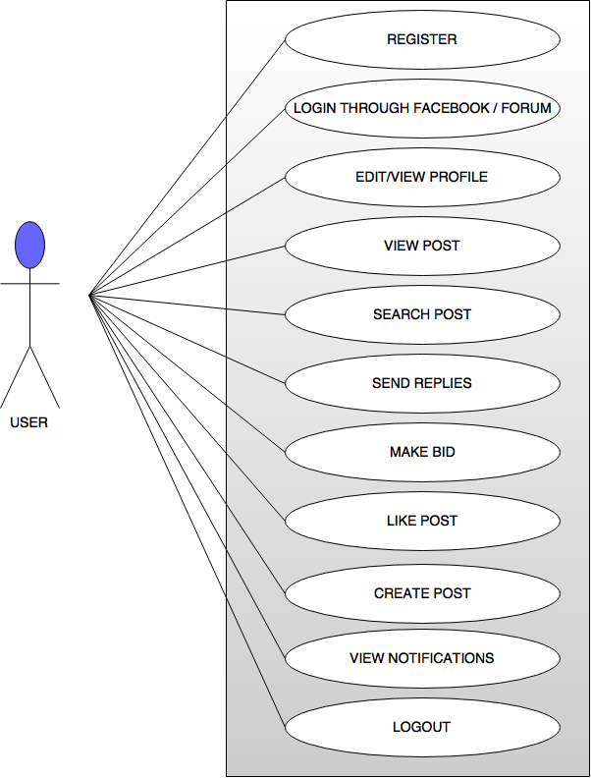

**Figure 1 USER USE CASE DIAGRAM**

7

|  |  |
| --- | --- |
| **USE CASE** | **DESCRIPTION** |
| REGISTER | User can register on the website to create their account |
| LOGIN THROUGH FACEBOOK/FORUM | User can login to website using forum or facebook registered account credentials |
| EDIT/VIEW PROFILE | User can update and view their profile details |
| VIEW POST | User can view Forum posts |
| SEARCH POST | User can search forum post on parameters like date,topic name or member name |
| SEND REPLIES | User can write replies on he other member Posts |
| MAKE BID | User can bid an amount only once for a particular post |
| LIKE POST | User can Like a post |
| CREATE POST | User can write their own Post |
| VIEW NOTIFICATIONS | User can view notifications of their Post including Highest Bid and replier details |
| LOGOUT | User can sign out from their account |

8

**3.2 CLASS DIAGRAM**

In [software engineering](https://en.wikipedia.org/wiki/Software_engineering), a class diagram in the [Unified Modeling Language](https://en.wikipedia.org/wiki/Unified_Modeling_Language) (UML) is a type of static structure diagram that describes the structure of a system by showing the system's [classes](https://en.wikipedia.org/wiki/Class_(computer_science)), their attributes, operations (or methods), and the relationships among objects.

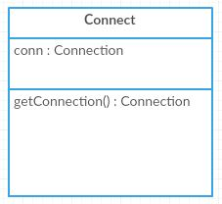

**Fig 1 Connect Class**

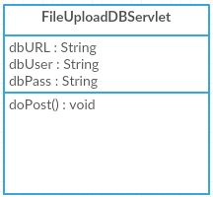

**Fig 2 FileUploadDBServlet Class**

**Figure 2 Class Diagram**

9

**3.3 SEQUENCE DIAGRAM**

This is an interaction diagram that shows how processes operate with one another and in what order. It shows object interactions arranged in time sequence.

**3.3.1 Sequence Diagram for Registration**

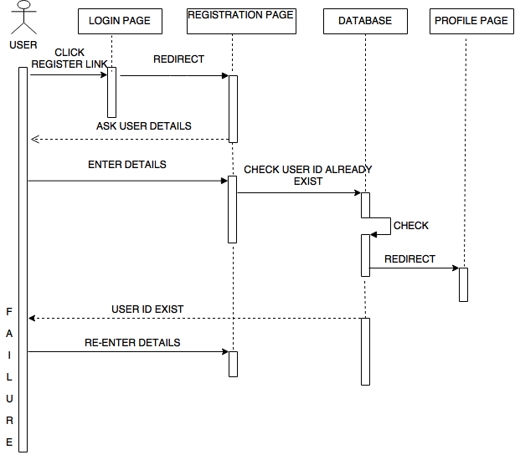

**Figure 3 Sequence Diagram for Registration**

10

**3.3.2 Sequence Diagram for Login**

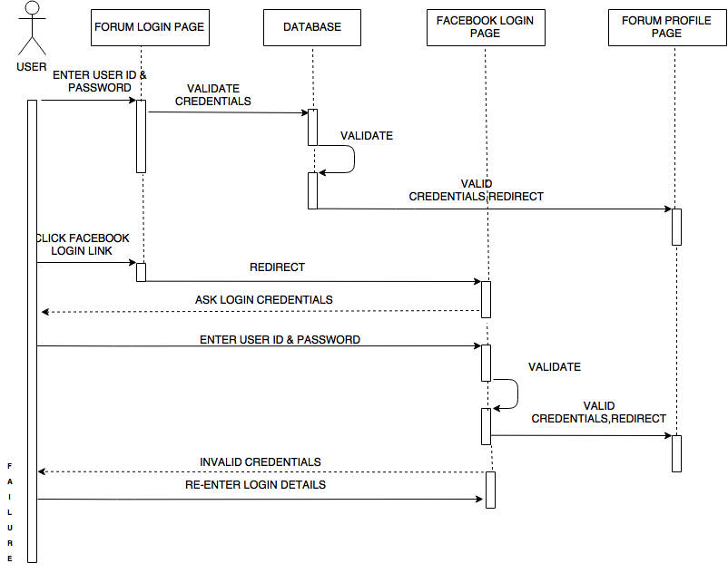

**Figure 4 Sequence Diagram for Login**

11

**3.3.3 Sequence Diagram for create post**

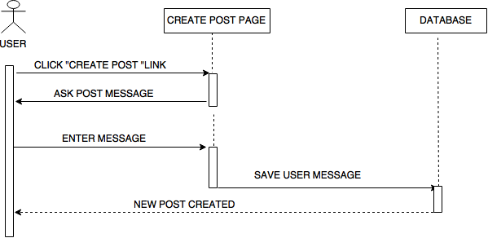

**Figure 5 Sequence Diagram for create post**

12

**3.3.4 Sequence Diagram for Search post**

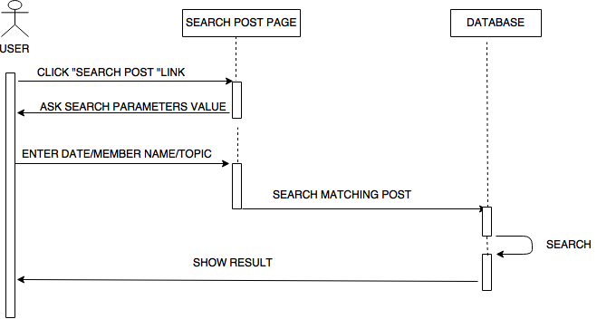

**Figure 6 Sequence Diagram for Search post**

13

**3.3.5 Sequence Diagram for Bid**

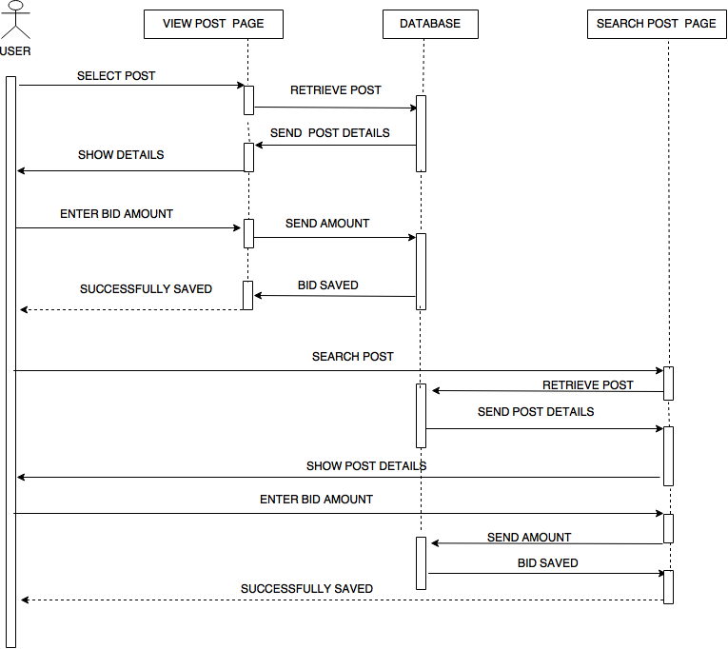

**Figure 7 Sequence Diagram for Bid**

14

**3.3.6 Sequence Diagram for reply**

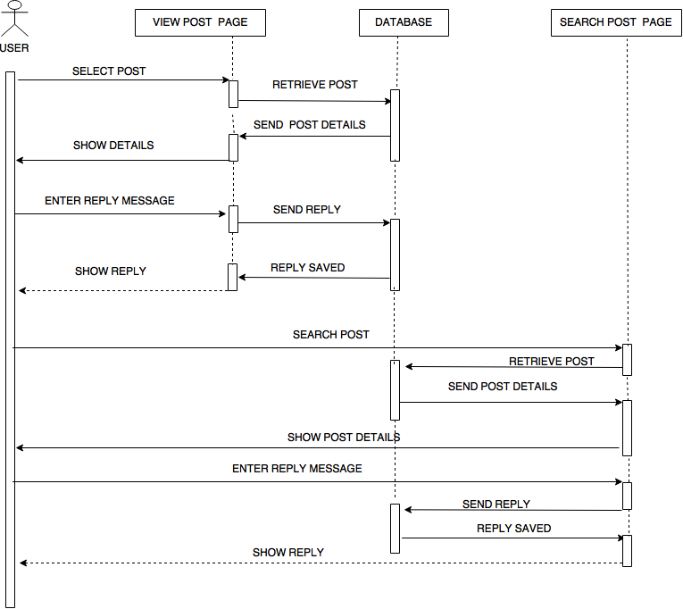

**Figure 8 Sequence Diagram for reply**

15

**3.3.7 Sequence Diagram for viewing Notifications**

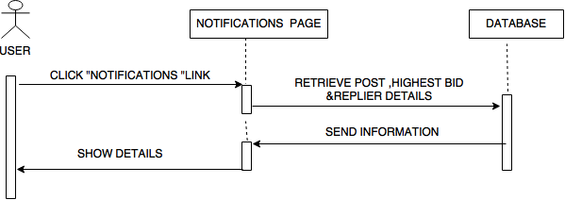

**Fig ure 9 Sequence Diagram for viewing Notifications**

16

**3.4 COLLABERATION DIAGRAM**

Collaboration diagram is an interaction diagram that shows, for one system event described by one use case, how a group of objects collaborate with one another, to show relationships among object roles such as the set of messages exchanged among the objects to achieve an operation or result.

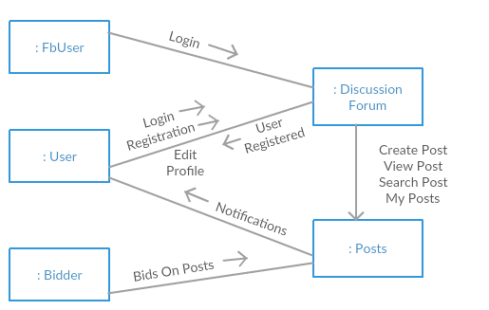

**Figure 10 Collaboration Diagram**

17

**3.5 ACTIVITY DIAGRAM**

Activity diagram is a graphical representation for representing the flow of interaction within specific scenarios. It is similar to a flowchart in which various activities that can be performed in the system are represented.

**3.5.1 Activity Diagram for Login**

User can login through Facebook account or by entering the registered user Id & Password on the forum.if all the credentials are valid ,the user will successfully login to access the profile page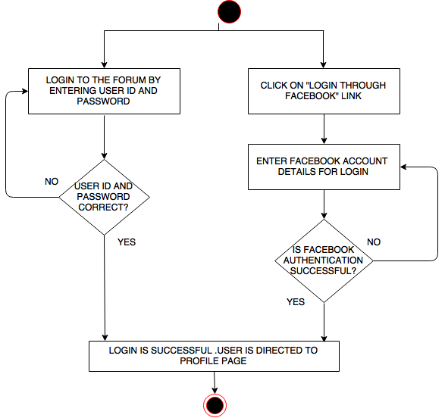

**Figure 11 Activity Diagram for Login**

18

**3.5.2 Activity Diagram for Registration**

User can create their account on the forum by using registration link on the forum page. They will be needed to fill the details which they can later on be changed after login. On user will after submitting the details, user will be directed to login page

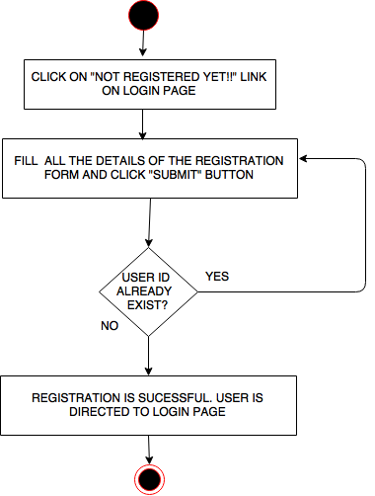

**Figure 12 Activity Diagram for Registration**

19

**3.5.3 Activity Diagram for create post**

User can write new post using “create post” link. It will direct them to create post page where textbox area and topic option is provided . User can easily choose the suitable topic of post and start writing the message on the forum.

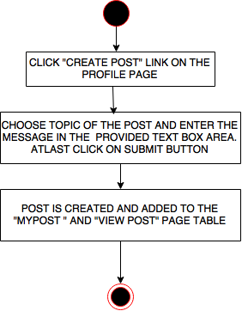

**Figure 13 Activity Diagram for create post**

20

**3.5.5 Activity Diagram for Bid**

As the user open a post ,they can easily bid by selecting the “make a bid”option and specifying the bidding amount in the textbox.bid will be saved in the database and will be kept private.

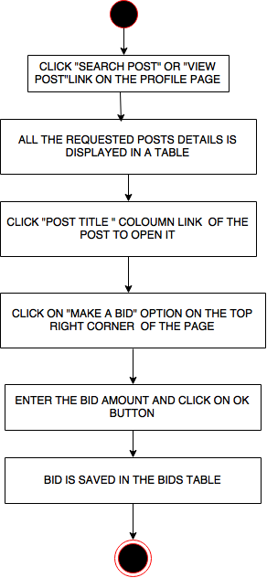

**Figure 14 Activity Diagram for Bid**

21

**3.5.6 Activity Diagram for view post**

User can view all the existing forum posts by selecting “view post” link or they can even filter the content by using “search post” link. User can search post by specifying date of post creation, post creator name or by the topic name to which the post belongs

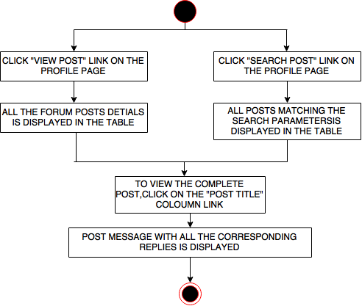

**Figure 15 Activity Diagram for view post**

22

**3.5.7 Activity Diagram for Search Post**

User can search particular post by specifying date of post creation, post creator name or the topic name to which the post belongs. All the posts matching the specified criteria will be shown in the result.

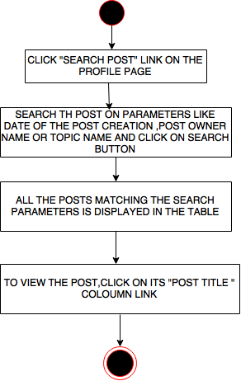

**Figure 16 Activity Diagram for Search Post**

23

**3.5.8 Activity Diagram for reply**

User can open the desired post and able to write a reply in the textbox which is provided along with the post’s message. There is no constraint on the no of replies posted for a particular user.

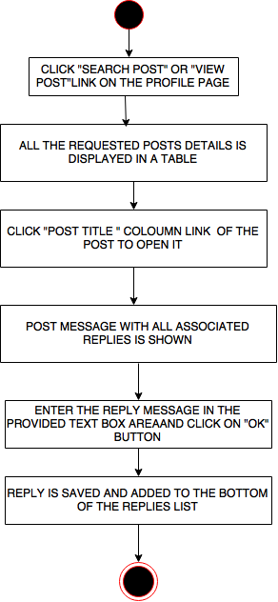

**Figure 17 Activity Diagram for reply**

24

**3.5.9 Activity Diagram for Edit Profile**

User can update their profile details such as password, contact details, profile picture using “edit profile” link. All the changes made to the profile can be viewed by clicking “view profile” link.

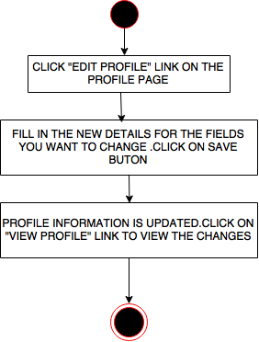

**Figure 18 Activity Diagram for Edit Profile**

25

**3.5.10 Activity Diagram for viewing Notifications**

User can view the highest bid of all their posts and bidder information on the notification page.

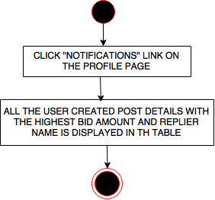

**Figure 19 Activity Diagram for viewing Notifications**

26

**3.6 DEPLOYMENT DIAGRAM**

A deployment diagram depicts a static view of the run-time configuration of processing nodes and the components that run on those nodes. In other words, deployment diagrams show the hardware for your system, the software that is installed on that hardware, and the middleware used to connect the disparate machines to one another.

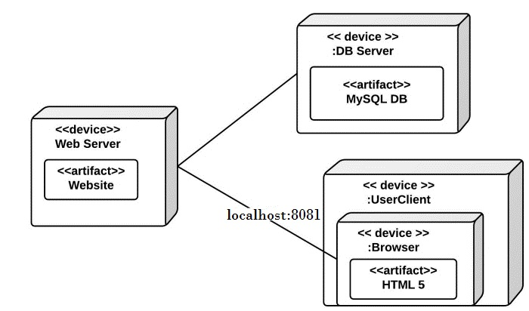

**Figure 20 Deployment Diagram**

27

**3.7 DATA FLOW DIAGRAM**

A data flow diagram (DFD) is a graphical representation of the "flow" of data through an [information system](https://en.wikipedia.org/wiki/Information_system), modeling its process aspects. A DFD is often used as a preliminary step to create an overview of the system, which can later be elaborated.

**3.7.1 Level 0 DFD**

The diagram consists of a process Online Discussion Forum with the participating entity User entering Post message and another entity replies that will view the post and give replies.

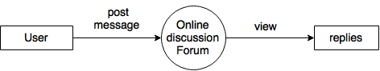

**Figure 21 Level 0 DFD**

28

**3.7.2 Level 1 DFD**

The diagram is level 1 dfd consisting of 1 entity, 4 processes and 4 data stores. User registers on the website, manage their created posts ,gives replies and bid on other member posts which are all stored in different data stores respectively.

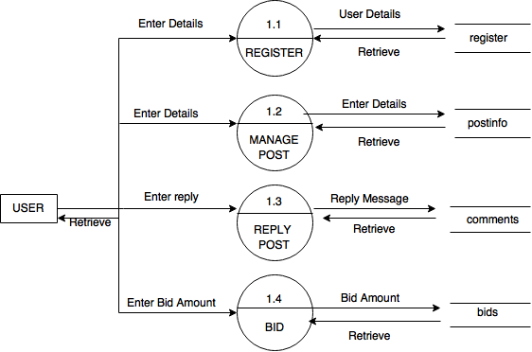**Figure 22 Level 1 DFD**

29

**3.7.2 Level 2 DFD**

The diagram is level 1 dfd consisting of 2 entities, 4 processes and 4 data stores. User creates their own post,view and search existing forum posts and their replies details which are all stored in different data stores respectively. User includes the process of viewing post notifications where the highest committed bid and replier details is shown.

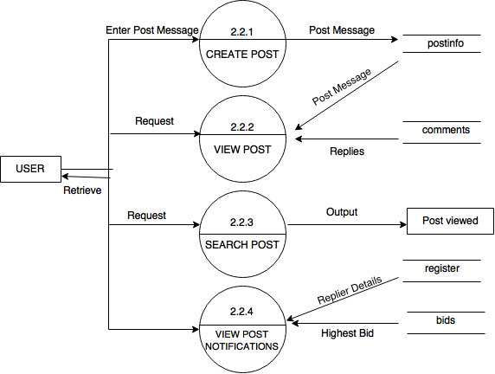

**Figure 23 Level 2 DFD**

30

**DATABASE DESIGN**

31

# 4. DATABASE DESIGN

# 4.1 DATA DESIGN

# Database design is the process of producing a detailed [data model](https://en.wikipedia.org/wiki/Data_model) of a [database](https://en.wikipedia.org/wiki/Database). This [data model](https://en.wikipedia.org/wiki/Data_model) contains all the needed logical and physical design choices and physical storage parameters needed to generate a design in a [data definition language](https://en.wikipedia.org/wiki/Data_definition_language), which can then be used to create a database. A fully attributed data model contains detailed attributes for each entity.

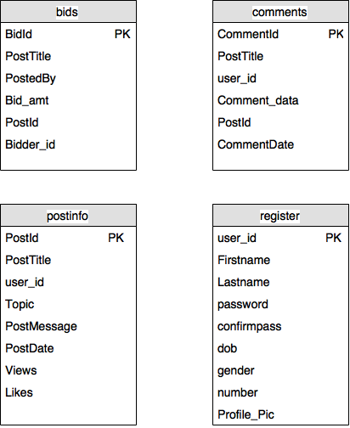

# Figure 24 Data Design

32

**4.1.1 ENTITY RELATIONSHIP DIAGRAM**

An entity-relationship diagram (ERD) is a data modeling technique that graphically illustrates an information system's entities and the relationships between those entities. An ERD is a conceptual and representational model of data used to represent the entity framework infrastructure.

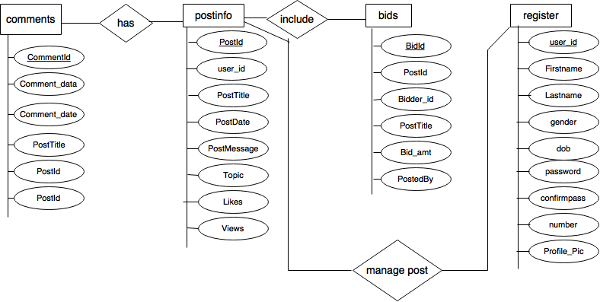

**Figure 25 Entity Relationship Diagram**

33

**4.1.2 DATA DICTIONARY**

**1. postinfo Table**

|  |  |  |  |  |
| --- | --- | --- | --- | --- |
| **Name** | **Type** | **Size** | **Constraints** | **Description** |
| PostId | int | 11 | Primary Key | Post Identification |
| User_id | varchar | 30 | null | User Identification |
| PostTitle | varchar | 100 | null | Title of the post |
| Topic | varchar | 20 | null | Topic of Post |
| PostMessage | text |  | null | Post Data |
| PostDate | date | 20 | null | Date of Post creation |
| Views | int | 11 | null | Number of Post views |
| Likes | int | 11 | null | Number of Likes on Post |

**Table 2 : postinfo Table**

**2. register Table**

|  |  |  |  |  |
| --- | --- | --- | --- | --- |
| **Name** | **Type** | **Size** | **Constraints** | **Description** |
| User_id | varchar | 30 | Primary Key | User Identification |
| Firstname | varchar | 20 | null | Users First name |
| Lastname | varchar | 20 | null | User’s Last name |
| password | varchar | 20 | null | User’s account Password |
| confirmpass | varchar | 20 | null | Confirm Password |
| dob | date |  | null | Date of Birth |
| gender | varchar | 10 | null | Gender |
| number | bigint | 20 | null | User’s Contact Number |
| Profile_pic | mediumblob |  | null | User’s Profile Picture |

**Table 3: register Table**

34

**3. comments Table**

|  |  |  |  |  |
| --- | --- | --- | --- | --- |
| **Name** | **Type** | **Size** | **Constraints** | **Description** |
| CommentId | int | 11 | Primary Key | Comment Identification |
| PostId | Int | 11 | null | Post Identification |
| PostTitle | varchar | 100 | null | Title of the Post |
| Comment_data | text |  | null | Comment |
| User_id | varchar | 50 | null | replier Identification |
| Comment_date | date |  | null | Date of the Comment |

**Table 4: comments Table**

**4. bids Table**

|  |  |  |  |  |
| --- | --- | --- | --- | --- |
| **Name** | **Type** | **Size** | **Constraints** | **Description** |
| BidId | int | 11 | Primary Key | Bid Identification |
| PostId | Int | 11 | null | Post Identification |
| PostTitle | varchar | 100 | null | Title of the Post |
| PostedBy | varchar | 30 | null | Post Creator Identification |
| Bid_amt | Double | 50 | null | Bid amount |
| Bidder_id | varchar | 30 | null | Bidder Identification |

**Table 5: bids Table**

35

**4.2 SYSTEM ARCHITECTURE**

A system architecture or systems architecture is the conceptual model that defines the structure, behavior, and more views of a system. An architecture description is a formal description and representation of a system, organized in a way that supports reasoning about the structure and behaviors of system.

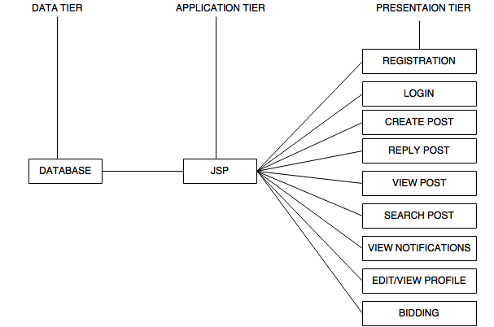

**Figure 26 System Architecture**

36

**4.2.1 STRUCTURE CHART**

A structure chart (module chart, hierarchy chart) is a graphic depiction of the decomposition of a problem. It is a tool to aid in software design. It is particularly helpful on large problems.

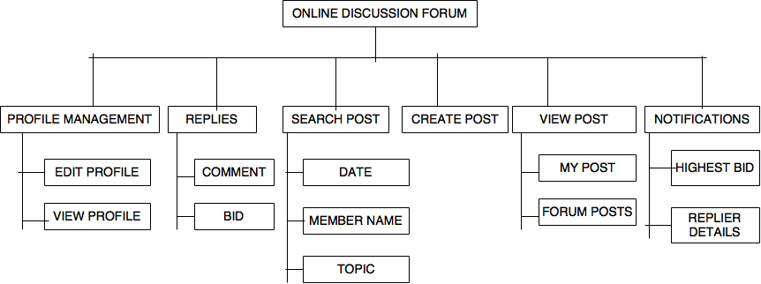

**Figure 27 Structure Chart**

37

# IMPLEMENTATION

38

**5. Implementation**

**5.1 IMPLEMENTATION OF MODULES**

Modules for this project were decided after brainstorming discussions, for proper management of data and ensuring utility to users

1. **Module for Registration:** users can register on the forum in easy steps by first clicking on the registration link provided on the main page and then filling registration form to provide necessary details like user name ,user Id and Password which will be later used for login, birth date, gender, contact details such as email ID ,Contact no. and then finally process for registration gets complete.
2. **Module for login :** user can login either by providing forum’s account user Id and Password in the fields on the main page or by clicking on “login through Facebook “ link. On clicking this link user will be directed to Facebook login page where they have to give their FACEBOOK account information. If all the information provided is successfully validate ,user will be allowed to access the forum services
3. **Module for Post creation:** user can click on “create post” link on the main profile page to start availing this facility. User can write their message in the provided text box area and choose the topic to which their post will belong . the post will be saved and displayed on the forum
4. **Module for searching and viewing the post:** user can view all the forum posts either by clicking on “view post” link or they can search a particular post on numerous parameters like date, topic name or member name under “search post” option. All the user requested posts will be displayed in a table where user just can click in the post column link to view the complete message and replies.
5. **Module for posting reply and bid:** as the user click on the post title “column link in the table, the required post will open on the page with a text box at the bottom to post the reply . the user can write its suggestions and feedback in the reply box .this reply will be public. Simultaneously at the top of the page “make a bid “option is also provided .user can click this option to state an amount. User is allowed to bid only once for a particular post

39

1. **Module for editing and viewing the profile information:** user may wish to update their profile details provided at the registration form. They can easily do this by clicking on the edit profile link.
2. **Module for notifications :** user can view the highest bid of his post and the replier information on the notifications page. This result is calculated by comparing all the available bids.

40

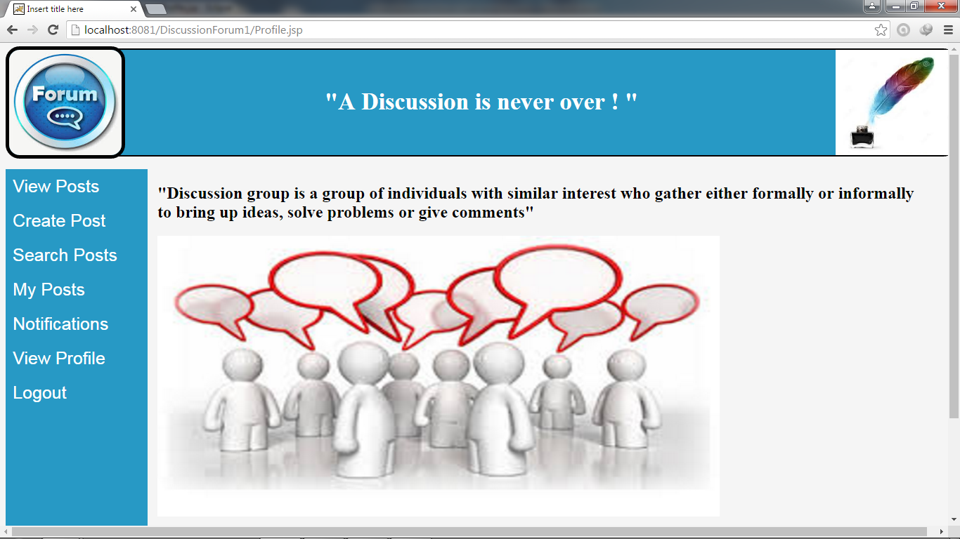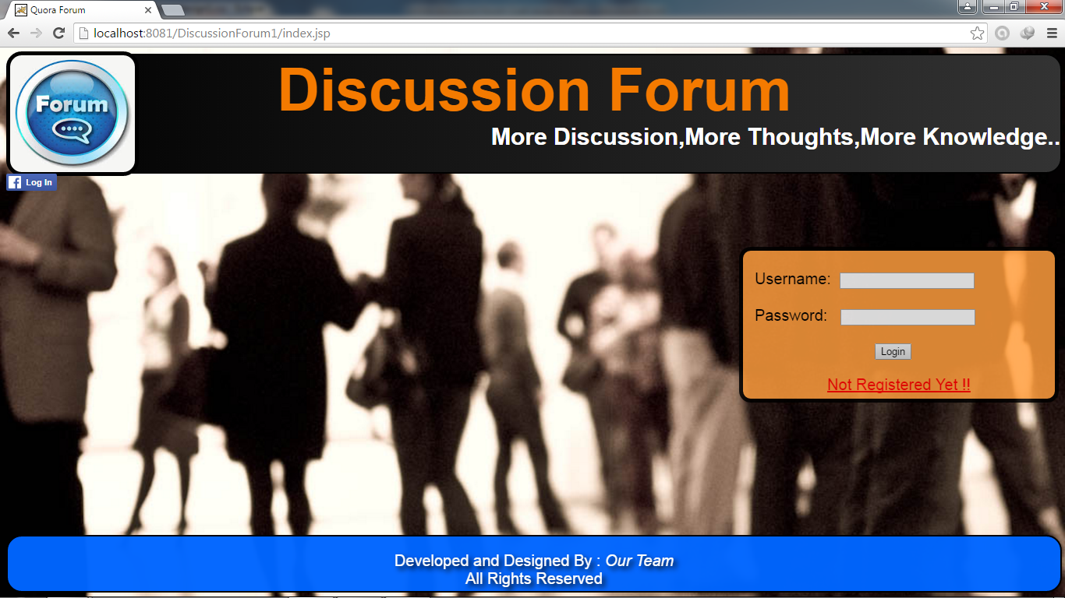**5.1.2 GRAPHICAL USER INTERFACE**

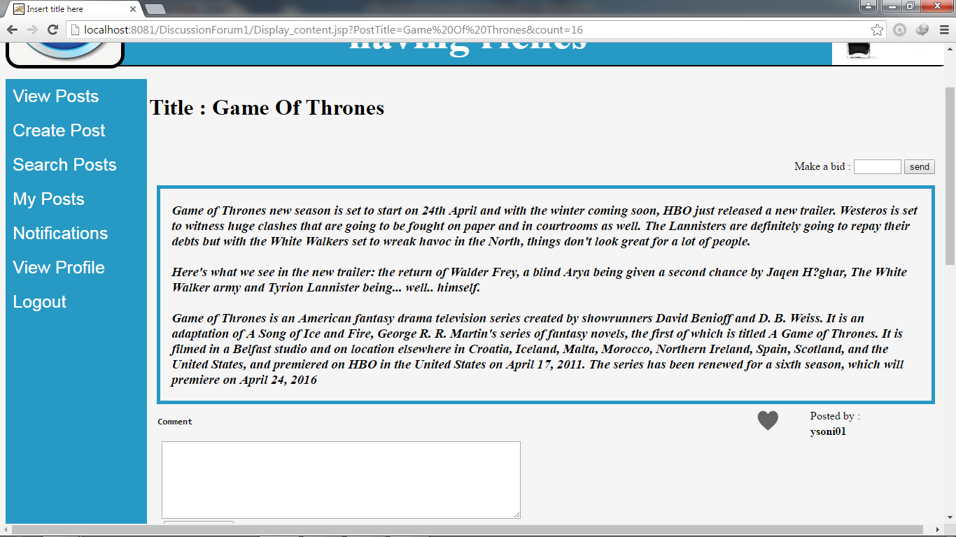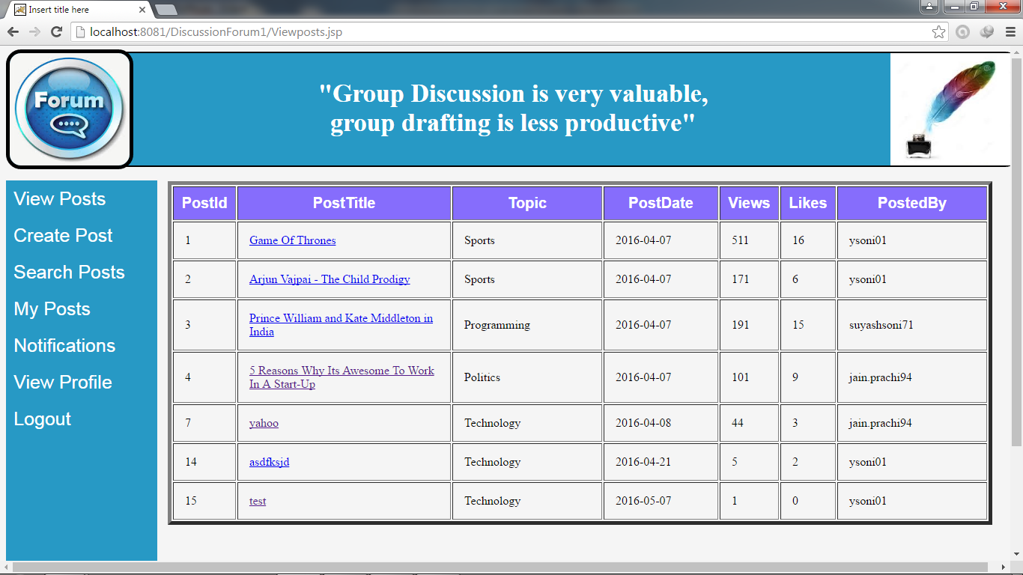

42

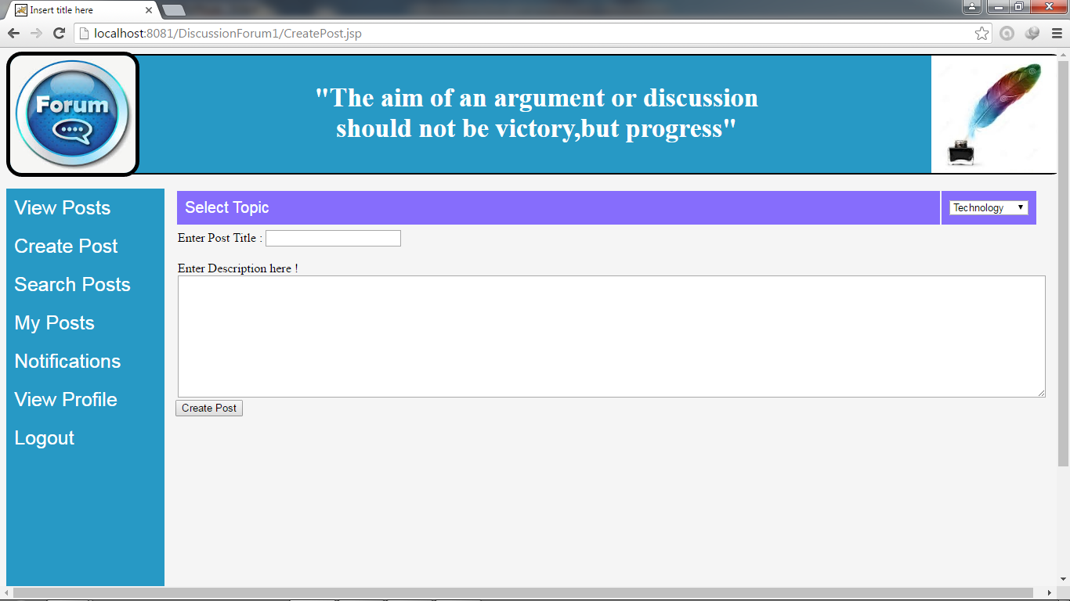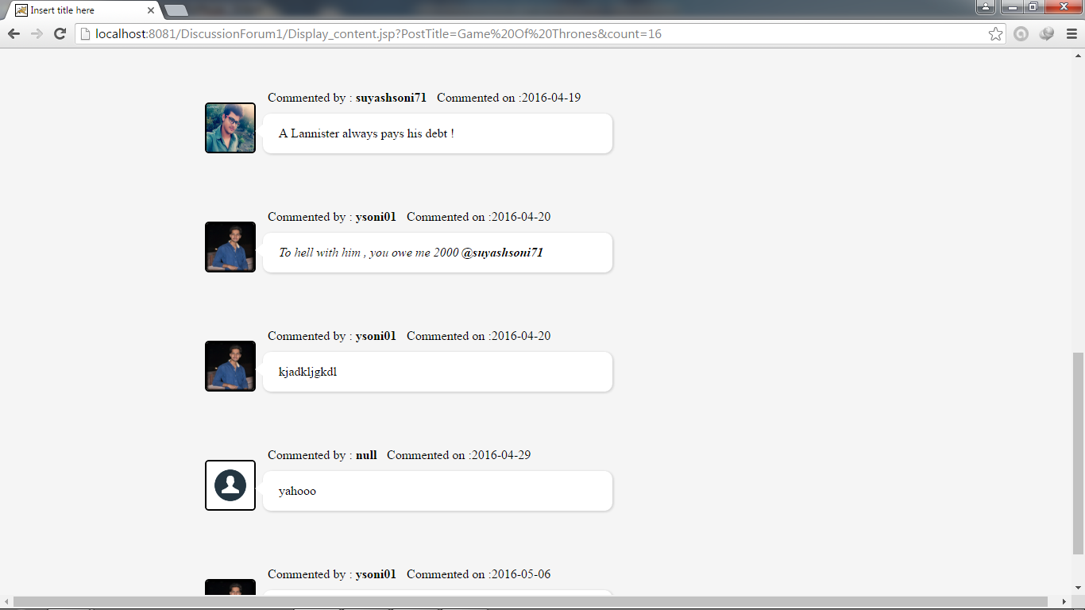

43

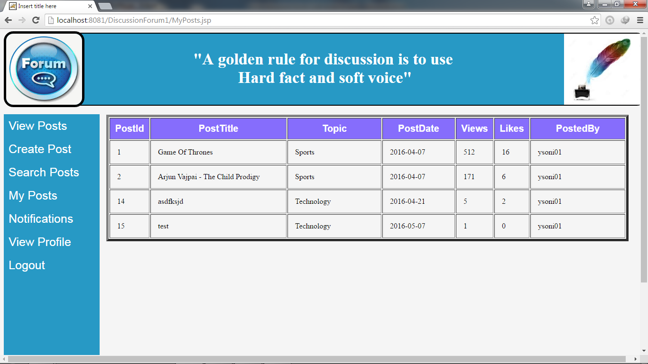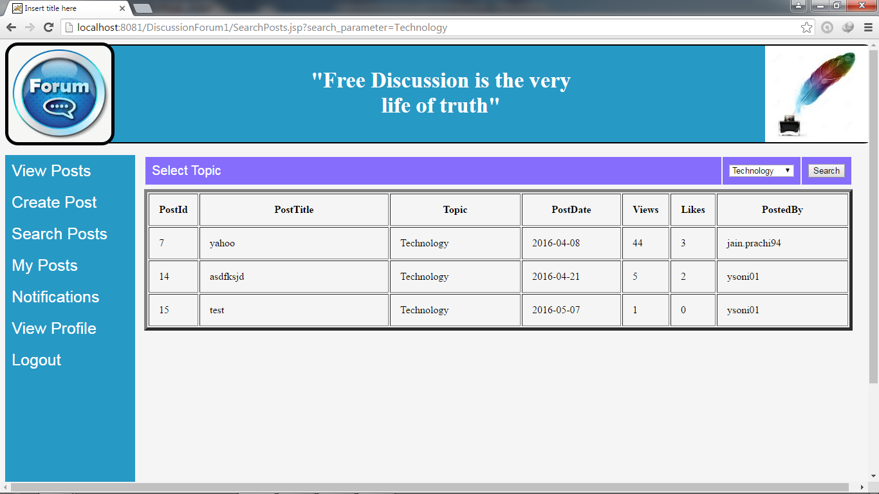44

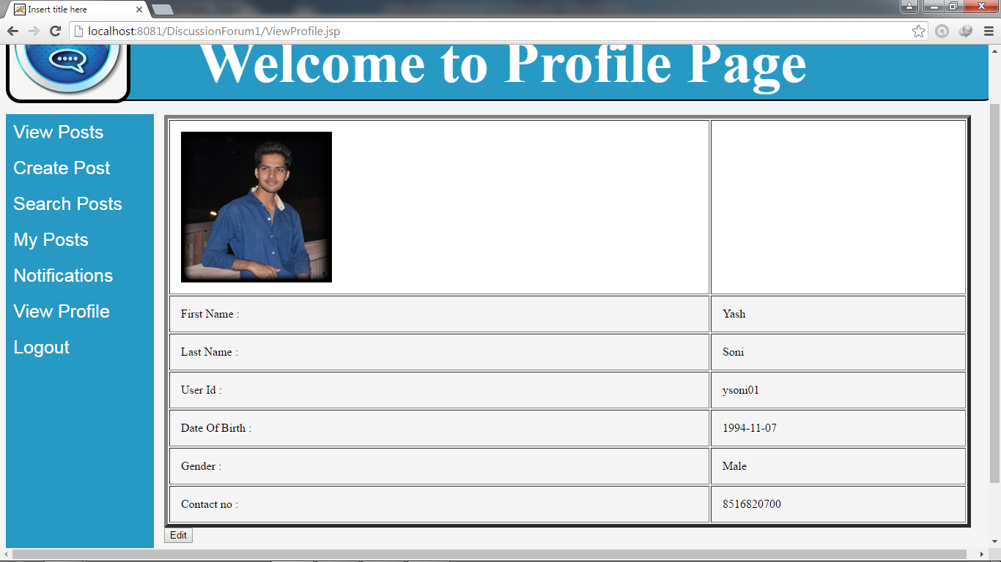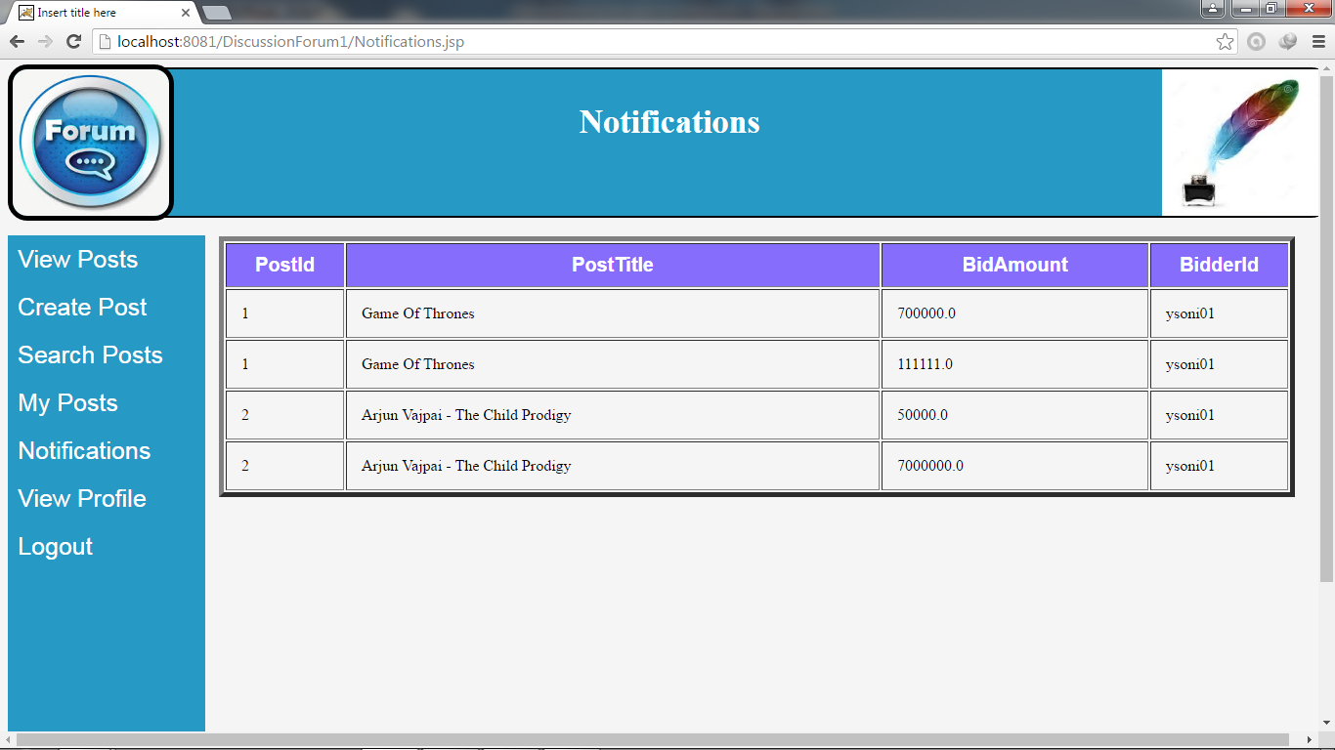45

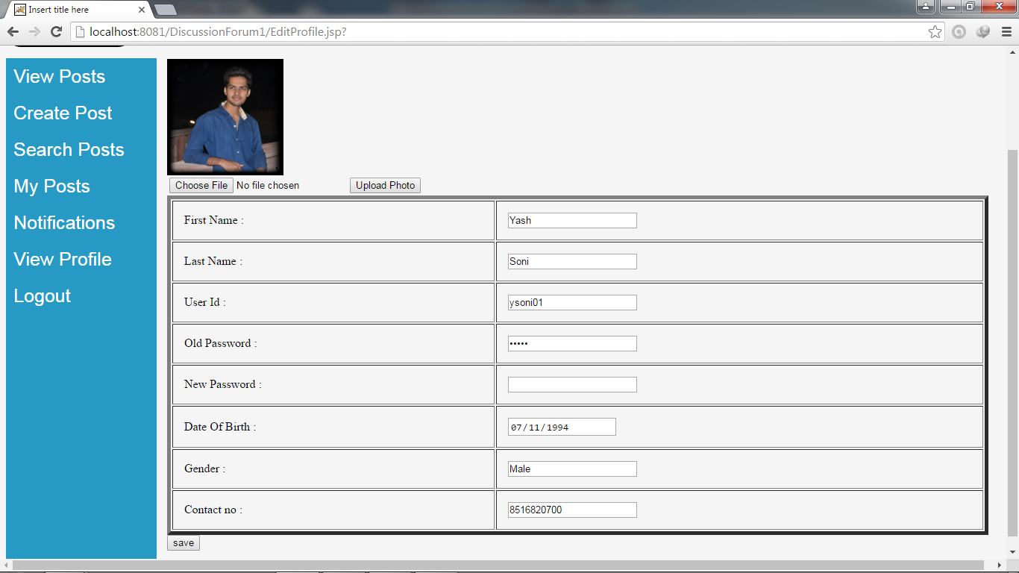

46

**5.2 RESULT**

Module wise generated results for Online Discussion Forum are:

* As the user request for the post ,a brief description of its properties is first displayed in a table that includes following fields :post title, no of likes, no of views, date and time of post creation, and posted by .user can click on the post title link to view the post’s message and replies
* Forum post is displayed with all its corresponding replies in top down fashion following the order of their creation which means that reply posted recently is added at the bottom of the post.
* Bids remain hidden on the forum and only the highest bid is displayed on the notification page with the replier name.

# 47

# DECLARATION

48

**6. DECLARATION**

We hereby declare that the project entitled “Online Discussion Forum” submitted to CSC India Pvt Ltd, Indore is a record of an original work done by us under the guidance of Project Mentor Ms.. Kamna Pamnani, Application Developer in CSC. The result embodied in this thesis is not submitted to any other institute for award of any degree or diploma.

Yash Soni

Padmavati Rai

49