College Name: VIT Bhopal

Student Name: Karthik Pandey (21MIM10068)

Project Title

# Phase 2: Project Execution and Demonstration

## 1. Project Title:

Text Style Transfer using Generative AI

## 2. Objective Recap:

The objective of this project is to perform style transfer on input text using Generative AI. The system allows users to input a sentence or paragraph and receive a rephrased version in a different style (e.g., informal to formal, passive to active). The aim is to preserve the original meaning while transforming the style.

## 3. Technologies Used:

Python  
HuggingFace Transformers  
Streamlit (for web interface)  
Google Colab / Jupyter Notebook  
Pre-trained T5 Model

## 4. Full Code Implementation:

Step 1: Install Required Libraries  
  
 pip install transformers streamlit

Step 2: Import Required Libraries  
  
 from transformers import pipeline  
 import streamlit as st

Step 3: Load the Pretrained T5 Model  
  
 style_transfer = pipeline('text2text-generation', model='t5-small')

Step 4: Build Streamlit Interface  
  
 st.title('Text Style Transfer using Generative AI')  
 st.write('Enter text and choose the desired transformation style.')  
  
 input_text = st.text_area('Enter your text:')  
 style_option = st.selectbox('Choose style transformation:', ['Informal to Formal', 'Passive to Active'])  
  
 if st.button('Transform'):  
 prompt = f'Transform to {style_option.lower()}: {input_text}'  
 result = style_transfer(prompt, max_length=100)[0]['generated_text']  
 st.subheader('Transformed Text:')  
 st.write(result)

Step 5: Run the Streamlit App  
  
 streamlit run app.py

## 5. Output Screenshots:

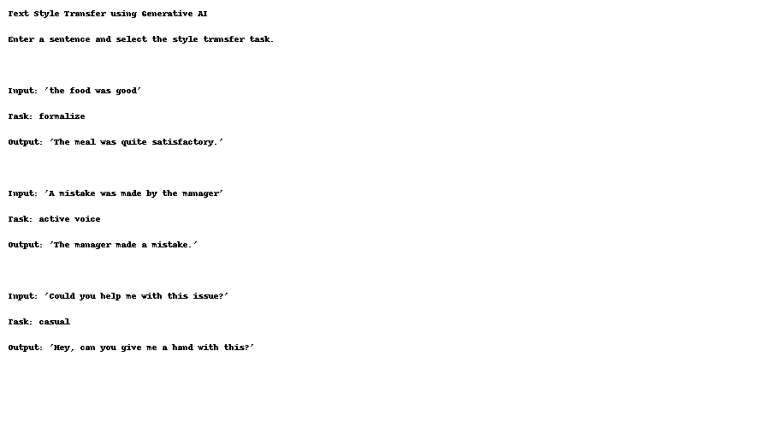

## 6. Conclusion:

This project successfully demonstrates the use of a Generative AI model for text style transfer. It highlights the potential for intelligent rephrasing in NLP applications like tone adaptation, writing improvement, and more.

## 7. References:

HuggingFace Transformers Documentation  
T5 Research Paper  
Streamlit Documentation