OCR Data Explorer – A MERN Stack Mini Project
Oct 21, 2026
Full Stack Development · Mini Project Report

1. Introduction
This project is a small web application, built with the MERN stack, that shows the tables from my own research paper in an interactive way.
My paper studies how many human-typed (transcribed) words a computer needs before it can read handwritten Devanagari text well. The experiments produced nine result tables. Instead of leaving them in files, I stored them in a database and built a website that shows any one of them on request, together with a short explanation of what the table and each of its columns mean.
MERN stands for MongoDB, Express, React and Node.js. I built the app step by step, using the same ideas we practised in the class labs: React hooks, a REST API with Express, and connecting Node.js to MongoDB.

2. Objectives
The app has six goals:
- Store the nine result tables of the paper in a MongoDB database.
- Create a REST API with Express that sends this data to the front end.
- Build a React front end where the user picks one table from a dropdown menu.
- Show a description of the chosen table and of every column in it.
- Let the user search, sort, add, edit and delete rows (CRUD).
- Show the main result of the paper as a chart on a dashboard.

3. Technologies Used
Technology | Used for | What it does in this project
MongoDB | Database | Stores each table as a collection of documents
Node.js | Backend | Runs JavaScript on the server
Express | Backend | Creates the API routes the front end calls
React (with Vite) | Frontend | Builds the pages and components
React Router | Frontend | Moves between pages without reloading
CORS | Backend | Lets the React app (port 5173) call the Express server (port 5000)
dotenv | Backend | Keeps the database address in a separate .env file

4. System Architecture
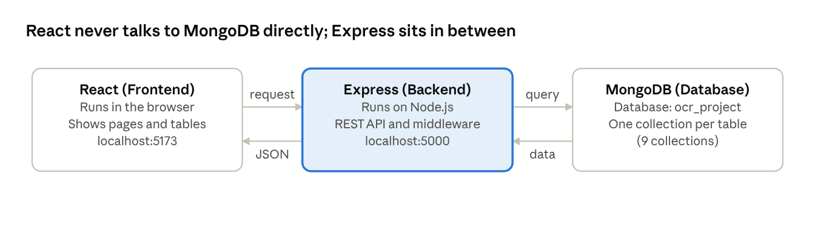
system architecture · 3 parts
The React app sends a request to the Express API, Express reads or writes MongoDB, and the JSON answer travels back to React, which shows it on the page.

5. The Data Used
The data comes from my research paper, "Measuring Annotation Efficiency for Handwritten Devanagari Recognition: Sample-Complexity Curves for Four Pretraining Regimes" (arXiv:2609.16859). My professor asked me to use the tables of this paper for the project.
In the paper, a handwriting-recognition model is trained in four different ways, using anywhere from 10 to 4000 human-transcribed words. After each run the model is tested and its error is recorded as the character error rate (CER). A lower CER is better. For example, to reach a CER of 0.5 the model trained from scratch needed about 355 words, while the pretrained model needed only about 81. The small-data setting is created on purpose, by using only a small part of a large dataset.
The nine tables are:
# | Table | What it shows
1 | Training runs | The error for each training method and each number of words
2 | Regime vs. scratch | How much better or worse each method is than training from scratch
3 | Annotation saving | How many fewer words are needed to reach a chosen error
4 | Words needed | The number of words needed to reach a chosen error
5 | Per-segment slopes | How fast the error falls between two word counts
6 | Encoder share | How much of the benefit comes from the encoder part of the model
7 | Sequence benefit | The extra gain from also transferring the rest of the model
8 | Errors by character class | Which kinds of letters are hard to read
9 | Zero-shot exact matches | Words read correctly with no real labels, and whether they were in the synthetic data

6. Database Design
The database is called ocr_project. Each of the nine tables is stored as one MongoDB collection, and each row of a table is one document, which looks like a JSON object. For example, one document in the runs collection looks like this (shortened):
{
"_id": "ObjectId(...)",
"arm": "synthsup",
"n": 100,
"n_seeds": 6,
"mean_cer": 0.4796,
"std_cer": 0.0281
}
The data was loaded from the paper's CSV files with a small script, seed.js, which is run once with npm run seed.
Collection | Documents
runs | 36
cer_difference | 27
annotation_saving | 21
sample_complexity | 28
segment_slopes | 32
benefit_decomposition | 9
sequence_benefit | 9
per_class_errors | 9
exact_matches | 57
The title, the description and the list of columns of every table are written once in a file called tableConfig.js. The front end reads them from the API, so no column name is typed into the React code.

7. Backend (Express API)
The backend is an Express server that connects to MongoDB and answers requests from the React app. Seven routes are used:
Method | Route | What it does
GET | /api/tables | Sends the list of tables for the dropdown
GET | /api/tables/:key | Sends one table: its description, columns and one page of rows
POST | /api/tables/:key | Adds a new document
PUT | /api/tables/:key/:id | Updates a document
DELETE | /api/tables/:key/:id | Deletes a document
GET | /api/stats | Sends the numbers and chart lines for the dashboard
GET | /api/health | Checks that the server is running
The server also uses some middleware, which runs before a request reaches its route:
- cors allows the React app to call the API from a different port.
- express.json reads the JSON that React sends in a POST or PUT request.
- logger is a small function I wrote that prints every request in the terminal.
- validateRow checks the data before it is saved, for example that a number field really contains a number.
- errorHandler sends a clear JSON message when something goes wrong or a route is not found.

8. Frontend (React)
The frontend is a React app created with Vite. It has three pages, switched with React Router:
- Dashboard shows four summary boxes and a line chart of error against the number of words.
- Tables is the main page, with the dropdown, the data table and the description panel.
- About the project explains the research and how the app is built.
The pages are built from small components: DataTable draws any table, RowForm is the add and edit form, and CerChart draws the chart. I drew the chart myself with SVG, so no chart library was needed.
The React hooks from our labs are used like this:
Hook | Where I used it
useState | Remembers the chosen table, page number, search text and sort order
useEffect | Fetches data from the API when the chosen table, page or search changes
useContext | Shares the list of tables with all pages (TablesContext)
useRef | Moves the cursor to the search box after a table is chosen

9. How the Table Dropdown Works
Only the table the user chooses is loaded. This is what happens, step by step:
- When the Tables page opens, React asks the API for the list of tables (GET /api/tables). Only the names and row counts come back.
- The dropdown is filled with these names, for example "Table 3 — Annotation saving at a target error (21 rows)". Nothing else is shown yet.
- The user picks a table. The page saves the choice in a state variable called selectedKey.
- Because selectedKey changed, useEffect runs and calls GET /api/tables/<key>?page=1&limit=12.
- Express reads that one collection from MongoDB and sends back the description, the list of columns and the first 12 rows.
- React shows the description, the data table, and the "Field descriptions" panel on the right.
- Searching, sorting by a column heading, and the Next and Previous buttons only change the request, and the same steps repeat.

10. Output Screenshots
Figure 1: Dashboard. It shows the headline numbers and the error-rate chart, which is drawn from a MongoDB aggregation.
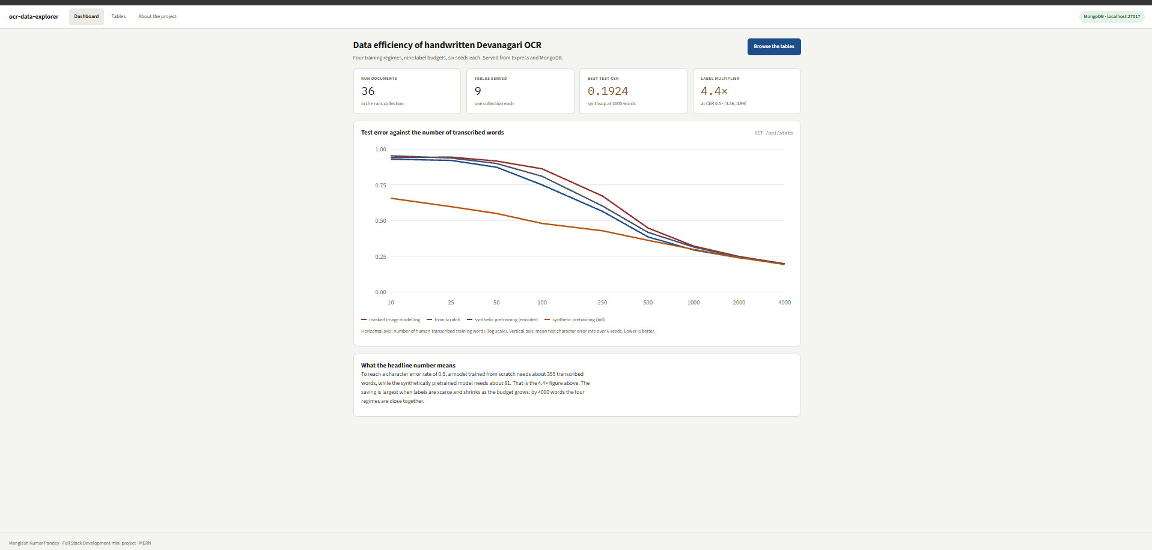
Figure 2: Tables page. One table is chosen from the dropdown (here Table 3). The description and the field descriptions appear next to the rows, and every row has Edit and Delete buttons.
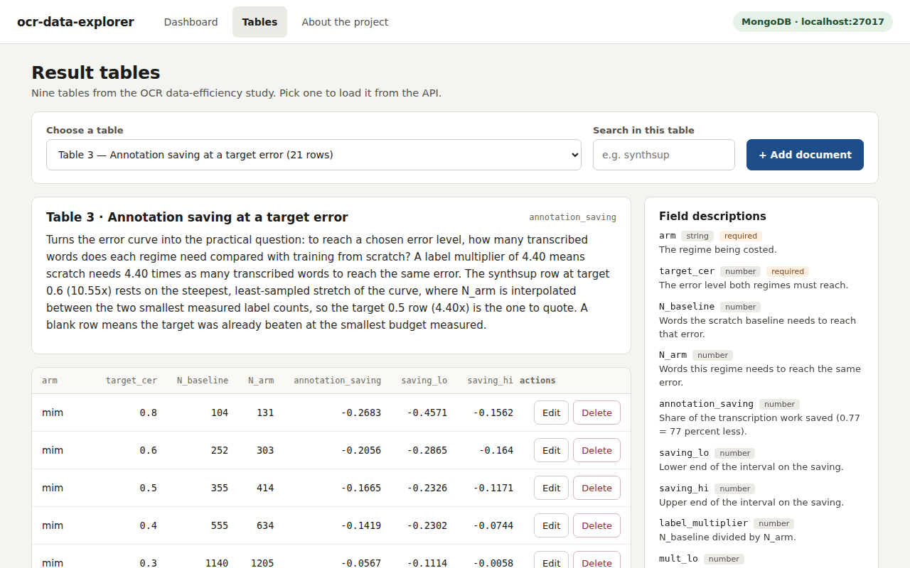
Figure 3: Add a document. The form is built automatically from the column list of the selected table, and required fields are marked with a star.
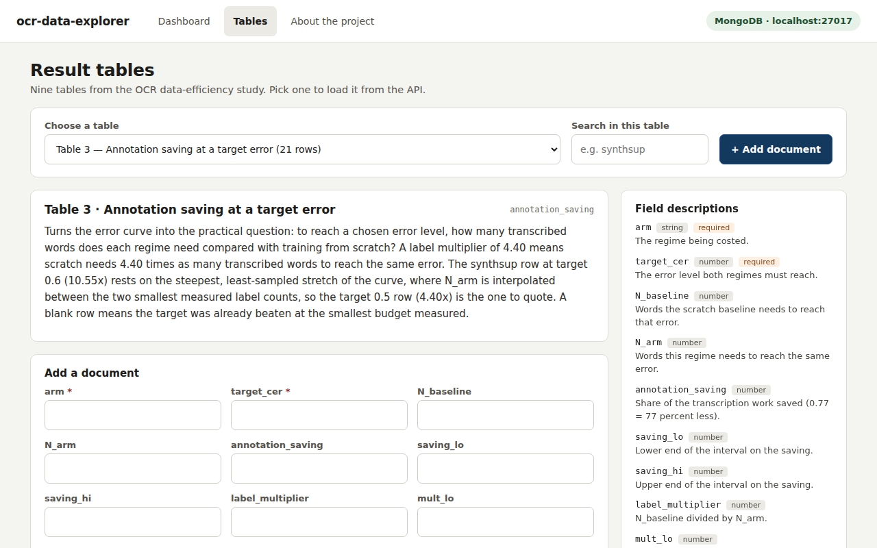

11. What I Learned
This project showed me how the three parts of a MERN app fit together. The most useful things I learned were:
- How React components keep their data in state and use useEffect to fetch from an API.
- How an Express route reads from MongoDB and returns JSON.
- Why CORS is needed when the front end and the backend run on different ports.
- How middleware can check data and handle errors in one place instead of in every route.
Some problems I faced:
- The first version of the chart was upside down, because in SVG the vertical position 0 is at the top of the picture. I fixed it by flipping the formula so that a lower error is drawn lower.
- On wide tables the Edit and Delete buttons scrolled out of view. I fixed this with CSS so that the actions column stays fixed at the right edge.
- While checking my work against the data, I found that one table description was wrong, so I corrected it. This taught me to check text against the real numbers.

12. Conclusion
The OCR Data Explorer meets its objectives: the nine tables of my paper are stored in MongoDB, served by an Express API, and shown one at a time in a React app with descriptions, search, sorting and full add, edit and delete.
The app could be improved in the future by adding a login page, more charts, and by putting the database online with MongoDB Atlas so it can be shown without a local setup.
Acknowledgement: Claude (Anthropic) was used to help write and debug the code and to draft this report. I ran, tested and checked the application myself.

