Project Report
Group: 6 Thursday

Introduction
The objective of performing this laboratory exercise should be mentioned here. The objective should not be more than 2-3 lines.
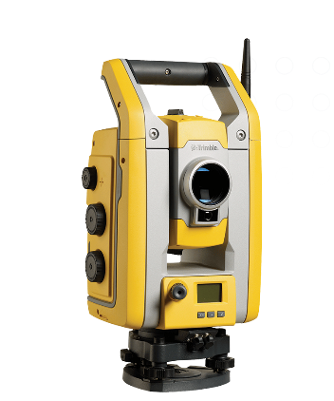
Figure 1:- Total Station Timble S5 model( https://geospatial.trimble.com/en/products/hardware/trimble-s5)

Objective
The student should explain the complete methodology used to perform the laboratory exercise. In case, there are multiple questions in the lab exercise, the student should explain the methodology for solving each of the questions. This should be done listed under this section. An example is given below.
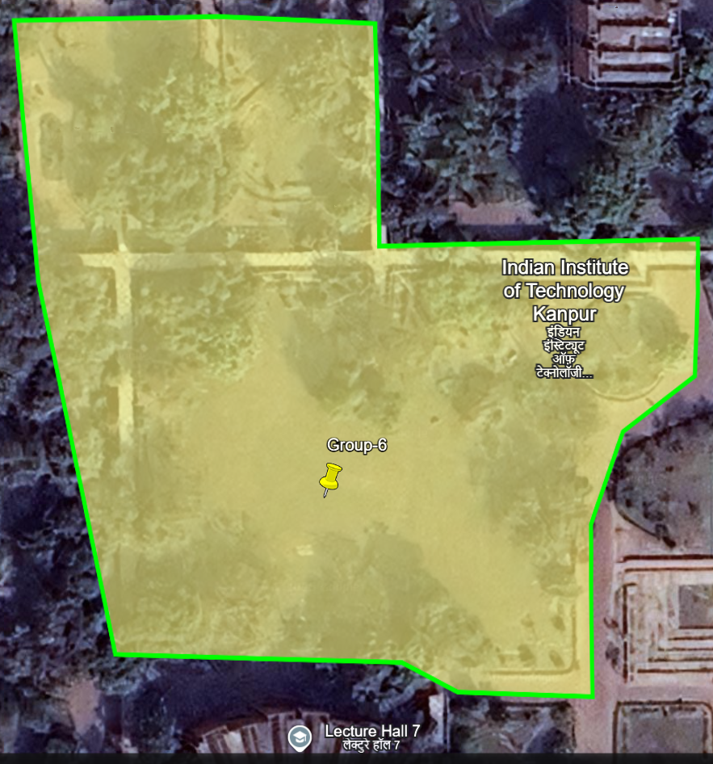
Figure 2:-Area allocated during groupwise distribution ( https://earth.google.com/web/@26.51279226,80.23264455,159.08720386a,1000d,30y,0h,0t,0r/data=CgRCAggBOgMKATBCAggASggIr_ubpwYQAA)

Reconnaissance of Survey

Levelling

Important Terms
- Back Sight (B.S.): The back sight is a staff reading taken at a point of known elevation, such as a benchmark or change point. It is the first reading taken after setting up the instrument. Also, to establish the instrument height.
- Fore Sight (F.S.): The fore sight is the second staff reading (after the back sight reading) taken on a point whose elevation is to be determined. It is used to establish the difference in elevation between two points.
- Intermediate Sight (I.S.): An intermediate sight is any staff reading taken between the back sight and fore sight. It is used to determine the elevation of points between the instrument setup and the final station.
- Change Point (C.P.): A change point is a point where the level instrument is shifted during a survey. Both back sights and fore sights are taken on this point to maintain a continuous line of measurement.
- Bench Mark (BM): A benchmark is a fixed reference point of known elevation, typically used in surveying as a starting point for establishing elevations across a site or area.
- Mean Sea Level (MSL): is the average height of sea surface calculated over a period of time.
- Closing Error: also known as misclosure, is the error in the reading of loop of points whose elevation is being calculated. It occurs when initial known elevation (some BM) doesn’t match with the final calculated elevation (when we complete the loop and come back to initial point from where we started).
- Datum Surface: A datum surface is a precisely chosen reference level from which elevations are measured. In geodetic levelling we often chose Mean Sea Level (MSL) as a datum surface.
- Reduced Level (RL): is the elevation of a point with respect to a known, fixed point or surface (Mean Sea Level in our case).

Methodology
- Setup and level the instrument
- Take the first reading (back sight) by putting staff on the known RL (near GI lab)
- Carryout fly levelling operation and calculate RL of some fixed features (Electric Poles and Markings on Ground) using two methods given above.
- Take the last reading (foresight) and close on the same point near GI lab.
Enter observations in the leveling field book by two methods
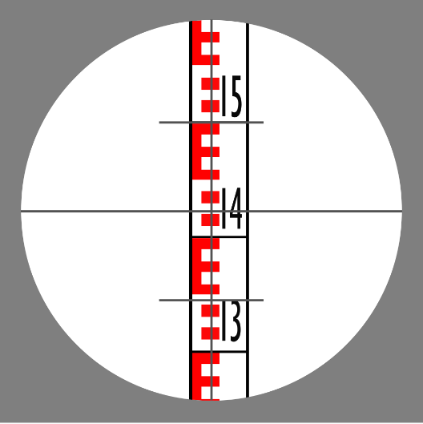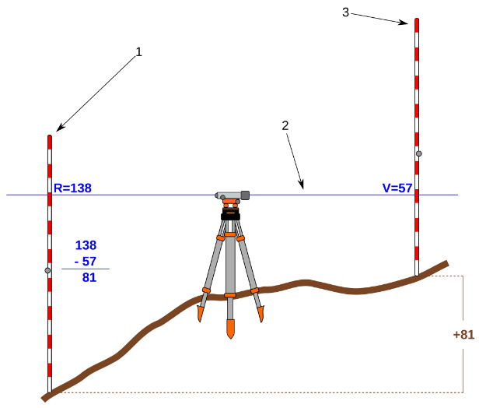
Figure 3:- Stadia marks on a crosshair and Diagram showing relationship between two level staff (https://en.wikipedia.org/wiki/Levelling)

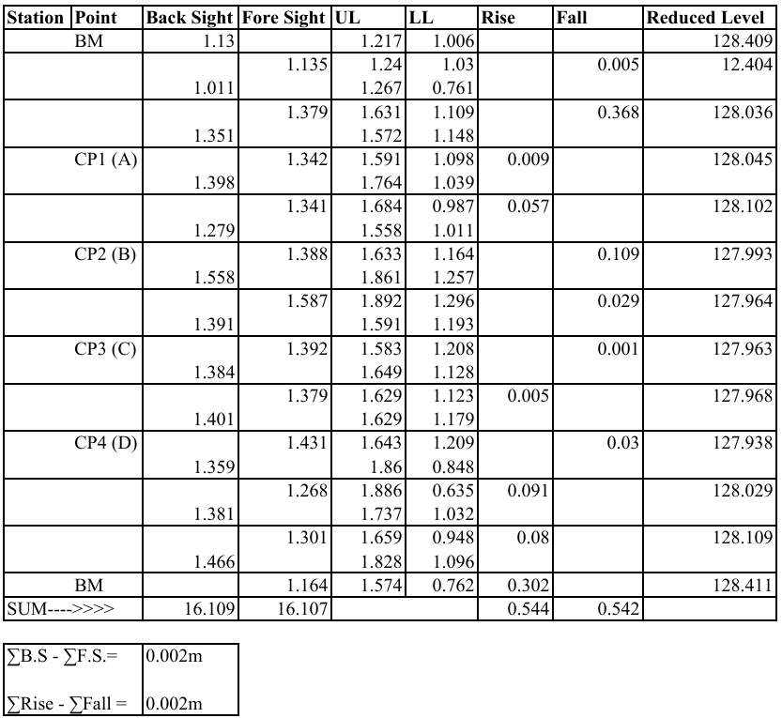

Traverse Survey
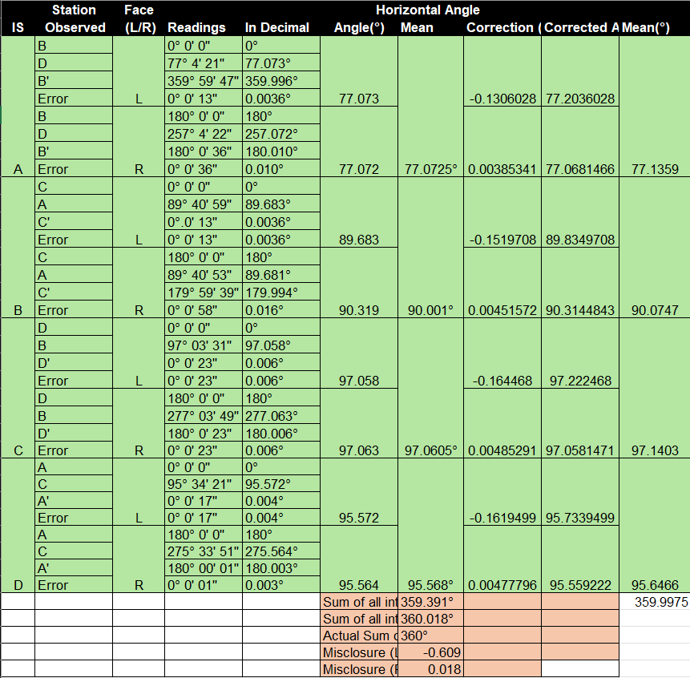
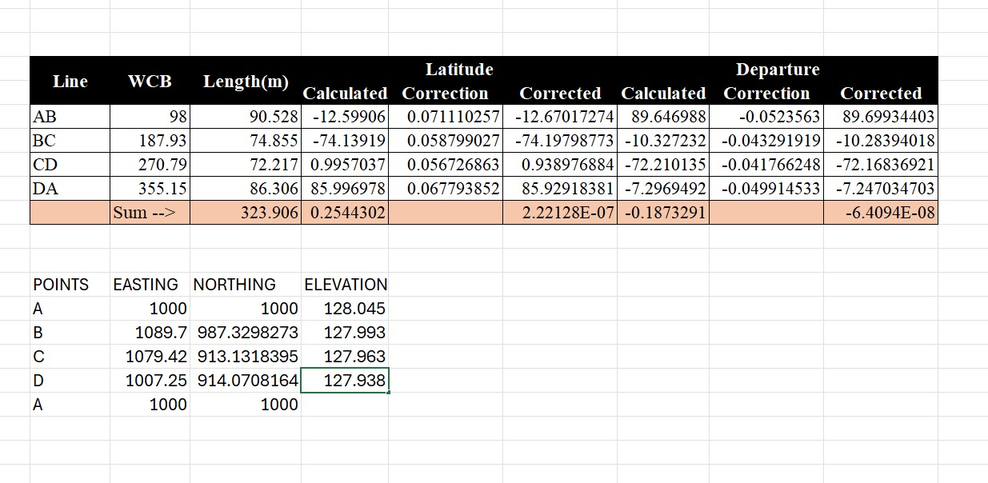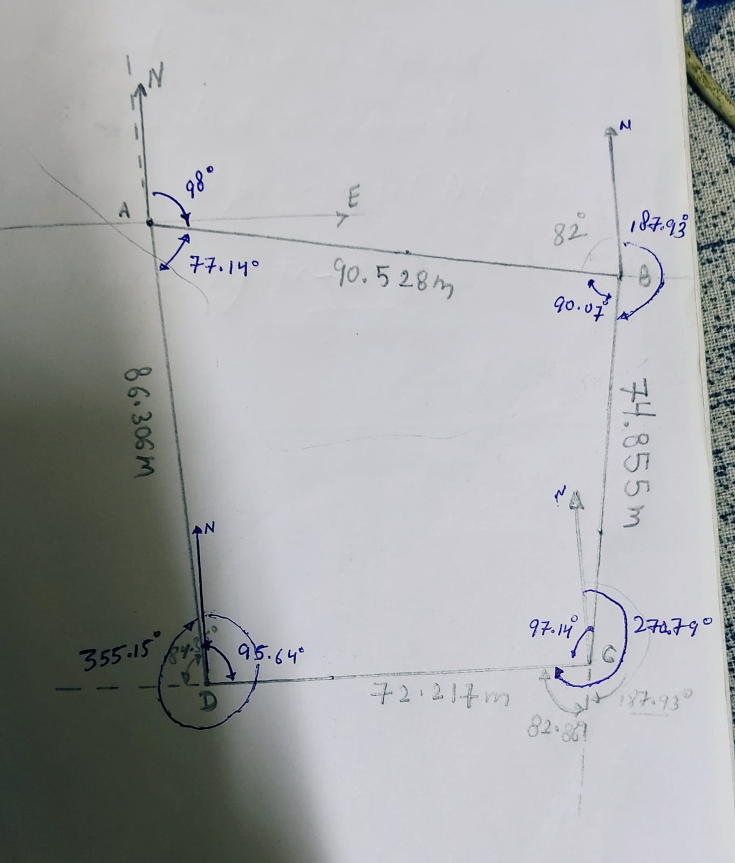

Feature Mapping

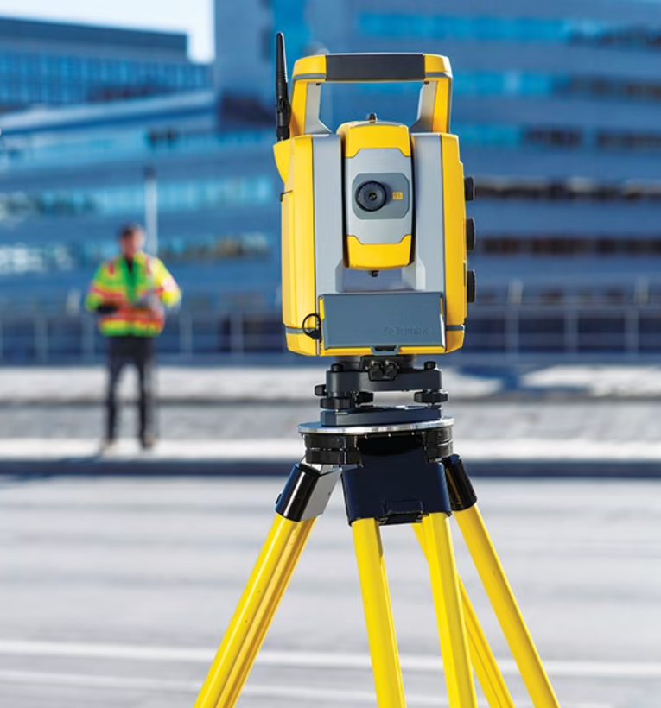
Figure 4:- Total Station on a Tripod with a person holding prism ( https://geospatial.trimble.com/en/products/hardware/trimble-s5)

Conclusions
The conclusions of this laboratory exercise should be mentioned here. The student should conclude the report and provide a brief summary of what all is achieved in this exercise. The student could also talk about what he/she learned from this exercise and how this exercise has helped him in understanding the concepts. In addition, he/she could mention how this laboratory exercise can be improved.

Map
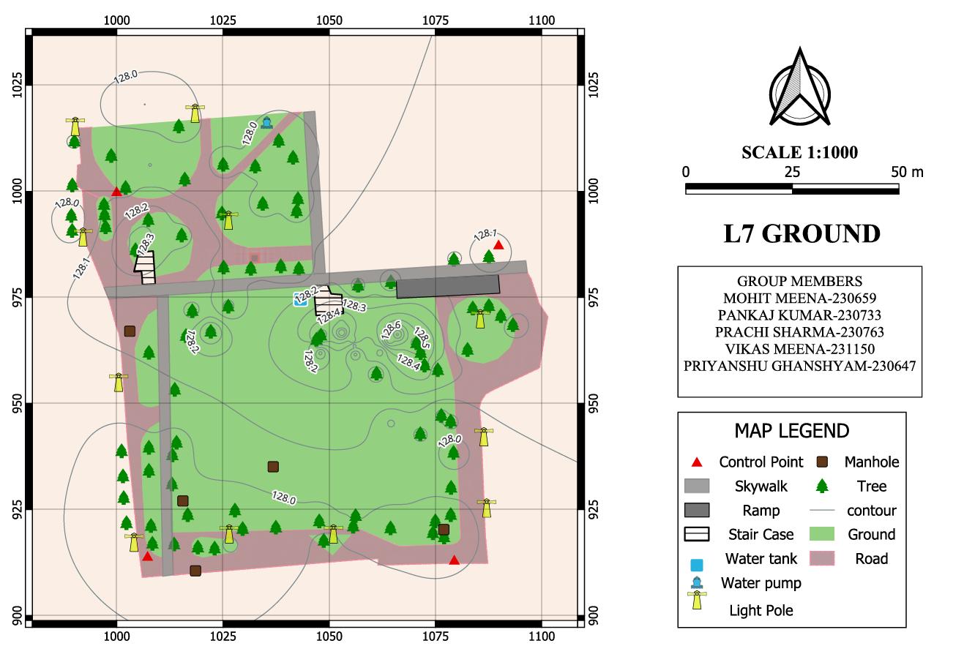

References
All the references used in preparing this lab report are clearly mentioned.

Group Members
Pankaj Kumar 230733
Mohit Meena 230659
Prachi Sharma 230763
Vikas Meena 231150
Meena Priyanshu Ghanshyam 230647

