Setting up a Tableau class with 14 day free trial.

All the files you will need for a Level 1 and Level 2 Tableau class are already installed on the Tableau image. You will find them on the desktop. See Basic_Learning_Tableau_Files and Advanced_Learning_Tableau_Files in little yellow folders on the desktop.

Start out by installing 14 day trial on all student machines AND your own. I generally get the instructor 2 machine open and install using an “assembly line” fashion. You can install all machines at same time, no problem. See directions below:

You will notice that the browser in this machine already has a tab for [www.tableau.com](http://www.tableau.com). Just click on that tab:

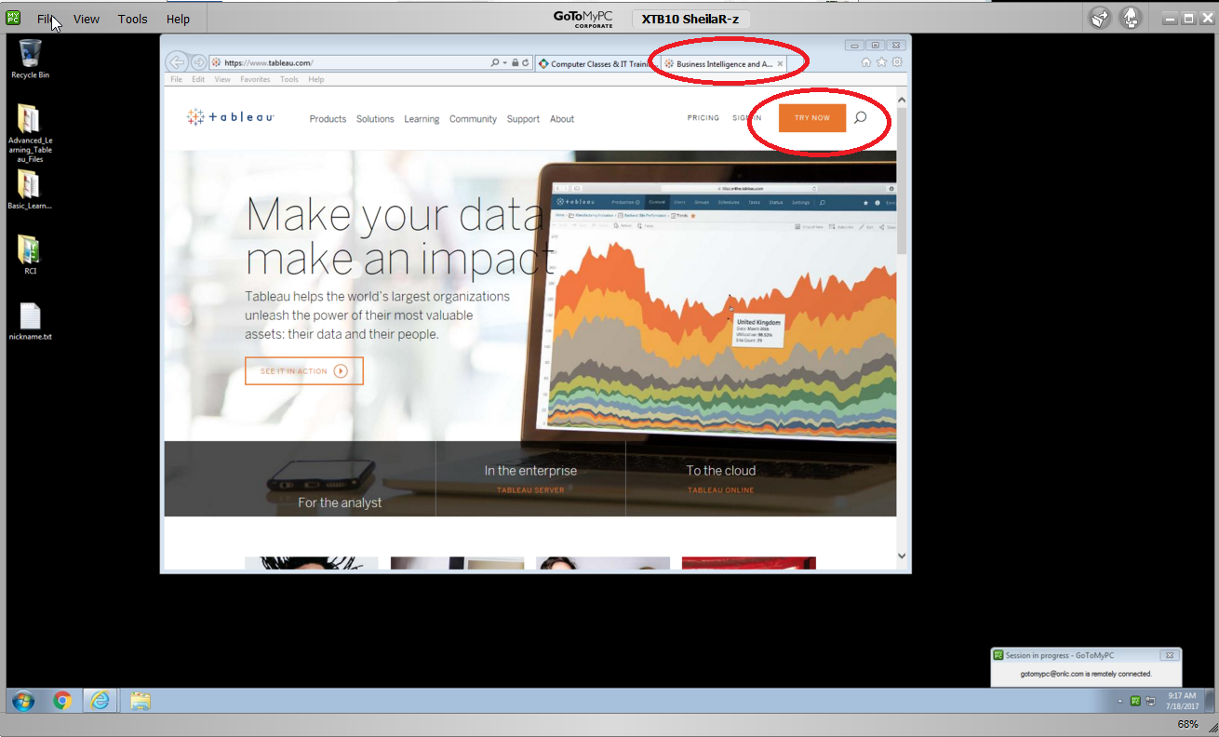

Click on the “Try it Now” button.

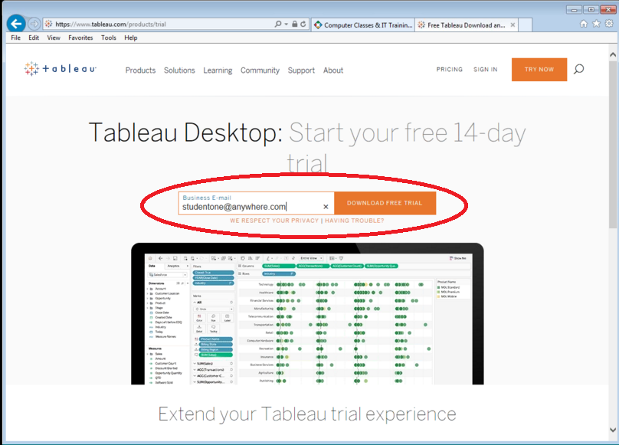

Type in a new set of emails each time. Ex: [MonStuOne@tab.com](mailto:MonStuOne@tab.com), [stuone@monday.com](mailto:stuone@monday.com)

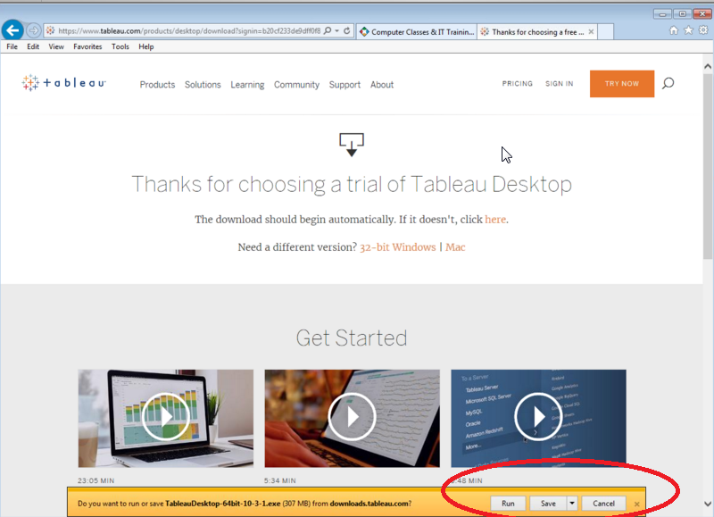

The default saving location is: C:\program files\tableau – Click the check box to install. As it installs, it will take approx. 30 seconds. See below:

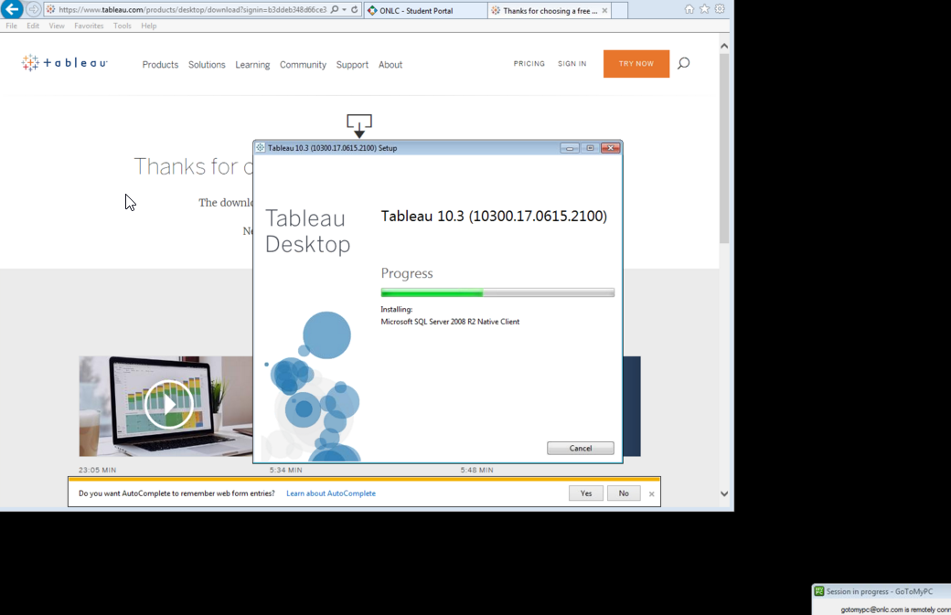

Once Tableau is installed, you will get a screen where all the info EXCEPT the phone number is already there. Just make up any phone number.

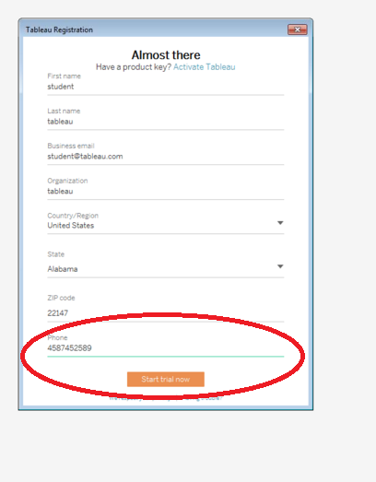

Next, Close tableau for now. You can also close the Tableau Tab in the browser and leave the Student Portal tab open. Also arrange the new Tableau Desktop icon and the files you are teaching with (Basic vs. Advanced). See desktop pic below:

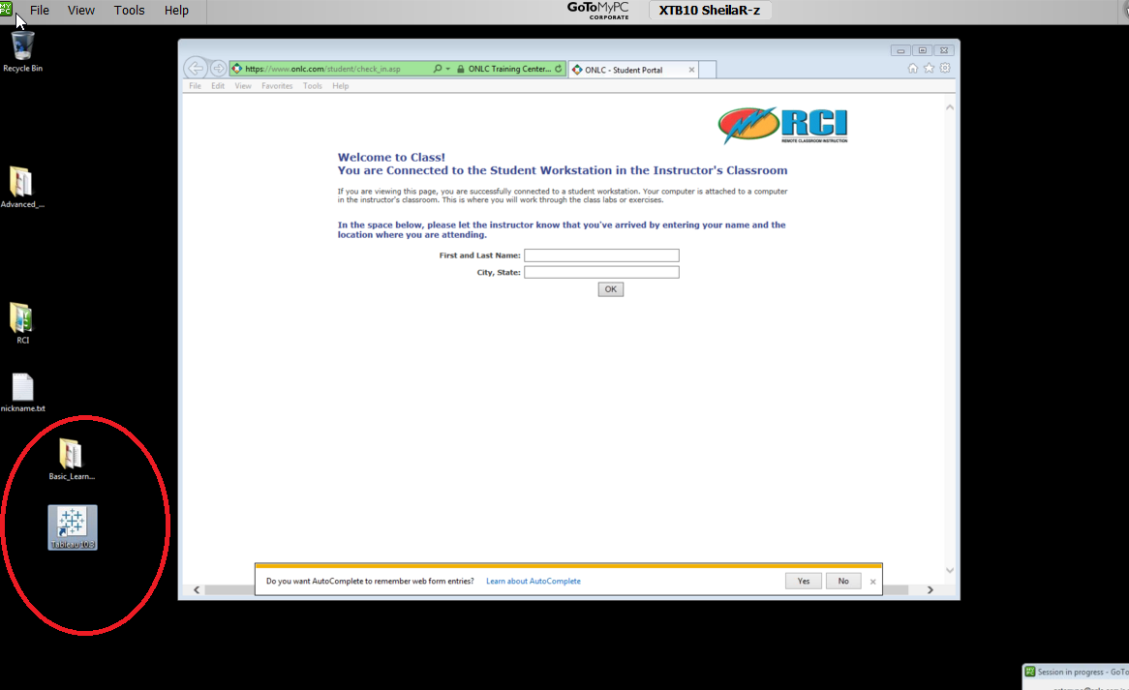

Next, and VERY important. Take the following steps to ASSOCIATE the files to open with YOUR new Tableau. There are other versions on the machine. PLEASE ignore them:

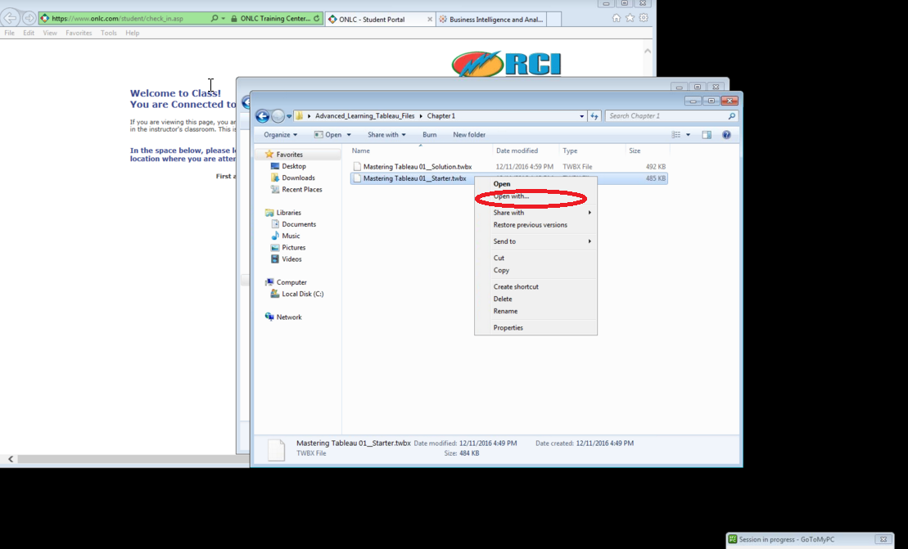

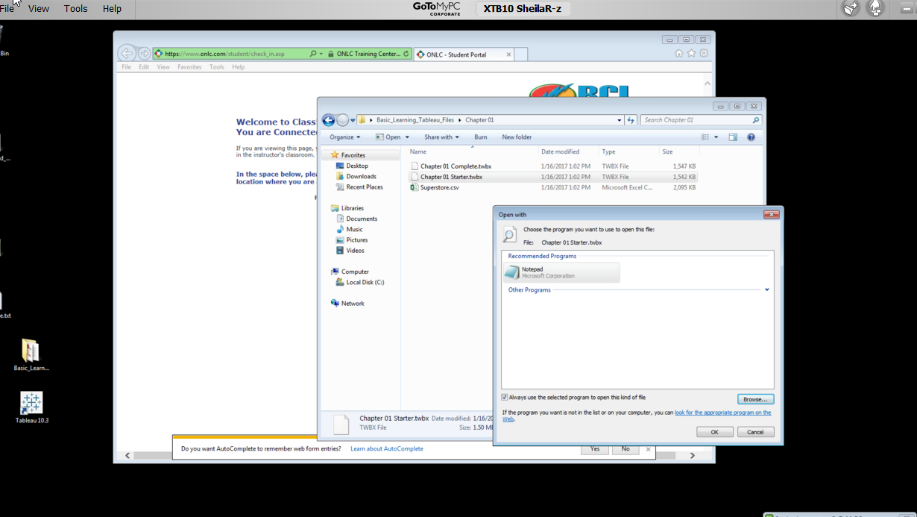

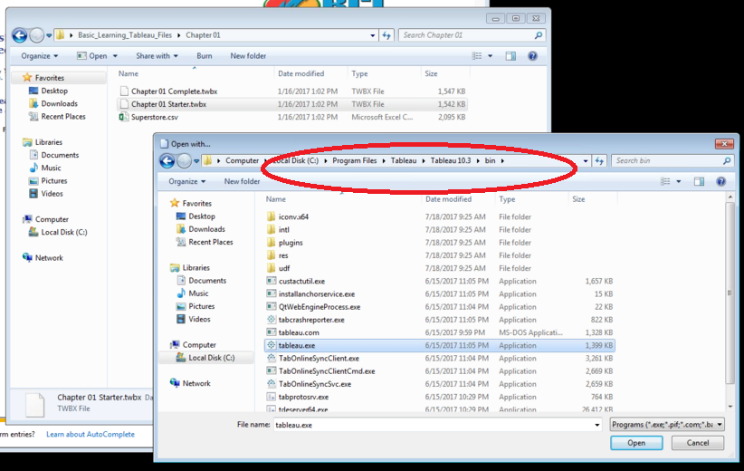

Your file will open in Tableau. Follow the next steps for SURE. The file will have a warning. Be sure to check the box so your students don’t have to each time:

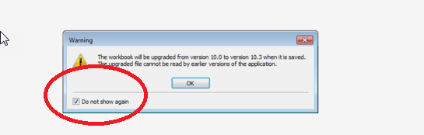

Tableau Opens:

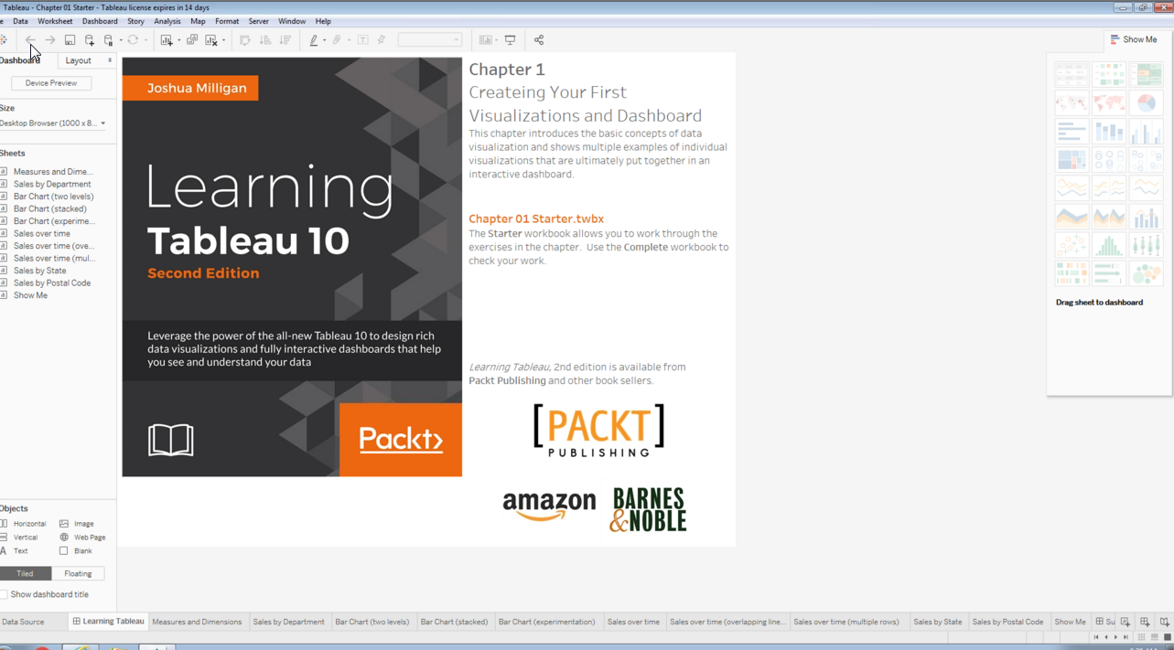

Do a SAVE AS – so that you get the warning below:

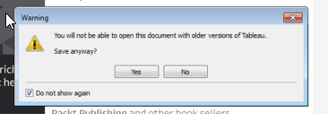

Be sure to click YES and to check the box “Do Not Show Again”

Once you do that on all machines (including your own), everyone will be set up for the week.