Analysis - Butera (2022)

# Statistical Analysis

The data were analyzed using generalized mixed effects models in which the outcome variable Relative Intensity (RI) in decibels was predicted by Region (7 regions total), point of articulation (velar, bilabial or dental), sonority (voiced or voiceless), stress (stressed or unstressed), horizontal position (anterior, central or posterior), vertical position (high, mid or low). Several interactions were also assessed. Three total 2-way interactions included a region by point of articulation, region by sonority, and a stress by region. Four total 3-way interactions were assessed: region by place of articulation and sonority, stress by region and sonority, region by sonority by horizontal vowel and finally region by sonority by vertical position. Random intercepts by participant were included to take into account the nested structure of the data. The normality of residuals were determined by visual inspections of a Q-Q and residual versus fitted plots. Main effects and interactions were determined by carrying out nested model comparisons. Finally, model fit was determined by marginal and conditional R squared.

# Results

## Main effects

Region - main effect (X(6) = 18.03; p < 0.006) overall, there were regional differences in RI.

Point of Articulation - **no** main effect (X(2) = 1.6; p < 0.45) - there was not a main effect for PoA, suggesting that the model could not detect a difference in RI between each PoA overall.

Sonority - main effect (X(1) = 1800; p < 0) - overall, voiceless and voiced consonants, were produced with distinct RI.

Stress - main effect (X(1) = 395.17; p < 0) - overall, the voiced and voiceless consonants were realized with distinct RI.

Horizontal Position - main effect (X(2) = 29.7; p < 0) - overall, there were differences in RI between anterior, central, and posterior vowels.

Vertical Position - main effect (X(1) = 78.15; p < 0) - - overall, there were differences in RI between high, central and low vowels.

## Interactions

Region*sonority - 2-way interaction (X(6) = 83.02; p < 0) - The effect of sonority (the difference in RI between voiced and voiceless consonants) depended on/differed by Region.

Region*poa - 2-way interaction (X(12) = 24.88; p < 0.015) - The effect of Point of Articulation (the difference in RI in dental, bilibial and velar points of articulation) depended on/differed by Region.

Region*stress*sonority - 2-way interaction (X(13) = 49.09; p < 0) - The difference in RI between stressed and unstressed positions varied by whether the consonant was voiced or voiceless and by Region.

Region*poa*sonority - 2-way interaction (X(7) = 28.33; p < 0) - The difference in the effect of RI between each point of articulation depended upon whether the consonant was voiced or voiceless and by Region.

**2-way Region x Sonority interaction**

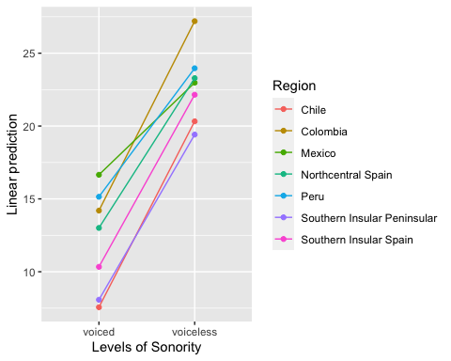

**2-way Region x PoA interaction**

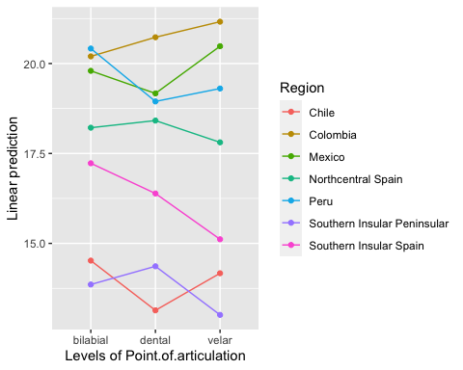

**3-way Region x PoA x Sonority interaction**

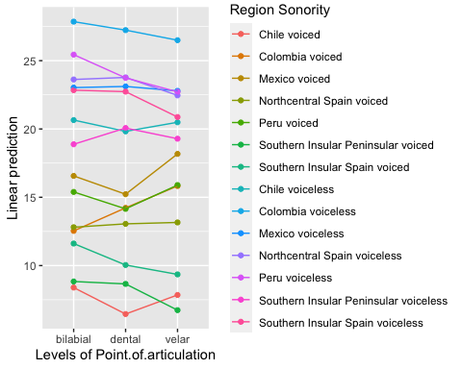

**3-way Region x Stress x Sonority interaction**

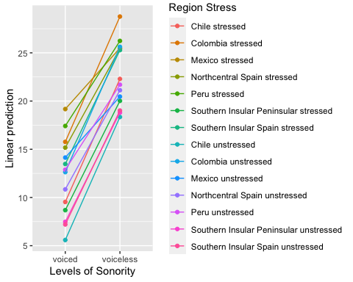

# Full model

Observations

2520

Dependent variable

Relative.intensity

Type

Mixed effects linear regression

AIC

14985.70

BIC

15405.61

Pseudo-R² (fixed effects)

0.60

Pseudo-R² (total)

0.69

Fixed Effects

Est.

S.E.

t val.

d.f.

p

(Intercept)

9.35

1.63

5.75

21.94

0.00

RegionColombia

2.72

2.30

1.18

21.94

0.25

RegionMexico

7.07

3.25

2.18

21.94

0.04

RegionNorthcentral Spain

4.13

1.94

2.13

21.94

0.04

RegionPeru

5.99

2.30

2.61

21.91

0.02

RegionSouthern Insular Peninsular

-1.32

2.57

-0.51

21.94

0.61

RegionSouthern Insular Spain

4.02

2.57

1.56

21.94

0.13

Point.of.articulationdental

-1.94

0.85

-2.27

2436.00

0.02

Point.of.articulationvelar

-0.54

0.85

-0.63

2436.00

0.53

Sonorityvoiceless

12.26

0.85

14.36

2436.00

0.00

Stressunstressed

-3.95

0.49

-8.01

2436.00

0.00

Horizontal.positioncentral

1.76

0.73

2.41

2436.00

0.02

Horizontal.positionposterior

0.01

0.55

0.02

2436.00

0.99

Vertical.Positionmid

1.27

0.55

2.31

2436.00

0.02

RegionColombia:Point.of.articulationdental

3.62

1.21

3.00

2436.00

0.00

RegionMexico:Point.of.articulationdental

0.60

1.71

0.35

2436.00

0.73

RegionNorthcentral Spain:Point.of.articulationdental

2.19

1.02

2.14

2436.00

0.03

RegionPeru:Point.of.articulationdental

0.70

1.21

0.58

2436.00

0.56

RegionSouthern Insular Peninsular:Point.of.articulationdental

1.76

1.35

1.30

2436.00

0.19

RegionSouthern Insular Spain:Point.of.articulationdental

0.37

1.35

0.27

2436.00

0.78

RegionColombia:Point.of.articulationvelar

3.83

1.21

3.17

2436.00

0.00

RegionMexico:Point.of.articulationvelar

2.15

1.71

1.26

2436.00

0.21

RegionNorthcentral Spain:Point.of.articulationvelar

0.89

1.02

0.87

2436.00

0.38

RegionPeru:Point.of.articulationvelar

1.05

1.21

0.87

2436.00

0.39

RegionSouthern Insular Peninsular:Point.of.articulationvelar

-1.56

1.35

-1.15

2436.00

0.25

RegionSouthern Insular Spain:Point.of.articulationvelar

-1.72

1.35

-1.27

2436.00

0.20

RegionColombia:Sonorityvoiceless

3.06

1.21

2.53

2436.00

0.01

RegionMexico:Sonorityvoiceless

-5.80

1.71

-3.39

2436.00

0.00

RegionNorthcentral Spain:Sonorityvoiceless

-1.45

1.02

-1.42

2436.00

0.16

RegionPeru:Sonorityvoiceless

-2.21

1.21

-1.83

2436.00

0.07

RegionSouthern Insular Peninsular:Sonorityvoiceless

-2.22

1.35

-1.64

2436.00

0.10

RegionSouthern Insular Spain:Sonorityvoiceless

-1.03

1.35

-0.76

2436.00

0.44

RegionColombia:Stressunstressed

0.81

0.70

1.17

2436.00

0.24

RegionMexico:Stressunstressed

-1.08

0.99

-1.10

2436.00

0.27

RegionNorthcentral Spain:Stressunstressed

-0.38

0.59

-0.64

2436.00

0.52

RegionPeru:Stressunstressed

-0.59

0.70

-0.85

2436.00

0.39

RegionSouthern Insular Peninsular:Stressunstressed

2.73

0.78

3.51

2436.00

0.00

RegionSouthern Insular Spain:Stressunstressed

-2.32

0.78

-2.98

2436.00

0.00

RegionColombia:Horizontal.positioncentral

1.08

1.03

1.05

2436.00

0.30

RegionMexico:Horizontal.positioncentral

1.82

1.46

1.25

2436.00

0.21

RegionNorthcentral Spain:Horizontal.positioncentral

0.42

0.87

0.48

2436.00

0.63

RegionPeru:Horizontal.positioncentral

1.51

1.03

1.47

2436.00

0.14

RegionSouthern Insular Peninsular:Horizontal.positioncentral

0.81

1.15

0.71

2436.00

0.48

RegionSouthern Insular Spain:Horizontal.positioncentral

-0.49

1.15

-0.43

2436.00

0.67

RegionColombia:Horizontal.positionposterior

1.04

0.78

1.33

2436.00

0.18

RegionMexico:Horizontal.positionposterior

2.29

1.10

2.08

2436.00

0.04

RegionNorthcentral Spain:Horizontal.positionposterior

0.61

0.66

0.93

2436.00

0.35

RegionPeru:Horizontal.positionposterior

0.94

0.78

1.21

2436.00

0.23

RegionSouthern Insular Peninsular:Horizontal.positionposterior

0.11

0.87

0.12

2436.00

0.90

RegionSouthern Insular Spain:Horizontal.positionposterior

0.58

0.87

0.66

2436.00

0.51

RegionColombia:Vertical.Positionmid

0.96

0.78

1.24

2436.00

0.22

RegionMexico:Vertical.Positionmid

0.82

1.10

0.74

2436.00

0.46

RegionNorthcentral Spain:Vertical.Positionmid

0.38

0.66

0.58

2436.00

0.56

RegionPeru:Vertical.Positionmid

1.46

0.78

1.88

2436.00

0.06

RegionSouthern Insular Peninsular:Vertical.Positionmid

0.27

0.87

0.31

2436.00

0.76

RegionSouthern Insular Spain:Vertical.Positionmid

1.01

0.87

1.16

2436.00

0.24

RegionChile:Point.of.articulationdental:Sonorityvoiceless

1.11

1.21

0.92

2436.00

0.36

RegionColombia:Point.of.articulationdental:Sonorityvoiceless

-2.31

1.21

-1.91

2436.00

0.06

RegionMexico:Point.of.articulationdental:Sonorityvoiceless

1.43

2.09

0.68

2436.00

0.50

RegionNorthcentral Spain:Point.of.articulationdental:Sonorityvoiceless

-0.10

0.79

-0.12

2436.00

0.90

RegionPeru:Point.of.articulationdental:Sonorityvoiceless

-0.47

1.21

-0.39

2436.00

0.70

RegionSouthern Insular Peninsular:Point.of.articulationdental:Sonorityvoiceless

1.37

1.48

0.92

2436.00

0.36

RegionSouthern Insular Spain:Point.of.articulationdental:Sonorityvoiceless

1.46

1.48

0.99

2436.00

0.32

RegionChile:Point.of.articulationvelar:Sonorityvoiceless

0.38

1.21

0.31

2436.00

0.75

RegionColombia:Point.of.articulationvelar:Sonorityvoiceless

-4.64

1.21

-3.85

2436.00

0.00

RegionMexico:Point.of.articulationvelar:Sonorityvoiceless

-1.85

2.09

-0.88

2436.00

0.38

RegionNorthcentral Spain:Point.of.articulationvelar:Sonorityvoiceless

-1.51

0.79

-1.92

2436.00

0.06

RegionPeru:Point.of.articulationvelar:Sonorityvoiceless

-3.23

1.21

-2.68

2436.00

0.01

RegionSouthern Insular Peninsular:Point.of.articulationvelar:Sonorityvoiceless

2.50

1.48

1.69

2436.00

0.09

RegionSouthern Insular Spain:Point.of.articulationvelar:Sonorityvoiceless

0.29

1.48

0.20

2436.00

0.84

p values calculated using Satterthwaite d.f.

Random Effects

Group

Parameter

Std. Dev.

Speaker

(Intercept)

2.48

Residual

4.68

Grouping Variables

Group

# groups

ICC

Speaker

21

0.22