Goodale Consult

First Author1 & Ernst-August Doelle1,2

1 Wilhelm-Wundt-University

2 Konstanz Business School

Author note

Add complete departmental affiliations for each author here. Each new line herein must be indented, like this line.

Enter author note here.

The authors made the following contributions. First Author: Conceptualization, Writing - Original Draft Preparation, Writing - Review & Editing; Ernst-August Doelle: Writing - Review & Editing, Supervision.

Correspondence concerning this article should be addressed to First Author, Postal address. E-mail: [my@email.com](mailto:my@email.com)

Abstract

One or two sentences providing a **basic introduction** to the field, comprehensible to a scientist in any discipline.

Two to three sentences of **more detailed background**, comprehensible to scientists in related disciplines.

One sentence clearly stating the **general problem** being addressed by this particular study.

One sentence summarizing the main result (with the words “**here we show**” or their equivalent).

Two or three sentences explaining what the **main result** reveals in direct comparison to what was thought to be the case previously, or how the main result adds to previous knowledge.

One or two sentences to put the results into a more **general context**.

Two or three sentences to provide a **broader perspective**, readily comprehensible to a scientist in any discipline.

*Keywords:* keywords

*Word count:* X

Goodale Consult

What Pitch Accents tend to mark focus?**

*Broad Focus Declaratives*

Full list, unchanged:

Table 1: Total percentage of each pitch accent in nuclear position for Broad Focus Decaratives.

| tones | Montevideo | Durazno |
| --- | --- | --- |
| !H* !H% | 1 | 0 |
| H+L *L% | 1 | 0 |
| H+L* L% | 1 | 3 |
| L* !H% | 1 | 0 |
| L* L% | 66 | 43 |
| L+<H* L% | 0 | 2 |
| L+H* !H% | 0 | 2 |
| L+H* L!H% | 0 | 3 |
| L+H* L% | 22 | 13 |
| L+H* L* | 0 | 2 |
| L+H*+L L% | 2 | 0 |
| L+¡H* L% | 2 | 2 |
| NA | 3 | 30 |

Full list, at least 5 total occurrences:

Table 2: Total percentage of each pitch accent in nuclear position in which one group had produced it atleast 5 percent of the time in the data for Broad Focus Decaratives.

| tones | Montevideo | Durazno |
| --- | --- | --- |
| L* L% | 66 | 43 |
| L+H* L% | 22 | 13 |
| NA | 3 | 30 |

*Plot of Table 2* 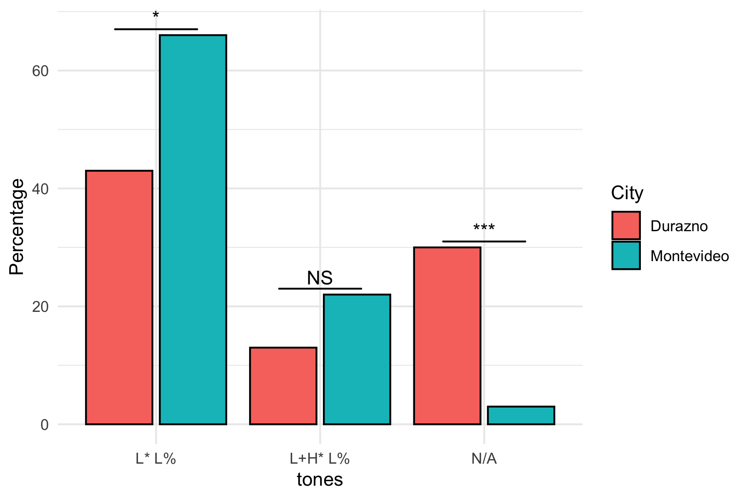

In BFD we could mostly ignore boundary tones (e.g., L- and L%)”

We can integrate these if you prefer, but there does not look like there would be a major shift in the trend.

*Narrow Focus Declaratives*

Full list, unchanged:

Table 3: Total percentage of each pitch accent in nuclear position for Narrow Focus Decaratives.

| tones | Montevideo | Durazno |
| --- | --- | --- |
| !H* L% | 1 | 0 |
| H+L* L% | 5 | 4 |
| L L% | 1 | 0 |
| L* L% | 25 | 28 |
| L+!H* L% | 1 | 1 |
| L+!H*+L L% | 2 | 2 |
| L+H* | 0 | 1 |
| L+H* !H% | 3 | 12 |
| L+H* L% | 23 | 32 |
| L+H* L% | 1 | 0 |
| L+H*+L H% | 1 | 0 |
| L+H*+L L% | 17 | 3 |
| L+H*L% | 0 | 1 |
| L+¡H L% | 0 | 1 |
| L+¡H* !H% | 1 | 1 |
| L+¡H* H% | 0 | 1 |
| L+¡H* L% | 13 | 7 |
| L+¡H*+L L% | 4 | 1 |
| L+¡H*+L LH% | 1 | 0 |
| L+¡H*L% | 1 | 0 |
| ¡H+L* L% | 1 | 0 |
| NA | 1 | 5 |

Full list, at least 5 total occurrences:

Table 4: Total percentage of each pitch accent in nuclear position in which one group had produced it atleast 5 percent of the time in the data for Narrow Focus Decaratives.

| tones | Montevideo | Durazno |
| --- | --- | --- |
| L* L% | 25 | 28 |
| L+H* !H% | 3 | 12 |
| L+H* L% | 23 | 32 |
| L+H*+L L% | 17 | 3 |
| L+¡H* L% | 13 | 7 |

*Plot of Table 4* 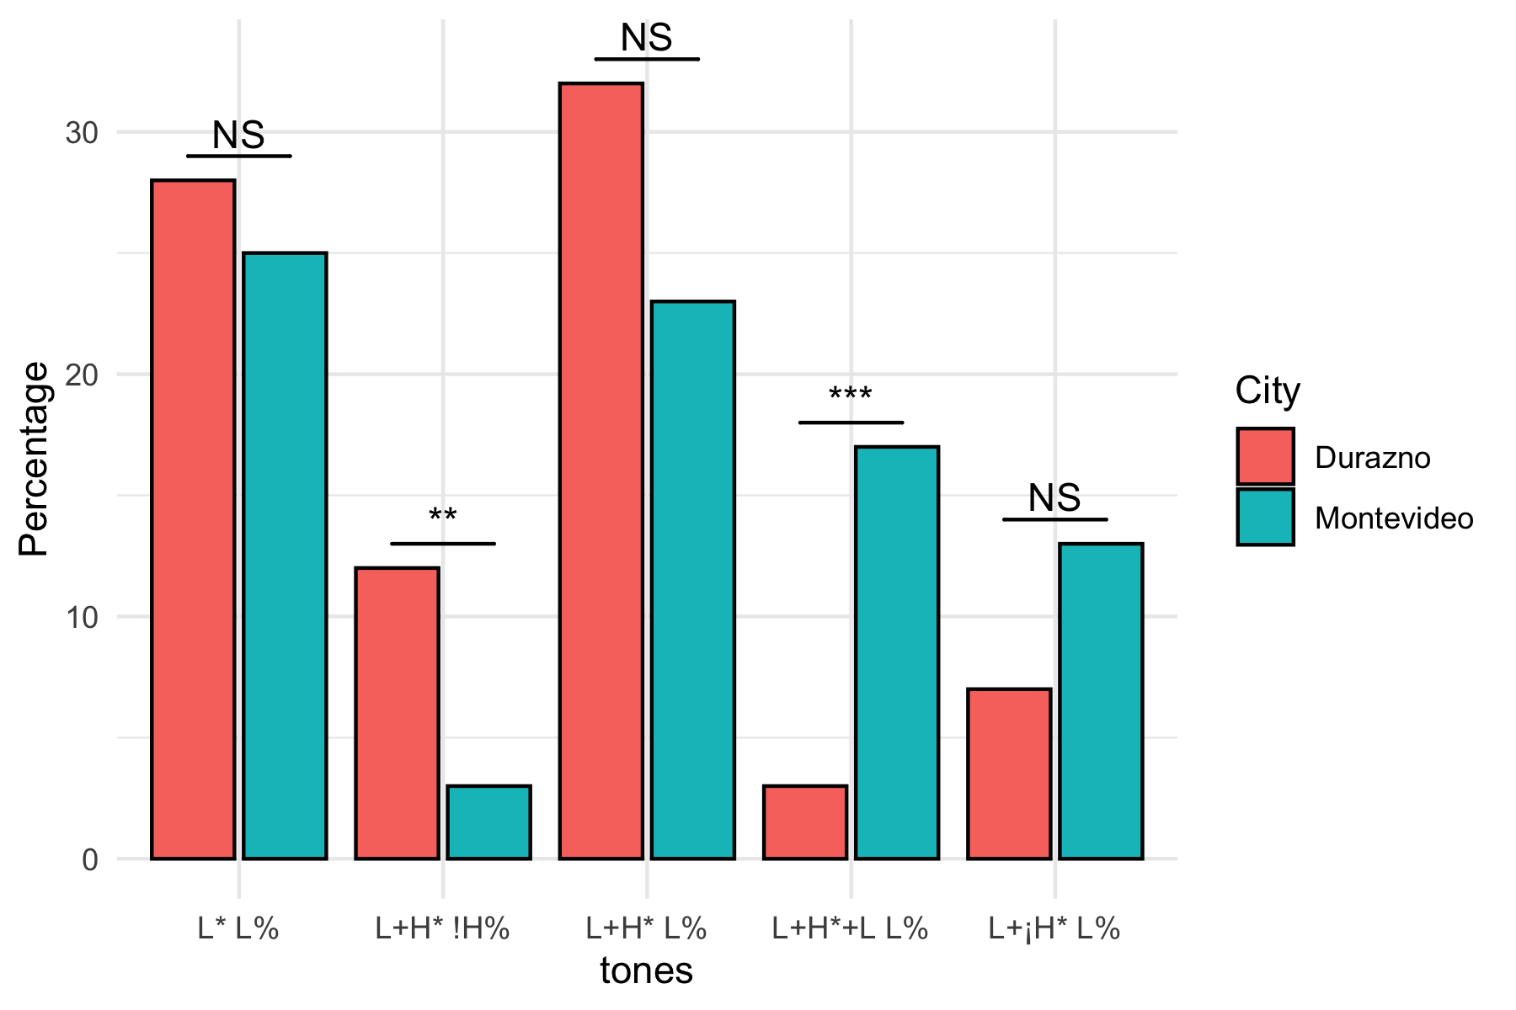

In the NFD it becomes clear that the !H% IP boundary tone is a clear difference between DZ (which has it) and MV (that mostly doesnt).”

There is a significant difference here (p < .005).

At the same time we see that the tritonal L+H*+L is more common in MV than DZ.

This is descriptively true (the count for MV is higher), but the poisson regression was not significant in this case (p > .05). This does not mean the difference is not real, but more likely that there just isn’t enough data for the model to return a significant effect.

L*+H is more common in DZ than MV.

I don’t actually see this in the data.

What seems clear in both DZ and MV is that upstepping (¡) is a big part of marking focus, thus in an utterance full of L+H*, focus is rightly marked with L+¡H*, in cases such as NFD5 Con Manuel, these are all high peaks but due to the lack of an earlier comparative peak they are not classified as upstepped.

Here’s a plot showing both cities productions for NFD5. It looks like the two groups are a little different than you’ve described above: Durazno speakers prefer L+H* !H%. The Montevideo group, on the other hand, produce L+H*+L L%

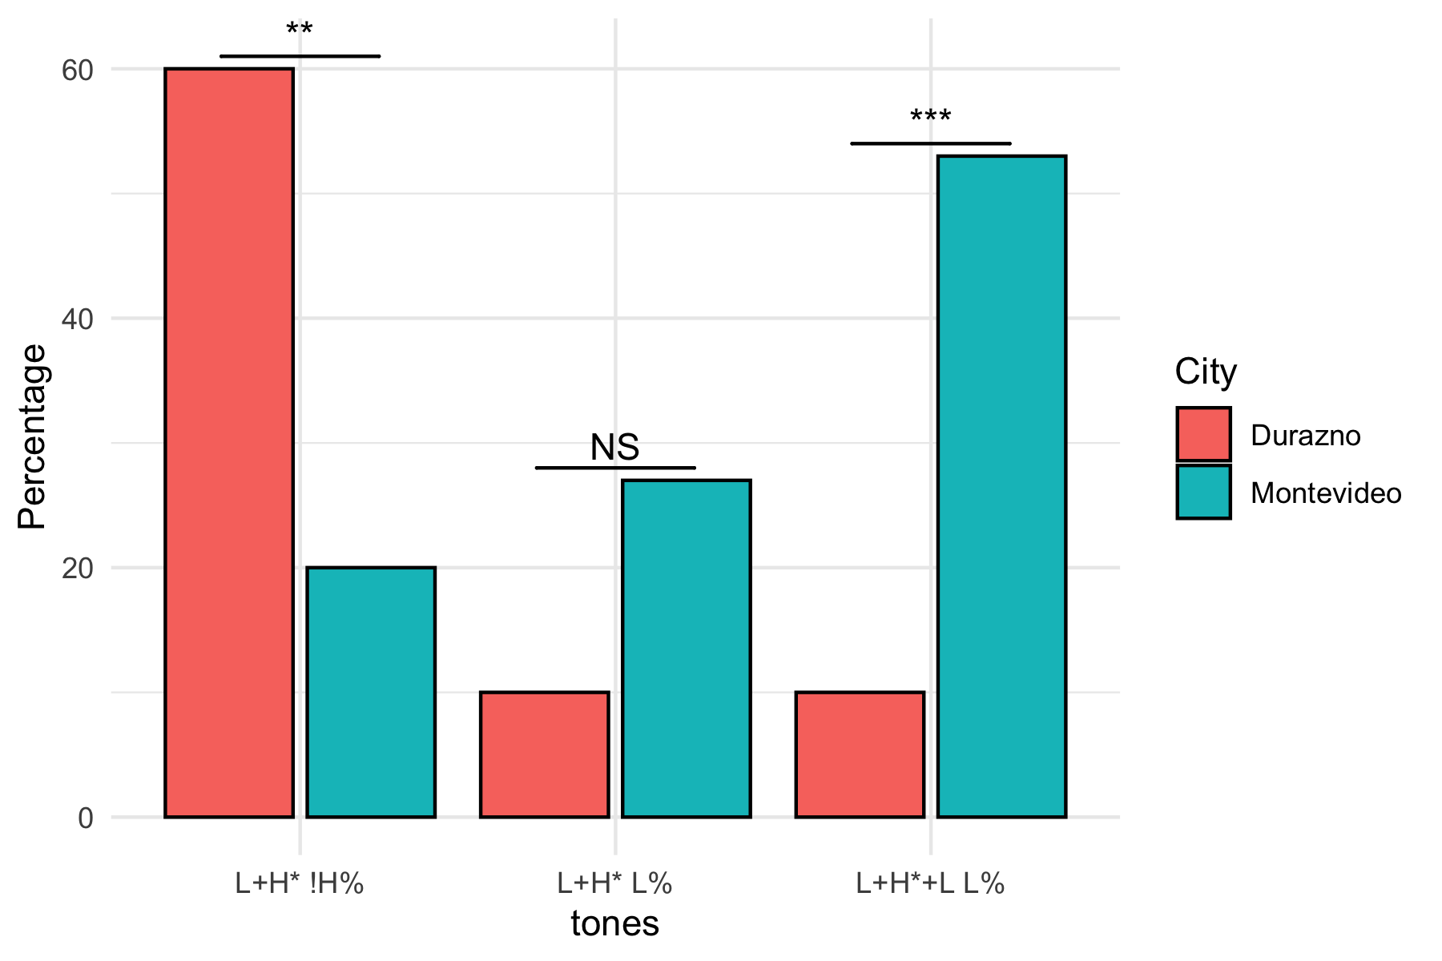

Thus if in the count for focalized items L+H* rather than L+¡H* it should be undestood that these are, in such a case not different and can be grouped, whereas in sentences with PN peaks these are different.

Let me know about specific groupings (a list would be ideal), and I can systematically integrate them in the analysis pipeline, which will spit out new plots etc. just by being run again after necessary adjustments.

Socially, (at least before the current updated data) women tended to use the tritonal L+H*+L as well as the upstep ¡ more than men, this again is a key distinction as it once again provided evidence for the theory of females making greater contrasts and therfore greater clarity in speaking.

Also if you find that certain utterance tend to prefer unique forms, such as NFD5 “a statement of the obvious” where tritonals may be more common or where the mid-boundary tone !H% is more frequent this is also of note.