Cumulative Cognate Facilitation in L3 Spanish: Evidence in Accuracy but Not Speed

Kyle Parrish¹ and Juan J. Garrido-Pozú²

¹Department of
²Department of Modern Languages and Literatures, Furman University

Author Note
Kyle Parrish  https://orcid.org/
Juan J. Garrido-Pozú https://orcid.org/0000-0002-3523-9623

We have no known conflict of interest to disclose.

Correspondence concerning this article should be addressed to Kyle Parrish, Department name, University name, address. Email:

Abstract
There is ample evidence that bilinguals benefit from cognates in word recognition, but less is known about whether this advantage increases when words are shared across three languages. The present study examined cognate facilitation in advanced L3 Spanish speakers (L1 German–L2 English) using a lexical decision task. Accuracy and reaction times were compared across non-cognates, double cognates (English–Spanish), and triple cognates (German–English–Spanish). Accuracy revealed a cumulative cognate effect: triple cognates were recognized more accurately than double cognates, which were in turn recognized more accurately than non-cognates. Reaction times, however, showed a general cognate effect: both double and triple cognates were recognized faster than non-cognates, with no evidence of a difference between the two cognate types. These findings suggest that lexical overlap across three languages provides an additional accuracy advantage, while processing speed benefits from cognate status more generally, with implications for models of multilingual lexical representation and L3 acquisition.
Keywords: cognate facilitation, L3 acquisition, multilingual lexical processing, L3 processing.

Cumulative Cognate Facilitation in L3 Spanish: Evidence in Accuracy but Not Speed

Introduction
It is estimated that between one-half and two-thirds of the world’s population uses two or more languages in daily life (UNESCO, 2025). Consequently, a substantial proportion of individuals engage in cognitive processes for communication that differ from those of monolingual speakers. During language use, bilinguals and multilinguals must continuously regulate the activation of multiple linguistic systems, inhibiting irrelevant linguistic representations to produce and comprehend the intended language.
The prevalence of bilingualism relative to monolingualism suggests that bilingualism is also a common starting point for subsequent language learning. In other words, learning a third or additional language (L3/Ln) is not the exception but the rule. Yet, despite the prevalence of multilingual language learning, we know remarkably little about how third (L3) and additional (Ln) languages are acquired and processed relative to second language (L2) learning. As a result, understanding how bilingual speakers acquire additional languages is essential for developing theories of language acquisition that reflect the linguistic experiences of most learners rather than a monolingual minority.
Whether L3 and L2 learning are indeed distinct has been addressed, though somewhat indirectly, in debates over wholesale transfer versus property-by-property transfer. In wholesale transfer accounts (e.g., Rothman, Alonso, & Puig-Mayenco, 2019; Rothman, 2015; Sprouse & Schwartz, 2023), either the L1 or L2 transfers to the L3 early in development, suggesting that when L3 learners transfer the L1, L3 and L2 learning would involve, in principle, the same process in that both learner types (L2 or L3) would be guided by their L1. Evidence for this view has primarily come from the testing of mirror image groups in studies of L3 morphosyntax (Bardel & Falk, 2007; Foote, 2009; Parrish, 2024a; Puig-Mayenco, González Alonso, & Rothman, 2020a; Rothman, 2011), which test the acquisition of the same L3 by two groups whose L1 and L2 order are reversed. For example, in a study on the acquisition of future probability in L3 Spanish, Borg (2013) tested both L1 English-L2 French and L1 French-L2 English groups and found that both groups benefited from their knowledge of French in L3 Spanish. Additional studies using mirror image groups have reported similar findings on the influence of Spanish in L3 Brazilian Portuguese (Cabrelli, Amaro, & Rothman, 2015; Giancaspro, Halloran, & Iverson, 2015; Ionin, Grolla, Santos, & Montrul, 2015; Montrul, Dias, & Santos, 2011; Parma, 2017), while further studies found evidence for typological transfer in other language combinations (Garavito & Perpiñán, 2014; Garcı́a Mayo & Slabakova, 2015; Puig-Mayenco, Miller, & Rothman, 2018).
Property-by-property views, in contrast, argue that transfer is not wholesale, and L3 speakers retain access to both L1 and L2 linguistic representations (Slabakova, 2017; Westergaard, Mitrofanova, Mykhaylyk, & Rodina, 2017). Evidence for this view comes from comparing L2 and L3 learners of the same language, referred to as a subtractive design. For example, in a study of one L3 and two L2 groups of English speakers, Westergaard et al. (2017) found that the L3 group’s grammaticality judgments of two word order conditions fell between two L1 comparison groups. This finding suggested that the L3 group was influenced by both the L1 and L2 simultaneously. Similar findings have been reported in L3 phonology, where initial imitations of French by L1 Spanish-L2 English bilinguals differ from L1 Spanish monolinguals (Parrish, 2024b). Additional studies also reported differences in cross-linguistic influence between L3 and L2 learners in L3 English (Jensen et al., 2023) and an artificial language (Mitrofanova, Leivada, & Westergaard, 2023). Overall, while there is evidence that typological effects seem to impact L3 acquisition, the studies supporting this overarching view cannot support the idea that L2 and L3 learning are, or at least can be, the same on their own. Studies in property-by-property influence, on the other hand, provide evidence that although L3 learners can be primarily influenced by their L1, they also experience relative degrees of additional L2 influence that meaningfully differentiates them from L2 learners.
As a result, in order to inform how and whether L2 and L3 learning follow distinct trajectories, it becomes necessary not to simply show that speakers have access to the L1 or L2, but rather examine the degree to which both are active at a given time. One way to do so is by examining language processing in multilinguals using a within-subject design. The present work takes this approach by investigating lexical processing of double and triple cognates in L3 Spanish by German-English bilingual speakers. Importantly, the within-subjects design allows for the testing of a cumulative effect by comparing the processing of double cognates (words present in the L2 and L3) with triple cognates (words present in all three languages). If such a cumulative effect is present, it would suggest that both previously acquired languages remain active during L3 processing. Specifically, if triple cognates are processed faster than double cognates (L2 English-L3 Spanish), it would indicate that both L1 German and L2 English are involved during L3 processing. If both double and triple cognates are processed similarly, but both faster than noncognates, this would suggest no additional benefit from overlap with L1 German. Finally, if triple cognates are faster than both double cognates and noncognates, while double cognates do not differ from noncognates, this would suggest limited influence from L2 English.

Cognate Facilitation Effects in Bilingual Populations
A large body of research has examined how lexical representations are activated across languages, particularly in bilingual populations, where cognates have been shown to facilitate lexical processing. However, comparatively less is known about how such cross-linguistic activation operates in L3 speakers, where multiple linguistic systems may simultaneously influence lexical activation and access. The extensive research on L1-L2 cognate effects provides a valuable foundation for understanding cross-linguistic interactions in L3 contexts.
Research on bilingual populations using a wide range of experimental tasks has consistently observed robust cognate facilitation effects in word recognition in both visual and auditory modalities as well as in language production. For instance, available evidence shows that cognates are learned and retrieved faster than noncognates (e.g., Ellis & Beaton, 1993; Lotto & Groot, 1998; Otwinowska & Szewczyk, 2019; Tonzar, Lotto, & Job, 2009), and that cognates facilitate word naming (A. Costa, Caramazza, & Sebastian-Galles, 2000), reading (Cop, Drieghe, & Duyck, 2015), and writing (Woumans, Clauws, & Duyck, 2021) in bilinguals and L2 learners. However, cognates can also be a source of cross-linguistic interference (Amengual, 2012) and in some cases produce inhibitory effects (e.g., Dijkstra, Miwa, Brummelhuis, Sappelli, & Baayen, 2010; Frances, Navarra-Barindelli, & Martin, 2021, 2022). Thus, cognates do not uniformly facilitate processing but instead give rise to complex, context-dependent interactions across languages.
Cognate effects are influenced by a range of linguistic, task-related, and speaker-specific factors. At the linguistic level, the degree of cross-linguistic form overlap affects the magnitude of the cognate facilitation effect (Carrasco-Ortiz, Amengual, & Gries, 2021; Comesaña et al., 2015; Dijkstra et al., 2010; Garrido-Pozú, 2024). Greater orthographic similarity (e.g., Aguinaga Echeverría, 2017; Otwinowska & Szewczyk, 2019) and phonological similarity (Garrido-Pozú, 2024; Tiffin-Richards, 2024) generally facilitate lexical processing, although their respective roles may vary depending on task modality (Carrasco-Ortiz et al., 2021; Comesaña et al., 2015; Frances et al., 2021, 2022). In addition, lexical frequency modulates the strength of cognate effects, with high-frequency cognates yielding faster and more accurate recognition than low-frequency cognates (Carrasco-Ortiz et al., 2021; Peeters, Dijkstra, & Grainger, 2013). Notably, cognate processing is affected by other linguistic factors such as sentence context (Hell & Groot, 2008) and the position of lexical stress (Muntendam, Rijswijk, Severijnen, & Dijkstra, 2022).
Cognate effects are also shaped by task-related factors, such as the composition of the stimulus list. Cognate effects are less likely to be observed when identical cognates are not included in the input (Arana, Oliveira, Fernandes, Soares, & Comesaña, 2022; Comesaña et al., 2015) or when the input contains a large variety of lexical items (Poort & Rodd, 2017). Task demands also influence cognate effects because different tasks tap into different levels of processing and may require different cognitive mechanisms. For instance, cognates are recognized faster in the written modality than in the auditory modality (Cornut, Mahé, & Casalis, 2022), and while facilitation effects are typically observed in lexical decision tasks, inhibitory effects tend to emerge in language decision tasks (Dijkstra et al., 2010). Moreover, speaker-specific factors such as language proficiency and experience modulate the extent to which cognates facilitate or inhibit processing. Less proficient speakers often benefit more from increased cross-linguistic similarity than more proficient speakers (e.g., Cornut et al., 2022; Garrido-Pozú, 2024). Other individual differences, including speaker accent (Frances et al., 2022) and language dominance (Carrasco-Ortiz et al., 2021), have also been shown to interact with cross-linguistic similarity. Together, these findings suggest that cognate effects emerge from dynamic interactions among multiple sources of influence, rather than reflecting a stable or uniform processing advantage.

Cross-linguistic Similarity in L3 Lexical Processing
While cognate processing is well documented in bilingual populations, cognate effects in third language (L3) contexts remain less clear. Unlike bilinguals, L3 learners must manage interactions among three linguistic systems, which amplifies the complexity of cognate effects in multilingual contexts and raises important questions about the source and direction of cross-linguistic influence. Notably, two hypotheses have been put forward regarding the source of cross-linguistic influence in L3 acquisition. De Angelis (2007) distinguishes between one-to-one transfer and many-to-one transfer. One-to-one transfer occurs when the primary source of cross-linguistic influence on the L3 is only one previously acquired language (L1 or L2), whereas many-to-one transfer involves the simultaneous influence of multiple previously acquired languages. While empirical evidence supports both hypotheses, a systematic review by Puig-Mayenco, González Alonso, & Rothman (2020b) showed that a vast majority of transfer studies in L3 acquisition provided supporting evidence for one-to-one transfer. However, most of the evidence addresses L3 morphosyntax, and research on L3 lexical acquisition remains scarce.
A similar distinction is described by Bartolotti & Marian (2017). Focusing on cross-linguistic lexical similarity, they proposed the Scaffolding model and the Accumulation model. In the Scaffolding model, L3 lexical acquisition is driven by the ability to create a direct association between a newly encountered word and an existing word in the L1 or L2 lexicon.
Novel words with greater form overlap with an existing word are more likely to have strong lexical associations. Importantly, novel words receive a learning benefit if they overlap with at least one of the previously acquired languages, with no additional benefit for overlapping with both. Therefore, lexical facilitation in this model is not cumulative across languages. The Scaffolding model (Bartolotti & Marian, 2017) is compatible with the Parasitic Model (Ecke, 2015), in which novel L3 words attach to an L1 or L2 host to facilitate learning. In contrast, the Accumulation model of Bartolotti & Marian (2017) proposes that L3 lexical acquisition depends on the frequency of sublexical features that a novel word shares with the L1 and L2. In this model, lexical benefits are additive across languages, and novel words with greater similarity to L1 and L2 words are easier to learn and retrieve. Overall, both models highlight the role of cross-linguistic similarity, but they differ in whether facilitation is cumulative across previously acquired languages.
Bartolotti & Marian (2017) tested both models by examining L3 lexical learning of double cognates (L1-L3 or L2-L3), triple cognates (L1-L2-L3), and noncognates in English-German bilinguals learning a novel language. Results of a word recognition task and a word production task showed no additive benefit for L3 words overlapping with both previously acquired languages. Double and triple cognates facilitated lexical learning to a similar extent relative to noncognates. Their findings supported the Scaffolding model and suggested that both languages of a bilingual contribute to L3 acquisition.
Further evidence in L3 lexical processing has yielded mixed findings. While some studies coincide with the findings of Bartolotti & Marian (2017) and report no cumulative benefits (e.g., Engemann & Radetzky, 2024; Lijewska, 2023; Lijewska & Louw, 2025), a growing body of research has observed that cross-linguistic similarity may enhance L3 processing in an additive manner (e.g., Foryś-Nogala et al., 2026; Lemhöfer, Dijkstra, & Michel, 2004; Poarch & Hell, 2014; Szubko-Sitarek, 2011). Lijewska (2023) examined how sentence context modulates the processing of non-identical triple cognates in an English reading task that recorded eye movements of Polish-German-English trilinguals. Results showed no facilitation effects for triple cognates and indicated that sentence context did not modulate cognate processing, unlike noncognate processing. Similarly, Lijewska & Louw (2025) investigated cognate effects in visual recognition of non-identical cognates in Polish-English-Dutch trilinguals. Two lexical decision tasks in Dutch revealed facilitation effects for triple cognates and for English-Dutch cognates, but not for Polish-Dutch cognates. These findings suggest a stronger L2 than L1 influence, although evidence for an additive effect of cross-linguistic similarity remained inconclusive because double and triple cognates were distributed across the two tasks. For L3 production, Engemann & Radetzky (2024) examined cognate effects in L1 and L3 word naming accuracy and latency in Italian-German-English trilingual children. Both tasks included double cognates (German-English and Italian-English), triple cognates, and noncognates. They found cognate facilitation effects only in the L3 task for all cognate types in word naming accuracy but not in naming speed. The findings support one-to-one cross-linguistic influence as no additive benefits were observed.
Contrasting evidence shows cumulative benefits of cross-linguistic similarity in L3 lexical processing. Lemhöfer et al. (2004) investigated non-selective lexical access in Dutch-English-German trilinguals. Participants completed a visual lexical decision task in German containing double cognates (Dutch-German), triple cognates, and noncognates. Results showed robust cognate facilitation effects for double and triple cognates, but a stronger facilitation effect was observed for triple cognates than double cognates. In a similar vein, Szubko-Sitarek (2011) examined cross-linguistic influence in L1 and L3 visual word recognition in Polish-English-German trilinguals. Two lexical decision tasks containing double cognates (Polish-German), triple cognates, and noncognates revealed additive effects of cross-linguistic similarity in both L1 and L3 lexical processing. In the L3 task, both types of cognates were recognized faster than noncognates, but triple cognates showed the largest effect. In the L1 task, a processing advantage of triple cognates was also observed. Their findings highlight that cross-linguistic influence in multilingual lexical processing is not limited to the non-native languages but can also modulate L1 processing. More recently, Foryś-Nogala et al. (2026) investigated how individual differences modulate cross-linguistic influence in L3 lexical learning and visual word recognition. Polish-English-Italian trilinguals completed a vocabulary knowledge test and a lexical decision task in Italian that included double cognates (English-Italian), triple cognates, and noncognates. Results showed an advantage for triple cognates in both lexical knowledge and visual processing, suggesting that cumulative similarity across three languages facilitates learning and processing more than L2-L3 similarity. Examining L3 production, Poarch & Hell (2014) studied cross-linguistic activation during speech production in three groups of trilinguals: German-English-Dutch, Dutch-English-German, and Russian-English-German trilinguals. They completed two naming tasks, one in L2 English and one in their respective L3 (Dutch or German), including double cognates, triple cognates, and noncognates. Results revealed faster naming for triple cognates in both the L2 task and the L3 task, indicating that facilitation effects of increased cross-linguistic similarity accumulate across three languages in L2 and L3 word activation.
The findings of the studies described above generally fall into two patterns, supporting either the Scaffolding model (Bartolotti & Marian, 2017) and one-to-one transfer (De Angelis, 2007) or the Accumulation model (Bartolotti & Marian, 2017) and many-to-one transfer (De Angelis, 2007). Available evidence is mixed with regard to the source of cross-linguistic influence in multilingual contexts. Some studies report stronger effects from the L2 than the L1, consistent with the L2-status factor (Bardel & Falk, 2007, 2012), whereas others report stronger L1 influence (Hermas, 2010). Notably, it remains to be explored how language proficiency modulates the strength and direction of cross-linguistic influence and the presence of cognate effects in L3 lexical processing. Some studies suggest that a sufficient level of proficiency is needed for cumulative cognate effects to emerge (e.g., Lemhöfer et al., 2004; Poarch & Hell, 2014; Szubko-Sitarek, 2011), although establishing such a threshold in multilingual speakers is difficult. The present study further explores the influence of cross-linguistic similarity in L3 lexical processing by examining cumulative cognate effects in L3 Spanish, an underrepresented language in the L3 literature. In doing so, we aim to advance our understanding of the interactions and contributions of previously acquired languages in L3 processing.

The Present Study
The present study investigates how cross-linguistic similarity modulates L3 lexical processing. Specifically, it examines whether cognate facilitation effects arise during visual processing in L3 Spanish and whether such effects reflect cumulative facilitation across languages. More precisely, the study tests whether visual processing of triple cognates (German-English-Spanish) and double cognates (English-Spanish) differ compared to noncognates in trilingual individuals. In addition, it assesses the role of L2 and L3 proficiency in modulating the magnitude and pattern of cognate facilitation. By comparing triple and double cognates, the study also contributes to broader theoretical debates on whether multilingual influence is cumulative or selectively constrained to a single previously acquired language. Overall, the study adds to ongoing discussions regarding the mechanisms underlying cross-linguistic influence in multilingual lexical processing.
The present study addresses the following research questions:
RQ1: Do German-English-Spanish trilinguals process triple cognates faster and more accurately than double cognates?
RQ2: Is L3 cognate processing modulated by L3 proficiency?
For RQ1, we formulated two working hypotheses. On the one hand, we hypothesized that trilinguals would process triple cognates more efficiently than double cognates. A growing number of studies has provided supporting evidence for many-to-one transfer (De Angelis, 2007), indicating that both previously acquired languages of a trilingual actively influence L3 lexical processing and that such influence accumulates across languages (e.g., Foryś-Nogala et al., 2026; Lemhöfer et al., 2004; Poarch & Hell, 2014; Szubko-Sitarek, 2011). This evidence supports the Accumulation model (Bartolotti & Marian, 2017), which suggests that greater cross-linguistic similarity has additive benefits for L3 lexical processing. In that line, triple cognates cause stronger co-activation across languages and facilitate L3 lexical access more than double cognates, resulting in more efficient recognition. On the other hand, it is possible that trilinguals process triple and double cognates similarly. There is also substantial evidence for one-to-one transfer (Bartolotti & Marian, 2017) and the Scaffolding model (Bartolotti & Marian, 2017), suggesting that overlapping with more than one previously acquired language does not have an additive advantage for L3 lexical processing (e.g., Bartolotti & Marian, 2017; Engemann & Radetzky, 2024; Lijewska, 2023; Lijewska & Louw, 2025).
For RQ2, our hypothesis was that higher L3 proficiency would facilitate L3 cognate processing. While the role of proficiency remains to be further explored, available studies suggest that a sufficient level of proficiency is needed for cumulative cognate effects to emerge and that low-proficiency trilinguals do not have the necessary level of co-activation to produce cumulative effects across the three languages (e.g., Lemhöfer et al., 2004; Poarch & Hell, 2014; Szubko-Sitarek, 2011). Following this evidence, in the present study, higher L3 proficiency is expected to be associated with stronger co-activation of cognates, resulting in stronger cognate effects.

Methodology

Participants
A total of 44 participants completed the study. A total of nine participants were recruited from Hispanic Linguistics courses at a public university in Frankfurt, Germany. They received extra credit for their participation in the study. The remaining 35 participants were recruited using Prolific (www.prolific.com) and received monetary compensation for their participation. The data of 9 participants were removed from the final data set due to low accuracy rates in at least one condition (less than 10 out of 24 correct in the cognate conditions). As a result, the final data set contained 35 participants (64% female; 36% male).
All participants completed an adapted version of the LEAP-Q questionnaire (Marian, Blumenfeld, & Kaushanskaya, 2007). The questionnaire was administered in Qualtrics and asked about language background and dominance. The survey contained 23 total questions including general information (age, gender, birthplace, and place of residence), language dominance, order of acquisition, and self-rated proficiency for both productive and receptive skills.
All participants were born and lived in Germany. The participants’ ages ranged from 22 to 69 (mean age 34.4, sd = 12.1). All participants reported German as their first language, English as their second language, and Spanish as their third language. This order applied both to acquisition and language dominance. The mean age of onset of English was 8.8 (sd = 2) and the mean age of acquisition (when participants first felt fluent) was 16.6 (sd = 3.5). The mean age of onset for Spanish was 18 (sd = 9.6), and the mean age of acquisition was 22.1 (sd = 5). However, many participants did not enter a value in the survey for age of acquisition of Spanish.
Participants rated their productive and receptive proficiency on a scale from 1 to 10, in which 10 was the most proficient and 1 was the least proficient. The average self-rated German proficiency was, as expected, near ceiling in both productive (mean rating = 9.84; sd = 0.37) and receptive proficiency (mean rating = 9.84; sd = 0.37). Self-rated English proficiency was the second highest, and the participants rated themselves slightly higher in receptive proficiency (mean rating = 8.32; sd = 0.63) than productive proficiency (mean rating = 8.04; sd = 0.84). The self-rated proficiency levels in Spanish were the lowest and showed the most variation. Specifically, the mean rating for productive proficiency was 3.6 (sd = 1.83), while receptive proficiency was 4 (sd = 1.98).

Materials and Procedure

Lexical Decision Task
Participants completed a visual lexical decision task (LDT) in Spanish. They saw individual strings of letters on a computer screen and indicated whether these strings constituted real words in the Spanish language. At the beginning of each trial, participants saw the response options “REAL” and “FALSA” on the sides of the screen, then 500 ms later, a letter string was displayed in the center of the screen. Participants responded by pressing the key “1” (REAL) or “0” (FALSA) on a computer keyboard. Instructions were presented in Spanish, and participants completed a practice section with 5 trials. The LDT measured accuracy and response time. The task was programmed in PsychoPy (Peirce et al., 2019) and delivered online via the Pavlovia platform.
The LDT included a total of 192 stimuli: 96 Spanish pseudowords, 48 Spanish noncognates, 24 double cognates (English-Spanish), and 24 triple cognates (German-English-Spanish). The stimulus list can be found in Appendix A. All items contained between 4 and 6 letters. Pseudowords were created using UniPseudo (New, Bourgin, Barra, & Pallier, 2024) and were phonologically and orthographically legal constructions in Spanish. Real words were matched for lexical frequency, which was calculated using SUBTLEX-ESP (Cuetos, Glez-Nosti, Barbón, & Brysbaert, 2011). Double and triple cognates were orthographically identical. Orthographic and phonological overlap were calculated using PHOR-In-One (A. S. Costa, Comesaña, & Soares, 2023). Table 1 summarizes the lexical properties of the stimulus items.

Proficiency Measure: adapted LexTALE
In addition to self-rated proficiency, participants’ accuracy on the experimental lexical decision task was used as an additional proficiency measure. Specifically, we considered the pseudoword and non-cognate trials as an adapted version of the LexTALE (Izura, Cuetos, & Brysbaert, 2014; Lemhöfer & Broersma, 2012). The item set was constructed to include real words with a broad range of frequencies in order to capture lexical knowledge across proficiency levels. Cognates were excluded from the item pool to minimize the possibility that participants could rely on cross-linguistic form overlap rather than target-language lexical knowledge. As a result of these design choices, the trials from the experimental task used to calculate a proficiency score contained 48 real words and 96 pseudowords. Scores were calculated using a similar scoring system to that of the original LexTALE to avoid a yes/no bias and to account for the unequal proportion of real words and pseudowords in the included data. Specifically, the following formula was used: (number of real words correct/48 x 100 + number of pseudowords correct/98 x 100)/2. The results yielded a score from 0 to 100, in which a score of 50 would represent saying either “yes” or “no” to all trials. Figure 6 in the appendix shows the distribution of adapted LexTALE scores. The scores ranged from 55.2 to 97.9 with a mean of 73 (sd = 10).

Table 1: Descriptive statistics by stimulus type
 |  |  | Orthographic NLD |  |  | Phonological NLD
Type | Length | Frequency | English-German | English-Spanish | German-Spanish | English-German | English-Spanish | German-Spanish
Non-cognates | 5.33 (0.83) | 2.62 (0.83) | 0.10 (0.07) | 0.05 (0.08) | 0.06 (0.07) | 0.37 (0.12) | 0.40 (0.13) | 0.38 (0.11)
Double cognates | 5.46 (0.59) | 2.53 (0.64) | 0.10 (0.07) | 1.00 (0.00) | 0.10 (0.07) | 0.40 (0.10) | 0.78 (0.14) | 0.39 (0.10)
Triple cognates | 4.96 (0.75) | 2.54 (0.64) | 1.00 (0.00) | 1.00 (0.00) | 1.00 (0.00) | 0.78 (0.15) | 0.81 (0.13) | 0.83 (0.17)

Data Analysis

Analysis justification
A Bayesian approach was chosen for two primary reasons. First, Bayesian models allow for a more gradient analysis than the often used frequentist p-value, in which it is more typical to take a binary, all-or-nothing approach (e.g. there either is or is not evidence for a difference between conditions). Additionally, frequentist models test against the null hypothesis, but are unable to provide direct evidence that the null hypothesis is true. Taken together, the Bayesian Framework offers greater flexibility and allows for more gradient interpretations of both the null and alternative hypotheses.
In the Bayesian framework, several metrics are reported. First, the 95% Highest Density Interval (95% HDI) refers to the range of the most credible 95% of the posterior distribution as determined by a probability density function. Next, the probability of direction (pd) refers to the probability that a parameter is positive or negative and ranges from 50% to 100%. It is mathematically defined as the proportion of the posterior distribution that is the same sign as its median estimate (Makowski, Ben-Shachar, Chen, & Lüdecke, 2019). Finally, the Region of Practical Equivalence (ROPE) is used to determine what proportion of the entire posterior distribution falls within researcher-specified upper and lower bounds and can be used to provide evidence for the null hypothesis.
Although the HDI and ROPE can be combined to create decision rules (e.g., concluding that a difference is credible when the entire 95% HDI falls outside the ROPE (Kruschke, 2018)), such binary decisions are not required in Bayesian inference. Rather, Bayesian analyses permit a more graded evaluation of evidence by examining the location and spread of the posterior distribution, the probability of direction, and the proportion of the posterior falling within the ROPE. Consequently, evidence can be interpreted as varying continuously in strength rather than being reduced to a dichotomous significant/non-significant outcome.

Model Speficications
The data were analyzed using two Bayesian multilevel regression models for accuracy and response time. Both models were fit using the brms package in R (Bürkner, 2017) and estimated with Markov chain Monte Carlo sampling using 4 chains, each with 4000 iterations, including 2000 warm-up iterations. Model convergence was evaluated using effective sample sizes and R-hat values. All regression coefficients were assigned Student’s t(3, 0, 2.5) priors, while the residual standard deviation was assigned a half-Student’s t(3, 0, 2.5) prior. The accuracy model was a multilevel Bayesian logistic regression model that predicted the log-odds of a correct trial (coded as 1 or 0) as a function of the fixed effect predictors word type (3 levels: non-cognate, two-way cognate, three-way cognate; reference level two-way cognates), lexical frequency (z-scored log frequency), and proficiency (z-scored adapted LexTALE score). The random-effects structure included a random slope for each participant and a random intercept for word (stimulus). The ROPE was set to +/-0.18 in log-odds, proportional to a negligible effect size of Cohen’s d = .1 (Plonsky & Oswald, 2014). The response-time model predicted the log response time of correct responses as a function of the same predictors and random effect structure. In this case, the ROPE was set to +/-0.0065 log reaction time, or +/- approximately 5 ms.

Results

Data trimming
The data set for accuracy included 35 participants, contained a total of 6720 data points (192 trials x 35 participants), and maintained all correct and incorrect trials. Due to an error, three stimulus items were duplicated in the data (two non-cognates and one double cognate) and were subsequently omitted from further analysis, resulting in a total of 6510 data points (186 per participant). For response time, the analyzed data frame contained 2180 data points after removing pseudoword trials (n = 3360), incorrect trials (n = 1473), trials that were too fast (n = 195) or too slow (n = 417). Some trials fit multiple criteria for removal. A trial was considered too fast or too slow when the response time was below 500 ms or above 2 seconds.

Accuracy
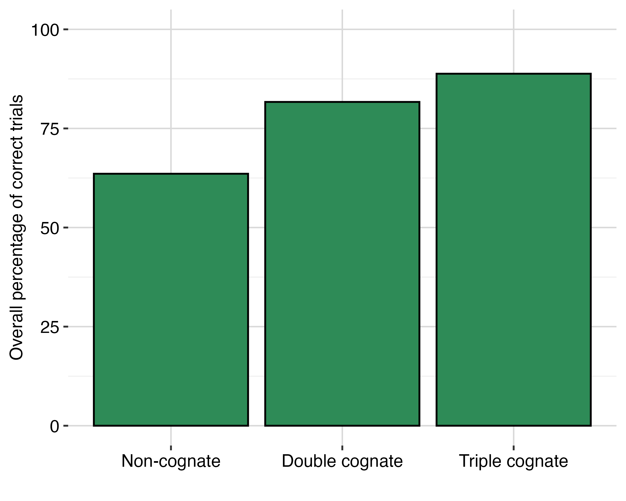
Figure 1: Percentage of correct responses by word type
Overall, there was evidence of a cumulative effect of cognate facilitation in accuracy. Figure 1 shows the overall accuracy within the entire data set (6510 trials) excluding pseudowords (in which 79.85% of trials were correct) Participants were most accurate for triple cognates (88.81%), followed by double cognates (81.69%) and least accurate for non-cognates (63.57%).
Most individual participants were generally more accurate on cognate trials, but there were a few exceptions. Figure 2 shows histograms of individuals’ percentage of correct trials in each word type. Individual accuracy in non-cognates ranged from 27.27 % of correct trials to 97.73% (median 63.64%). As in the data set as a whole, median individual accuracy was the highest for triple cognates: 91.67% (range 58.33% - 100.00%), followed by double cognates (median percentage correct = 81.82%; range = 50.00% - 100.00). Taken together, these descriptive results suggest that, while most participants benefit from cognates in accuracy, a minority also experience steep drops in accuracy. Indeed, two participants showed the opposite of the expected pattern and were most accurate for non-cognates (60.4% and 68.7%) and much less accurate for double (25% and 16.7%) and triple cognates (20.8% and 8.3%).
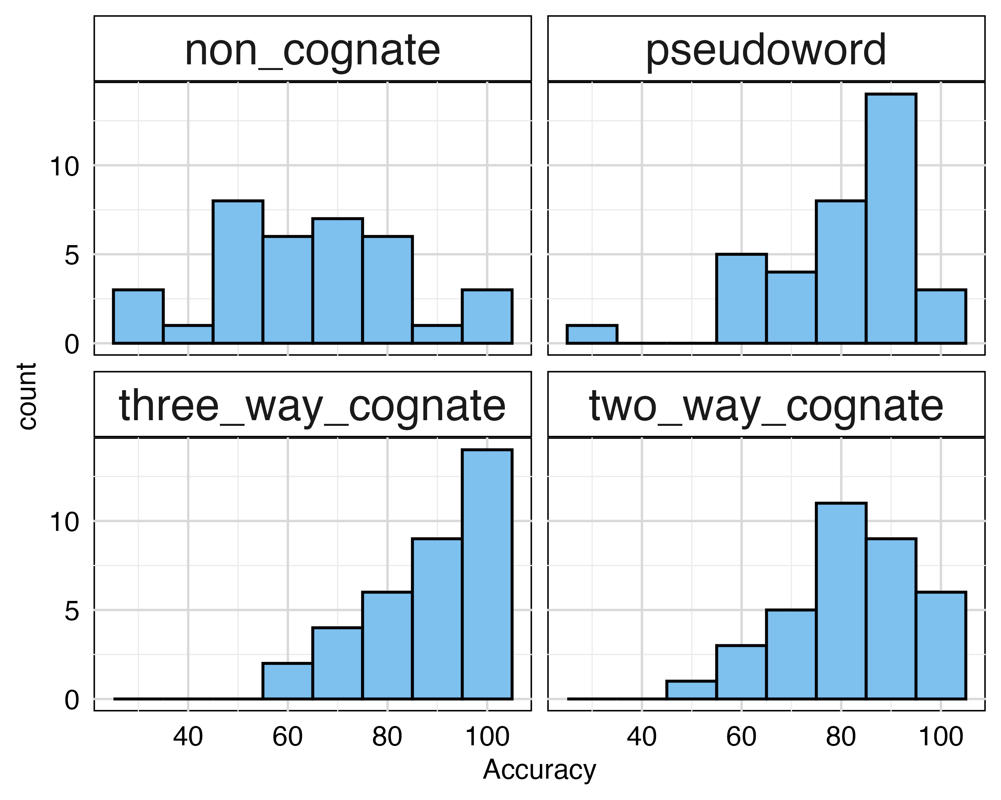
Figure 2: Histograms of individual accuracy percentages by word type
The relative accuracy advantage for cognates was greater at lower levels of L3 proficiency, as measured by the adapted LexTALE. Figure 3 shows the change in accuracy for non-cognates relative to both double and triple cognates. A positive value indicates an accuracy advantage for the corresponding cognate type relative to non-cognates, with the magnitude of the advantage represented on the y-axis. For example, a value of 40 on the y-axis means that a specific participant was 40% more accurate on a cognate condition than non-cognates. On the other hand, negative values suggest they were less accurate. The fitted lines represent the predicted change in the cognate advantage as proficiency increases. The negative slope suggests that as proficiency increases, the relative benefit of cognate status for accuracy diminishes.
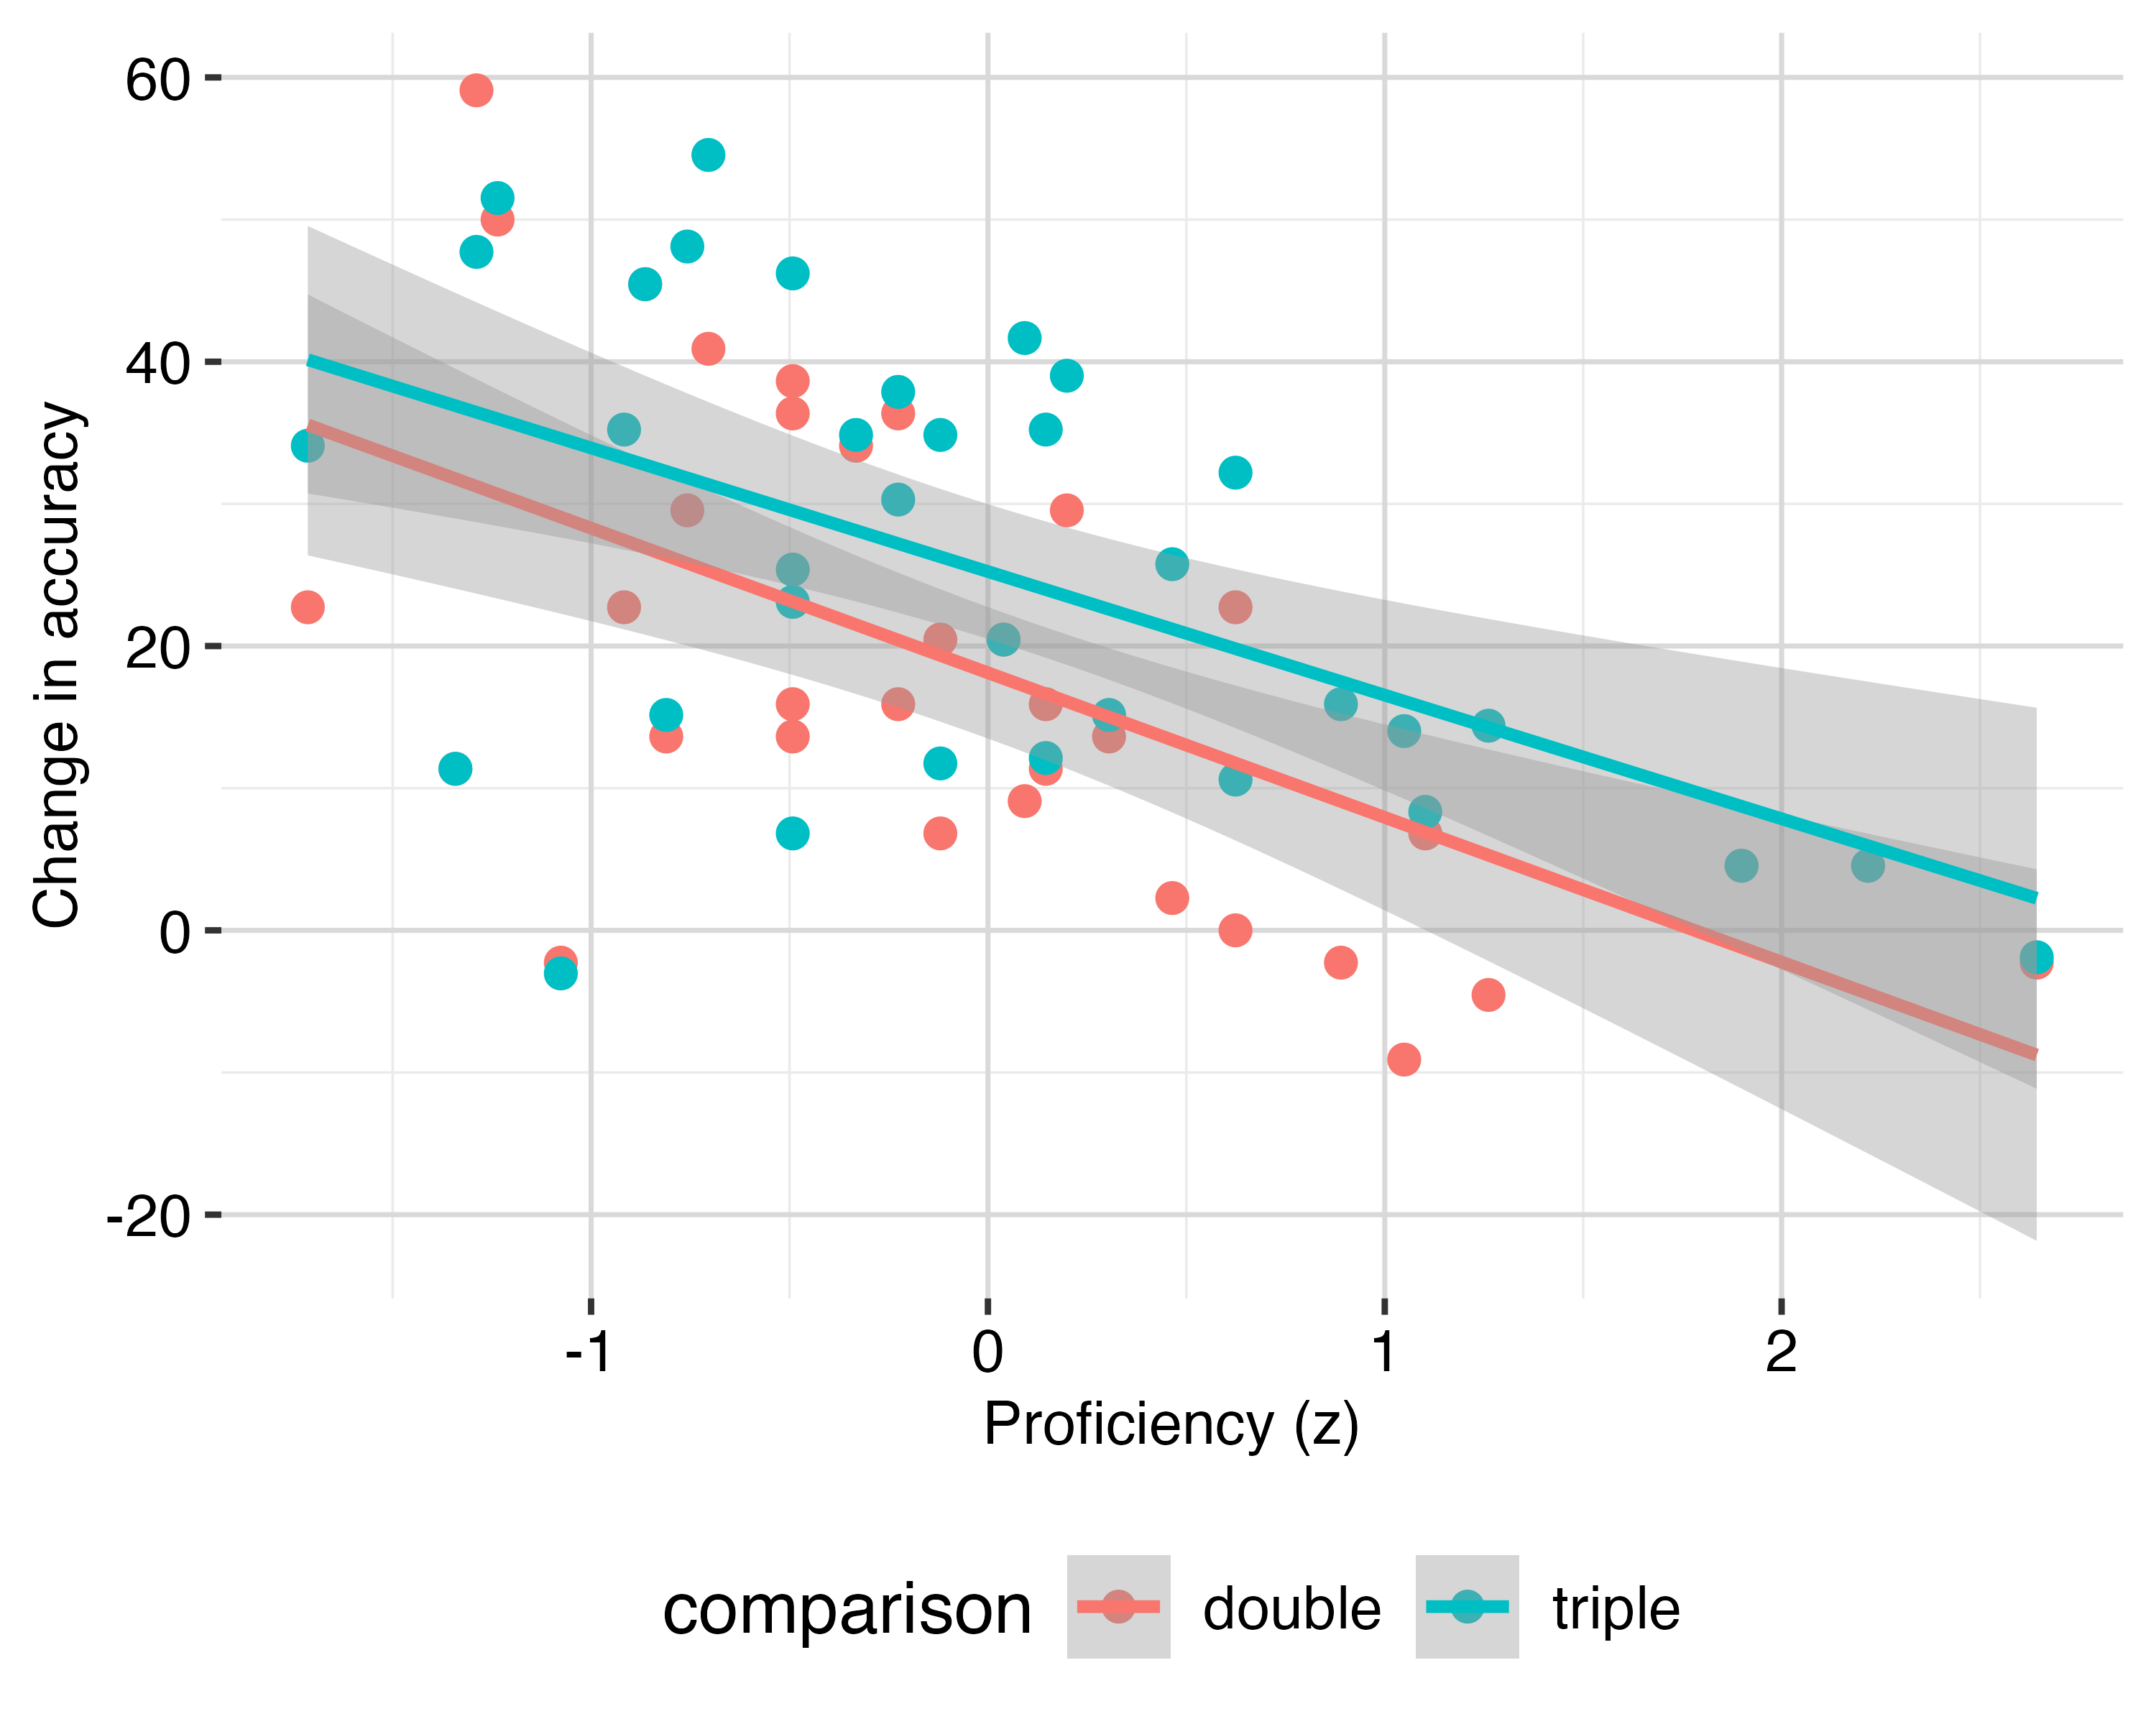
Figure 3: Increase in accuracy as a function of proficiency and word type
Table 2: Posterior Distribution of the Accuracy Model
Parameter | Median | 95% CI | pd | ROPE | % in ROPE | Rhat | ESS
Intercept | 2.34 | [1.75, 2.98] | 1.00 | [-0.18, 0.18] | 0.00 | 1 | 3,103.25
Non Cognate | -1.46 | [-2.12, -0.84] | 1.00 | [-0.18, 0.18] | 0.00 | 1 | 3,385.79
Triple Cognate | 0.71 | [0, 1.39] | 0.98 | [-0.18, 0.18] | 0.04 | 1 | 3,792.57
Frequency (z) | 1.01 | [0.79, 1.24] | 1.00 | [-0.18, 0.18] | 0.00 | 1 | 3,846.57
Proficiency (z) | 0.78 | [0.43, 1.15] | 1.00 | [-0.18, 0.18] | 0.00 | 1 | 3,288.93
The Bayesian model largely corroborated the descriptive effects. Overall, there was strong evidence for a general cognate effect in accuracy, and somewhat weaker evidence for a cumulative effect. Figure A.2 visualizes the posterior distribution for the accuracy model and Table 2 includes specific estimates of each model term. In this model, the intercept was 2.34 and represents the log-odds of an accurate response in the reference condition (double cognates) when the adapted LexTALE scores (proficiency_z) and lexical frequency (frequency_z) are average. In practice, this corresponds to an estimated accuracy of 91.2% for a participant with average proficiency responding to a word of average lexical frequency. The effect for non-cognates was -1.46, 95% HDI = [-2.12, -0.84], pd = 1, which corresponds to a lower predicted probability of a correct response (70.7%). The probability of direction was 1.00, signaling that virtually the entire posterior distribution is below zero, providing extremely strong evidence for a negative effect. Additionally, 0% of the posterior distribution fell within the ROPE, suggesting that none of the credible parameter values were practically equivalent to zero. For triple cognates, the median effect was 0.71, 95% HDI = [0, 1.39], indicating that the most credible values of the effect were positive. The effect was associated with a pd of 0.98, indicating that approximately 98% of the posterior distribution supported a positive effect. Additionally, only 4% of the posterior distribution fell within the ROPE, suggesting that most credible parameter values were not practically equivalent to zero. Taken together, these results provide evidence that triple cognates were identified more accurately than double cognates, although the evidence was somewhat weaker than that observed for the non-cognate effect.
Higher values for both continuous predictors, lexical frequency and proficiency, were associated with greater accuracy. For lexical frequency, the median estimate was 1.01, 95% HDI = [0.79, 1.24], indicating that a one standard deviation increase in lexical frequency was associated with an increase of 1.01 in the log-odds of a correct response. Holding all other predictors constant, predicted accuracy increases to around 96.6% in words that were 1 standard deviation more frequent than average, while it dropped to 79.1% for words that were one standard deviation less frequent than average. Again, the pd (1) and ROPE percentage (0%) provide strong evidence for the existence of a positive association between lexical frequency and accuracy. Proficiency was also shown to be positively associated with accuracy; the estimate 0.78, 95% HDI = [0.43, 1.15] suggests that a one standard deviation increase in the adapted LexTALE score was associated with an increase of 0.78 in the log-odds of a correct response. Predicted accuracy increases to around 96.6% by participants who were 1 standard deviation more proficient than average, while it dropped to 82.6% for participants that were one standard deviation less proficient than average. Like frequency, the pd (1) and ROPE percentage (0) provide compelling evidence that the effect is positive and not negligible.

Response time
Like accuracy, the analysis of the response time data showed evidence of a general cognate facilitation effect. Figure 4 shows the overall mean response times in milliseconds for each word type. Non-cognate words were recognized as real words the slowest (mean response time 881.67ms, sd = 304.77), while both double (827.33ms, sd = 296.70) and triple cognates were recognized faster 817.38ms, sd = 263.04. The difference in response time between double and triple cognates was quite small (d = .03).
In the case of response time, individual differences were even more pronounced. Figure 5 shows individual effect sizes in three situations: going from double to triple cognates, non-cognates to double cognates, and non-cognates to triple cognates. It was predicted that if there was a cumulative effect of cognate facilitation, the double-to-triple contrast would yield negative values. However, many participants were faster (14 of 35) for double cognates than triple cognates, while the remaining 21 participants showed the opposite pattern and processed triple cognates fastest.
The second facet shows the individual effects for non-cognates relative to double cognates.
In this instance, as expected, most participants (26) were faster for double cognates than non-cognates, although 26 individuals were not. Similar proportions of participants were also faster at deciding that triple cognates were real words (27). Taken together, these results suggest that while most individuals showed descriptive evidence of general cognate effects in response time, there was no strong evidence for a cumulative effect in which triple cognates were processed faster than double cognates.
Unlike accuracy, there was no descriptive evidence regarding a relationship between differences in response time and L3 proficiency. Figure A.4 shows the individual effect sizes for non-cognates to double cognates, non-cognates to triple cognates, and the cumulative contrast (double cognate to triple cognates). A negative value in this case indicates that a specific participant was faster in the latter condition (e.g. a negative value for non-cognates to double cognates would show that the participant reacted faster on average to double cognates). The relatively flat slopes on the fitted lines in each case suggest that the magnitude of effects does not vary by proficiency level.
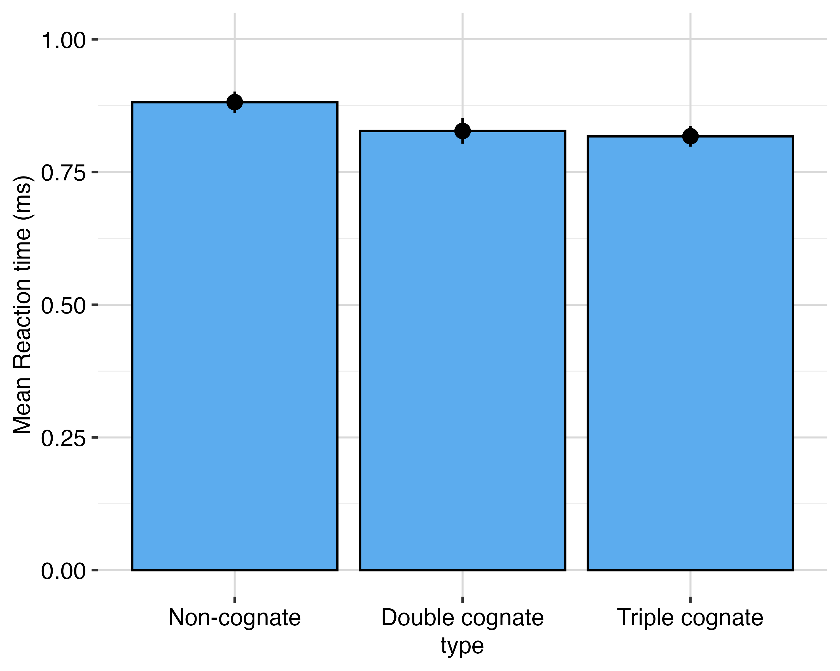
Figure 4: Mean response time of each word type
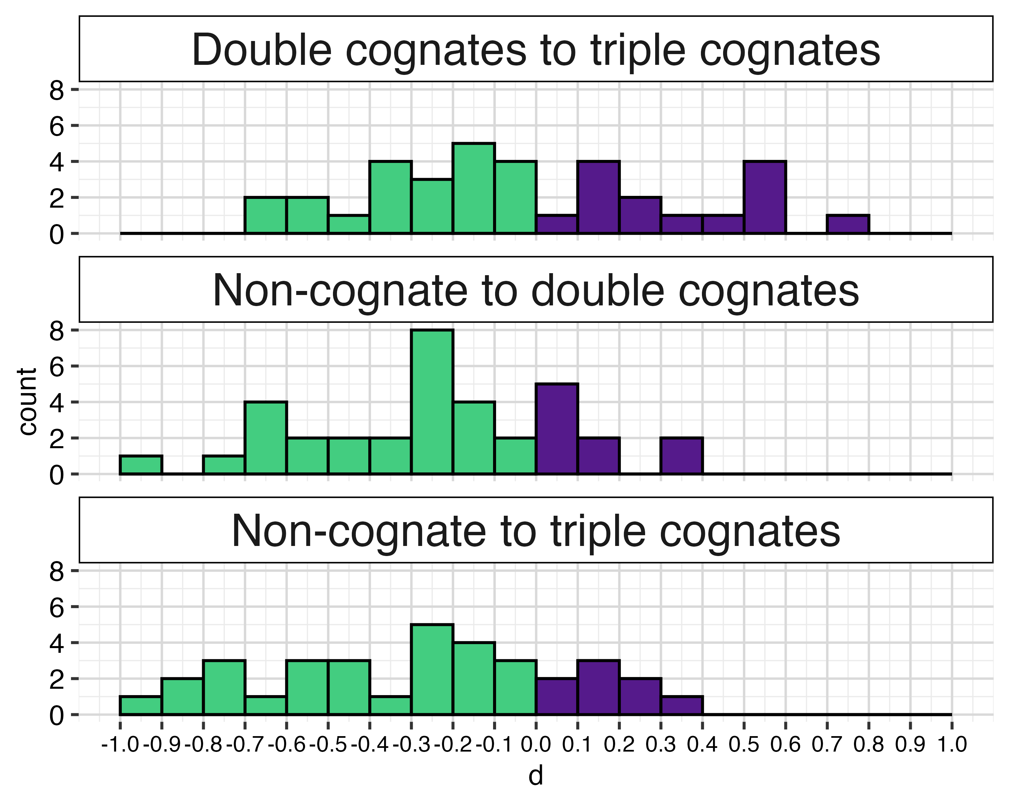
Figure 5: Individual effects in response times
Table 3: Posterior Distribution of the Response Time Model
Parameter | Median | 95% CI | pd | ROPE | % in ROPE | Rhat | ESS
Intercept | -0.23 | [-0.3, -0.17] | 1.00 | [-0.01, 0.01] | 0.00 | 1 | 998.69
Noncognate | 0.08 | [0.04, 0.12] | 1.00 | [-0.01, 0.01] | 0.00 | 1 | 4,868.24
Triple Cognate | -0.02 | [-0.07, 0.02] | 0.83 | [-0.01, 0.01] | 0.16 | 1 | 4,197.74
Frequency (z) | -0.07 | [-0.08, -0.05] | 1.00 | [-0.01, 0.01] | 0.00 | 1 | 6,185.96
Proficiency (z) | -0.03 | [-0.09, 0.02] | 0.89 | [-0.01, 0.01] | 0.10 | 1 | 1,358.50
The Bayesian model largely corroborated the descriptive results for response time. Figure A.3 visualizes the posterior distribution of the Bayesian model while Table 3 provides additional details regarding the posterior shape and fit. The intercept term of this model (-0.23) corresponds to the log response time of a double cognate of average frequency by a participant with average proficiency. This value corresponds to 794.53 milliseconds. The non-cognate model term is 0.08 [0.04, 0.12] and indicates a slowdown relative to double cognates of about 288.75 milliseconds. Triple cognates were predicted to be processed slightly faster than double cognates (-0.02 [-0.07, 0.02]) but had both positive and negative plausible estimates in the posterior distribution, as well as a relatively low pd (0.83) and % in the ROPE. Lexical frequency was a strong predictor of response time. As with accuracy, the model term represents the change in response time associated with a one standard-deviation increase in frequency, predicting faster responses (-0.07 [-0.08, -0.05]) in more frequent words, corresponding to an estimated difference of round2(abs(exp(rt_table$Median[1])*1000 - exp(rt_table$Median[4])*1000)) milliseconds. Finally, the adapted LexTALE score (proficiency) was associated with a slight speedup in processing, but this difference did not fall completely outside the ROPE (-0.03 [-0.09, 0.02]), rendering the effect inconclusive. Taken together, the results of the model provide evidence for a general cognate effect after accounting for proficiency and lexical frequency. Importantly, the model does not support a cumulative effect in lexical decisions.

Discussion
The present study investigated whether cognate facilitation effects accumulate across three languages in multilingual individuals (L1 German, L2 English, L3 Spanish) by comparing the processing of double cognates (English-Spanish), triple cognates (German-English-Spanish), and noncognates in a visual lexical decision task in Spanish. In addition, the study examined the role of L3 proficiency in lexical processing. Overall, the findings provided strong evidence for a cognate facilitation effect in L3 Spanish, but the evidence for a cumulative facilitation effect differed across dependent measures. In accuracy, participants performed best with triple cognates, followed by double cognates and noncognates. In response time, both double and triple cognates were processed faster than noncognates, but there was no compelling evidence that triple cognates were processed faster than double cognates. Thus, the results reveal an asymmetry between accuracy and speed of lexical processing for a cumulative facilitation effect.

Cognate Effects in L3 Lexical Processing
Our first research question asked whether German-English-Spanish trilinguals process triple cognates more efficiently than double cognates. Given the mixed findings in previous research, we considered two primary possibilities. Following the Accumulation model (Bartolotti & Marian, 2017) and previous evidence of cumulative cognate effects (e.g., De Angelis, 2007; Foryś-Nogala et al., 2026; Lemhöfer et al., 2004; Poarch & Hell, 2014; Szubko-Sitarek, 2011), triple cognates might receive an additional processing benefit because they activate overlapping representations in both previously acquired languages. Alternatively, following the Scaffolding model (Bartolotti & Marian, 2017) and previous evidence of non-cumulative facilitation (e.g., Bartolotti & Marian, 2017; De Angelis, 2007; Engemann & Radetzky, 2024; Lijewska, 2023; Lijewska & Louw, 2025), lexical overlap with one previously acquired language may be sufficient to facilitate processing, such that additional overlap with a second language provides little or no further benefit.
Our results provided strong evidence of a general cognate facilitation effect. In both accuracy and response time, cognates were processed more successfully than noncognates. Double and triple cognates yielded substantially higher accuracy than noncognates, and both cognate types were also recognized more quickly than noncognates. This pattern is consistent with models of non-selective lexical access, according to which lexical representations from non-target languages remain activated during target-language processing (Dijkstra et al., 2018; Dijkstra & Van Heuven, 2002). It is also consistent with extensive evidence from multilingual research showing that knowledge of previously acquired languages facilitates the recognition or production of cognates in an L3 (e.g., Lemhöfer et al., 2004; Poarch & Hell, 2014; Szubko-Sitarek, 2011).
Crucially, however, the evidence regarding cumulative facilitation differed between accuracy and response time. The accuracy results showed a graded pattern in which triple cognates were identified most accurately, followed by double cognates and then noncognates. This finding is compatible with the Accumulation model (Bartolotti & Marian, 2017), according to which overlap across multiple previously acquired languages can produce additive lexical benefits. It also converges with studies reporting stronger facilitation for triple than double cognates. Lemhöfer et al. (2004), for example, found cumulative cognate effects in L3 lexical decision, and Szubko-Sitarek (2011) likewise reported stronger facilitation for triple than double cognates in L3 word recognition. Previous research has therefore demonstrated that lexical overlap across three languages can, under some conditions, provide an additional advantage beyond overlap across two languages.
However, the response time results produced a different pattern. Although both cognate conditions were faster than noncognates, triple cognates were only approximately 10 ms faster than double cognates. Thus, the response time data provided no compelling evidence that additional overlap with German produced a further benefit in the speed with which L3 Spanish words were recognized. In this respect, the response time results are more consistent with the Scaffolding model (Bartolotti & Marian, 2017) and previous studies that found no cumulative benefits (e.g., Bartolotti & Marian, 2017; Engemann & Radetzky, 2024; Lijewska, 2023; Lijewska & Louw, 2025). Overlap with English may have been sufficient to facilitate L3 lexical access, with additional overlap with German producing little additional reduction in processing speed.
The discrepancy between accuracy and response time is not unprecedented in cognate processing research. Previous studies have reported cognate facilitation in accuracy in the absence of corresponding effects in processing speed (Engemann & Radetzky, 2024; Koutamanis, Kootstra, Dijkstra, & Unsworth, 2024), suggesting that accuracy and latency may capture partially distinct consequences of cross-linguistic activation. Importantly, Covey & Mikheeva (2023) reported a dissociation between accuracy and latency in the processing of double and triple cognates. They examined Russian-English-German trilinguals in picture naming and found a particularly similar pattern. Their participants were most accurate with triple cognates, followed by double cognates and noncognates. In contrast, word type did not significantly affect naming latency. Their findings showed that cumulative cross-linguistic overlap can appear clearly in accuracy without producing a corresponding cumulative advantage in response speed, closely paralleling the dissociation observed in the present study. Greater overlap across three languages may increase the strength or reliability with which the target lexical representation is activated, increasing the probability that a word is correctly recognized, without necessarily accelerating lexical access beyond the advantage already provided by overlap between the L2 and L3. In other words, activation from an additional language may improve the likelihood of successful lexical identification more readily than it improves the speed of an already successful response.
The difference between the two measures may also partly reflect the structure of the response time analysis itself. Following previous studies (e.g., Covey & Mikheeva, 2023; Engemann & Radetzky, 2024; Lemhöfer et al., 2004; Poarch & Hell, 2014; Szubko-Sitarek, 2011), reaction times were analyzed only for correct responses, meaning that the trials in which cross-linguistic overlap may have been especially beneficial for achieving successful recognition are not represented in the latency analysis. This could reduce differences between double and triple cognates among the subset of items that participants were already able to identify correctly.
Consequently, the present findings do not support a categorical conclusion that multilingual lexical influence is either cumulative or non-cumulative. Instead, they suggest that the consequences of cumulative cross-linguistic overlap may depend on the particular dimension of processing being measured. The additional German-English-Spanish overlap associated with triple cognates increased recognition accuracy, but it did not yield compelling evidence of an additional speed advantage beyond that already provided by English-Spanish overlap. This measure-dependent pattern may help explain some of the mixed findings in previous trilingual cognate research, where cumulative effects have varied across tasks, participant populations, and dependent measures.

The Role L3 Proficiency
Our second research question concerned the role of L3 proficiency in cognate processing. We predicted that higher Spanish proficiency would be associated with stronger cognate facilitation, following previous work suggesting that sufficient proficiency may be necessary for weaker language representations to become strongly integrated into the multilingual lexical system (e.g., Lemhöfer et al., 2004; Poarch & Hell, 2014; Szubko-Sitarek, 2011). The results did not support a straightforward interpretation in which higher proficiency produces stronger cognate facilitation. Instead, proficiency was clearly associated with greater overall accuracy, as participants with higher proficiency scores were more likely to identify Spanish words correctly across conditions.
Importantly, however, the descriptive data suggested that the relative accuracy advantage for cognates over noncognates became smaller as proficiency increased. Lower-proficiency participants appeared to rely more heavily on cross-linguistic overlap, whereas higher-proficiency participants performed increasingly well on noncognates as their Spanish lexical knowledge improved. This pattern is consistent with Covey & Mikheeva (2023), who found that greater L2 and L3 proficiency was associated with smaller cognate effects. In their study, cognate status was particularly beneficial to less proficient multilingual speakers, suggesting that cross-linguistic overlap provides more benefits when representations of the target language are relatively weak. As proficiency increases, successful lexical processing may depend less on support from related words in previously acquired languages. The response time findings, however, provided no evidence that higher proficiency strengthened cognate facilitation. Notably, whereas the results provided evidence of an overall proficiency effect, with more proficient participants performing more accurately overall, the findings did not support proficiency-related modulation of cognate facilitation.

Lexical Frequency and Individual Variation
Lexical frequency also made a substantial contribution to performance. More frequent words were both more accurately recognized and processed more quickly than less frequent words. Although frequency was included primarily as a control variable rather than as a central theoretical predictor, its robust effects confirm that lexical accessibility contributed independently to performance beyond cognate status. Importantly, the cognate effects remained after lexical frequency was statistically controlled, indicating that the advantage for cognates cannot simply be attributed to differences in Spanish word frequency.
The descriptive results also revealed considerable individual variability. Although the majority of participants showed the expected cognate advantage, the magnitude of facilitation differed substantially across individuals, and some participants even showed the reverse pattern. Individual variability was particularly evident when contrasting the response times for triple and double cognates. 21 participants were faster with triple cognates, whereas 14 were faster with double cognates. Such variability is consistent with the broader multilingual literature showing that cross-linguistic activation can depend on proficiency, immersion, language experience, and the relative status of the languages involved. Poarch & Hell (2014), for example, found that multilingual cognate effects varied with proficiency and immersion experience, and Covey & Mikheeva (2023) documented substantial proficiency-related variation in cognate effects. Therefore, future research could examine whether other factors such as frequency of language use, language-switching experience, or immersion history may help explain why some individuals show stronger cumulative facilitation than others.
Taken together, the present findings support a view of multilingual lexical processing characterized by robust cross-linguistic activation but not necessarily uniform additive facilitation across all processing measures. Cross-linguistic overlap strongly facilitates lexical processing, but the cumulative contribution of multiple languages appears more evident in the accuracy of lexical identification than in the speed of successful recognition. The results caution against drawing conclusions about additive benefits in multilingual lexical processing from a single dependent measure. Studies reporting only latency or only accuracy may reach different conclusions about whether triple cognates receive an additional processing benefit.

Conclusion
The present study investigated how cross-linguistic similarity shapes lexical processing in L3 Spanish among German-English-Spanish trilinguals. Specifically, it examined whether cognate facilitation accumulates across previously acquired languages by comparing double cognates, triple cognates, and noncognates. Additionally, the study assessed the role of proficiency in L3 lexical processing. The findings provided evidence that cross-linguistic similarity facilitates L3 lexical processing. Importantly, cumulative benefits of overlap across multiple languages were not observed similarly across measures. Double and triple cognates were processed more accurately and more quickly than noncognates, revealing robust cross-linguistic activation during L3 Spanish word recognition. However, the additional cross-linguistic benefit associated with triple cognates emerged clearly in accuracy but not in response time, which highlights the importance of considering multiple dependent measures when evaluating cumulative cognate effects. L3 proficiency was associated with greater overall accuracy but did not modulate cognate facilitation, while lexical frequency independently facilitated performance. Together, these findings suggest that multilingual lexical processing reflects dynamic interactions among cross-linguistic similarity, lexical knowledge, and individual experience, and that additive effects across languages may be more apparent in the reliability of lexical identification than in the speed of successful access.
Data Availability Statement
The data that support the findings of this study are openly available in [repository name] at http://doi.org/, reference number [reference number].

Appendix A: Stimulus List of the Lexical Decision Task
Table A.1: Stimulus List
English | German | Spanish | Word Type
moral | Moral | moral | triple cognate
tumor | Tumor | tumor | triple cognate
disco | Disco | disco | triple cognate
flora | Flora | flora | triple cognate
extra | extra | extra | triple cognate
horror | Horror | horror | triple cognate
albino | Albino | albino | triple cognate
kilo | Kilo | kilo | triple cognate
portal | Portal | portal | triple cognate
drama | Drama | drama | triple cognate
golf | Golf | golf | triple cognate
dogma | Dogma | dogma | triple cognate
plan | Plan | plan | triple cognate
aura | Aura | aura | triple cognate
test | Test | test | triple cognate
chat | Chat | chat | triple cognate
clan | Clan | clan | triple cognate
altar | Altar | altar | triple cognate
mafia | Mafia | mafia | triple cognate
trauma | Trauma | trauma | triple cognate
hotel | Hotel | hotel | triple cognate
mango | Mango | mango | triple cognate
plural | Plural | plural | triple cognate
retina | Retina | retina | triple cognate
vigor | Kraft | vigor | double cognate
enigma | Rätsel | enigma | double cognate
piano | Klavier | piano | double cognate
ardor | Inbrunst | ardor | double cognate
clamor | Geschrei | clamor | double cognate
fiscal | steuerlich | fiscal | double cognate
civil | bürgerlich | civil | double cognate
animal | Tier | animal | double cognate
collar | Hundehalsband | collar | double cognate
actor | Schauspieler | actor | double cognate
aurora | Polarlicht | aurora | double cognate
viable | lebensfähig | viable | double cognate
torso | Oberkörper | torso | double cognate
halo | Heiligenschein | halo | double cognate
casual | zufällig | casual | double cognate
pelvis | Becken | pelvis | double cognate
pasta | Nudeln | pasta | double cognate
rumor | Gerücht | rumor | double cognate
honor | Ehre | honor | double cognate
editor | Herausgeber | editor | double cognate
total | gesamt | total | double cognate
mortal | sterblich | mortal | double cognate
color | Farbe | color | double cognate
pelvis | Becken | pelvis | double cognate
dye | färben | teñir | noncognate
mountain | Gebirge | sierra | noncognate
ready | fertig | listo | noncognate
soft | weich | blando | noncognate
tip | Spitze | punta | noncognate
lid | Deckel | tapón | noncognate
evil | Böse | maldad | noncognate
beak | Schnabel | pico | noncognate
gift | Geschenk | regalo | noncognate
quilt | Tagesdecke | colcha | noncognate
ugly | hässlich | feo | noncognate
century | Jahrhundert | siglo | noncognate
customs | Zoll | aduana | noncognate
stick | zusammenkleben | pegar | noncognate
thread | Faden | hilo | noncognate
curly | lockig | rizado | noncognate
war | Krieg | guerra | noncognate
fin | Flosse | aleta | noncognate
call | anrufen | llamar | noncognate
dagger | Dolch | puñal | noncognate
chalk | Kreide | tiza | noncognate
mood | Laune | ánimo | noncognate
cake | Kuchen | torta | noncognate
face | Gesicht | rostro | noncognate
carry | tragen | llevar | noncognate
wing | Flügel | ala | noncognate
kick | Fußtritt | patada | noncognate
clash | zusammenprallen | chocar | noncognate
smooth | weich | suave | noncognate
yield | ergeben | rendir | noncognate
ground | Boden | suelo | noncognate
bowl | Schüssel | cuenco | noncognate
withdraw | abheben | sacar | noncognate
sparkle | Glanz | brillo | noncognate
breath | Atem | hálito | noncognate
notice | Benachrichtigung | aviso | noncognate
huge | riesig | enorme | noncognate
bowl | Schüssel | cuenco | noncognate
crutch | Krücke | muleta | noncognate
hanger | Kleiderbügel | percha | noncognate
wrist | Handgelenk | muñeca | noncognate
deer | Hirsch | venado | noncognate
team | Mannschaft | equipo | noncognate
arrow | Pfeil | flecha | noncognate
tidbit | Leckerbissen | tapa | noncognate
lining | Futter | forro | noncognate
ready | bereit | listo | noncognate
expensive | teuer | caro | noncognate
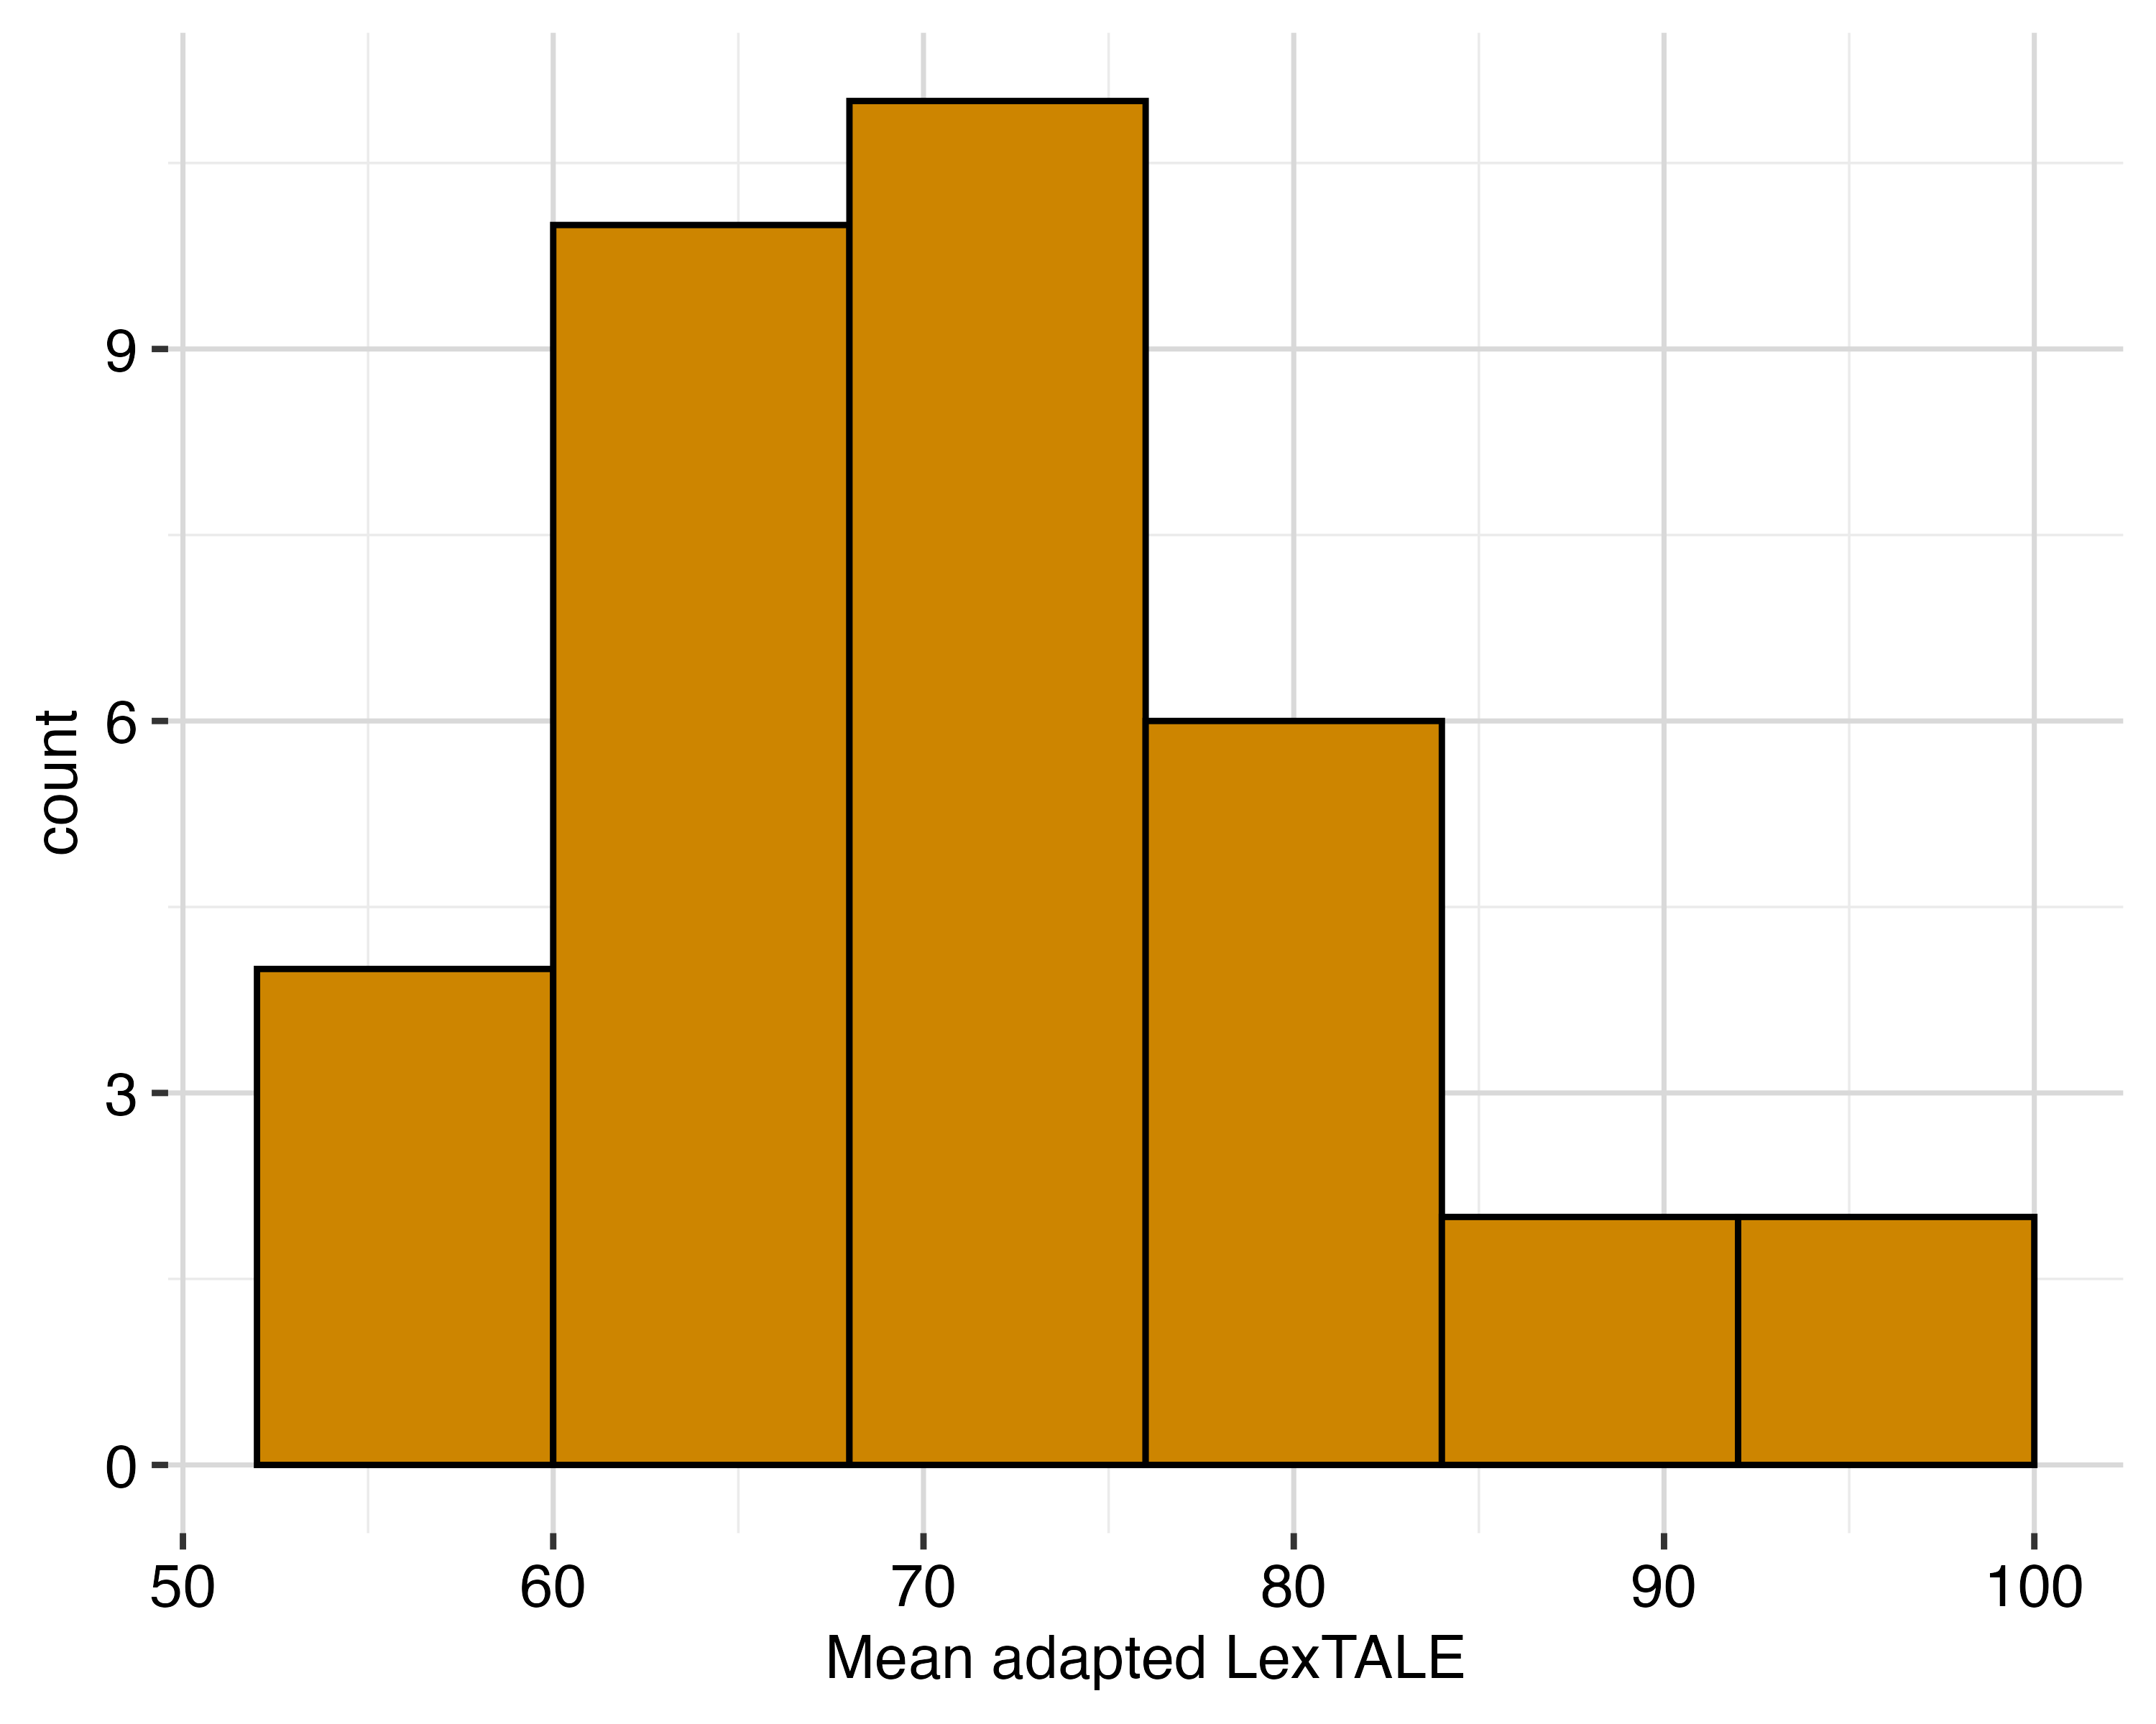
Figure A.1: Histogram of the adapted LexTALE scores
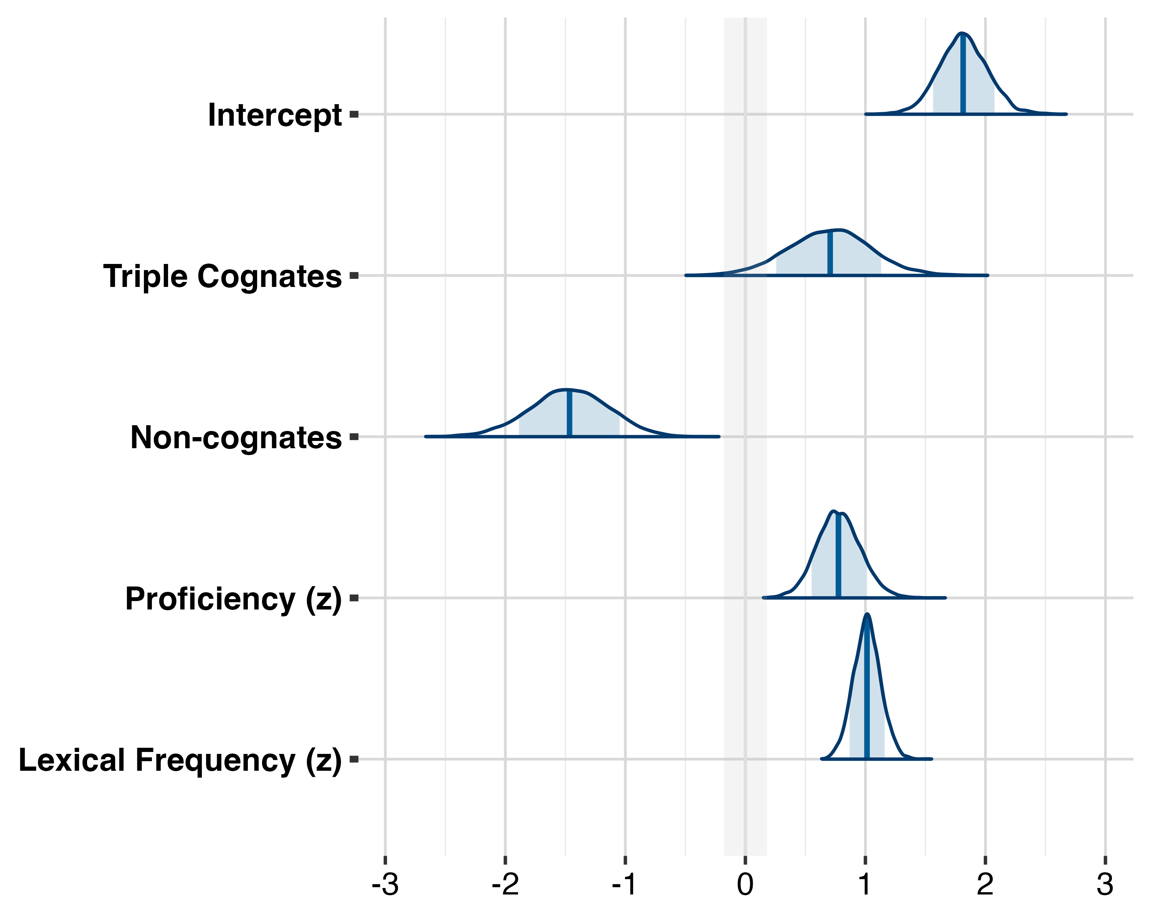
Figure A.2: Posterior Distributions of the accuracy model
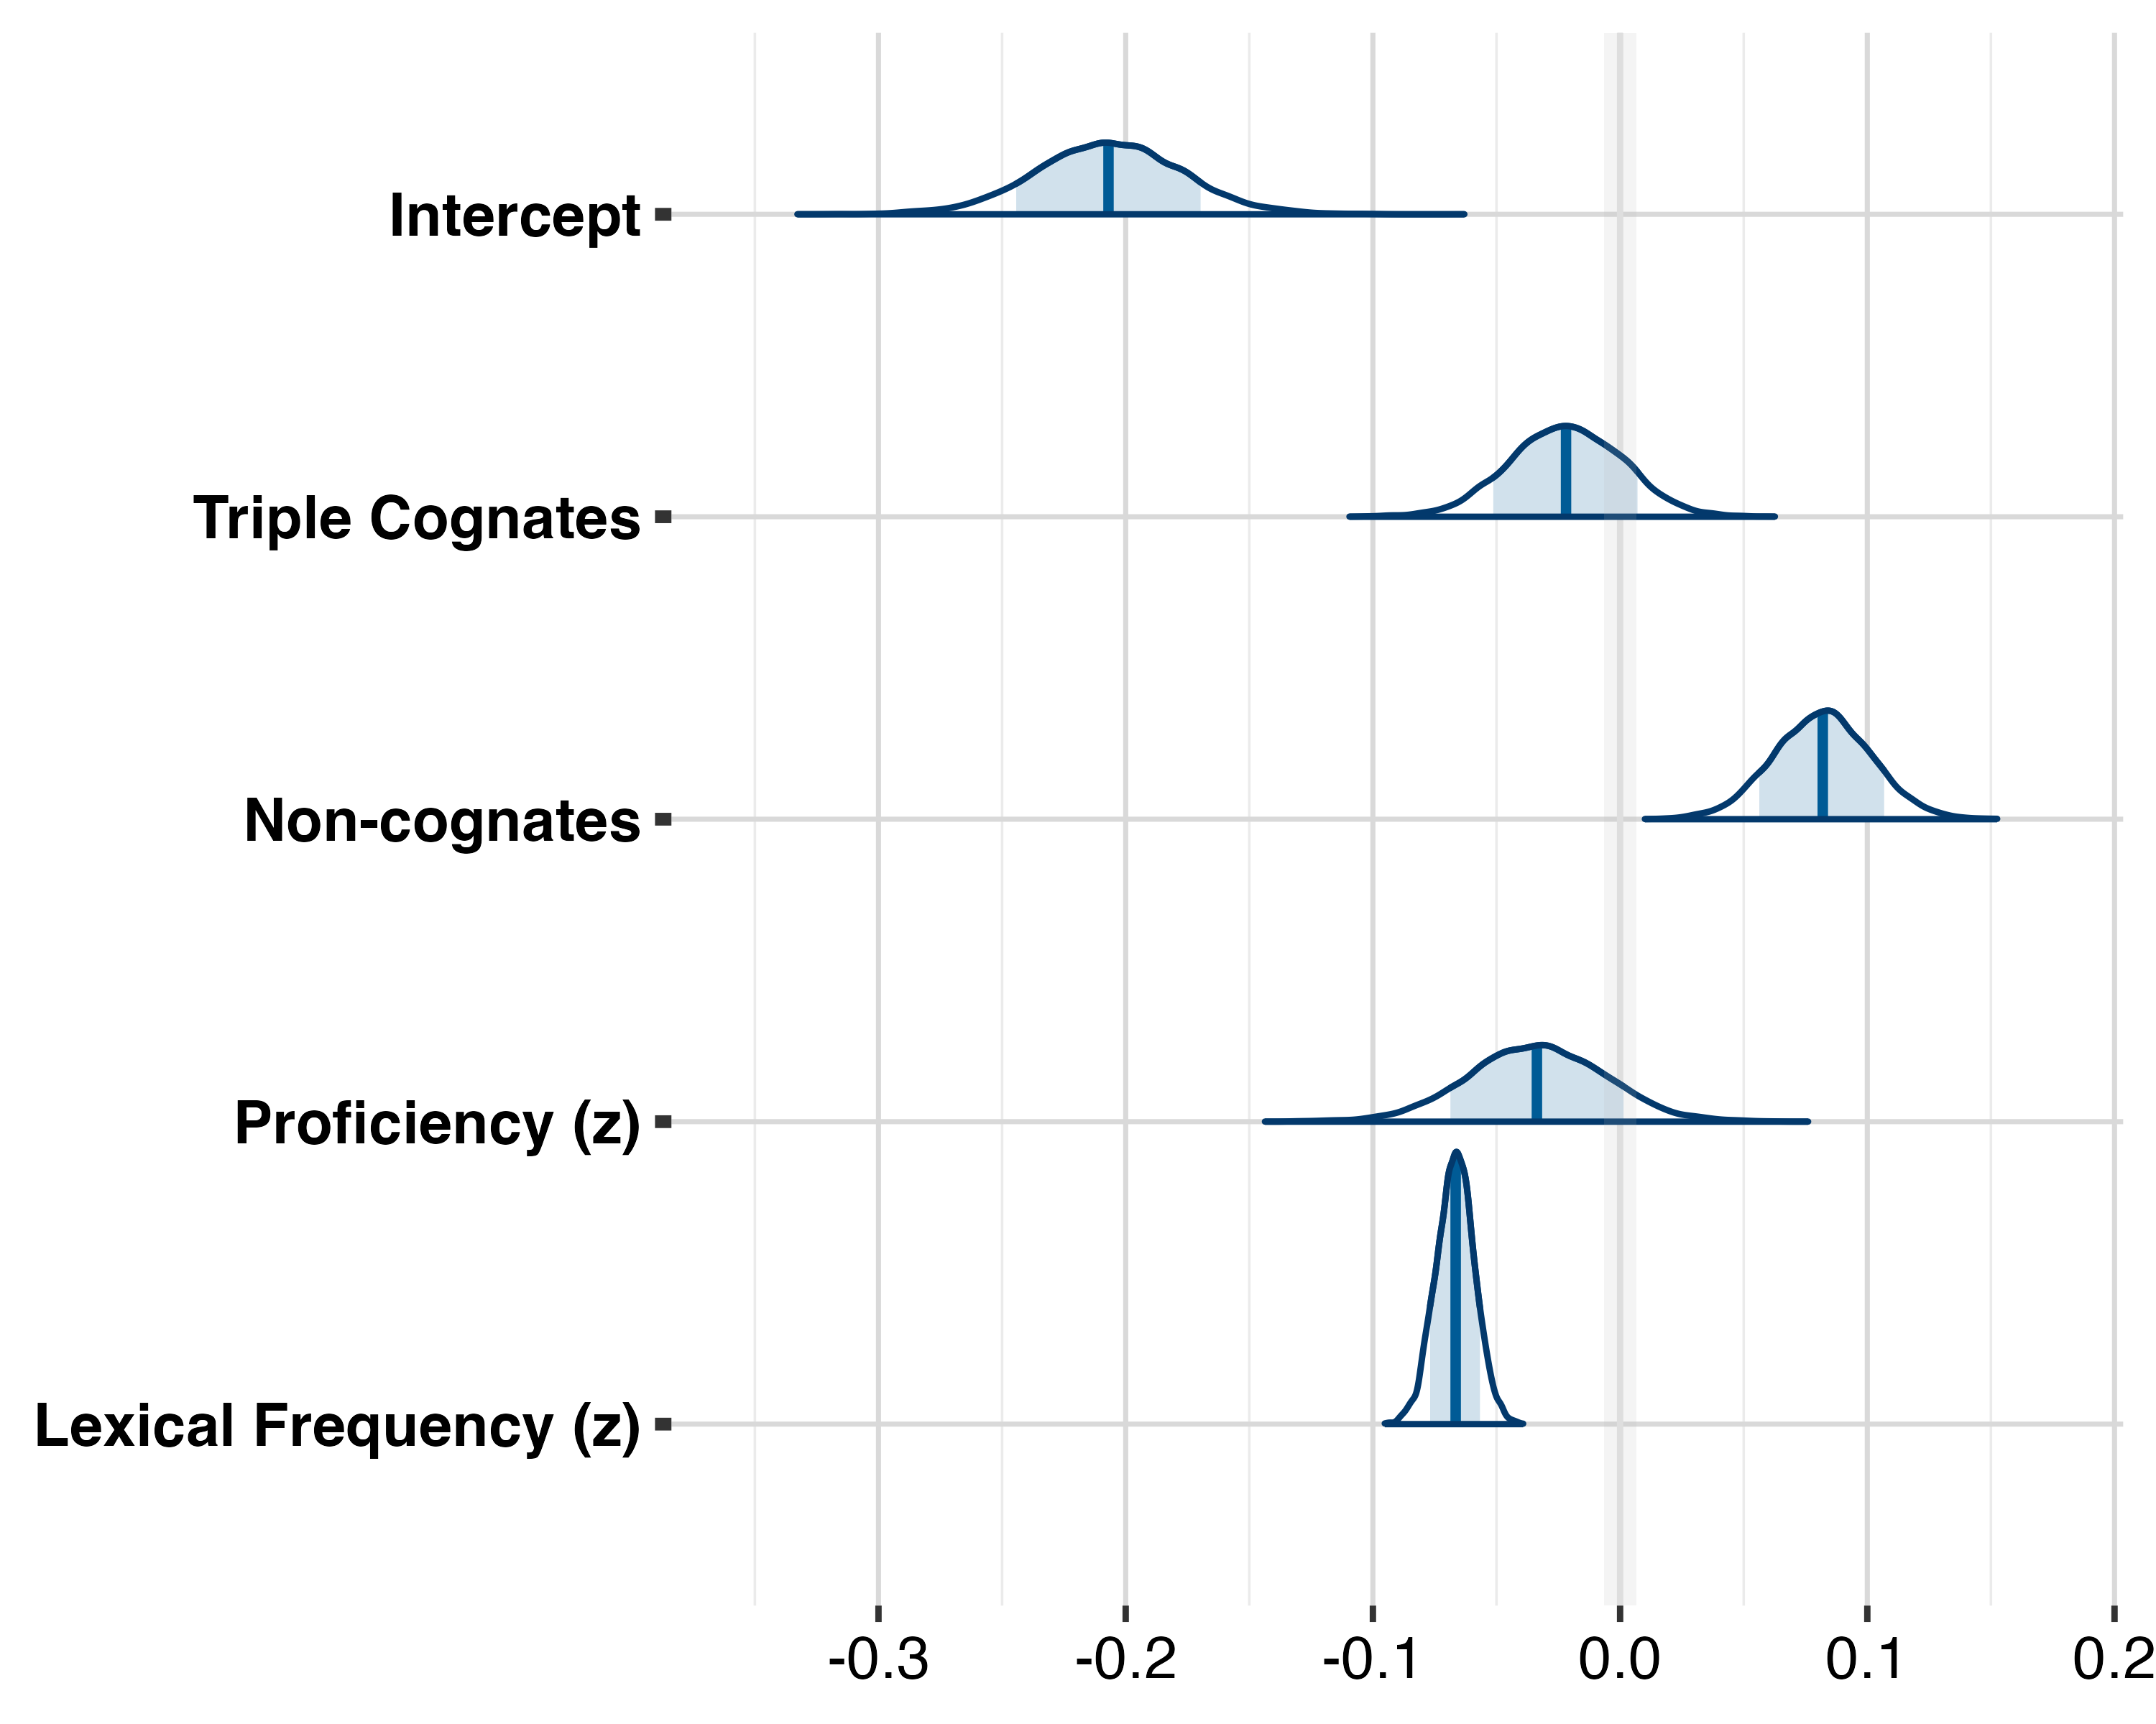
Figure A.3: Posterior Distributions of the reaction time model
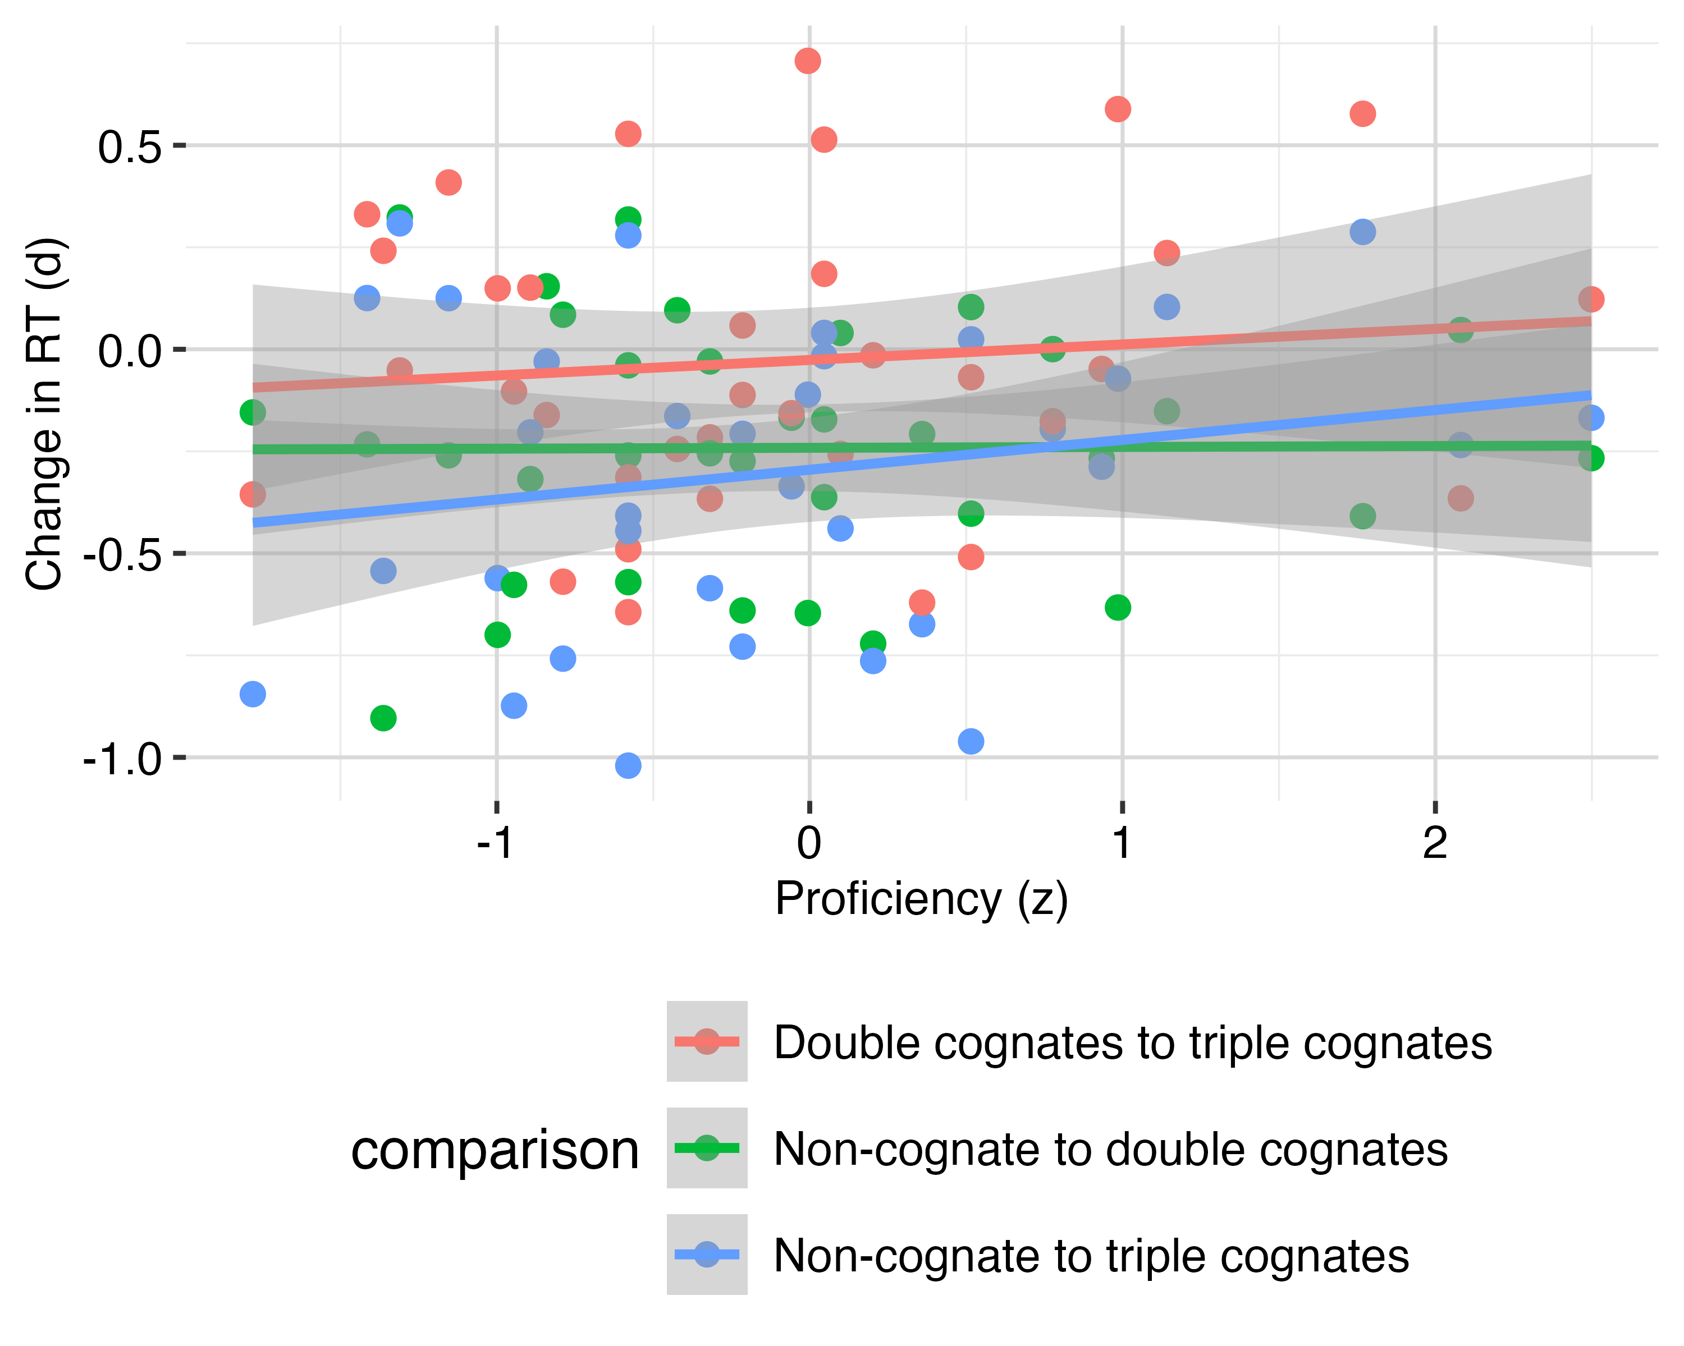
Figure A.4: Individual effects in reaction times as a function of L3 proficiency

References
Aguinaga Echeverría, S. (2017). All Cognates are not Created Equal: Variation in Cognate Recognition and Applications for Second Language Acquisition. Revista Electrónica de Lingüística Aplicada, 16(1), 23–42. Retrieved from https://matrix.aesla.org.es/RAEL/article/view/313
Amengual, M. (2012). Interlingual influence in bilingual speech: Cognate status effect in a continuum of bilingualism. Bilingualism: Language and Cognition, 15(3), 517–530. http://doi.org/10.1017/S1366728911000460
Arana, S. L., Oliveira, H. M., Fernandes, A. I., Soares, A. P., & Comesaña, M. (2022). The cognate facilitation effect depends on the presence of identical cognates. Bilingualism: Language and Cognition, 25(4), 660–678. http://doi.org/10.1017/S1366728922000062
Bardel, C., & Falk, Y. (2007). The role of the second language in third language acquisition: The case of Germanic syntax. Second Language Research SAGE Second Language Research, 234, 459–484. http://doi.org/10.1177/0267658307080557
Bardel, C., & Falk, Y. (2012). The L2 status factor and the declarative/procedural distinction. In (pp. 61–78). http://doi.org/10.1075/sibil.46.06bar
Bartolotti, J., & Marian, V. (2017). Bilinguals’ Existing Languages Benefit Vocabulary Learning in a Third Language. Language Learning, 67(1), 110–140. http://doi.org/10.1111/lang.12200
Borg, K. (2013). The acquisition of future of probability in L3 spanish. In Proceedings of the 12th generative approaches to second language acquisition conference (pp. 11–21). Cascadilla Proceedings Project Somerville, MA.
Bürkner, P.-C. (2017). Brms: An r package for bayesian multilevel models using stan. Journal of Statistical Software, 80, 1–28.
Cabrelli, J., Amaro, J. F., & Rothman, J. (2015). The relationship between L3 transfer and structural similarity across development: Raising across an experiencer in brazilian portuguese. In Transfer effects in multilingual language development (pp. 21–52). John Benjamins.
Carrasco-Ortiz, H., Amengual, M., & Gries, S. T. (2021). Cross-language effects of phonological and orthographic similarity in cognate word recognition: The role of language dominance. Linguistic Approaches to Bilingualism, 11(3), 389–417. http://doi.org/10.1075/lab.18095.car
Comesaña, M., Ferré, P., Romero, J., Guasch, M., Soares, A. P., & García-Chico, T. (2015). Facilitative effect of cognate words vanishes when reducing the orthographic overlap: The role of stimuli list composition. Journal of Experimental Psychology. Learning, Memory, and Cognition, 41(3), 614–635. http://doi.org/10.1037/xlm0000065
Cop, U., Drieghe, D., & Duyck, W. (2015). Eye Movement Patterns in Natural Reading: A Comparison of Monolingual and Bilingual Reading of a Novel. PLOS ONE, 10(8), e0134008. http://doi.org/10.1371/journal.pone.0134008
Cornut, C., Mahé, G., & Casalis, S. (2022). L2 word recognition in French–English late bilinguals: Does modality matter? Bilingualism: Language and Cognition, 25(1), 121–136. http://doi.org/10.1017/S1366728921000511
Costa, A. S., Comesaña, M., & Soares, A. P. (2023). PHOR-in-One: A multilingual lexical database with PHonological, ORthographic and PHonographic word similarity estimates in four languages. Behavior Research Methods, 55(7), 3699–3725. http://doi.org/10.3758/s13428-022-01985-3
Costa, A., Caramazza, A., & Sebastian-Galles, N. (2000). The Cognate Facilitation Effect: Implications for Models of Lexical Access.
Covey, L., & Mikheeva, A. (2023). Cognate effects during speech production in russian-english-german trilinguals. In P. Gappmayr & J. Kellogg (Eds.), Proceedings of the 47th annual boston university conference on language development (pp. 187–199). Cascadilla Press.
Cuetos, F., Glez-Nosti, M., Barbón, A., & Brysbaert, M. (2011). SUBTLEX-ESP: Spanish word frequencies based on film subtitles. Psicológica, 32(2), 133–143.
De Angelis, G. (2007). Third or Additional Language Acquisition. (D. Singleton, Ed.). Multilingual Matters & Channel View Publications. http://doi.org/10.2307/jj.27710839
Dijkstra, T., Miwa, K., Brummelhuis, B., Sappelli, M., & Baayen, H. (2010). How cross-language similarity and task demands affect cognate recognition. Journal of Memory and Language, 62(3), 284–301. http://doi.org/10.1016/j.jml.2009.12.003
Dijkstra, T., & Van Heuven, W. J. B. (2002). The architecture of the bilingual word recognition system: From identification to decision. Bilingualism: Language and Cognition, 5(3), 175–197. http://doi.org/10.1017/S1366728902003012
Dijkstra, T., Wahl, A., Buytenhuijs, F., Van Halem, N., Al-Jibouri, Z., De Korte, M., & Rekké, S. (2018). Multilink: A computational model for bilingual word recognition and word translation. Bilingualism: Language and Cognition, 22(4), 657–679.
Ecke, P. (2015). Parasitic vocabulary acquisition, cross-linguistic influence, and lexical retrieval in multilinguals. Bilingualism: Language and Cognition, 18(2), 145–162. http://doi.org/10.1017/S1366728913000722
Ellis, N., & Beaton, A. (1993). Factors affecting the learning of foreign language vocabulary: Imagery keyword mediators and phonological short-term memory. The Quarterly Journal of Experimental Psychology A: Human Experimental Psychology, 46A(3), 533–558. http://doi.org/10.1080/14640749308401062
Engemann, H., & Radetzky, S. (2024). Cognate Facilitation in Child Third Language Learners in a Multilingual Setting. Languages, 9(10). http://doi.org/10.3390/languages9100310
Foote, R. (2009). Transfer in L3 acquisition: The role of typology. Third Language Acquisition and Universal Grammar, 37, 89.
Foryś-Nogala, M., Silva, B., Ambroziak, A., Broniś, O., Janczarska, A., Jastrzębski, B., & Otwinowska, A. (2026). Cumulative L1–L2–L3 lexical similarity versus L2–L3 lexical similarity: What impacts learners’ L3 word knowledge and L3 word processing more? Bilingualism: Language and Cognition, 29(2), 367–380. http://doi.org/10.1017/S1366728925000410
Frances, C., Navarra-Barindelli, E., & Martin, C. D. (2021). Inhibitory and facilitatory effects of phonological and orthographic similarity on L2 word recognition across modalities in bilinguals. Scientific Reports, 11(1), 12812. http://doi.org/10.1038/s41598-021-92259-z
Frances, C., Navarra-Barindelli, E., & Martin, C. D. (2022). Speaker Accent Modulates the Effects of Orthographic and Phonological Similarity on Auditory Processing by Learners of English. Frontiers in Psychology, 13. http://doi.org/10.3389/fpsyg.2022.892822
Garavito, J. B. de, & Perpiñán, S. (2014). Subject pronouns and clitics in the spanish interlanguage of french L1 speakers. In Canadian linguistic association conference proceedings.
Garcı́a Mayo, M. del P., & Slabakova, R. (2015). Object drop in L3 acquisition. International Journal of Bilingualism, 19(5), 483–498.
Garrido-Pozú, J. J. (2024). Cross-linguistic effects of form overlap in aural recognition of Spanish–English cognates. Bilingualism: Language and Cognition, 27(5), 914–926. http://doi.org/10.1017/S1366728924000270
Giancaspro, D., Halloran, B., & Iverson, M. (2015). Transfer at the initial stages of L3 brazilian portuguese: A look at three groups of english/spanish bilinguals. Bilingualism: Language and Cognition, 18(2), 191–207.
Hell, J. G. van, & Groot, A. M. B. de. (2008). Sentence context modulates visual word recognition and translation in bilinguals. Acta Psychologica, 128(3), 431–451. http://doi.org/10.1016/j.actpsy.2008.03.010
Hermas, A. (2010). Language acquisition as computational resetting: Verb movement in L3 initial state. International Journal of Multilingualism, 7(4), 343–362.
Ionin, T., Grolla, E., Santos, H., & Montrul, S. A. (2015). Interpretation of NPs in generic and existential contexts in L3 brazilian portuguese. Linguistic Approaches to Bilingualism, 5(2), 215–251.
Izura, C., Cuetos, F., & Brysbaert, M. (2014). Lextale-Esp: A test to rapidly and efficiently assess the Spanish vocabulary size. Psicológica, 35(1), 49–66.
Jensen, I. N., Mitrofanova, N., Anderssen, M., Rodina, Y., Slabakova, R., & Westergaard, M. (2023). Crosslinguistic influence in L3 acquisition across linguistic modules. International Journal of Multilingualism, 20(3), 717–734.
Koutamanis, E., Kootstra, G. J., Dijkstra, T., & Unsworth, S. (2024). Shared representations in cognate comprehension and production: An online picture naming and lexical decision study with bilingual children. Applied Psycholinguistics, 45(3), 489–515. http://doi.org/10.1017/S0142716424000158
Kruschke, J. K. (2018). Rejecting or accepting parameter values in bayesian estimation. Advances in Methods and Practices in Psychological Science, 1(2), 270–280.
Lemhöfer, K., & Broersma, M. (2012). Introducing LexTALE: A quick and valid Lexical Test for Advanced Learners of English. Behavior Research Methods, 44(2), 325–343. http://doi.org/10.3758/s13428-011-0146-0
Lemhöfer, K., Dijkstra, T., & Michel, M. (2004). Three languages, one ECHO: Cognate effects in trilingual word recognition. Language and Cognitive Processes, 19(5), 585–611. http://doi.org/10.1080/01690960444000007
Lijewska, A. (2023). The influence of semantic bias on triple non-identical cognates during reading: Evidence from trilinguals’ eye movements. Second Language Research, 39(4), 1235–1263. http://doi.org/10.1177/02676583221128525
Lijewska, A., & Louw, R. de. (2025). Facilitation for non-identical cognates in L3. Linguistic Approaches to Bilingualism, 15(5), 632–661. http://doi.org/https://doi.org/10.1075/lab.21016.lij
Lotto, L., & Groot, A. M. B. de. (1998). Effects of learning method and word type on acquiring vocabulary in an unfamiliar language. Language Learning, 48(1), 31–69. http://doi.org/10.1111/1467-9922.00032
Makowski, D., Ben-Shachar, M. S., Chen, S. A., & Lüdecke, D. (2019). Indices of effect existence and significance in the bayesian framework. Frontiers in Psychology, 10, 2767.
Marian, V., Blumenfeld, H. K., & Kaushanskaya, M. (2007). The language experience and proficiency questionnaire (LEAP-q): Assessing language profiles in bilinguals and multilinguals. Language.
Mitrofanova, N., Leivada, E., & Westergaard, M. (2023). Crosslinguistic influence in L3 acquisition: Evidence from artificial language learning. Linguistic Approaches to Bilingualism, 13(5), 717–742.
Montrul, S., Dias, R., & Santos, H. (2011). Clitics and object expression in the L3 acquisition of brazilian portuguese: Structural similarity matters for transfer. Second Language Research, 27(1), 21–58. http://doi.org/10.1177/0267658310386649
Muntendam, A., Rijswijk, R., Severijnen, G., & Dijkstra, T. (2022). The role of stress position in bilingual auditory word recognition: Cognate processing in Turkish and Dutch. Bilingualism: Language and Cognition, 25, 1–12. http://doi.org/10.1017/S1366728922000037
New, B., Bourgin, J., Barra, J., & Pallier, C. (2024). UniPseudo: A universal pseudoword generator. Quarterly Journal of Experimental Psychology, 77(2), 278–286. http://doi.org/10.1177/17470218231164373
Otwinowska, A., & Szewczyk, J. M. (2019). The more similar the better? Factors in learning cognates, false cognates and non-cognate words. International Journal of Bilingual Education and Bilingualism, 22(8), 974–991. http://doi.org/10.1080/13670050.2017.1325834
Parma, A. (2017). Cross-linguistic transfer of object clitic structure: A case of L3 brazilian portuguese. Languages, 2(3), 14.
Parrish, K. (2024a). Statistical insignificance is not wholesale transfer in L3 acquisition: An approximate replication of rothman (2011). Studies in Second Language Acquisition, 46(5), 1439–1456.
Parrish, K. (2024b). The production of L3 stop-initial words by spanish/english bilinguals. International Journal of Multilingualism, 21(1), 131–148.
Peeters, D., Dijkstra, T., & Grainger, J. (2013). The representation and processing of identical cognates by late bilinguals: RT and ERP effects. Journal of Memory and Language, 68(4), 315–332. http://doi.org/10.1016/j.jml.2012.12.003
Peirce, J., Gray, J. R., Simpson, S., MacAskill, M., Höchenberger, R., Sogo, H., … Lindeløv, J. K. (2019). PsychoPy2: Experiments in behavior made easy. Behavior Research Methods, 51(1), 195–203. http://doi.org/10.3758/s13428-018-01193-y
Plonsky, L., & Oswald, F. L. (2014). How big is “big”? Interpreting effect sizes in L2 research. Language Learning, 64(4), 878–912.
Poarch, G. J., & Hell, J. G. van. (2014). Cross-language activation in same-script and different-script trilinguals. International Journal of Bilingualism, 18(6), 693–716. http://doi.org/10.1177/1367006912472262
Poort, E. D., & Rodd, J. M. (2017). The cognate facilitation effect in bilingual lexical decision is influenced by stimulus list composition. Acta Psychologica, 180, 52–63. http://doi.org/10.1016/j.actpsy.2017.08.008
Puig-Mayenco, E., González Alonso, J., & Rothman, J. (2020b). A systematic review of transfer studies in third language acquisition. Second Language Research, 36(1), 31–64. http://doi.org/10.1177/0267658318809147
Puig-Mayenco, E., González Alonso, J., & Rothman, J. (2020a). A systematic review of transfer studies in third language acquisition. Second Language Research, 36(1), 31–64.
Puig-Mayenco, E., Miller, D., & Rothman, J. (2018). Language dominance and transfer selection in L3 acquisition. Meaning and Structure in Second Language Acquisition. Studies in Bilingualism (55), 229–260.
Rothman, J. (2011). L3 syntactic transfer selectivity and typological determinacy: The typological primacy model. Second Language Research, 27(1), 107–127.
Rothman, J. (2015). Linguistic and cognitive motivations for the typological primacy model (TPM) of third language (L3) transfer: Timing of acquisition and proficiency considered. Bilingualism: Language and Cognition, 18(2), 179–190.
Rothman, J., Alonso, J. G., & Puig-Mayenco, E. (2019). Third language acquisition and linguistic transfer (Vol. 163). Cambridge University Press.
Slabakova, R. (2017). The scalpel model of third language acquisition. International Journal of Bilingualism, 21(6), 651–665.
Sprouse, R. A., & Schwartz, B. D. (2023). L3 cognitive states and the abbreviated grappling period model. Variation in Linguistics: Second Language Acquisition, Discourse Studies, Sociolinguistics, Syntax, 1.
Szubko-Sitarek, W. (2011). Cognate facilitation effects in trilingual word recognition. Studies in Second Language Learning and Teaching, 1(2), 189–208. http://doi.org/10.14746/ssllt.2011.1.2.2
Tiffin-Richards, S. P. (2024). Cognate facilitation in bilingual reading: The influence of orthographic and phonological similarity on lexical decisions and eye-movements. Bilingualism: Language and Cognition, 27(5), 964–981. http://doi.org/10.1017/S1366728923000949
Tonzar, C., Lotto, L., & Job, R. (2009). L2 Vocabulary Acquisition in Children: Effects of Learning Method and Cognate Status. Language Learning, 59(3), 623–646. http://doi.org/10.1111/j.1467-9922.2009.00519.x
UNESCO. (2025, March 4). What you need to know about multilingual education. Retrieved July 7, 2026, from https://www.unesco.org/en/languages-education/need-know
Westergaard, M., Mitrofanova, N., Mykhaylyk, R., & Rodina, Y. (2017). Crosslinguistic influence in the acquisition of a third language: The linguistic proximity model. International Journal of Bilingualism, 21(6), 666–682.
Woumans, E., Clauws, R., & Duyck, W. (2021). Hands Down: Cognate Effects Persist During Written Word Production. Frontiers in Psychology, 12, 647362. http://doi.org/10.3389/fpsyg.2021.647362

