CAPSLAP abstract

**Name:** Kyle Parrish

**Affiliation:** Rutgers University

**Email:** [kyle.parrish@rutgers.edu](mailto:kyle.parrish@rutgers.edu)

**Paper Title:** The VOT productions of L3 French by Spanish-English bilinguals at first exposure.

Recent work in third language phonological acquisition has aimed to uncover how the phonological systems of two previously acquired languages interact in the acquisition of a third. Empirical findings have yielded mixed results, with some studies in production finding a greater influence of the L2 (CITATIONS), where others have found evidence that L3 values, such as VOT, are influenced by both the L1 and L2. Generally, studies in L3 phonological acquisition have included L3 learners of various L2 and L3 proficiency levels, creating a situation in which, on on hand, learners of lower L2 proficiency may exhibit L2 productions with greater variability as a potential consequence of a less established L2 phonological representation. In the case of the variation in levels of L3 proficiency, it is difficult for previous studies to separate the effects of acquisition from (facilitative) cross-linguistic influence of previously acquired phonological systems.

Additionally, low sample sizes and choices of statistical analyses in recent work may explain some of the variability in the findings. Studies in L3 phonology to date have typically employed low sample sizes (n < 20 per group), and have not used tests of equivalence to provide evidence that either groups or within subjects data are practically equivalent. A potential issue to low sample size, which in turn may lead to low statistical power, is sampling error. Sampling error refers to the likelihood of reporting a statistically significant effect when one does not exist (type I error), or reporting that there is not an effect when one does exist (type II error). The present study addresses these potential gaps in the literature by examining L3 learners’ first exposure to L3 words in order to avoid confounding a facilitative influence of a language and acquisition, and both by conducting a power analysis to justify sample size and reduce the risk of sampling error and using tests of equivalence and Bayesian inference.

The present study examined the production of L3 French words by Spanish-English bilinguals who had no prior knowledge of the L3. Using a shadowing task, 75 Mexican Spanish L1/English L2 and 50 Mexican Spanish monolingual speakers produced 24 tokens of word-initial voiceless plosive consonants (/p/, /t/, /k/) in French, Spanish, and English in isolation. Importantly, Spanish and French plosives are typically produced with short-lag voice-onset time (VOT), whereas English plosives are produced with a long-lag VOT and aspiration. The data will be analyzed using a Bayesian linear regression model, in which VOT is the outcome variable and language is the categorical predictor variable. Random effect structure and the best fitting fixed effect predictors will be determined by hierarchical partitioning of the variance by way of nested model comparisons (CITATION). The results of the model will provide a posterior distribution of plausible parameter estimates of the effect of language. Using this posterior distribution and a region of practical equivalence (the HDI + ROPE decision rule), practical equivalence of either the L1, the L2, or neither can be determined. Additionally, frequentist within-subjects tests of equivalence (TOSTs) will be done with the upper and lower equivalence bounds set to .4, a small effect size reported in L2 literature (Oswald & Plonsky, 2014). If the results of these statistical tests are inconclusive, then it could be determined that L3 learners begin the process of L3 phonological acquisition with influence of both the L1 and L2 on a particular segment. On the other hand, if the TOST and Bayesian regression model both provide evidence of a single language’s influence, it could be argued that L3 learners begin the process of L3 phonological acquisition with the influence of a single language, and that access to their other language is, at least in the beginning, inhibited.

Table 1: Word List

|  |  |  |
| --- | --- | --- |
| English | Spanish | French |
| tipping | tiro | tir |
| teller | tema | terre |
| tacky | talla | tasse |
| penny | quiso | quitte |
| pass | queja | quelle |
| parrot | cama | pile |
| kitten | piso | pere |
| kennel | pena | patte |
| cabbage | pato |  |

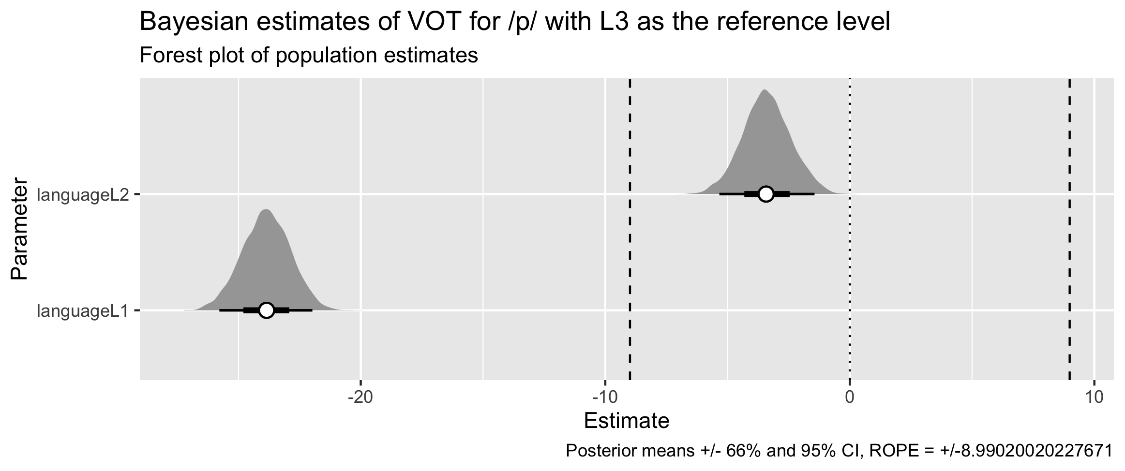

A nice image.

**Figure 1: An example of a Bayesian Regression visualization using simulated data** 

**Figure 2: Shadowing Task Example** 