Tables and plots

Table 1: Descriptive Relative VOT for /k/ per language

|  |  |  |  |
| --- | --- | --- | --- |
| Language | Segment | Relative VOT | SD |
| english | k | 0.160 | 0.055 |
| french | k | 0.148 | 0.055 |
| spanish | k | 0.086 | 0.034 |

Table 2: Descriptive Relative VOT for /t/ per language

|  |  |  |  |
| --- | --- | --- | --- |
| Language | Segment | Relative VOT | SD |
| english | t | 0.134 | 0.046 |
| french | t | 0.078 | 0.053 |
| spanish | t | 0.046 | 0.021 |

Table 3: Descriptive Relative VOT for /p/ per language

|  |  |  |  |
| --- | --- | --- | --- |
| Language | Segment | Relative VOT | SD |
| english | p | 0.109 | 0.058 |
| french | p | 0.063 | 0.042 |
| spanish | p | 0.041 | 0.022 |

Table 4: Descriptive pooled Relative VOT per language

|  |  |  |
| --- | --- | --- |
| Language | Relative VOT | SD |
| english | 0.134 | 0.057 |
| french | 0.090 | 0.060 |
| spanish | 0.058 | 0.033 |

Table 5: Linear Regression of the full data set

relative vot z

Predictors

Estimates

CI

p

(Intercept)

1.21

0.92 – 1.51

<0.001

language [french]

-0.66

-0.96 – -0.36

<0.001

language [spanish]

-1.27

-1.56 – -0.97

<0.001

text [p]

-0.95

-1.25 – -0.65

<0.001

text [t]

-0.69

-0.99 – -0.39

<0.001

Random Effects

σ2

0.35

τ00 participant

0.14

τ00 word

0.09

ICC

0.39

N participant

39

N word

26

Observations

949

Marginal R2 / Conditional R2

0.424 / 0.650

Table 6: L2 subset Descriptive pooled Relative VOT per language

|  |  |  |
| --- | --- | --- |
| Language | Relative VOT | SD |
| english | 0.130 | 0.056 |
| french | 0.106 | 0.064 |
| spanish | 0.059 | 0.034 |

relative vot z

Predictors

Estimates

CI

p

(Intercept)

1.14

0.81 – 1.48

<0.001

language [french]

-0.34

-0.67 – -0.02

0.038

language [spanish]

-1.19

-1.50 – -0.87

<0.001

text [p]

-0.96

-1.28 – -0.63

<0.001

text [t]

-0.68

-1.01 – -0.36

<0.001

Random Effects

σ2

0.35

τ00 word

0.10

τ00 participant

0.17

ICC

0.43

N participant

23

N word

26

Observations

561

Marginal R2 / Conditional R2

0.398 / 0.659

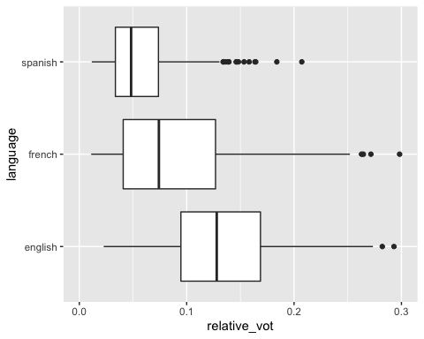

fig.cap = “Life expectancy from 1952 - 2007 for Australia. Life expentancy increases steadily except from 1962 to 1969. We can safely say that our life expectancy is higher than it has ever been!”} library(ggplot2) library(dplyr)

gapminder %>% filter(country == “Australia”) %>% ggplot(aes(x = lifeExp, y = year)) + geom_point()

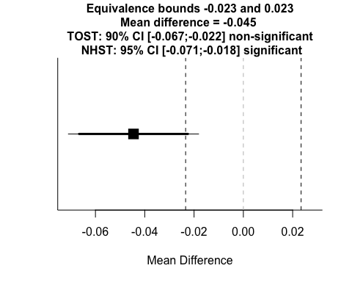

## TOST results:  
## t-value lower bound: -1.60 p-value lower bound: 0.943  
## t-value upper bound: -5.13 p-value upper bound: 0.000001  
## degrees of freedom : 75.72  
##   
## Equivalence bounds (Cohen's d):  
## low eqbound: -0.4   
## high eqbound: 0.4  
##   
## Equivalence bounds (raw scores):  
## low eqbound: -0.0234   
## high eqbound: 0.0234  
##   
## TOST confidence interval:  
## lower bound 90% CI: -0.067  
## upper bound 90% CI: -0.022  
##   
## NHST confidence interval:  
## lower bound 95% CI: -0.071  
## upper bound 95% CI: -0.018  
##   
## Equivalence Test Result:  
## The equivalence test was non-significant, t(75.72) = -1.595, p = 0.943, given equivalence bounds of -0.0234 and 0.0234 (on a raw scale) and an alpha of 0.05.  
## Null Hypothesis Test Result:  
## The null hypothesis test was significant, t(75.72) = -3.361, p = 0.00122, given an alpha of 0.05.  
## Based on the equivalence test and the null-hypothesis test combined, we can conclude that the observed effect is statistically different from zero and statistically not equivalent to zero.

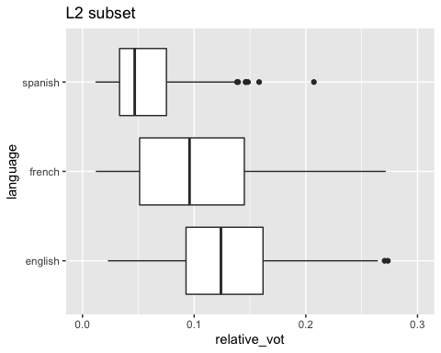

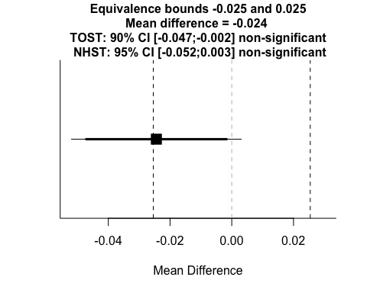

## TOST results:  
## t-value lower bound: 0.0754 p-value lower bound: 0.470  
## t-value upper bound: -3.76 p-value upper bound: 0.0005  
## degrees of freedom : 22  
##   
## Equivalence bounds (Cohen's dz):  
## low eqbound: -0.4   
## high eqbound: 0.4  
##   
## Equivalence bounds (raw scores):  
## low eqbound: -0.0254   
## high eqbound: 0.0254  
##   
## TOST confidence interval:  
## lower bound 90% CI: -0.047  
## upper bound 90% CI: -0.002  
##   
## NHST confidence interval:  
## lower bound 95% CI: -0.052  
## upper bound 95% CI: 0.003  
##   
## Equivalence Test Result:  
## The equivalence test was non-significant, t(22) = 0.0754, p = 0.470, given equivalence bounds of -0.0254 and 0.0254 (on a raw scale) and an alpha of 0.05.  
## Null Hypothesis Test Result:  
## The null hypothesis test was non-significant, t(22) = -1.843, p = 0.0788, given an alpha of 0.05.  
## Based on the equivalence test and the null-hypothesis test combined, we can conclude that the observed effect is statistically not different from zero and statistically not equivalent to zero.

### L1 subset model

|  |  |  |
| --- | --- | --- |
| Language | Relative VOT | SD |
| english | 0.140 | 0.058 |
| french | 0.066 | 0.046 |
| spanish | 0.057 | 0.032 |

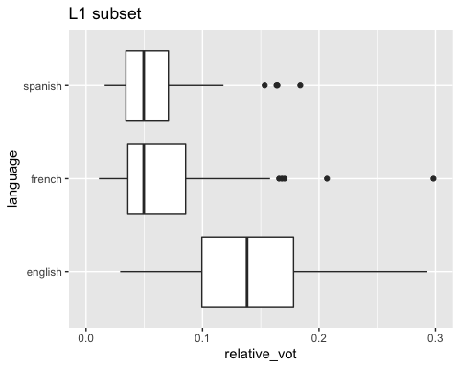

relative vot z

Predictors

Estimates

CI

p

(Intercept)

1.31

0.96 – 1.66

<0.001

language [french]

-1.13

-1.43 – -0.82

<0.001

language [spanish]

-1.39

-1.71 – -1.07

<0.001

text [p]

-0.94

-1.23 – -0.65

<0.001

text [t]

-0.70

-0.99 – -0.41

<0.001

Random Effects

σ2

0.28

τ00 word

0.07

τ00 participant

0.23

τ11 participant.languagefrench

0.04

τ11 participant.languagespanish

0.10

ρ01 participant.languagefrench

-1.00

ρ01 participant.languagespanish

-1.00

N participant

16

N word

26

Observations

388

Marginal R2 / Conditional R2

0.657 / NA

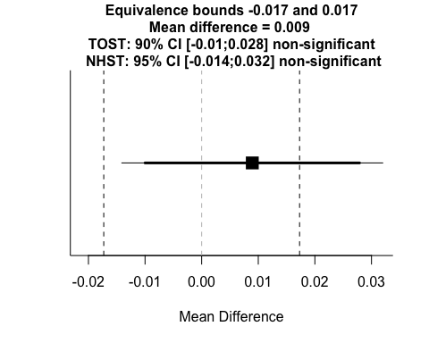

## TOST results:  
## t-value lower bound: 2.43 p-value lower bound: 0.014  
## t-value upper bound: -0.773 p-value upper bound: 0.226  
## degrees of freedom : 15  
##   
## Equivalence bounds (Cohen's dz):  
## low eqbound: -0.4   
## high eqbound: 0.4  
##   
## Equivalence bounds (raw scores):  
## low eqbound: -0.0173   
## high eqbound: 0.0173  
##   
## TOST confidence interval:  
## lower bound 90% CI: -0.01  
## upper bound 90% CI: 0.028  
##   
## NHST confidence interval:  
## lower bound 95% CI: -0.014  
## upper bound 95% CI: 0.032  
##   
## Equivalence Test Result:  
## The equivalence test was non-significant, t(15) = -0.773, p = 0.226, given equivalence bounds of -0.0173 and 0.0173 (on a raw scale) and an alpha of 0.05.  
## Null Hypothesis Test Result:  
## The null hypothesis test was non-significant, t(15) = 0.827, p = 0.421, given an alpha of 0.05.  
## Based on the equivalence test and the null-hypothesis test combined, we can conclude that the observed effect is statistically not different from zero and statistically not equivalent to zero.