The Beginning (1)

“As you step over yet another crumbling rock that’s barely binding this decrepit bridge upright, you take a moment to peer over the side. You see a blazing fury of orange and red lava, the thick glow seems in a rage, just gasping for its next victim. Pacing slowly forward you absorb your surroundings, the sombre grey clouds that have carpeted the sky since forever are finally beginning crack, allowing spectacular rays of sunshine to shoot through. There’s a pillar at the far end, but why do you notice it? Its no different from the hundreds of other pillars this journey has served up to you and there presence has become second nature, so why now? You put it out your head this is illogical you have mission, and time is diminishing fast. You carry on pacing, a slow assured step, hoping the bridge doesn’t give in to the inevitable. The depth of bridge is not vast there’s a clearing at the end, where a grand area thriving with grass resides, the middle of the almost mirage like setting plays host to a platform, you cant quite make out the what the platform conveys to, but you’ve never really worried about thinking that far ahead so why bother now.

Tick-tock Tick-tock, you carry on stepping through, the only wary feeling you have about this mundane task, is the very modest skills it requires to complete. You make your way to the clearing. What’s the deal, the platform leads to nothing, you’re confused but assured, this is not the first dead end your journey has levied. There’s a screeching behind you, this is it.

It’s the pillar that first caught your attention when you entered this murky landscape, your senses have served you well. The impressive stone is hurled up from its roots sailing effortlessly into the awaiting lava. You notice a second object floating towards the empty platform it lands elegantly and there stands the reason you entered this quest. Finally you’re face to face with enemy. Its eyes blood red, breathing heavily you feel its powerful presence its not human not even close, but you know it’s a warrior, you can almost see the fowl green gasses flowing out its body, you can certainly smell them. The face demonic glaring down at you it has a powerful stance, ready for battle. Every foe you have seamlessly devoured, the giant spiders the pacey lizards with a thirst for blood, the floating skulls itching to bite your face off and many others have led to this defining moment. The environment is just as fitting, the lurky clouds have dipped and broken rigorously there’s is a fine red sky that makes its presence known through the gaps, the walls surround the clearing are dominant, huge they leer over almost watching in anticipation. You grasp your sword, the gleaming silver never looked so spectacular, and leap.

For the next few minutes you are no longer John Allen, assistant shop salesmen on minimal wage struggling to make ends meet through your higher education, that person is buried deep into the subconscious. Normally all logical parts of your mind would be screaming reasons why this scene could never actually happen, but that part is no where to be seen, its taken a back seat, all your resources are being pumped into the fourth coming battle with this magnificent beast. This was your chosen battle and now its time to fight.”
-scene developed by Kunal Patel

The reason I was able to describe the detailed scenes in the preceding chapter is due to the rapid advances the game industry has made. Today we can expect deep engaging storylines and music put together by the most respected Hollywood producers. Combine this with image generation that only a few years prior were only available on the highest of high-end UNIX workstations and you have a pretty solid formula for elevating a market that today financially exceeds both the movie and music industry.

Games offer the ability that no other form of entertainment can, the ability to interact, to be the central entity of the action as it unfolds. You’re no longer watching your favourite super hero blowing up buildings and taking names, you are the superhero.

30 Years of Video Games (1.1)

Of course things were not always this spectacular, it all started with vector graphics some 30 years ago. Purely 2D (two dimensional) the only form of images were combination of lines (vectors) to create a scene. As you can imagine the games created with this technology were very modest indeed, but it wasn’t long before things advanced.

Next came sprite based rendering. This time round it was possible to load images into chunks of memory, this created a cell very similar to a frame of animation in a cartoon, it represented a character or object at one particular point in its animation sequence. By loading subsequent chunks of memory with the rest of the animation sequence they were able to flip between memory buffers and create the illusion of smooth character movement. These games were also strictly 2D. The Memory demand for this model was high but adequate for machines of their age. In 1987 ID software release wolfenstien the first ever 3D game, although not truly three-dimensional it used to the same sprite based technology to create the illusion of a partial virtual world. 4 years later in 1991 and from the same company came doom, and this game was to spawn a revolution in the graphics industry.

Doom was big, real big. Evan today it stands as one the highest selling games of all time. Still based on sprites (a strictly 2 dimensional entity) Doom used a technique known as ray casting to create a world which had shook off many of the rigours restrictions applied in wofenstien. Yet the problem was this technique was still a hack of how real 3D scenes are supposed to be created.

1995 ID software created quake. This marked the beginning of truly three-dimensional graphics, we were no longer dealing with sprites but abstract entities known as polygons. We had 6 degrees of freedom (the ability look all around you), characters had depth, and perspective was extremely convincing. Lighting was a lot more accurate than anything that had preceded it and played a huge role in creating the atmosphere the game is now legendry for.

BQ: Before Quake (1.2)

Prior to quake the algorithms used to create real-time computer graphics were all run on software, soon hardware vendors realised that the speciality of creating computer graphics could be levied off the CPU (central processing unit) and onto a separate processor whose sole purpose is executing the instructions of specialised 3D graphics algorithms, the graphics processing unit (GPU). This parallel architecture gave a huge speed boost, which in turn led to the ability to produce 3D worlds in real-time.
That’s the way things stayed up until early 2000. Inevitably the hardware got faster, the algorithms got more refined which led too much more complex worlds and all round bigger games. But the underlying concepts were the same, we were still dealing with the model known as the graphics pipeline.

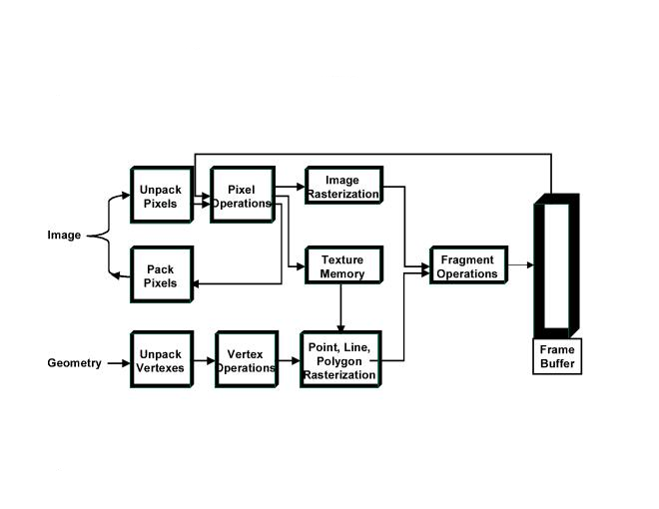Fig 1.0
A pipeline is a series of steps performed in parallel and operating in a fixed order(1). Each stage receives as input the output that was produced by the pipelines previous stage. A common analogy would be the assembly line in an automobile factory.

(1)Ahmed, S (2002) Lecture Notes, Kingston university

Figure 1.0 shows the graphics pipeline. The application code sends to the GPU a batch of vertices grouped commonly grouped into geometric primitives such as lines, polygons or points.

Every vertex has a position but also several other properties such as texture coordinates, colour, depth value and usually a normal vector.

Graphics pipeline stages:

Stage 1 Vertex transforms:

Vertex transforms are usually the first operation performed in the graphics pipeline and usually consist of a series of mathematical operations on every vertex. The operations include transforming the vertex into screen space for use by the rasterizer, producing texture coordinates, and applying light calculations to determine its final colour.

Stage 2 Primitive Assembly and Rasterization:

The now transformed vertices enter a second stage known as Assembly and Rasterization. The First part (primitive assembly) takes individual vertices and groups them into geometric primitives, the type of primitive they produced is based on secondary information that is passed to the pipeline along with the raw vertex data. The process results to a group a triangles, lines or points, which now have to be clipped to the view frustum (the scenes visible 3D space). Some primitives may be discarded based on whether they face backwards or forwards, this process is known as clipping.

Polygons that pass clipping and culling steps must be rasterized, this is the process of determining the set of pixels covered by each geometric primitive. The result of rasterization is a group of pixel locations as well as a set of entities known as fragments.

A fragment is represented as a pixel on the screen monitor, however it is important to understand the difference between pixels and fragments.
Pixel is short for picture element. A pixel holds the contents of the frame buffer at a specified location (the frame buffer is simply an array of pixels that make up the display area) and also any additional information associated with the frame buffer such as colour and depth information. A fragment is the state required to potentially update a pixel. A fragment is like a “potential pixel”, various fragment tests (known as raster ops) are performed, if the fragment passes these tests, the pixel is updated.

Interpolation and texturing:

Once a primitive has been rasterized into a group of fragments the Interpolation and texturing stage occurs. A series of math and texturing operations are performed that determine the final colour for each fragment. The operations may update the fragments depth value or even discard the fragment completely based on the tests. The result of this stage is zero or more updated fragments ready for the next stage, raster operations.

Raster Ops

The raster operations handle the final set of per fragment operations just before the final update to the frame buffer. During this phase the depth value for each fragment are tested to remove hidden surfaces. Other effects such as blending also occur here.

The raster operations stage processes each fragment based on a number of tests, these tests include scissor, alpha, stencil and depth tests. Explanation of these tests is beyond the scope of this document but each test results in either having the colour value for the pixel being updated, an associated value (such as depth, or stencil) being updated or the fragment being discarded.

Finally the frame buffer is written to and the scene is updated.

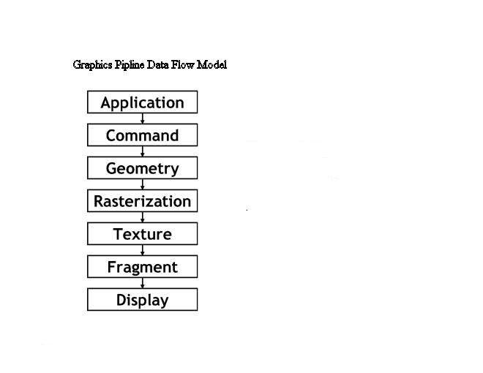

The performance obtained by employing dedicated graphics hardware to execute the brute force tasks of transforming vertices, rasterising triangles and updating pixels greatly exceeded the performance possible with just the CPU programming, but graphics programmers gave up a considerable amount of control in exchange for this boost in speed. Developers were now limited to using a fixed function palette of graphics operations that the hardware could handle.

While the specialisation of pixel pushing hardware continued, the offline rendering community were making leaps and bounds in creating amazing computer generated special effects. The pre-recorded nature of these applications (offline) allowed scenes to be generated in days, weeks or even months, using general purpose CPUs to realise the effects. The advantage of using general purpose processors (CPU’s) rather than settling for the hardwired algorithms the real time graphics community were exploiting (GPU’s) was that they were able to create any kind of effect imaginable, without any restraint on the speed the effects took to complete.
The real time graphics programmers were giving up the flexibility and generality of offline rendering systems for speed, the essence of real time graphics. These were the key features graphics hardware had been missing, we had lost programmability

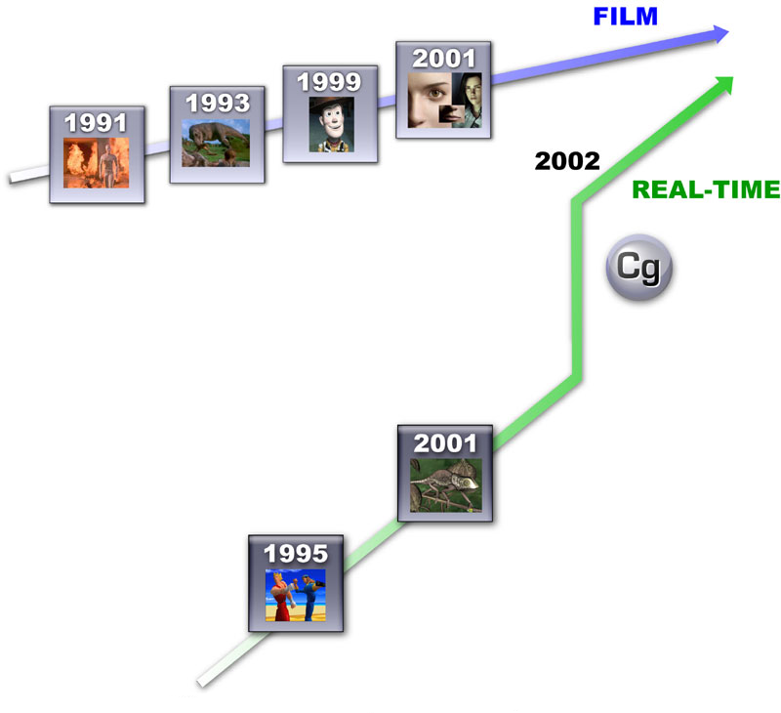(2)

The figure documents how far behind the real-time community is up until the programmable pipeline.

(2) [www.nvidia.com/progrsammableshaders.asp] [2002]

TAKING THE POWER BACK: AN INTRODUCTION TO THE PROGRAMMBLE PIPLENE (1.3)

Realising the limitations of the fixed function pipeline, computer graphics architects have designed the next generation of graphics hardware that permits an unparallel level of programmability. Now many of the shading techniques that had been employed so successfully in the offline rendering community are now entering the world of real time computer graphics.

The modern concept driving graphics hardware design today is the ability to expose more programmability in the GPU. As Figure 1.xxx shows the new stages of the programmable graphics pipeline.

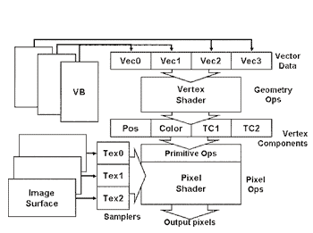

The figure shows each programmable unit, the vertex and fragment units. The vertex unit is the part of the graphics processor that exposes instructions for processing vertices. These instructions are predominantly mathematical for executing the vector (for 2,3 and 4 component vectors) and matrix operations that are the foundation of the geometric assembly.

The vertex unit begins by loading in vertices attributes. These attributes include position, colour, texture coordinates etc. The processor has an output register for every attribute a vertex has. The vertex unit then continually fetches and executes instructions and writes to these various registers as well as utilising temporary registers to hold intermediate results. These instructions are the heart of the pipeline. They allow vertex attributes to be set programmibly rather than through the fixed function pipeline previously. The assembled vertices are then passed to the next stage in the pipeline, the fragment processor

The fragment processor:

The fragment processor uses many of the same mathematical instructions the vector unit used but they also include texture operations.

Developing For The Model (1.4)

Early development on the new type of hardware occurred purely in assembly language, the programs were confined to 128 instructions and just as with anything written in a very low level language, the code was difficult to maintain and debug.
In 2001 the graphics hardware company nVidia released a new shading language entitled Cg (C for graphics), it was a natural evolution of GPU programming (very much like CPU programming where early programs were written solely in assembly).
This new abstraction entitled programmers to express their ideas and techniques at a higher lever, which meant the programs were easier to writ, debug and maintain. The Cg compiler takes code written in Cg and outputs GPU assembly based on the type of hardware profile it’s working on.
Microsoft soon woke up and took note, they were not about to let nVidia claim the lions share in the shading community (evan though the two companies collaborated in the production of Cg) bundled with the release of directX 9.0 came HLSL (the high level shading language). HLSL does the same job as Cg, it’s a simplified programming language for interfacing with the new generations of GPU’s however whilst Cg remains API independent HLSL is propriety to directX.

Impact of Shading Languages (1.5):

Having just recently had the chance of experimenting with the new shading language I can convey my personnel thoughts and insights into the new technology.
Whilst I did find the ability to split my program into functions mildly useful, this wasn’t enough to convince me, since there weren’t many practical uses for it. Most hardware can still only support programs that are 128 instructions long; GPU programs have to be small by necessity. We have to keep in mind that the code will be run for every vertex you supply, having large shading code will bring your application to a Holt very quickly. My major conclusion on these languages is that they don’t really offer anything that’s is truly ‘higher level’, mostly all instructions in Cg map directly, 1:1, with a corresponding instruction in assembly; E.G

X = dot(y,z) //Cg code for calculating a dot product
And
dot x,y,z ; ASM version of the same instruction

Practically speaking not a lot has been gained.

But I am still optimistic, there’s still a future for high level shading languages. The only problem is at the moment graphics hardware does not have the power to run large shader programs and so the ability to abstract relatively small bits of code is very limited in its practical uses. But as hardware continues to evolve this ability will certainly take more precedence and will undoubtedly become a more central tool in real time shading.

The figure shows one major advantage in using CG, its not API specific. This means you can use your shader code regardless of what underlying API you use for your engine.

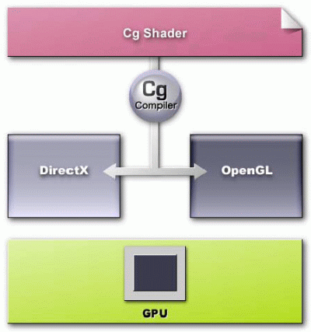

(3)

Microsoft Vs SGI; A TALE OF 2 APIs (1.6)

All the graphics hardware in the world doesn’t mean anything unless there’s a way to interface with the chips, of course GPU interface is not limited to just graphics cards, all hardware needs to be communicated with. The mechanism used to solve this problem is in the form of Application Programming Interfaces (APIs) and is not limited to communicating with hardware i.e. software can also export APIs.

(3) [www.nvidia.com/progrsammableshaders.asp] [2002]

Pre 1995 things were very unorganised. Many 3D workstation users were using the OpenGL API, while others were using 3DFXs propriety API Glide still others were developing their own. This led to a hugely fragmented market. Developers needed to account for all hardware and the API it supported. This meant an OpenGL application needed to be re-written to work on a 3DFX card. What made matters worse was the fact that other gaming hardware devices such as sound cards had almost no standard set of APIs at all. Thus a game would have to completely re write its sound routines for every soundcard they wished to support, or purchase 3rd party libraries which usually licensed for thousands of pounds.

What was needed was a standard specification for all hardware vendors to adhere to. That way developers would be safe in knowledge that writing an application that used the standard would be run on all hardware regardless of manufacturer.

After the huge success of doom, Microsoft releasing the potential in the games industry released its own API for the windows platform, directX (having acquired the technology from a company they purchased, RenderMorphocis). Early versions of the API was not the best thing since sliced bread the Microsoft marketing people would have liked you to believe. But by the time Windows 95 was released directX was up to version 5 and was very solid indeed, it soon became a hardware standard. DirectX elevated the fragmentation in the games industry. DirectX was actually a set of multimedia APIs for supporting all types of gaming hardware, including sound, control and networking devices. Microsofts’ power in the operating systems market meant that all hardware manufacturers pretty much had to support directX if their product was to run in the windows environment.

At this stage the Microsoft family of APIs are the standard for sound (DX music), network (DX play) and control (DX Input) devices in the PC gaming industry. However in the graphics market the Microsoft API (DX graphics) is yet to shake off one major player, OpenGL.

Developed at SGI labs, OpenGL has the longest standing history of all the APIs and is still the dominant API in the offline rendering community (CGI films such as Jurassic Park, Shrek, Monsters Inc. are just a handful of modern movies that use OpenGL as there renderer.). Combine this with the simplistic structured architecture and cross platform abilities and its safe to say that openGL is going anywhere anytime soon.

Today DirectX Graphics is up to version 9.1, whilst the new revision of OpenGL (2.0) is still in the specification stage. There’s not a lot between them, both essentially do the same thing. From a technical stand point a lot of people point out (myself included )that OpenGL’s structured architecture as apposed to DXs COM methodology makes it a simpler API to use and although initialising DX is a little more evolved, the bulk of the API is just as easy. In the end it’s really a personnel decision about which one is used.

The Bison Game Engine (2.0)

Raw Data: (2.0.1)

As described in the product document an engine is responsible for taking a games raw data and process it for real time execution, but where do these raw data files come from? At a professional development studio this task would be offloaded onto specialist teams who’s job would be the creation of these files. A sound team would compose and record music, an art team would create texture files, a design team would develop game worlds. It is the job of the programmer to then create the application that uses these raw files to create a game, in essence they provide the ‘glue’ binding the work of other departments together.

Bison Data. (2.0.2)

Unfortunately I am not in a position to employ a team of artists, musicians or level designers to create data for my project. There’s an easy solution however, use a pre existing games data, then build an engine using the data as the foundation for the project.

Choosing to target a game for this form of ‘reverse engineering’ boiled down to a simple question, “how much information about file formats is available?”
For example, if the game uses MP3 files for its sound representation, then to use them
in an engine one must know the file format in order to load them in programmably.

Researching how much information is available for what game I found two games that had enough information for me to base my project around them, the quake series and Half Life. Booth games had adequate information between them for an engine to be developed.

I choose quake 3. Not for any technical reason, both had published file specs on their site, and both had a large development community behind them. When reading about the games creator , John Carmack I learnt he had started off his career with projects a lot like Bison. He had taken a Nintendo game(Super Mario bros) and used it as the basis for his own game engines. Learning from this he went on to create to Doom, one of the biggest selling games of all time. I felt it fitting following the footsteps of someone who is at the top of the field.

Game On (2.0.3)

Now that I had a source of data for my project, the next phase was the design of the bison engine.

33 is a magic number (3)

Designing any particular part of the engine, I have to keep one thing constantly in my mind, speed.

I’m typing this document in word. Word like most applications is event based. You open it up and it’ll sit there waiting for you to press something. Once you press a key an event is triggered which leads to that character being put on the screen. Games on the hand are real-time applications. Something is always happening, behind the scene process are continuously occurring in loop.

Just Like an animation sequence games are composed of individual frames, by continually updating the frames with an image that is slightly altered from the pervious we can trick our eyes into believing it is occurring in one continuous motion. In an animation sequence every frame is pre rendered. i.e. every image has been completed before the whole sequence is shown. Then the images are flicked through and the animation begins until the image sequence is over. With games each frame is composed on the fly, through the engine. A frame is built by collecting and processing a myriad of input parameters, such as user input, character AI, Game physics etc. For example, if you pressed the fire button on your joystick, the games next frame would be built of the beginning of the fire sequence leaving your pistol then continually updated by applying a physics formula to the bullet you just fired and finally the explosion it will create,.

Figure 1.1 Animation sequence is pre rendered


Next frame known

Figure 1.2 Real time: Sequence Calculated

Engine Code

The rate at which individual frames are updated is what determines the quality of the illusion. Games don’t have the luxury of knowing what the next frame will look like so the rate at which it is able to process all input that forms the next frame must be fast. More precisely, a game must be able maintain a frame rate of no lower than 33 frames per second(fps). For it is at this rate that the switching between frames is no longer noticed and our eyes are tricked into believing smooth motion is occurring.
TVs refresh at 25fps but use a special type of blending, (they blend the result of the previous frame with part of the new frame) graphics hardware is able to replicate this model, but are not optimised for it and thus it eats to many cycles to be considered a viable method. Game Engines completely wipe out the image buffer and start every frame from a blank canvas.

Engines must be designed around the notion that whatever it sends to the graphics hardware must be the absolute minimum data needed to complete a frame. If your graphics card is ,for example, busy drawing a chair that will eventually be drawn over by some other object that is obscuring it and thus never seen, you have wasted time and resources on redundant processing. Muda has occurred.

Muda is a Japanese word used in car manufacturing, it stands for wasting resources. Toyota became the fist company to streamline there production line for more than one vehicle, It is commonly used in the industry to identify places where an assembly line is failing.

Game World Issues (3.1)

Game Worlds should be big. You should have a vast playing arena for the player to explore, no one wants to kill enemies in the same room over and over. Creating huge arenas is a trivial task, however given the vast amount of data how do you apply your fundamental design strategy to only draw what you see when walking through the level?. Remember rendering levels is only part of the frame, characters, special effects, AI, Sound etc all have to processed and delivered within the 33fps window.

The method here is two fold. The first part is visibility determination i.e. how do you know which part of the scene to draw at all. Consider drawing 1.4 if the sphere is drawn before the wall, than the wall would appear to be in front of the sphere as in figure 1.5. obviously this is incorrect, painter(painters algorithm) first deduced the method that all polygons in a scene should be rendered back to front if correct rendering is to occur.

 1.4 the sphere is in front of the wall

 1.5 if the sphere is drawn before the wall it is overwritten

The second part to designing a strategy for efficient level rendering is disregarding as many polygons when drawing a scene

This is done using portals and will be described in section 2.1

The next section describes a method for implanting the painters algorithm using BSP trees.

Introduction to Binary Space Partition trees(BSP) (3.2)

BSP trees are a relatively simple data structure that subdivides a given space in order to isolate certain features of interest. A given node of a bsp tree splits a volume into two parts along a line or plane; hence the term ‘Binary Space Partition’. This sub division occurs in a hierarchical fashion. The root node splits the world into two subspaces, the two children node then divide one of the two subspaces into two or more subspaces. This division of subspaces continues until each entity of interest (line segment or polygon) has been assigned its own unique space.

Deriving BSP trees (3.2.1)

The following example is 2D, note that the same principles apply for 3D worlds.

Figure 1.5 shows for lines that constitute walls in a virtual world. Each wall has a front face this is denoted by the normal( a perpendicular vector.) and a back face. As explained above a BSP tree is constructed by subdividing the space into two, then each resulting subspace into two and continuing until each wall resides in its own unique subspace.

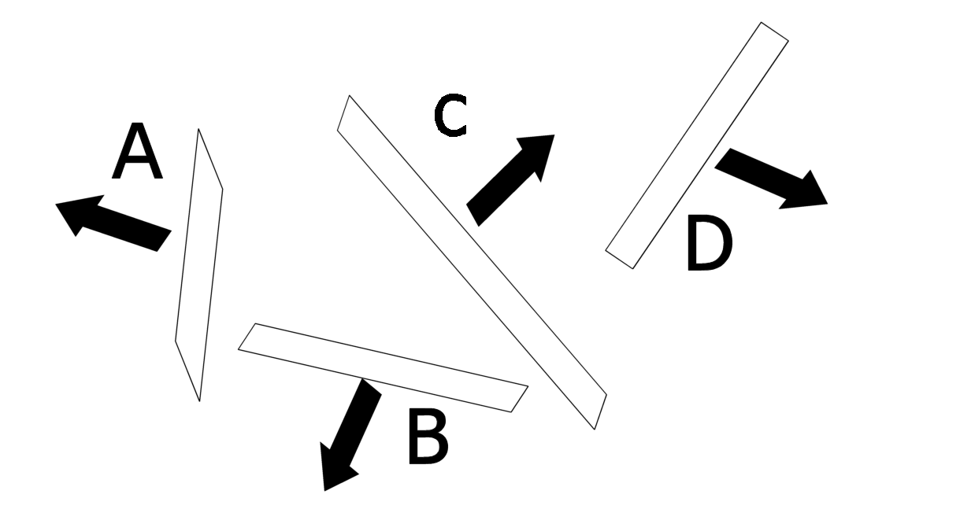 Fig 1.5 four walls viewed from above.

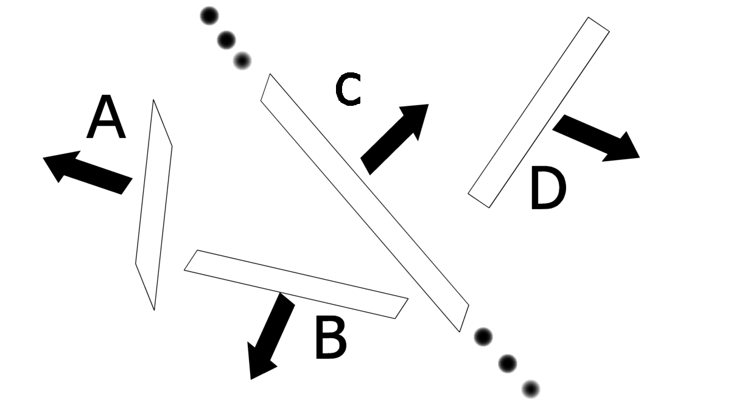 Fig 1.6 First split along wall C.

CC

front back child
child

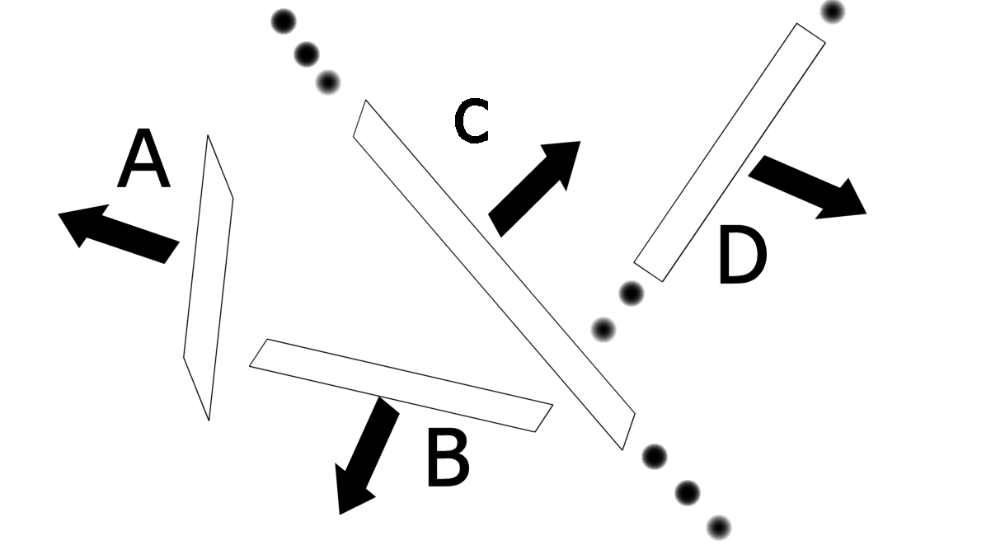 fig 1.7 C’s front subspace now splits D

C

front child back child

D

There are many ways to do this sub division but the simplest way is to simply cut along the walls themselves. The creation of the BSP trees is a recursive process, figure1.6 shows the world being cut along wall C. The world now resides in two subspaces, walls that are behind wall C and those that are in front of wall C. Next we split along wall D, D is the only wall that exists in this subspace(remember we created two subspaces when we split along C) and so that’s everything taken care of for wall C. We now move onto the back of C, lets start by splitting B. this time we hit a glitch. Extending B goes right through the middle of wall A. Where does ‘A’ belong, the front of B’s subspace or at the back of B’s subspace? The answer is both. ‘A’ gets Split into two walls, 'A’ and E. each wall is assigned to its own subspace. The BSP tree is now complete.

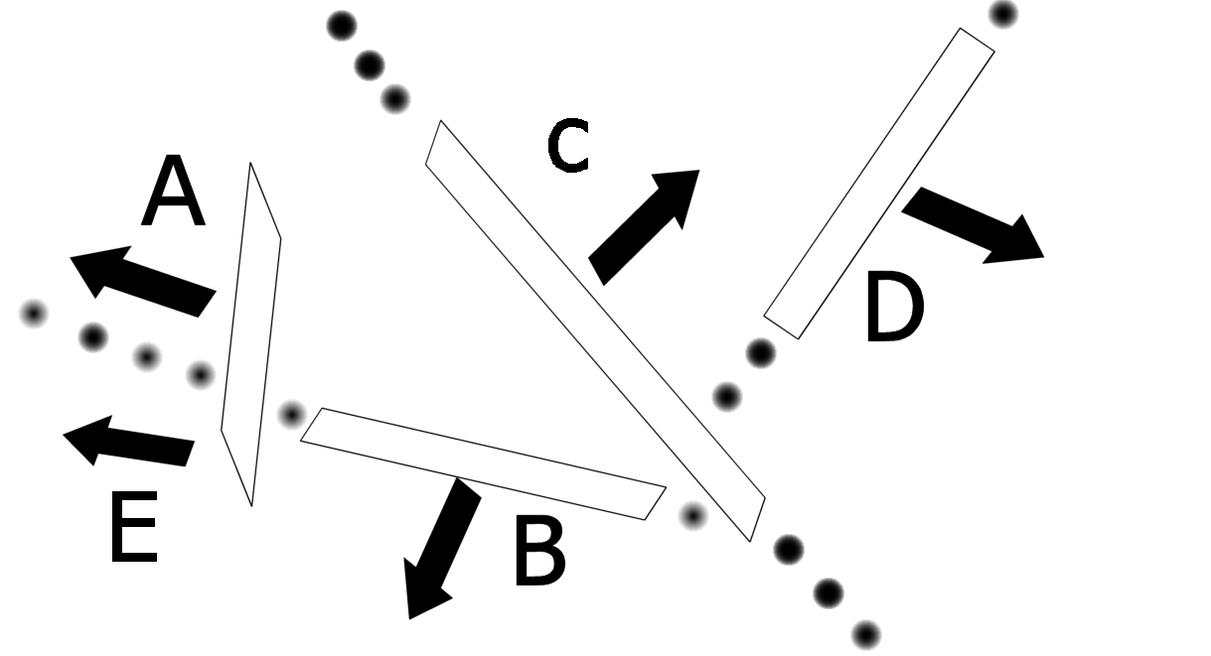
Fig 1.8 the final split along B

C

D

front child back child

B

front child back child

A

E

Lets return to our original problem, the implementation of the painters algorithm. Given a BSP tree we must visit each node recursively then decide if we are in front of or behind the node given our current view point

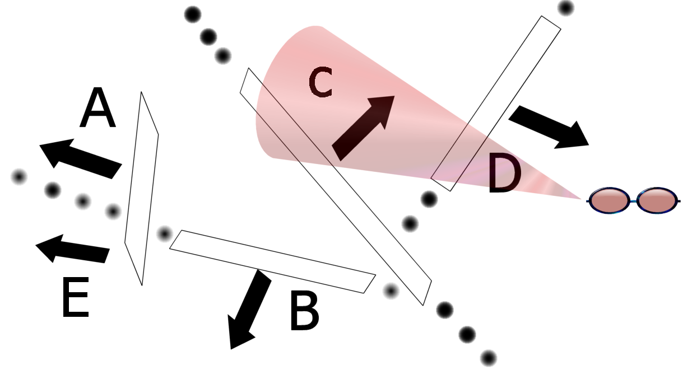

fig 1.9 Drawing the world in correct order, the cone represents our
line of sight.

If we start at our root node C then traverse down the back child, we end up at B, we then ask if there’s another back child, there is, we end up at E. we ask if there’s a back child available again, there’s not. So we render E. now we traverse back up to the node this time visiting all front child. We get back up to B and visit its front child and render E we move back up the tree and render B itself this leads us back to root. We then follow the some procedure but for front faces of C. in the end the complete world has been rendered in a back to front order.

FRONT (4) BACK

(5) (3)

C

D

B

A

E
(2) (1)

At the top of the chapter 1 i said that BSP trees was one of a two step model for efficient rendering of game worlds, now its time to discuss the second part of the strategy, Portals.

Reference: (chap 54)“the idea of bsp trees”, Abrash, M. Graphics Programming Black Book

First its important to understand why we need portals to supplement BSP rendering, consider the figure

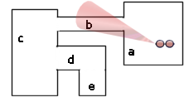 Fig 2.0 A sample world viewed
from above.

The coloured triangle represents what the viewer can see. She is standing in room A. currently are BSP system will render all inclusive polygons in rooms A through E. The trouble is rooms D and E can never be seen by the player in the current room, yet we have wasted valuable microseconds sending them to the graphics hardware for processing, ‘Muda!’.

In a small capacity like our example world this hit doesn’t make to much difference, but when the world grows to hundreds and then thousands of rooms this efficiency it will bring our application to a holt very quickly indeed.

Look again at figure 2.0 one thing comes to mind, rooms D and E can never be seen from room A no matter were you stand in the room.
We can use this information to create a database of room information prior to loading the game, then looking up this information up at run time. The Potential Visible Set(PVS) holds for each room, every other room that can potentially be seen. The PVS for room A contains B and C, at run time we can find these rooms then only consider them for rendering.

Drop it into 5th, Going further with optimisations(3.2.2)

So for we have a pretty efficient method for rendering worlds, but we can still go one step further, using a method known as frustum culling.

Refer again to figure 2.0 our user is looking away from all rooms only staring at 3 walls, our PVS will bring us rooms B-C-A for rendering, but many of the walls that make up our rooms cannot be seem, Muda!.

Bison solves this inefficiency by encapsulating each room into a conceptual bounding box, then testing this bounding box against our viewing frustum. This simple test prior to BSP rendering will fail for room C and hence these rooms will be disregarded. In the end the only entities sent to the renderer are the walls that make up Rooms A and B, Its not perfect(we’re only looking at 3 walls but rendering 6) but its close enough for real time rendering.

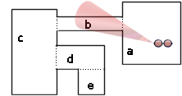The dashed lines represent how the rooms are split into boxes. these boxes are then compared out visible frustum (the red cone),if the box lies outside the frustum it is disregarded.

Refer To Appendix Chapter “Game Levels Source Listing” To View How the design strategy was implemented.

Bison Scripting System(4)

The scripting system is composed of three layers. The front end layer exposes the main language BisonC. This is them main interface game designers use to communicate with the engine. Designing this language is vital if the scripting system is to be a valuable tool in the engine model, to simple and it will not give enough flexibility to be used to implement anything useful, to powerful or complex and the designer will be baffled. More time could be spent teaching them how to use it than if you took the alternate approach and simply hard coded the script into the game.

The fist part of the model reduces BisonC into BisonASM. This phase mimics real world programs which are decomposed into processor dependent machine code (x86 in the case of Pentium class processors). The design of this language is very open ended. The language wont be run on a hardware processor but be interpreted at run time and as such I am is free to design this language syntax in any form i desire.

The final executable which is then run on the engines runtime environment, the Bison Virtual Machine. A runtime environment is a piece of software designed to run the execution of some other piece of data or software- in our case executable machine code. Run time environments come in many flavours examples include, Apache Web Servers that can be expanded with runtime environments for many web scripting languages such as PHP or Perl. Even Microsoft Word has an embedded runtime environment for its own scripting system based on BASIC, WordBASIC.
The common trend among these examples is without using a physical processor these programs are capable of executing code in the form of scripts and providing them with necessary memory address spaces and other such facilities. This is what the Bison Virtual Machine will do.

. This Virtual Machine will be embedded into the engine, its task is to execute script. If your engine code is written in C and your script code is written in BisonC their must be a middle layer that is able to translate between the two language if effective communication is to occur. For example if you had a business meeting with a Japanese Analyst but did not know the language an interpreter would usually be required. You would communicate with the interpreter in English and he would convey the message into Japanese and vice versa. In essence the virtual machine will be this interpreter capable of communicating with the engines raw data and the scripts logic.

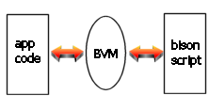

Designing BisonC (4.1)

A couple of issues effected the design of my scripting language

Choosing and existing Syntax. I had to base my script code around an already existing language. Inventing new syntax would not be viable in the time frame provided. I choose the C language for a couple of reasons. First and foremost it’s the one I was most comfortable with, I’ve been learning programming since the first year of university so I had most experience using this language. OOP languages like C++ or Java were ruled out simply because of the complexity OO compilers bring to the table. These compilers take many man years to make.

My personal ability to implement a language. This is my first attempt to do any form of language processing. So I had to choose features that I was fairly sure I could implement in the given time frame. I felt a strongly typed (i.e. one that worked on well defined data types such as int, floats chars, etc) was a good idea, however the implementation issues were vast, they added a lot of complexity to the compiler and as such I decided it was not viable, I decided to keep the language type less.

Keeping the language simple. If I were to implement every feature of the C programming language the whole reasoning behind having a scripting system would be void. As such it was important to only to pick out the absolute minimum features I feel are necessary, but also keeping enough flexibility so other features could be added if required.

BisonC features

- Type less
- Loops(while loops only)
- Expressions (if/else etc)
- Function Calling

Features Excluded Reason

- Heap based memory(e.g malloc) Adds to complexity of language
- Data Structures Unable to implement.
- Pointers Adds to complexity of language

Bison ASM Design issues (4.2)

The design considerations of this language were the same as the design issues with
BisonC. Again I decided to base my language around and all already existing syntax. I choose x86 assembly because I had most experience with it.

Instructions Supported English Translating

MOV MOVE
ADD,SUB, ADD,SUBTRACT
MUL,DIV MULTIPLY,DIVIDE
JMP JUMP
CMP COMPARE
JG(E),JL(E) JUMP IF GREATER/LESS THAN
CALL CALL
RET RETURN
PUSH
POP

Instructions Excluded

IMUL
SHL
SHR

Designing The VM (4.3)

My Strategy: A Hardware Mirror

I felt the best way to design an effective run time environment is to mimic a real world computer. The reason for this was that it automatically came with countless examples about what to base my design strategies around. Computer architecture has been evolving for decades, which means I can leverage the diligent work of thousands of engineers who have found out exactly what works and what doesn’t when implementing a computer system.

It didn’t seem necessary to go to all the trouble of re inventing an already tried and tested wheel, this would have been designing just for he sake of designing which is pointless.

The runtime environment will be a simplified implementation of a von Neumann based computer system. Just as real life computers stream compiled opcodes through its processor and maintains random memory access through its run time stack so to will my virtual machine. The only difference is that rather than being hardwired into the silicon components, I will write them through C/C++.

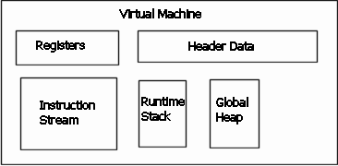
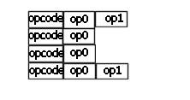

At the heart of the BVM is a simple loop that continuously reads and executes ASM instructions.

The Appendix section covers implementation issues for all 3layers of the scripting system.

Delving Knee Deep into Compiler Theory(5.0)

Im going to kick off my explanation of the scripting system by discussing the underlying concepts around both the Assembler and The bisonC compiler were built.
Namely lexing and parsing. These concepts apply to any form of compiler, the next chapter focuses in on issues that are specific to the flavour of the language being implemented.

Lexing and Parsing(5.1)

Consider the following ASM program

Func myMult
{
param x ; parameter x and y
param y
var sum ; variable to hold the final result

mov sum,x ; assign sum with the value of x
mul sum, y ; multiply sum by y, sum *=y;
}

To humans this short piece of code is relatively simple to understand. Computers however view the world in a much more simple fashion. As with most things silicon the process is handled in a series of smaller well defined steps.

The first phase involves breaking the source code into its constituent ‘words’. These words are known as lexemes. Much like humans string words together to form a sentence, lexers string together a sequence of lexemes in order to analyse source code.

Consider the following
mov x,5

The lexemes compromising this line are [mov] [x] [,] [5] by splitting the code into its very core elements we can present the code in a clean, clutter free fasion, this rids us of all ambiguity. If there’s one thing computers just will not stand for its ambiguity.

Your assembly program enters the assembler as a stream of characters, because raw source is represented as a character file. It passes through the first phase of the lexer and leaves as a stream of lexems.

mov x, 5 [mov] [x] [,] [5]

After the lexer isolates lexemes the lexer converts the stream into a token stream. Unlike lexemes tokens are not strings at all, rather they are simple codes (represented as integers, think primary key) that tell you exactly what a lexeme is. Just like the human language is made up of verbs, adjectives etc source code is described as a series of tokens.
Consider the example a the top of the chapter once more:

mov x,5

The token stream here would be

TOKEN LEXEME

TOKEN_TYPE_INSTRUCTION, mov
TOKEN_TYPE_IDENTIFIER, x
TOKEN_TYPE_COMMA, ,
TOKEN_TYPE_INTEGER 5

What we’ve done essentially is to abstract the source code further. We now have the ability to tell the compiler exactly what the source code is as a series of tokens. If the compiler were a human being than at this stage he would be able to know what the words I say to him mean. I can say ‘the sky is blue’, and each word of the sentence is comprehendible I couldn’t say ‘the egwv is blue’ because ‘egwv’ isn’t a word . If I say ‘blue the is sky’. again each word is valid, and so at this stage it appears to be a valid sentence to the compiler. But obviously this isn’t the case, it is for this reason that a further step is needed, parsing.

Parsing

The job of the parser is to piece together a series of tokens to validate the program. So the task of the lexer is to break the source into atomic entities, lexemes and convert them into tokens. Then the parser takes the stream of tokens and builds the program back up again into a far more structured view of the source code.

[mov] [x] [,] [5]

[TOKEN_ INSTR] [TOKEN_IDENT] [TOKEN_COMMA] [TOKEN_TYPE_INT]

The parser reconstructs the source as a series of tokens

The parser reads a group of tokens until it recognizes a pattern between them that indicates the overall goal of that particular token group. Based on the initial token type, the parser can predict what token should come next then compare that with the actual token in the stream.

Designing BisonC and ASM components(5.2)

The working functionality of the lexer and parser just screamed an object oriented approach. Both took an input and produced a certain output, both leant themselves well to the idea of real world ‘objects’. Both have slight variations of a single base concept. Hence I designed them to us a common base classes CParser Clexer, then specialised the classes through inheritance to form specialist classes for BisonC’s lexer and parser and Bison ASMs compiler and lexer.

Reference “Compiler Issues” , Varanese, A.Crafting a compiler with C

BisonC (6.0)

The job of the compiler is to turn high level code into low level assembly language. This document discusses how this is done.

Translating simple instructions with a fixed set of opcodes such as

mov var,3
is relatively simple compared to translating high level expressions such as

x= cos(y) * sin (x);

The heart of the compiler and the main difference between compiling assembly and C rolves around parsing expression. There are two primary methods for high level language parsers, top-down and bottom-up

Top-Down

Because of the recursive nature of parsing this method is also known as recursive decent parsing.

Recursive descent parsing is best described with an example, consider the following.

for (int i=0;i<MAX_LOOP; i++)

At first glance we know we are dealing with a loop. This is due to the keyword ‘for’. If the ‘for’ didn’t exist we wouldn’t know what we’re dealing with. After recognising the initial keyword we can build upon what the next set of tokens should be.
Recursive decent parsing works in a similar fashion. It reads an initial token then has a set path for every keyword that can possibly exist in a given program. This method is pretty rigid, in order to add a new keyword you have to hard code a given validation path.

As described a recursive decent parser has a given code path for every language feature, once the parser reaches the opening brace it know leaves parsing the loop keyword then switches to parsing expressions. Once the closing brace is fond it switches back to parsing the loop.

Bottom-Up parsing (6.0.1)

Bottom up parsers do not branch off to a specific parsing mechanism for a given token, rather it uses inductive reasoning to piece together a more refined picture of the source code.

Although more complex bottom up method is certainly a more flexible and efficient approach to parsing because it uses a single loop to parse the entire source file rather than branching off to specific method for specific circumstances. Rather parsing is handled through large procedurally generated lookup tables that helps detect patterns in the token stream.

Bottom-Up parsing is analogous to a state-machine methodology whilst top down is geared more towards a brute force approach(4)

Designing a Parsing strategy (6.0.2)

I decided to use top down parsing method for the BisonC compiler. The main reason was that it was relatively simpler than that of its counterpart- bottom up parsing. This would allow me to complete and test the approach in the given time frame.

The second main design strategy was whether to use single or multiple pass compiler
A pass is defined as a complete scan over the source code regardless of what information is collected . Single pass compilers are faster (because they only make one pass).Multi pass compilers are easier to work with because you can gather information about variables and functions before processing the instructions that use them

I decided to go with multi pass approach because it allowed future extensibility to be implemented easier. If I decided to add such features as macros or dll support in the future having all function and variable information before hand will makes things a lot simpler to implement. Another driving factor was that most modern compilers are built around the two pass method, it seemed to be the given consensus in the compiler writing community.

(4) “parsing techniques” , Varanese, A.Game Scripting Mastery

Bison Assembler (7)

How The Bison Assembler Works

At this stage we have a simple text file containing a program written in BisonASM

the Job of the assembler is as follows

- Reducing each instruction to its corresponding opcode.
- Convert all variable and array references into relative stack indices depending on the scope they reside in.
- Take note of each line label and replace it with the instruction index it references.
- Discard all human induced content such as comments or white spaces
- Writing out a structured binary executable file that is recognised by the BVM.

The heart of the assembly language: instructions(7.1)

An assembly program is composed of one to many instructions. An instruction has ageneric name that also maps to a number for that instruction opcode(think of the opcode as a primary key defining the instruction). For each opcode there is 0 to n operands. For example the MOV instruction takes two operands

Mov op1,op2

Each operand can take a variety of forms depending on what instruction it’s mapped two.

Op1 for example could be memory reference or variable e.g.

Mov myVar, op2

Op2 can assume any type from op1 but also absolute values such as strings or numbers, e.g.

Mov myVar, 5
Mov myVar, “hello world!”

Op1 can never assume any absolute values

Mov 5, “hello world” ; Error, this makes no sense!

From this example we derive a structure to hold instructions for Bison Assembly.

Mnemonic Opcode Number Operands Operand Types
‘Mov’ 1 2 Op1 bit vector, Op2 bit Vector
‘Add’ 2 2 Op1 bit vector, Op2 bit Vector
‘Push’ 3 1 Op1 bit Vector

Bit vectors are simple 32 bit integers(int) where each bit represents a particular type of operand(memory reference, register reference, absolute value). if the bit is set it means it’s a valid type for the operand.

Bit Operand Type

0 Memory Reference
0 Absolute Value
0 Floating Point Value
1 String Literal
0 Function Name

The only valid type for this operand would be a floating point value.

Sound & Input(8.0)

Before mainstreams multi media APIs such as directX hit the game programming world, I could probably dedicated the entire project to either one of these topics, simply because there wasn’t a consensus in the industry as two how to allow developers to access sound and device hardware. As such, special code would be required for every brand of sound card or every type of joystick on the market. This was a very ugly situation indeed.

Luckily we’ve come out of the dark ages, directX has made itself comfortable sitting in between the hardware and application code. As long as the hardware supports directX (and all windows hardware vendors have conformed to this) your application can be safe in the knowledge that the abstraction layer this model provides means you wont have to change a single line of code when using any particular type of hardware.

This phase of the project was enhanced in terms of speed and design by the fact that I had a very powerful API to work with. My job was to take the plethora of small but vital tasks it takes to setup the API to communicate with the hardware and wrap them up into a nice client class, thus simplifying for the client the use of these libraries.

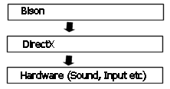

When visualising how to design the Music class I pictured the CD player in my room. What I had learnt was that unlike software engineers , hardware engineers had to expose the exact balance of interfaces if there product was to be deemed user friendly. To many buttons and a lot of users get confused and generally the product doesn’t sell, too few and the product wont have enough features to compete with the opposition. It was through circumstances like this that the hardware industry has become adept at perfect user interface, and it seemed logical to base my design decisions around there wealth of experience.

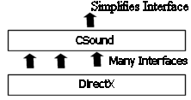

Actors and objects (9.0)

Every game today stores its objects and characters in some sort of 3D model file. Extensibility is added to the players experience by allowing users to add there own models for more customisable game play. This chapter focuses on who the files are processed by the bison engine.

Designing A Character Strategy(9.0.1)

Deciding what model file formats to support was once again down to how much information the suppliers had made publicly available. Luckily most developers understand that giving information to the software community is a good thing, Having an open format can only mean getting a wider audience for your product, remember we only interested in who to load a given file creating the file in the first place can still only be done with the original product. I decided not to support any file format completely out and out, instead I would convert file formats into my own pro priority structure. This design decision meant that the engine was always working with data in the same format (The Bison model format), what I could then do is write specific converters for every file format I wished to support.

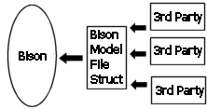
Bison Model Loading Architecture

This part of the document shows how I added file support to the MD2 file format used in the game quake2.

The animation methodology behind this format is that of key frames.

A key frame is like a picture or snap shot of any given moment much like the cell of a cartoon reel. Unlike a carton reel not every frame of animation is stored in the key frames rather snapshots are taken at specific intervals for the model, then the intermediate frames are calculated at run time.


calculate intermediate
frames

Say you have an animation of your arms to you sides at x0,y0,z0, and you want to animate your object so that the arms are out in front x1,y1,z1. The modeller creates only these two frames of animation, your job as the programmer would be to get the engine to calculate and render all arbitrary points between x0,y0,z0 and x1,y1,z1.

The idea behind key frame animation is to keep track of the two frames you’re interpolating and then calculate each vertex based on a function of time. Specifically

vi = interPolatePercentage * (vf - vi);

where
vi = initial keyframe vertex
vf = nextKeyframe vertex

interPolatePercentage would be the level of interpolation. I.e. 100 would mean the current vertex is completely at vf and hence the vf becomes the intial vertex(vi) the next vertex is requested(vf) and the process starts over.

Particle Systems(10.0)

Arguably the most effective system for creating special effects such as snow, rain magic spells fire, explosions, a particle system is a collection of a number individual atomic elements or particles. Each element has a number of attributes such as speed, colour, life span etc. Each particle acts in a mostly autonomous way – i.e. they don’t know or care what other particles are doing. A given range of attributes are shared amongst all particles so that even though each particle acts independently they all function to achieve a common effect. An easy way to visualise this is to think of a snow storm, even though each individual snow flake is autonomous to the rest of the snow all snowflakes combined work to form the effect.

Designing the Particle System(10.0.1)

Analysing the nature of particles we can see that they are mostly self contained hence they lend themselves well to an object oriented design. I drew up two main designs for the system and had to decide between them.

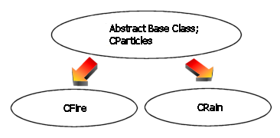Fig 1.
First Particle System architecture

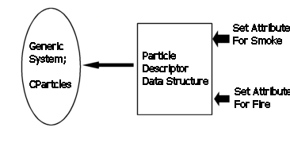Fig 2.
Second attempt create amore flexible system

The first evolved creating a generic base class then for each type of effect create a child from that base.

The second involved creating a single Particle System class. For each type of effect a special Particle Descriptor data structure can be given to the particle system class. The Particle System’s responsibility is to manage its particles e.g. memory allocation, updating of properties whilst the descriptor structure described the type of effect by setting particle attributes.

I felt the second method offered more in terms of flexibility ,efficiency and represented the problem in a more cleaner way. The Descriptor which contains only data can represent the effect in a generic way, and the Particle System can handle putting it on screen. The flexibility this method meant can be explained through an example

Lets say I want to create a fire effect. Using method 1 I would inherit from the base particle system and set properties for a fire effect, then call render to draw the effect.
Later in the game I have no need for fire and need to create a rain effect. I once again inherit from the base class and create a rain class and set the data attributes and again call render. There’s a flaw in the method here, the only thing that changed between the two effects was the data attributes the base class has, i didn’t need to specialize the class in anyway, yet this is the main principle behind inheritance. None of the methods changed either the same render routine can be called for both effects, yet i still derive a new Render method(although this can be avoided using virtual functions this however brings its own implementation issues such as bigger classes and a slight hit on efficiency (5)

Using OOP is viable when both methods and data change because this is the very essence of the paradigm , but in the example above only data changed hence it makes good sense to separate the two.

Returning to our example, if we wanted to change the effect we would simple delete the fire descriptor from memory, create a new rain descriptor and set our particle system to work with the new descriptor data structure.

(4) “item24: understand the costs of virtual functions” , Myers,S, More Effective C++

Review and Conclusion(11.0)

“If I have seen further it was by standing on the shoulders of giants”
-Sir Albert Einstein

So there you have it, 63 files, 120,000 lines of code and some 50 odd pages of documentation, so the only remaining question is, what have I learnt?

The right Project? (11.1)

Before I begin to analyse the project now its complete, I must first take a step back and decide whether the theme of the project was correct in the given context of our design course.

Mid June 2002, Mary Thomson visits me at my industrial placement. My project was to design and implement a management information system for a soft skills training company. Now the whole system was built from scratch, no legacy, no off the shelf products just a blank canvas that the good people of the company entrusted me to fill with an online booking system. Sounds good for a project right? I had a client, a well defined scope real tools and it really did give me the opportunity to apply everything I learnt on the course. All except the timing, you see by the time the project year came round I was on the finishing stages. I could have developed the project around adding enhancements but decided against it because the scope for adding improvements was very small. My company had a different project in the pipeline that they requested me to develop specifically for the project year, a tracking system for computer components and a central knowledge base for recording problems to the system.
My head said “yes!”, I mean all bases are covered, a real life client, the chance to enhance my database development skills another opportunity to apply project management methodologies to a real life client. Having said that, I rejected the project.

I followed my heart on this one. You see I feel I have truly found my niche in the computer industry, I want to make games. For lack of a better word, its just more fun. Hence anything else I felt I just would not be able to approach with the same enthusiasm or heart as I did with this project and that I felt would not be doing justice to what I believe was the right thing to do.

What’s a Design?? (11.2)

Deciding what to document around the design decisions made to implement the bison game engine was hard to do. When dealing information systems at the lowest level (the code) just about everything can be considered a design decision. I could show you 500 different ways to print “hello world” on the screen, each one will take a different approach. However, no one talks about designing a hello world program, we just do it because these decisions are so irrelevant it doesn’t seem worth documenting.
My point is there were insignificant decisions, middle of the road decisions and major design decisions, I had to pick out the most relevant, I feel this document went some way into discussing all major topics to a fair length.

TANSTAARM : There ain’t no such thing as a Right Methodology(11.3)

I drew one major conclusion when reviewing potential methodologies, there’s no right one. Methodologies are a lot like tools, some are like hammers, powerful heavy to handle, leave you susceptible to breaking your thumb if used in the wrong way. Others like spanners, elegant, well thought out and shiny but only good for one thing. What I’ve learnt is deciding which one to use is a matter of understanding your problem domain and finding the right tool for the right job. I disregarded using any formal project management strategies because I felt it would have bogged me down into conforming my goals to meet with the specification of a given strategy. I felt more time would be spent making sure my project meets ,for example, the idea of what a PRINCE project is than actually doing the project itself.

Having completed the project I stand by my original thoughts. For this project no formal strategy was needed, and I don’t think it would have turned out any better if one were used. PRINCE and other such strategies do have there place, if I were in charge of a group of developers or designers then the complexity of managing each human resource grows ten fold, then using a formal method would certainly seem justified. But this project was a one man effort. I didn’t need a formal method to tell me to draw up a list of milestones then come hell or high water to meet them.

Get Down with OOP! (11.4)

I used the object oriented approach a lot more in this project than any other I had previously done, this was a conscious decision. The OOP paradigm is vast and its extremely complex to things the right way. OOP gives you so much flexibility to solve any particular design issue that theres never I right or wrong answer, just good models and bad models of any particular problem. I raised my use of OOP to enhance my experience with it on a larger scale. I still don’t know OOP. I understand the syntax and can solve problems with it as many people can, but I still don’t know it this I feel will take many years of practice, this project was the chance to get some. However I am a little bit closer, a little wiser. The project has taught me a lot in terms of practical uses for the paradigm

OOP What they don’t want you to know(11.5)

For me OOP has an inherent flaw that I recognised through designing the Bison game engine, not everything is an object. Computers systems are abstract models designed to solve a particular problem. The essence of OOP is that everything should be modelled around the idea of an object, a real life entity that you can use to build a system. But by nature computer systems are abstract, for example when developing the render class, what do I model it around? I know what it has to do (draw stuff on the screen) but do I give it access to all draw able objects? Do I send all draw able objects too the render class? There’s no real world entity to help you out because its an abstract concept. I have learnt the true art of OOP is using it in the correct domain. Eventually I used a structured approach to render objects written purely in C and implementation went a lot smother.

A word On Java(11.6)

I used C/C++ to implement my project. I had the efficiency of a compiled language (remember speed was at the essence of all design decisions) and also the flexibility of being able to switch paradigms. I could use a structured approach where I felt necessary (i.e. render module) and switch to OOP when the domain issue seemed to fit e.g. Game characters worked well through OOP because they naturally mapped to a real world entities. The problem with java is that it locks you into a paradigm and will not let go. I felt this was unacceptable, and looking back now there are places in the project code (especially with regard to level rendering) that would have been an absolute nightmare to implement using a purely object oriented approach. I highly doubt my ability as a programmer is high enough to complete the entire project under objects, the mixing of paradigms gave me a scape goat and a lot of problems were solved quicker because of it.

Project Management(11.7)

I used a very simple method for project management. I drew up a list of milestones for a weekly basis, I would work to meet them and the project would be completed on time. Initially I had planned to keep up with documentation whilst the 8 week development cycle was proceeding. I had to change this when I realised just how difficult it was to leave implementation during the middle of the day and start typing up what was going on in the project or doing parts of the state of the art review. When programming, I remained very focus on the job at hand, often spending hours on just a single implementation issue. In this state of mind it was nearly impossible for me to take a break and re focus on a different task, especially one such tasks as documentation which I am not particularly fond of.

I re arranged the schedule so I would use the 2 week buffer prior to the deadline date to complete the documentation, and I feel this has worked well. Again it allowed me to concentrate on a single task throughout the day and not have worry at all about what’s happening with the code.

On a weekly basis (11.7.1)

I had given 3 to 4 days a week to work on the implementation of the engine. Sometimes (more often than id care to mention:) bugs would creep into the code. I had to allocate extra days (usually the weekend) to iron out the bugs so the project remained on course. Analysing this some of the bugs were due to unforeseen circumstances (e.g. bugs in the video card drivers that I had no control over, undocumented or inaccurate API documentation) but looking back many could have bee avoided if I had spent a little more time doing a thorough design. I feel I designed at to high of a level, I would list all methods a module or class should expose but that was about it, in hind sight I should have gone an extra step and designed the actual routines prior to implementing them. This shortcoming was due to my own over enthusiasm to roll the sleeves up and start creating. This gun-ho attitude did more damage than good in the end, I have certainly learnt a valuable lesson from this experience, good code is the result of good design.

Burning Out(11.8)

It was about early April, I had been working about 6 days trying to get the lexer to return the correct lexemes. I was in string processing hell! I was getting weird assertion errors and lord only knows what my pointers where de referencing. To top it all off my only ally the Visual C++ debugger had a nasty habit of completely hanging every time it was called upon….. Then it happened.

I completely burnt out. This project had been going on for weeks every week coding, testing and debugging, eventually I mentally caved in. I didn’t want to see, think or even smell a piece of code. I didn’t want to be anywhere near a computer. Programmers are a weird bunch, they can stay with a problem for long hours maintaining high levels of concentration. I had gotten to a stage where the body had simply had enough. At the time I didn’t know how long it would take to find the motivation to restart the project and looking back now it’s a pretty scary thought. 4 days later I came back completely refreshed. I rearranged the schedule to take account of the break. I was up and running again and completely erased the initial bug (its funny how simpler a problem can seem if you take a step back from it for a while). Another valuable thing to add to my list of experiences from the project, take it easy some times and take a break occasionally. Recognise when to code, and when not to.

A Word on Black Board(11.9)

Having a central management site was a great idea. And it worked well for me. It’s a little rough around the edges (i.e. the group pages taking forever to load!) But undoubtedly it will get more refined. The fact that all documents concerning the project was readily available ment organising my project was a lot simpler because I always had a constant source of reference without having to look after a plethora of handouts which I’m liable to loose anyway. I felt the moderators were a bit unresponsive to some messages made in the discussion board and certainly feel they can be pro active in that area, but overall a very valuable tool.

My performance in Review (12)

This project has also taught me a lot about my own shortcomings as a student. I felt my eagerness to code and to get things done on a practical level certainly detracted my resources away from the documentation side of things. I feel if I had better time management skills some areas of this document would not have been so rushed. Its not the plan that failed, it was me not being motivated enough to keep to the schedule of the documentation plan. A prime example of this was me misinterpreting the product document deadline, I assumed that both pieces of work were due on the 16th the 9th deadline had completely slipped my mind. Fortunately the product document was written up, but had not been printed. I ended up printing on the very morning the paper was due. When the papers page numbers only half showed I wasn’t left with enough time to compensate for the error and had to resort to completing the page numbers by hand. If I had been a little more astute to the dynamics of the project as a whole I feel I could certainly of handed in a more refined report.

Strength and Guidance: Mary Thomson (12.1)

In conclusion, the role my supervisor played was vital. The defining moment came when she said to me “this is your project, you have to manage it”. I then knew exactly how what role the supervisor would play. She left me to my own devices which was very important to me because a lot of the time I was away, busy coding something and I really didn’t want someone breathing down my neck about when x,y and z documents were going to ready ☺ and when called upon was always there to give guidance.

Having a supervisor who was willing to take on a unique project was very valuable. In completing this project I feel I have hopefully stretched the bounds of what a design project can be. Either that or I have failed this module miserably and hopefully no one will ever try something so foolish again. Either way I’m proud of what I have accomplished, I came to university without a clue as to what I wanted to do with myself, I had never programmed before or had any prior knowledge to what information systems were. I failed my first year programming basics, class but ever since then I have been learning trying new things and learning a little more, everyday a little wiser. This project truly represented a 4 year effort.

-Kunal Patel

[insert witty quote]

APPENDIX A: Project Planning

Project Planning

Aim

Project is two fold. 1st the design and development of a 3D Game Engine, code named Bison. 2nd the design and development of a scripting language, code named Bison C.

General Overview

1 month design
2 months implementation
R & D, throughout
State of the art Review, throughout

Tasks

Decide the features of the engine, what features are core
and what features are flexible In terms of R&D time.

An implementation methodology including which coding paradigm to utilize, some form of coding convention, version control, contingency plan etc

The project will take a top down approach.
This means breaking the engine into core components.
Then the components into modules, the modules into
Routines and where appropriate, the routines into
PDLs(1)

Time line

Month Week Task

February
1 High level design
- R & D
- Low level design
- Project Management

March (Game Engine)
- Geometry Loading, Rendering
- Special Effects
- Model Loading, Animation Control
- Sound & Input
April (Language Implantation)
- BASM – assembler implementation
- Bison Virtual Machine
- Bison C – compiler implantation
- Prototype production
May
1 Prototype production
2 Documentation

(1) S. McConnell, Code Complete. (1997),
Microsoft Press
ISBN: 1556154844

APPENDIX B: Risk Management

Risk Control & Management

The following risks have been identified and solutions for them have been documented.

Problem:
Implementation issues: bugs, patches, unpredictable results:

Solution:
Resolve: buffer days are created, these are days that are not originally meant for implantation but are utilize as and when needed.

Problem:
Data Loss; Computer crashes resulting in partial or complete data loss

Solution:
Resolve: Weekly backups are made and stored on an external server.

Problem
Illness: The possibility of getting a long-term illness is low, but it’s still a possibility

Solution.
Go the hospital. Rearrange schedule

Problem:
The project over runs:

Solution
Maintain schedule, be flexible with working hours. Use buffer days.

Problem:
Other modules interfere with schedule

Solution
Stay flexible, Work Flexible hours

