CIS355A Lab Report

**Your Name: Krishna**

**Date: November 19, 2017**

**Lab Week 4**

**Objective/Purpose of the program**

The application is used to manage personal stock purchases. The stock should be stored in a list where can be viewed, and removed as well. Also be able to add new stocks if necessary.

**Analysis/Design**

The way I built this application was for starters building the stock class, which contains of all the setter/getters and algorithm. Than in the GUI class I built the gui and created 2 tabs including one list used for list of stock storage. The GUI calls the stock class to store and retrieve information.

**Testing/Results**

Does your program satisfy all requirements of the lab?

My program satisfies the requirements of the lab.

If yes, how did you test it? Indicate test cases used, expected values, and *show results with screen shots.* **For example:**

|  |  |  |  |  |
| --- | --- | --- | --- | --- |
| **Case** | **Description** | **Test Data** | **Expected Result** | **Actual Result** |
| 1 | Add a Stock in the Add Stock tab and check to see if added to the list in the Show Stocks tab. | Data Used:  Stock Name: FloorComp  Quantity: 4  Purchased Price:  29  Current Price: 43 | Once add stock btn pressed, should be added to the list | FloorComp can be seen in the list in the first tab  Refer to Case One below |
| 2 | Select the added stock in the Show Stocks tab to see if profit or loss amount is displayed | FloorComp previously added | Result should be in profit of $ 56.00 | The Actual result is profit of 56  Refer to Case Two below |
| 3 | Select the stock and press the remove stock button to delete the stock |  | Once remove stock btn hit, the stock item should be deleted | Removed form list  Refer to Case Three below |

**Case One Screenshots**

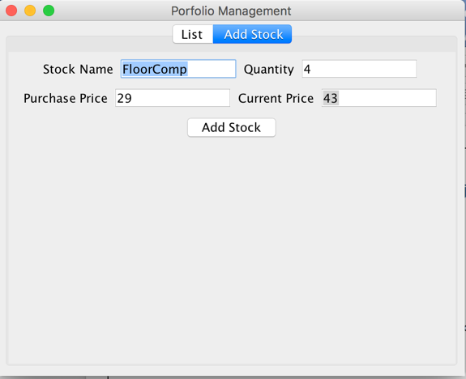 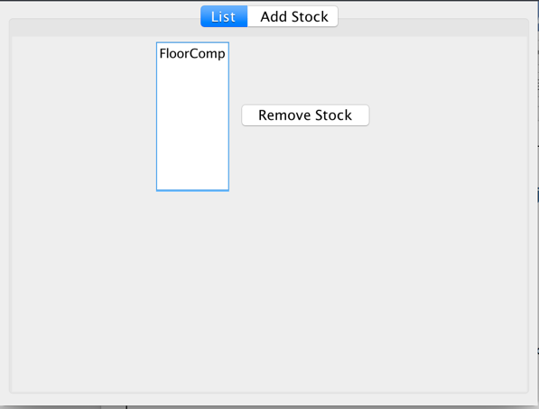

**Case Two Screenshots**

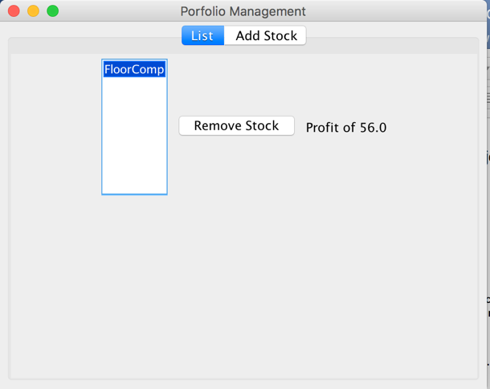

**Case Three Screenshots**

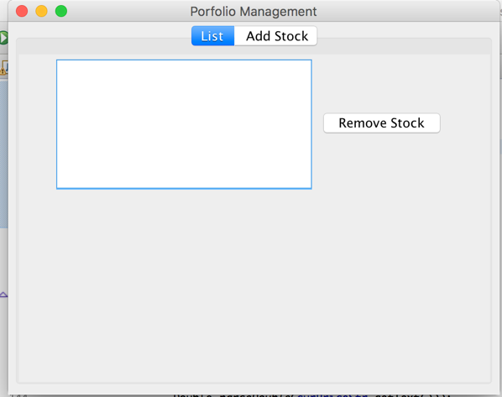

If any requirements are NOT met, *document the known issues.* What did you do to try to solve them?

Make sure you demonstrate in your testing the parts that are working correctly.

**Conclusions / Lessons Learned**

What difficult problems did you encounter, and how did you handle them?

Since gui is still new, I did have to figure out how to properly use the tabs and list but I was able to understand through the lesson notes.

What new concepts did you learn/reinforce with this lab?

I learned how to use array lists, as well create tabs and list in gui.

Is there anything you would have done differently?

No