CIS355A Lab Report

**Your Name: Krishna Patel**

**Date: October 29, 2017**

**Lab Week One**

**Objective/Purpose of the program**

The main objective of the lab was to be able to create a class with methods in java. Also to be able to get the correct input from user using a scanner and get a console output. The purpose of this program was to be able to provide the health information to the clients, and correctly calculate BMI and maximum heart rate.

**Analysis/Design**

*Describe the approach/structure of program. What classes/functions were used?*

There are two classes used, the HealthProfile class and the main class. Starting with the Health Profile class, I organized my class with first the private instances at the top followed by the constructor, and setters/getters. In the main class, no additional functions were needed. My main class is organized with first all the variables listed/initialized at the top. After I called the Health Profile class and scanner before writing the code for user input. The user input is put inside a while loop, so the program runs until the user enters X to exit. In the user input, you will also see the a format to make the decimal point round to 1 place for BMI and than the output of the profile of the user entered.

**Testing/Results**

*Does your program satisfy all requirements of the lab?*

My program does satisfy all the requirements for the following lab, which includes the functional requirements as well as the output requirements.

*If yes, how did you test it? Indicate test cases used, expected values, and show results with screen shots.* ***For example:***

|  |  |  |  |  |
| --- | --- | --- | --- | --- |
| **Case** | **Description** | **Test Data** | **Expected Result** | **Actual Result** |
| 1 | The user enters Three clients, one normal, one overweight, and one underweight and then exits successfully. | **First Client:**  Emma  Age = 34  Weight = 130  Height = 5’6”  **Second Client:**  Jacob  Age = 50  Weight = 190  Height = 5’10”  **Third Client:**  Liz  Age = 25  Weight = 96  Height = 5’6 | **First Client**  BMI is 21.0, Normal  Max Heart Rate is 166  **Second Client**  BMI is 27.3, Overweight  Max Heart Rate is 150  **Third Client**  BMI is 15.5, Underweight  Max Heart Rate is 175 | Actual results –  See Image below |

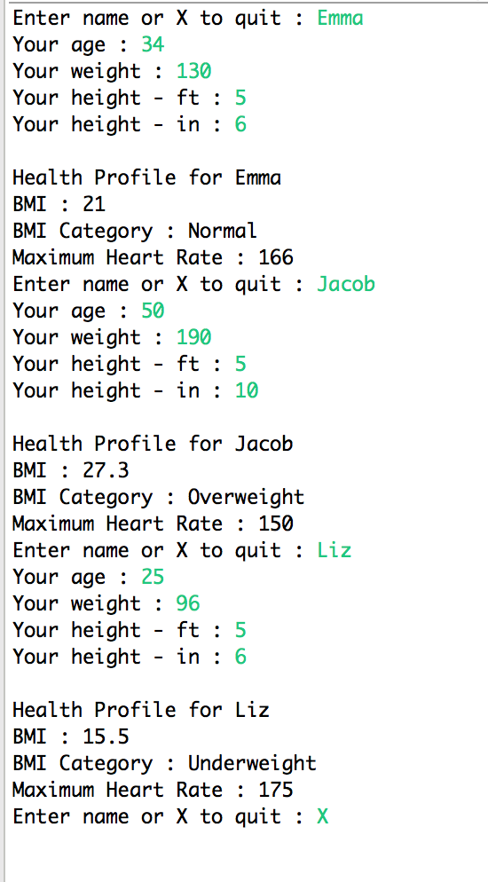

*If any requirements are NOT met, document the known issues. What did you do to try to solve them?*

*Make sure you demonstrate in your testing the parts that are working correctly.*

**Conclusions / Lessons Learned**

*What difficult problems did you encounter, and how did you handle them?*

I’m not the best with while loops so that’s something a struggled with. I took help of a tutor to figure out how to make the while loop work so the client can enter as many users to get BMI of as he/she wants. I realized that I was missing one line of code which was why my while loop originally wasn’t running as it should be.

*What new concepts did you learn/reinforce with this lab?*

This was my first time coding in java so in a way all of it was new, but having heavy knowledge in C++ helped. Adding a class to the main and using two separate files was a good learning concept in this lab. As well as reinforcing object oriented programing and using setters and getters.

*Is there anything you would have done differently?*

One thing I would do differently is the way I prepared for the lab. I believe that I should of created a flowchart to better understand the program, rather than jumping right into the coding, and than being like wait where does this go. Which in the end as whole means I should of planned better but in the end it worked out.