CIS355A Lab Report

**Your Name: Krishna Patel**

**Date: 12/10/17**

**Lab Week 6**

**Objective/Purpose of the program**

The purpose of the program was to take students 3 test scores and give the average grade in letter and percentage.

**Analysis/Design**

The program consists of three different java class files. First is the Student Class which contains the getter/setter as well as required calculations and constructors. The Second is a class for database, through this class it allows the program to connect to database to get and store data in to the apporiate table. Also in this class, the needed queries are there to perform in the program. Last class is the gui class which builds the program and gives the front end portion. Allows the user to input, and read the data to store in the database as well as gets the data from the database.

**Testing/Results**

Does your program satisfy all requirements of the lab? Yes it does

If yes, how did you test it? Indicate test cases used, expected values, and *show results with screen shots.* **For example:**

|  |  |  |  |  |
| --- | --- | --- | --- | --- |
| **Case** | **Description** | **Test Data** | **Expected Result** | **Actual Result** |
| 1 | I will enter the student name, and three test scores and press add student button | Name : Emma  Test –  1: 69  2: 90  3: 98 | Expected Result is to be successfully added to the database and the average is :  86% or B | Refer to 1.1 and 1.2 |
| 2 | Press the display student button |  | Display all the data | Refer to 1.2 |

1.1

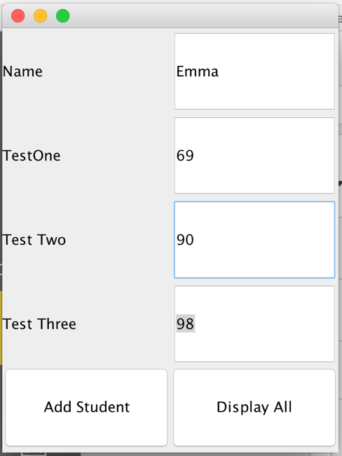

1.2

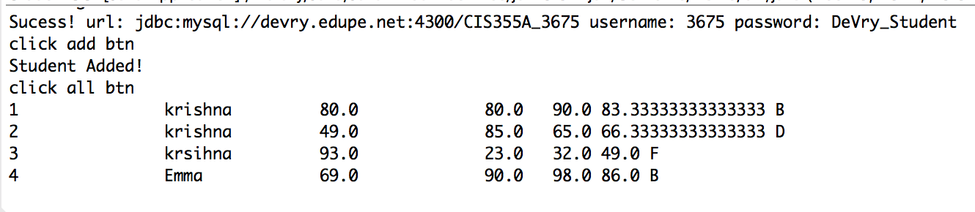

If any requirements are NOT met, *document the known issues.* What did you do to try to solve them?

Make sure you demonstrate in your testing the parts that are working correctly.

**Conclusions / Lessons Learned**

What difficult problems did you encounter, and how did you handle them?

The difficult part of this assignment was working with the database since I’m new to it. I had to do a lot of research and problem solve but in the end worked out.

What new concepts did you learn/reinforce with this lab?

I learned how to work with database in this lab along with applying it to GUI.

Is there anything you would have done differently?

No