Setup:

Download ngrok server and put that in **c disk**

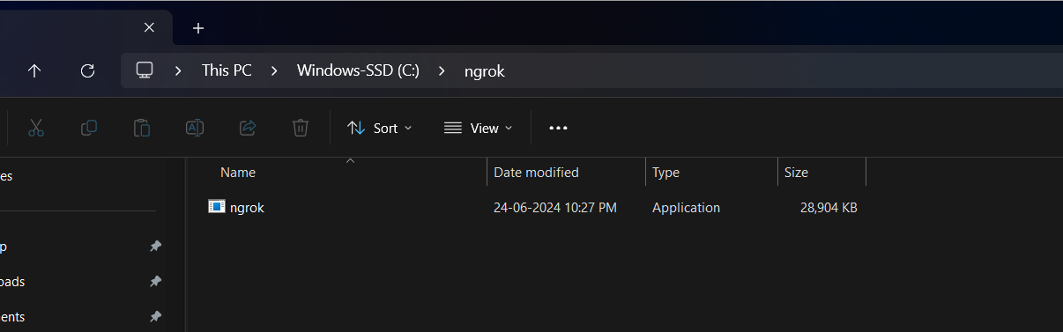

Create one account from ngrok server portal once you create you can find authentication token that we will use to verify it here.

Ngrok : <https://dashboard.ngrok.com/login?state=RPxx4InshNl6Bc6liv63HGqm9LuaDAvQZsfG6cQl7d5zV2-kkOebrxernHSKB8_XQ21ewGlbRj_V0QvNwuK_T8wBVYhSlZjL7CbvHiybUCEpyzP8P05KYyCsNEXLMhNBqTi_m2HtpSrGntC9nfdPlr4bqv-BK6BmsiJApi65bFBL>

* Double click the above **ngrok** application
* Paste you config authentication token which you got from you ngrok account

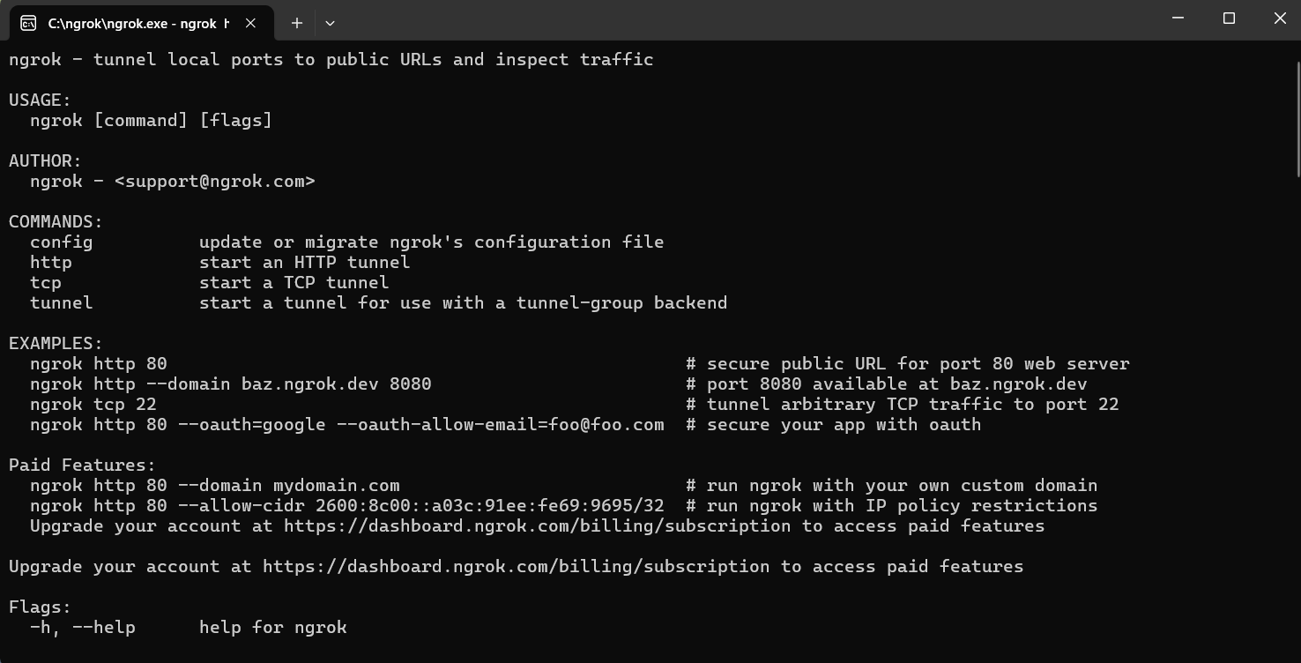

Add that ngrok path to your environment variable.

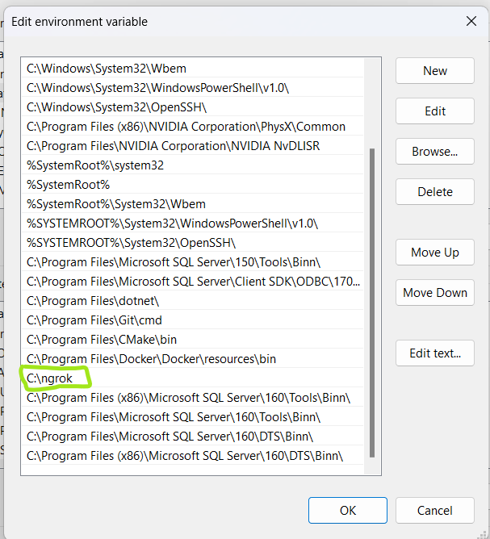

Once its done.

Run your **flaskapp.**

* Python “yourappname”.py or py “yourappname”.py

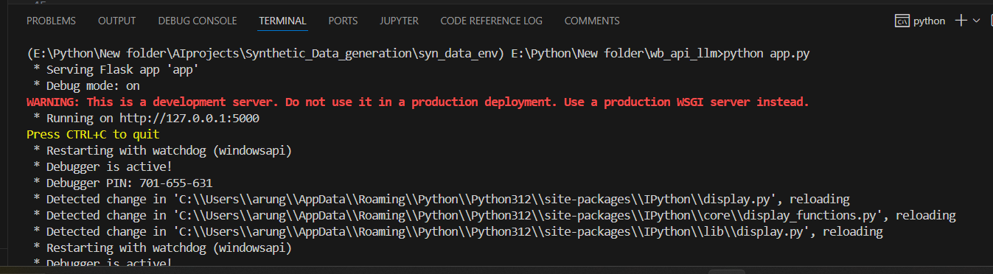

* Copy the port number <http://127.0.0.1:5000>

Go to your ngrok terminal command type : **ngrok start past above url**

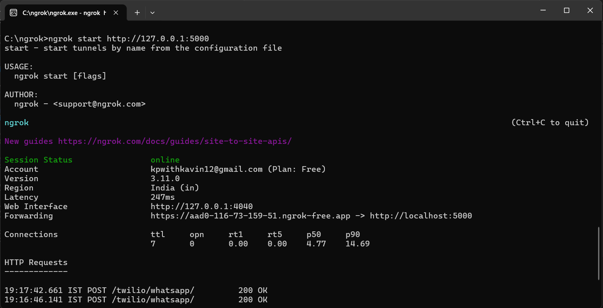

The you will get the running session status . here we need do one things is copy the forwarding url

<https://aad0-116-73-159-51.ngrok-free.app> ( whenever you run newly it will genereate new url that we have to give twilio sandbox setting url

**and create one account from twilio**

**Twilio setup:**

Create one account from twilio using your google account.

Once you sign in you should go to message->sendWhatsapp message -> sandbox setting you need to specify the above ngrokserver URL here and save it

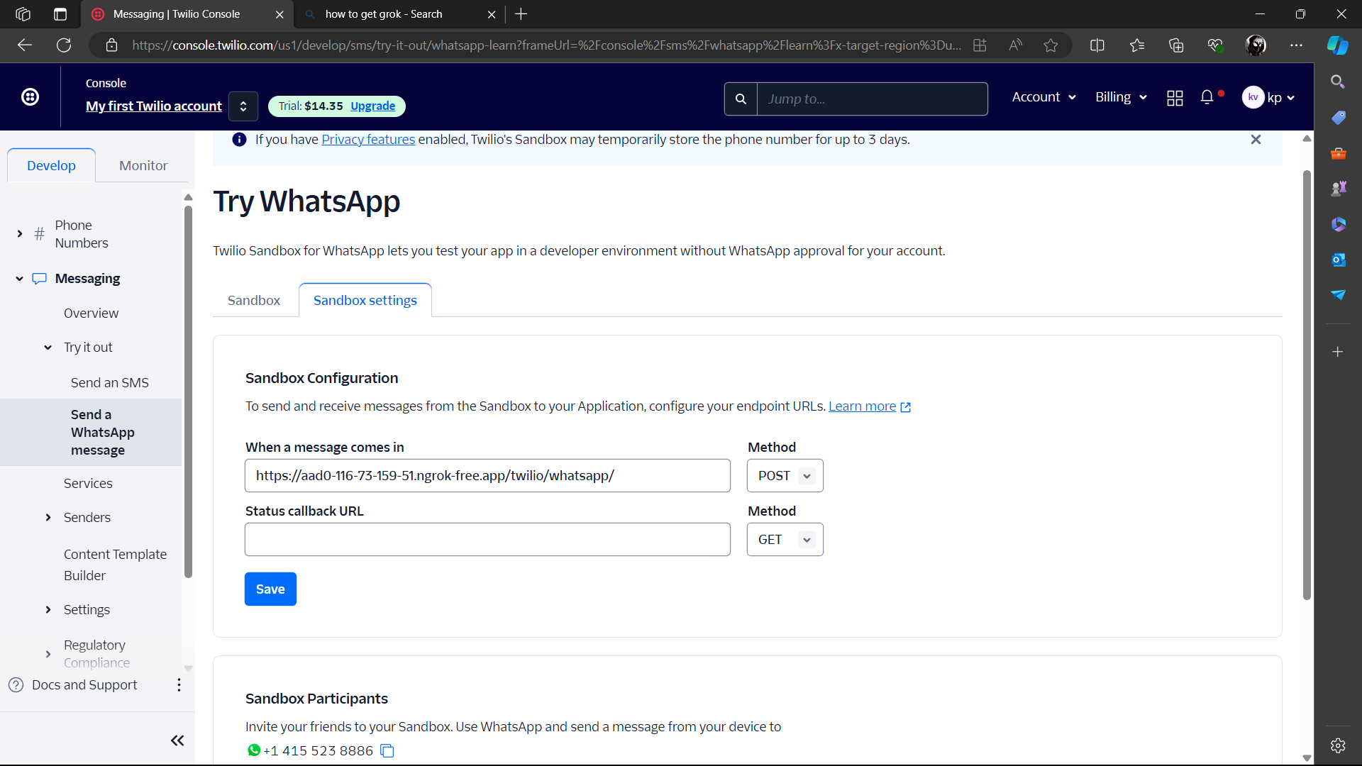

Then .

If we send a message through whatsapp this twilio secure connection pass that message to our local ngrokserver .

This is ngrok server already connected with our flaskserver port 5000 which will receive message and pass to our function the asusal process.

Configure these you code **env** file

OPENAI_API_KEY="your api key"

TWILIO_ACCOUNT_SID="you account sid"

TWILIO_AUTH_TOKEN="your account auth token"

FROM="twilio whatsapp number"

