
Renaissance School of Medicine
Department of Microbiology and Immunology
Center for Infectious Diseases
12/11/2025
Ananda Goldrath, PhD
Dhruv Khanduja
Dear Ananda and Dhruv,
We provide this detailed protocol and Listeria information sheet to labs that request Listeria mutants we have generated. We are providing you with Listeria monocytogenes expressing the internalin A S192N Y369S mutations (InlA^{M}) that also expresses the gp33 epitope on the 10403s background strain. The InlA^{M} is based on the work of Wollert et al., Cell, 2007. The Lm-gp33 strain was generated by Hao Shen and murinized by my lab. Please cite Sheridan et al., Immunity, 2013 when referencing the InlA^{M} Lm in any publications. Please reach out for any clarifications or questions.
Listeria:
InlA^{M} Lm (10403s)
InlA^{M} Lm-gp33 (10403s)
Sincerely,

Brian S. Sheridan, Ph.D.
Associate Professor
Department of Microbiology and Immunology
Center for Infectious Diseases
Renaissance School of Medicine
Stony Brook University
246 Centers for Molecular Medicine
Stony Brook, NY 11794-5120
Phone: 631-632-4459
Email: brian.sheridan@stonybrook.edu

Listeria monocytogenes Protocol
L. monocytogenes is the causative agent of listeriosis, a food-borne disease of humans and animals. Typical human exposure occurs through ingestion of unpasteurized milk products, vegetables, or prepared meats. Listeriosis can present in healthy adults with symptoms of fever and gastroenteritis. Pregnant women and their fetuses, newborns and the immunocompromised are at great risk of developing severe infections including meningoencephalitis and septicemia that may be fatal. Infection during pregnancy can lead to fetal loss. Pregnant women or women trying to become pregnant should consult your institute’s occupational health division prior to work with this pathogen. Strains that are on the 10403s background are naturally streptomycin resistant. L. monocytogenes is susceptible to gentamicin, penicillin, and ampicillin and as such listeriosis is treated via administration of gentamicin plus penicillin or ampicillin. Lab acquired transmission could be through an aerosol exposure, a splash to the face causing ingestion or to an open wound or exposed mucous membrane, or a needle stick. No confirmed cases of lab acquired listeriosis have ever been reported. Excessively high levels of L. monocytogenes (~3x10¹¹ cfu via consumption of contaminated food) are required for a healthy human to develop signs of gastroenteritis without any associated mortality (Dalton et al., 1997). L. monocytogenes is classified as a risk group 2 agent and is handled under BSL-2 and ABSL-2 procedures and containment.
Per IATA, we don’t consider that Listeria "is transported in a form that, when exposure to it occurs, is capable of causing permanent disability, life-threatening or fatal disease in otherwise healthy humans or animals." In this context, an exposure constitutes "when an infectious substance is released outside of the protective packaging, resulting in physical contact with humans." While it is not exhaustive, L. monocytogenes is also not indicated on the UN 2814 table of pathogens. As such, we ship L. monocytogenes as a UN 3373 designation.
We typically ship L. monocytogenes on Brain Heart Infusion (BHI) agar stabs/plates at room temperature. Colonies usually grow during shipment. If no colonies or growth are visible, place them in a 37°C incubator overnight and check for colonies the next day. We recommend colony purification to generate your stocks and that you confirm (via PCR) that the bacteria you requested was shipped.
• The EGDe strain L. monocytogenes internalin A mutation replaces inlA with inlA^{S192N-Y369S} and expressed at native levels (Wollert et al., Cell, 2007).
• The 10403s strain L. monocytogenes internalin A mutation replaces inlA with inlA^{S192N-Y369S} and made similarly (Xayarath et al., Mol Microbiol, 2009 and Sheridan et al., Immunity, 2013) • It is unknown whether these internalin A mutations make L. monocytogenes more pathogenic in humans. However, it increases the binding kinetics to human E-cad and attachment to Caco-2 cells (Wollert et al., Cell, 2007).
• L. monocytogenes strain EGDe (more pathogenic)
o No antibiotic resistance. Use standard aseptic techniques
• L. monocytogenes strain 10403s (less pathogenic; `expression of ova further reduces pathogenicity) o Naturally streptomycin resistant at 5 ∝g/mL (up to 200 ∝g/mL without impaired growth). o Ova expressing L. monocytogenes is also erythromycin resistant at 5 ∝g/mL.
▪ Ova expression is chromosomally inserted and does not require selection after confirmation.
▪ Our Lm-ova is a truncated Ova that does not express the OT-II epitope
o For quantifying bacterial burden, use plates with strept at 50 – 100 ∝g/mL.
Day -1:
• In the afternoon (or evening) inoculate 5 mL of BHI with 5 ∝L L. monocytogenes from stock aliquots • Culture L. monocytogenes ON at 37°C and 220 rpm
Day 0:
• Subculture the L. monocytogenes in the morning using a 1:10 dilution into BHI. Typically, 2 mL of ON culture into 18 mL of BHI for up to 10 mice. Depending on the size of the experiment you may need a larger culture.
• Shake at 37°C in a 50 mL conical flask at 220 rpm
• Incubate until OD₆₀₀ reaches 0.8 (roughly 90 – 120 min)
• Pellet L. monocytogenes at 6000 rpm 15 min 4°C (we routinely use 4000 rpm at 15 minute in an eppendorf 5810 R centrifuge)
• 20 mL of L. monocytogenes culture at OD₆₀₀ = 0.8 yields ~ 2x10¹⁰ CFU
• To generate glycerol stocks, resuspend pellet in 2 ml sterile PBS and 2 ml sterile 100% glycerol. Aliquot a few larger volumes (500 ∝l) for permanent stocks (from which future batches will be made) and smaller single use aliquots (25 ∝l) for working stocks. Stocks are maintained at -80°C.
• For i.v. infections in Balb/c or C57Bl/6: Above volumes can be adjusted as i.v. infections require a lot less L. monocytogenes. Resuspend pellet in PBS and serial dilute to appropriate titer. Different doses are reported in the literature, but we typically infect 1-2x10³ CFU/mouse in 100 ∝L.
• For oral infections in Balb/c or C57Bl/6: Resuspend pellet in 0.5 mL PBS and infect with 50 ∝L (~2x10⁹ CFU/mouse).
o Most labs gavage for oral infections. We use a feeding approach which prevents esophageal microabrasions and direct access of the bacteria to the blood stream. However, some strains or transgenics may have peculiar eating habits that may require gavage (e.g., CBy)
For Foodborne Infection Protocol
• Remove food and water from the mice cages for infections. Food and water deprive for approximately 4 hours prior to infection. The closer to the evening the better they eat. We also cover mice cages with a dark sheet during feeding, away from noise and traffic flow. It is best if a separate room is available.
• Remove 90% of bedding from infection cages to prevent mice from burying their food. You only need enough bedding to sponge urine.
• Place L. monocytogenes on small bread pieces (~0.5 cm³) in cages. The bread should be the smallest size that still absorbs the entire inoculum. Inoculate 1 piece of bread per cage for a single mouse.
• House mice individually during infection to be sure each mouse consumes a single inoculated bread piece.
• Mice fully consume inoculated bread in about 1 hr. Approximately 10% of mice take longer than 1 hr. We provide a maximum of 4 hours before marking mice which do not fully consume inoculated bread (which is very rare). This allows us to longitudinally track any mouse that did not consume a complete inoculum. Condense mice back into their original cages with their original cagemates so that social hierarchies are not disrupted.
Bug Counts (to confirm infection dose)
• Make 10-fold serial dilutions in PBS.
• Plate 10 ∝L of respective dilutions on BHI agar (with antibiotics where appropriate) using loop spreader. In this case, we have an approximate titer so you can plate the appropriate dilution +/- 1 – 2 dilutions.
Bug Counts from Tissue
• Filter sterilize 1% saponin in PBS
• Mush tissues (usually spleen, mes LN, and liver) through 70um mesh cap
• Spin at 4000rpm 15min 4°C
• Resuspend in 1% saponin: MLN in 2 ml, spleen in 3ml, and liver in 5ml
o Guts: Use gentleMACS to disassociate tissues in 9 parts PBS. After disassociation add 1 part 10% saponin (use lung 2 setting 2X)
• Incubate at least 30 - 60 min at 4°C
• Make 10-fold serial dilutions in PBS.
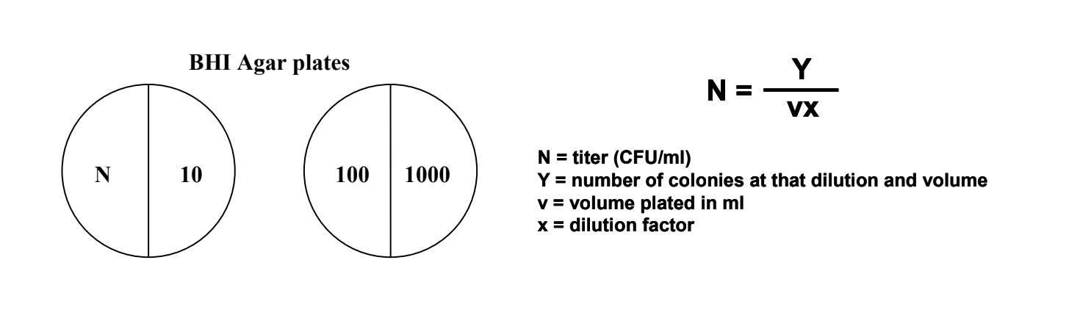
• Plate 10ul of respective dilutions on BHI agar (with antibiotics where appropriate) using loop spreader. Volume plated and dilution strategy may be adjusted for your needs.

