1. Login Page

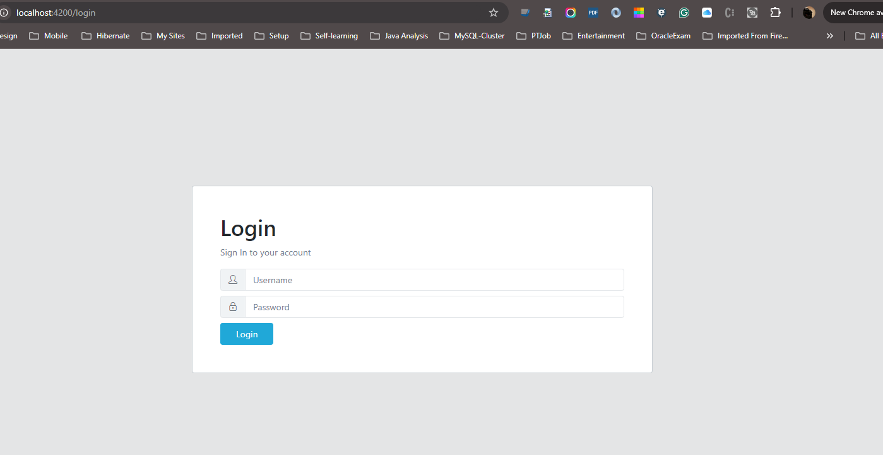

1. Invalid Login

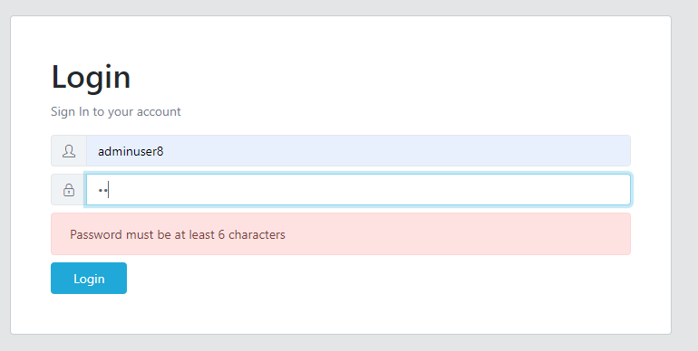

1. Login with adminuser8/12345678 and redirect to Home page. I am using CoreUI Framework.

JWT token will be stored in Redis once login successfully. Logout JWT token will be removed.

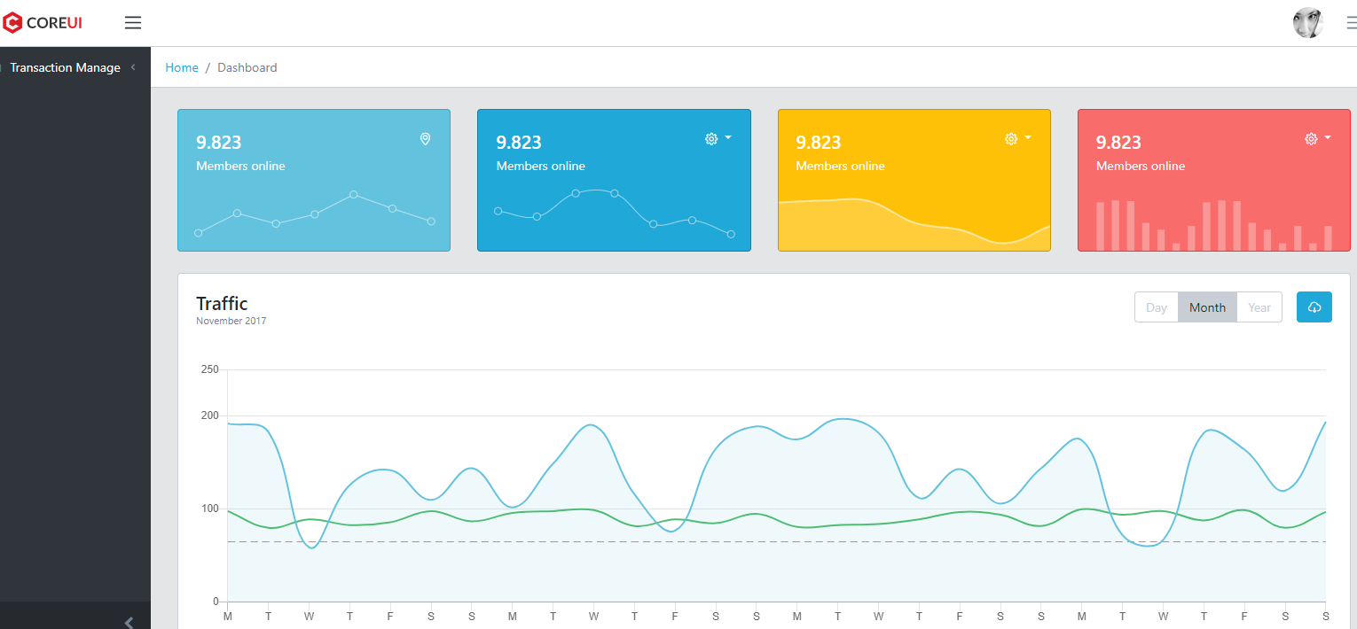

1. Transaction Listing Pagination page

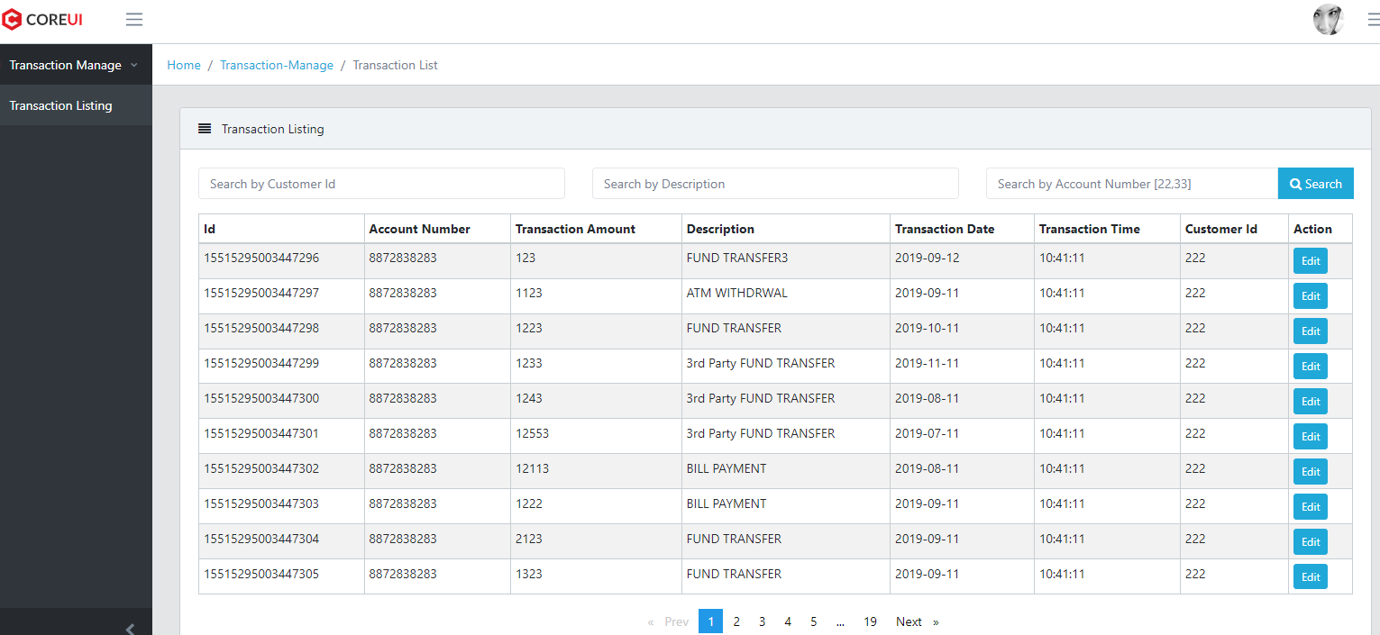

1. Pagination onChange Items per Page to 20 from 10

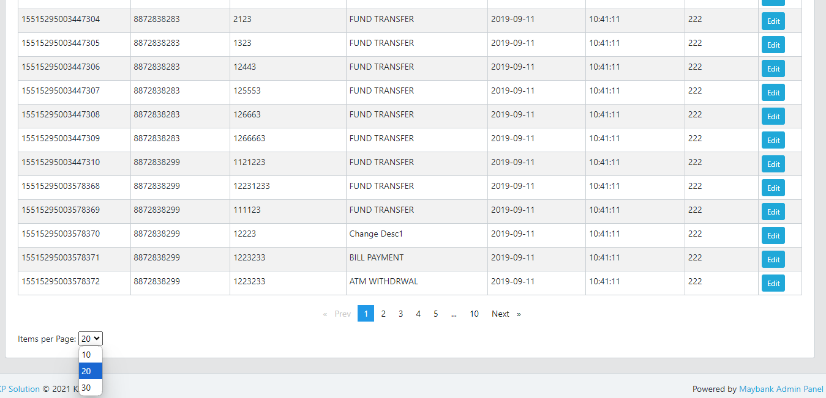

1. Change to Page number 5

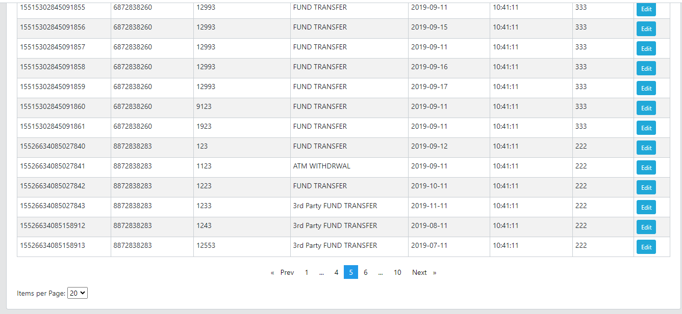

1. Search by Customer Id 333

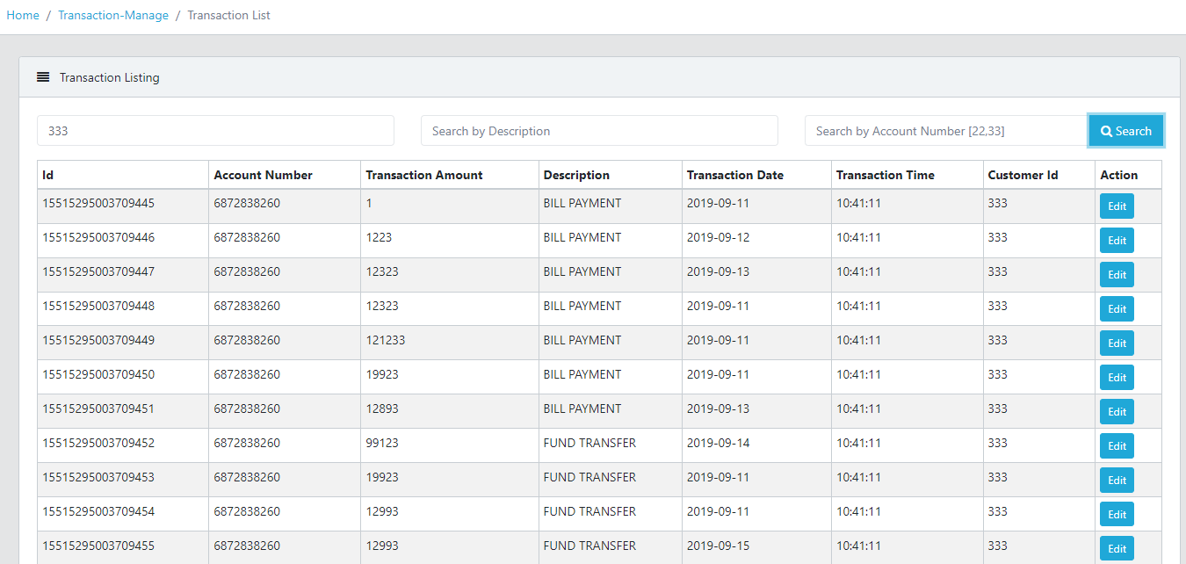

1. Search by Customer Id 333 and Description “BILL”

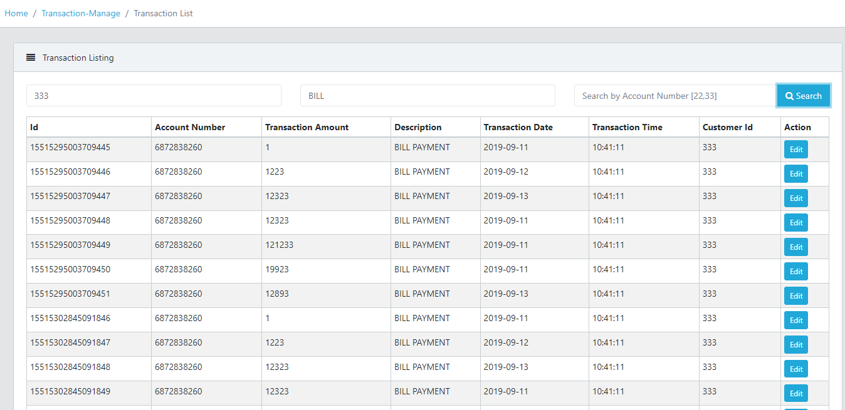

Continue with next page  
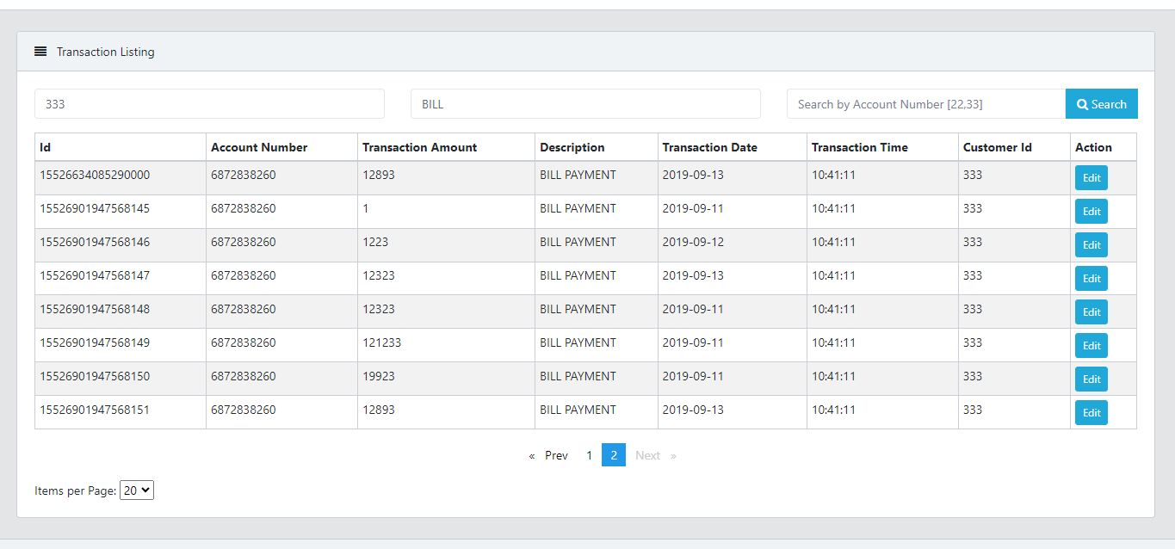

1. Search by AccountNumber 8872838299

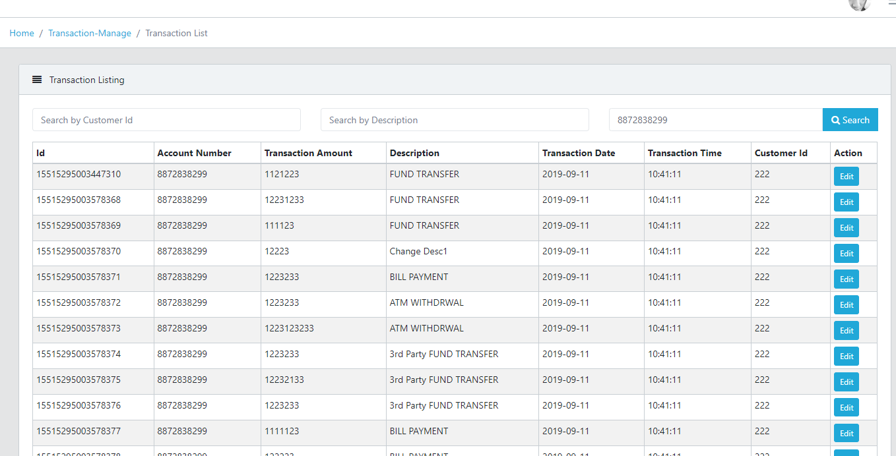

1. Search by AccountNumbers 6872838260,8872838299 (split by comma)

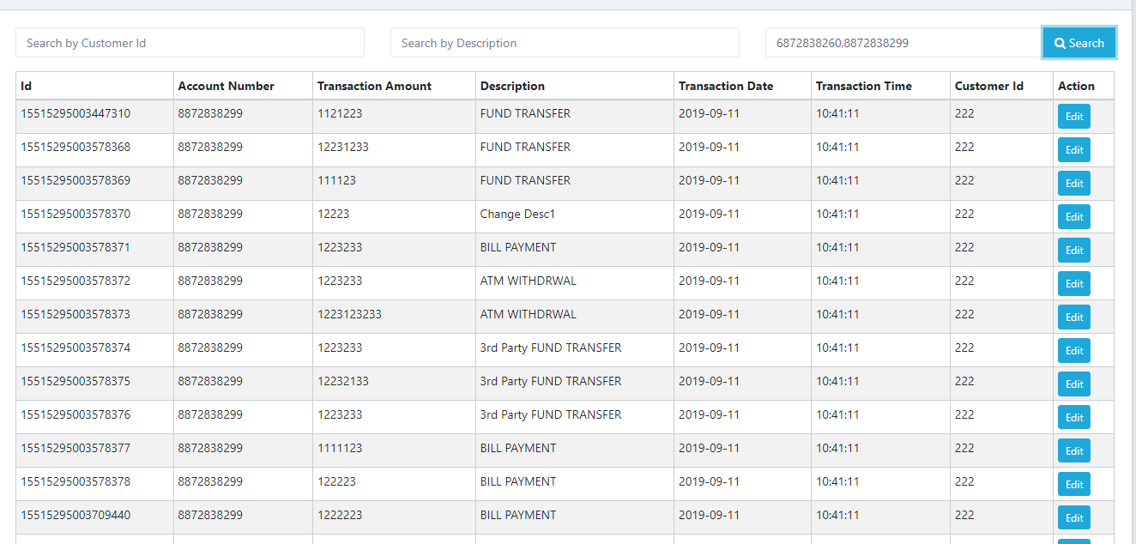

Continue

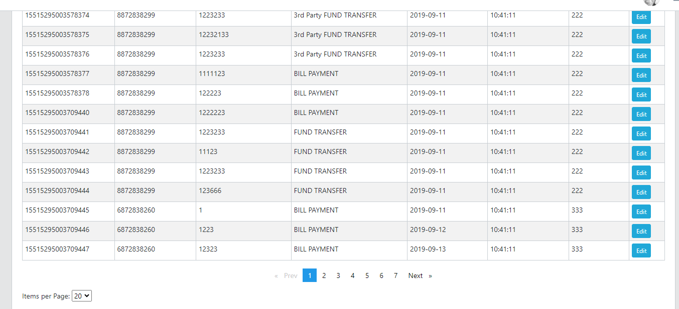

1. Now I want to change description for id: 15515295003578370  
   From “Change Desc1” to “BILL PAYMENT 2024-10”

Before Change:

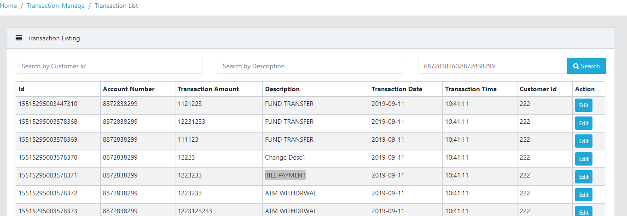

After Clicked Edit Button will redirect to Edit Transaction form page  
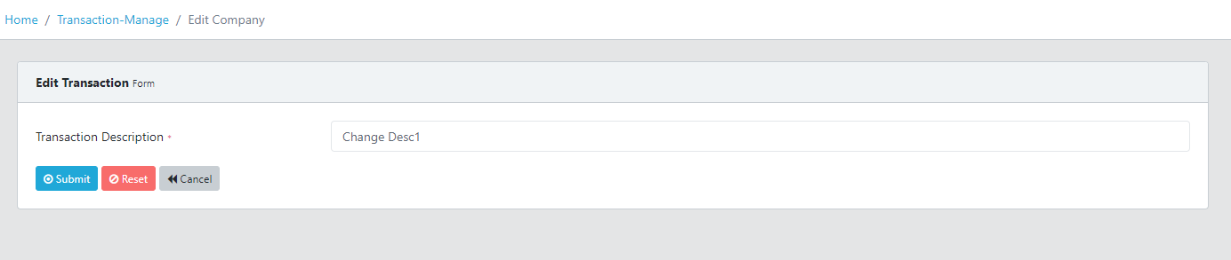

After Change: Updated Successfully message.

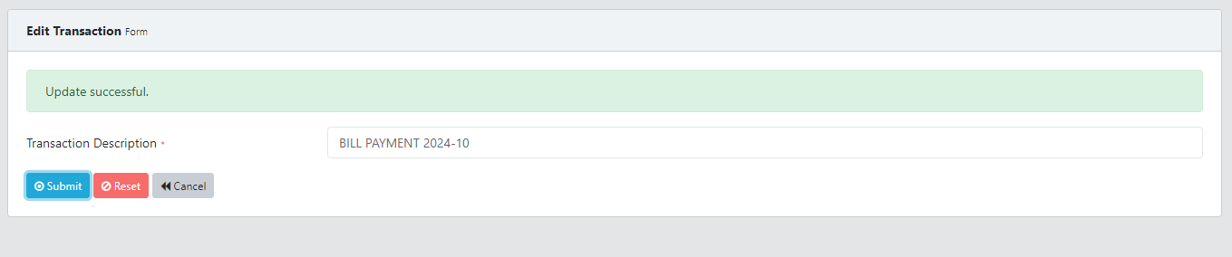

Listing Description for id: 15515295003578370 is updated to BILL PAYMENT 2024-10

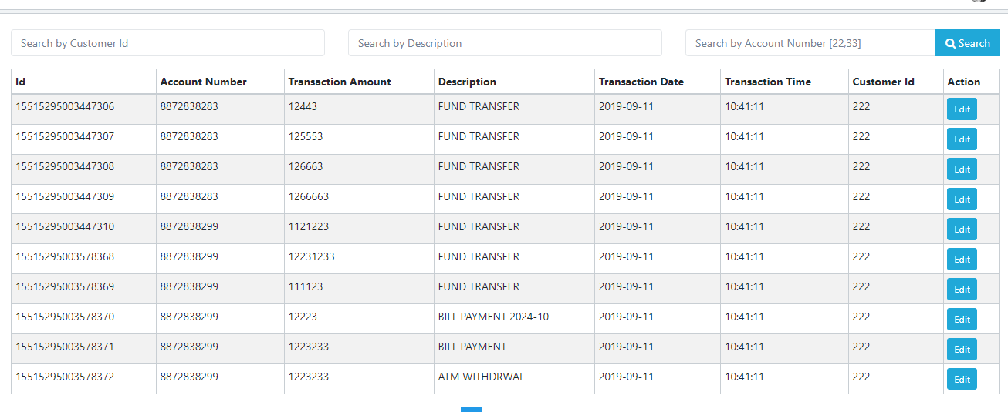

1. Logout. JWT token will be removed from Redis

