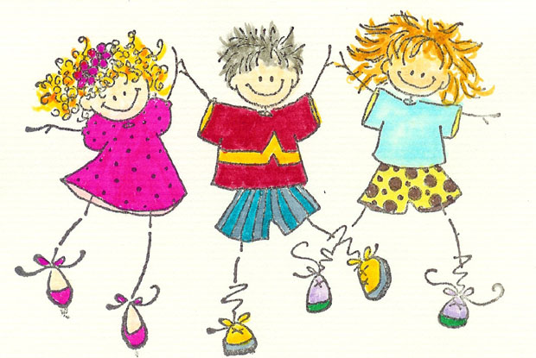

**KNOTTWOOD MONTESSORI DAYCARE &**

**OUT-OF-SCHOOL CARE**

**________________________________________________________________________**

**HEALTH AND SAFETY POLICIES**

Knottwood Montessori Daycare strives to stay current with best practices in health & safety as recommended by Licensing & Health authorities and responds to this information in policy and practices. Policies and procedures are developed to provide the staff with clear expectations and requirements for maintaining a safe and hygienic indoor and outdoor environment and to promote a healthy lifestyle. All staff members are required to read the health and safety policies and sign an acknowledgement form and agreement to comply with the policies. Parents will be informed of the Health and Safety Policies at the time of registration.

**HEALTH CARE & ILLNESS**

**Exclusion of Sick Children:** Having sick children at the centre poses an increased risk to the sick child, to other children and staff at the centre as well and to extended family members. Parents are encouraged to call the centre if they unsure at to whether or not a child can attend.

In keeping with the Child Care Licensing Regulations, children who are ill or have any contagious conditions cannot be at the centre. Parents are required to keep their child at home or find alternative care if their child doesn’t feel well enough to play and participate in the activities at the centre, if a child displays any of the following symptoms or if the child has received one or more of the following diagnoses from a physician or other health professional:

* Undiagnosed or unexplained open sores or rash;
* Temperature, with a fever of 38.0 degrees C or higher;
* Vomiting with two or more episodes of vomiting in the last 24 hours;
* Diarrhea or loose stool (the child should be excluded for 24 hours until symptoms are resolved or assessed by a physician);
* Wheezing/Persistent coughing; (the child should be excluded until assessed by a physician or the symptoms are resolved);
* Mouth sores with drooling (the child should be excluded until a physician has determined that the symptoms are non-infectious);
* Rash, with fever or behavioural change (the child should be excluded until a physician has determined that the symptoms are non-infectious);
* Symptoms of Possible Severe Illness, such as lethargy, uncontrolled coughing, irritability, persistent crying, difficult breathing, wheezing (the child should be excluded until assessed by a physician or the symptoms are resolved);
* Chickenpox (the child can be permitted to return to the program when he or she feels well enough to participate in all activities, regardless of the state of the rash and as long as the child returns to the same group they were with one to two days before the onset of the rash);
* Scabies, Head Lice, or other Infestation (the child should be excluded until appropriate treatment has been completed);
* Impetigo (the child should be excluded until 24 hours after antibiotic treatment has been initiated);
* Measles (the child should be excluded until four days after the appearance of a rash);
* Mumps (the child should be excluded until nine days after onset of parotid gland swelling);
* Pertussis, or Whooping Cough¨ (the child should be excluded until five days after antibiotic treatment has been completed, until three weeks after onset of symptoms, or until the coughing has stopped);
* Purulent conjunctivitis, or Red/Pink Eye¨ (the child should be excluded until 24 hours after antibiotic treatment has been initiated);
* Rubella (the child should be excluded until at least four days after onset of the rash, or up to five to seven days at the option of local health authority);
* Strep throat or other Streptococcal Infection (the child should be excluded until 24 hours after appropriate antibiotic treatment and cessation of the fever);
* Hepatitis A (the child should be excluded until 14 days after onset of illness or seven days after onset of jaundice);
* Tuberculosis (the child should be excluded until a physician has approved his or her return); or
* A child is displaying any other illness or symptom the staff member knows (or believes) may indicate that the child poses a health risk to persons on the program premises.

When children become ill while at the centre, parents will be notified and asked to pick the child immediately and seek medical attention as required. If parents can not be contacted or if parents have not picked up the child within one hour, emergency contacts will be called to pick up the child.

A notice will be posted on the Parent Information Board to inform families when a child enrolled in the centre has any contagious condition.

*Source: *Health Child Care, Healthy Child – A Guide to Promoting Health & Preventing Illness in Early Learning & Child Care Settings,* Government of Alberta, Sept 2011

**Supervision of Sick Children:** If symptoms of illness are present while the child is at the daycare, the sick child must be isolated or kept as far away as possible from the other children. Staff with first aid will attend to the child and make the child as comfortable as possible on a cot until the parent/ guardian arrives.

**Returning to the Centre after Illness:** Normally children may return to the centre when they are symptom free for 24 hours or 24 hours after antibiotics have been administered. However, at the discretion of the Director, a written statement from the child’s doctor may be required to ensure the illness is no longer contagious to others.

**Required Reporting of Illnesses:** If two or more children have influenza-like symptoms, such as a sudden high fever, dry cough, headache, muscle ache and feeling very weak and tired, that started within 48 hours of each other, it is considered to be a potential “outbreak” in the program. All outbreaks, including an outbreak of any of the communicable diseases, must be reported by the Director (or person in charge) to the local Alberta Health Services public health office. Once a report has been made, Alberta Health Services will provide assistance in assessing and preventing further illness in the centre. A list of diseases and guidelines that require the notification of the local Public Health Centre is available at www.health.alberta.ca under the “Health Professionals” tab and “Manuals and Guidelines” section.

**Reducing Cross-Contamination:** When a sick child uses a cot, the cot must be wiped with a bleach solution and left to air dry as soon as the child leaves. The blanket used by the sick child must be placed in a bag, sealed and sent home with the family of the sick child to be laundered. Cot sheets used by sick children must be placed into a bag and the bag must be sealed. The centre will launder the cot sheet.

**Documentation:** A log sheet will be maintained of children’s illnesses including the name of the child, the date the child was ill and description of the illness.