Mandatory Assignment 1: SMTP Cleint
Submission Date and Time : 10th march 2020 13:00
To be handed in individually on campusnet.
This assignment is obligatory for each student to get to the exam.

Student: Kaloyan Penov s133967

What to Hand in:

The complete code for the SMTP mail client can be found here: https://github.com/kpenov16/smtp_client.git
and in the archive file.

Screenshots showing:
- a received e-mail message from one of the TA’s (TA’s dtu student mail) assigned to group 5 s171242@student.dtu.dk

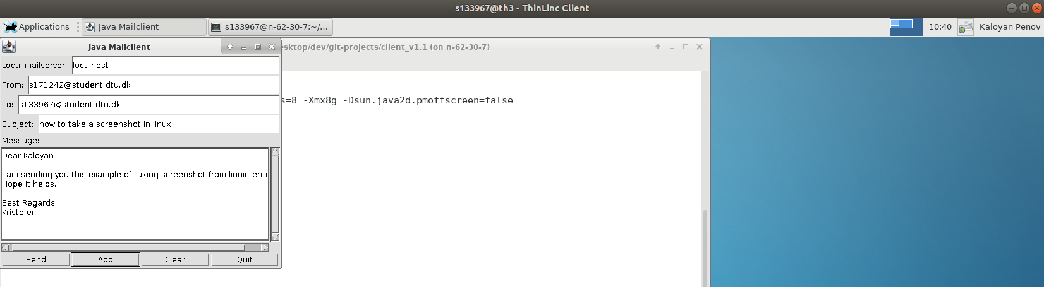
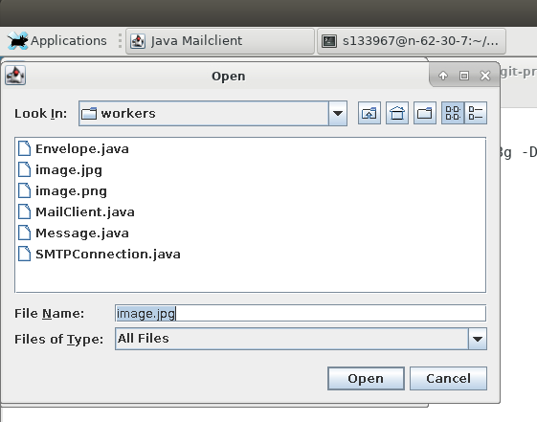

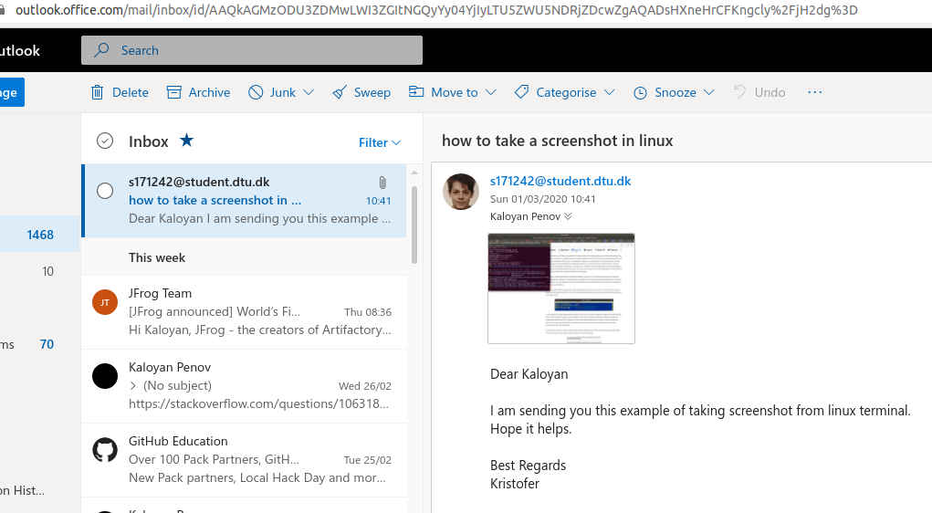

- a reply send to the TA’s dtu student mail:
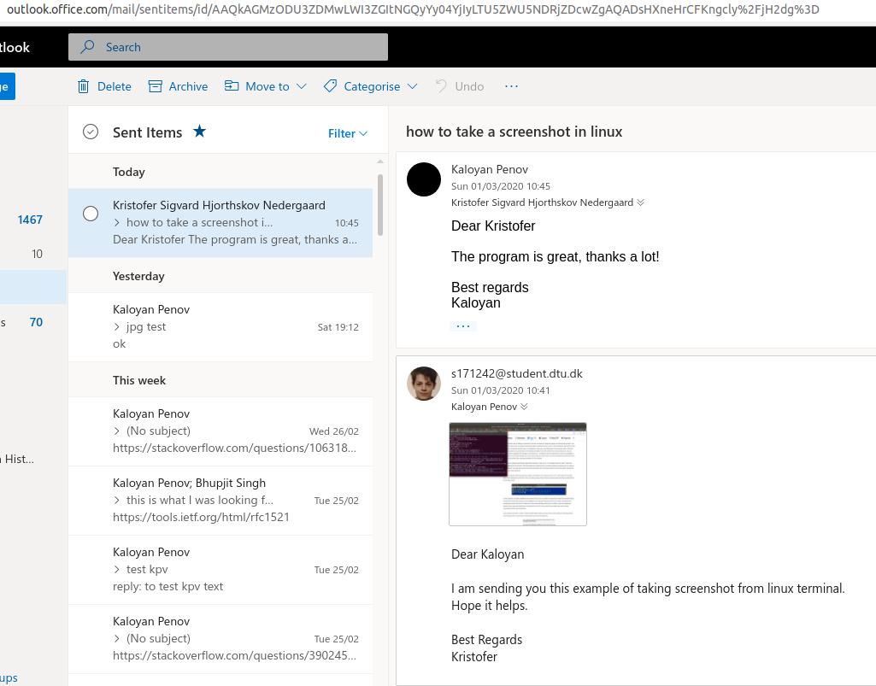
Tasks 1. SMTP mail client only handles sending text messages in the email body.
Task 2. SMTP mail client send emails with both text and images (more than one image).
- the client requires you to add the image files one by one via the “Add” button and then the mail can be send:

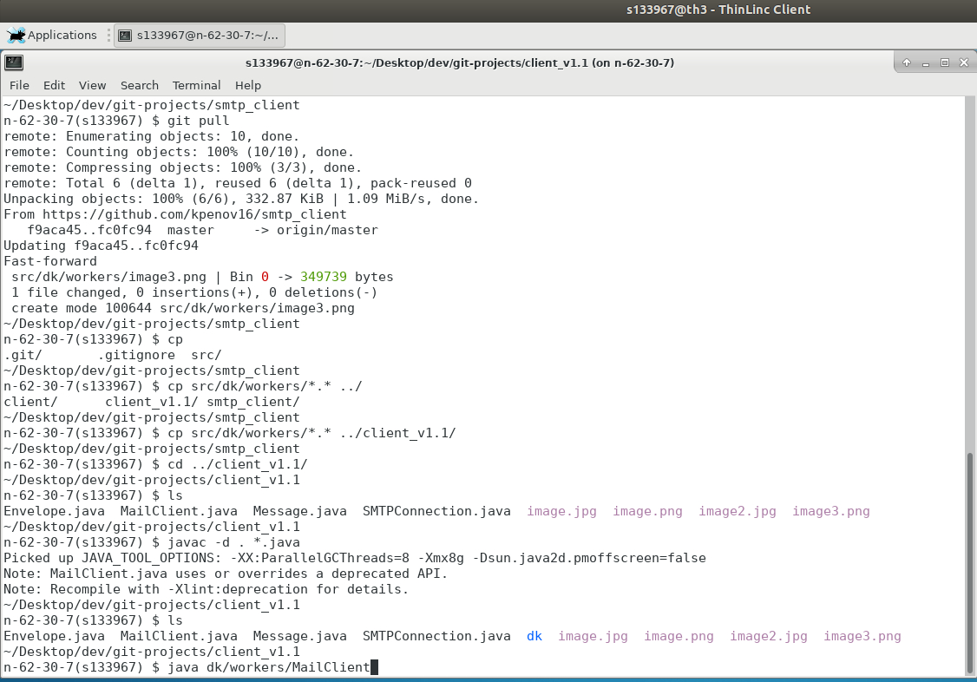
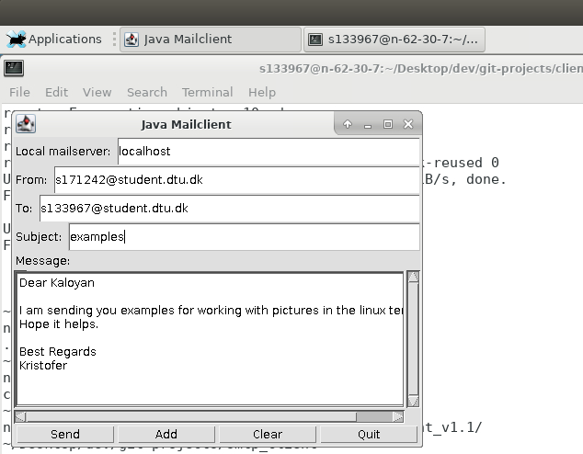

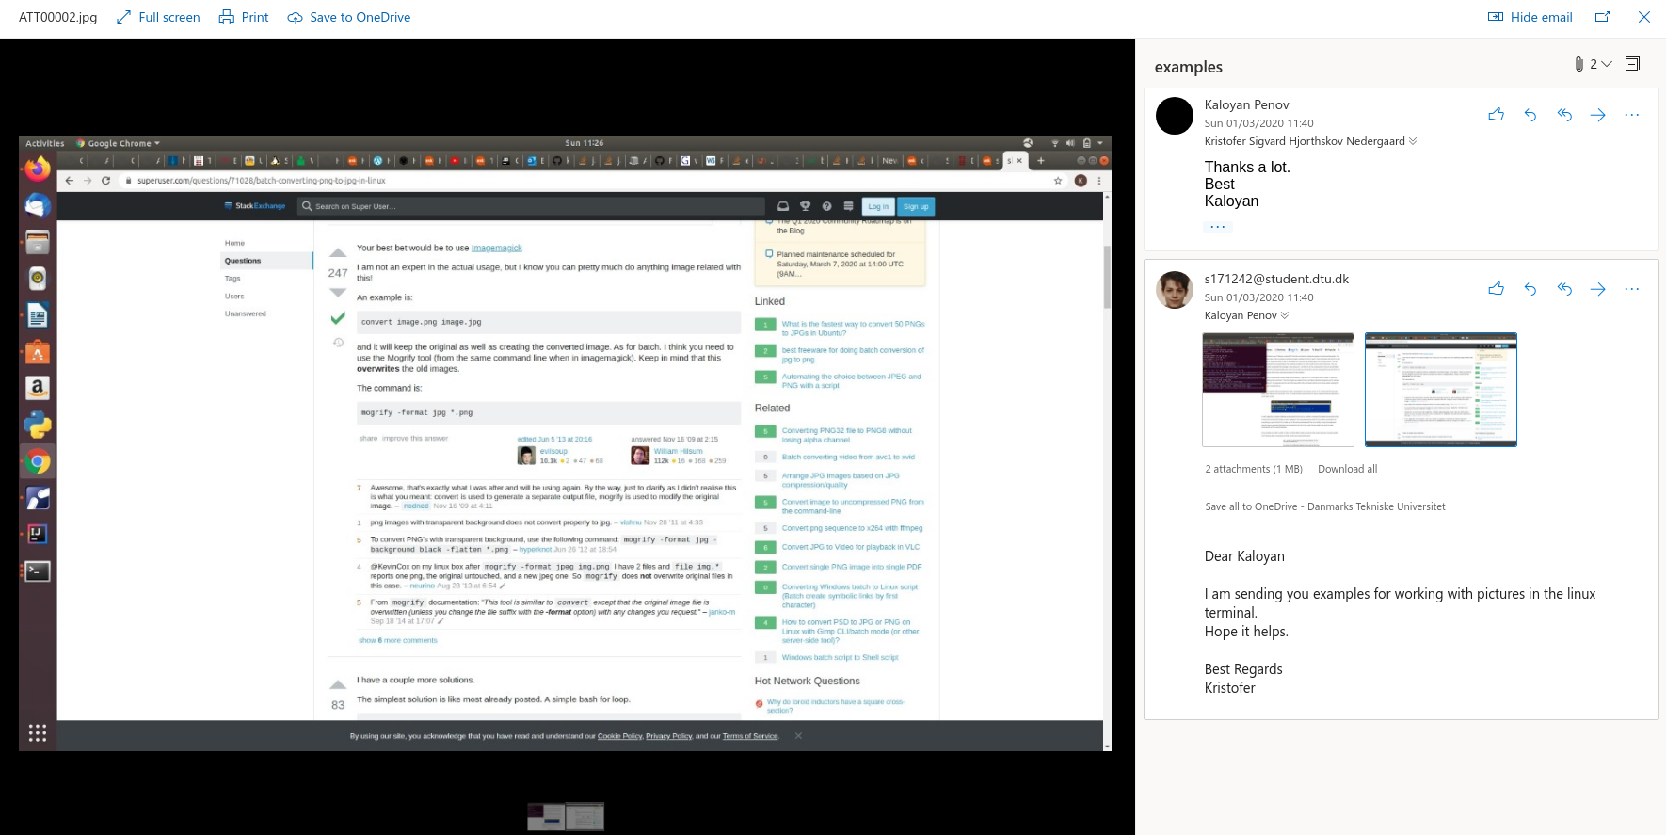
https://media.pearsoncmg.com/aw/aw_kurose_network_3/labs/lab2/lab2.html

