Module 8: Portfolio Project Part 2
Java Concurrency and Comparison with C++
Kyle Petersen
Department of Computer Science, Colorado State University Global
CSC450: Programming III
Professor Bindu George
September 12, 2026

Sequenced Dual-Thread Counter Application
This application implements the Module 7 counter demonstration in Java. Thread one counts from 1 to 20, and thread two then counts from 20 to 0. Both workers start before either is joined. A shared monitor protects the counter and controls the phase handoff. The countdown verifies the value 20 before proceeding, and the coordinator verifies zero after both workers finish. A shared failure record lets an interrupted worker release the waiting phase and prevents a handled failure from being reported as success.

Pseudocode
PROGRAM SequencedDualThreadCounter
BEGIN
SET target = 20, floor = 0, stepDelayMillis = 25
CREATE stateLock and outputLock
SET counter = floor, upPhaseDone = false, failure = null

FUNCTION printMessage(text)
LOCK outputLock, DISPLAY text, UNLOCK outputLock

FUNCTION recordFailure(cause)
LOCK stateLock
IF failure is null, SET failure = cause
NOTIFY ALL threads waiting on stateLock
UNLOCK stateLock

WORKER countUpTask
DISPLAY count-up starting banner
FOR value FROM 1 THROUGH target
LOCK stateLock
IF failure exists, UNLOCK AND RETURN
SET counter = value, UNLOCK stateLock
DISPLAY value, SLEEP stepDelayMillis
DISPLAY count-up finished banner
LOCK stateLock, SET upPhaseDone = true
NOTIFY ALL waiting threads, UNLOCK stateLock

WORKER countDownTask
LOCK stateLock
WHILE upPhaseDone is false AND failure is null
WAIT on stateLock (releases and reacquires the lock)
IF failure exists, UNLOCK AND RETURN
COPY counter into startValue, UNLOCK stateLock
REQUIRE startValue equals target
DISPLAY count-down starting banner
FOR value FROM startValue DOWN THROUGH floor
LOCK stateLock
IF failure exists, UNLOCK AND RETURN
SET counter = value, UNLOCK stateLock
DISPLAY value, SLEEP stepDelayMillis
DISPLAY count-down finished banner

IN EITHER WORKER: on interruption, RECORD failure and RESTORE
interrupt status; on runtime exception, RECORD failure
MAIN: CREATE application; START both workers; JOIN both
If interrupted, RECORD failure, INTERRUPT both, PROPAGATE
LOCK stateLock; CHECK failure; COPY counter; UNLOCK
REQUIRE final counter equals floor; DISPLAY final counter
END PROGRAM

Source Code: CounterThreads.java
Line numbers are added for reference; the analysis cites this listing.
1 /**
2 * Portfolio Project Part 2: Sequenced Dual-Thread Counter Application.
3 *
4 * Two worker threads share a counter. The first counts from 1 to 20; the
5 * second waits for that phase to finish, then counts from 20 down to 0.
6 * Both workers start before either is joined. A monitor controls the handoff.
7 *
8 * Compile: javac -Xlint:all CounterThreads.java
9 * Run: java CounterThreads
10 */
11 public final class CounterThreads {
12 private static final int COUNT_TARGET = 20;
13 private static final int COUNT_FLOOR = 0;
14
15 // Display pacing only. Synchronization does not depend on this delay.
16 private static final long STEP_DELAY_MILLIS = 25L;
17
18 private final Object stateLock = new Object();
19 private final Object outputLock = new Object();
20
21 // Every access to these mutable fields is guarded by stateLock.
22 private int counter = COUNT_FLOOR;
23 private boolean upPhaseDone = false;
24 private Exception failure = null;
25
26 private void printMessage(String message) {
27 synchronized (outputLock) {
28 System.out.println(message);
29 }
30 }
31
32 private void printLine(String label, int value) {
33 printMessage("[" + label + "] " + value);
34 }
35
36 private void printBanner(String message) {
37 printMessage("\n=== " + message + " ===");
38 }
39
40 /** Wake any waiter if a worker is interrupted or encounters an error. */
41 private void recordFailure(Exception cause) {
42 synchronized (stateLock) {
43 if (failure == null) {
44 failure = cause;
45 }
46 stateLock.notifyAll();
47 }
48 }
49

Source Code: CounterThreads.java (continued)
50 private void countUpTask(String label) {
51 try {
52 printBanner(label + " starting: counting up to " + COUNT_TARGET);
53
54 for (int value = 1; value <= COUNT_TARGET; value++) {
55 synchronized (stateLock) {
56 if (failure != null) {
57 return;
58 }
59 counter = value;
60 }
61 // Never hold stateLock while printing or sleeping.
62 printLine(label, value);
63 Thread.sleep(STEP_DELAY_MILLIS);
64 }
65
66 // Print before signaling so the phase banners stay in order.
67 printBanner(label + " finished at " + COUNT_TARGET);
68 synchronized (stateLock) {
69 upPhaseDone = true;
70 stateLock.notifyAll();
71 }
72 } catch (InterruptedException exception) {
73 recordFailure(exception);
74 Thread.currentThread().interrupt();
75 } catch (RuntimeException exception) {
76 recordFailure(exception);
77 }
78 }
79
80 private void countDownTask(String label) {
81 try {
82 final int startValue;
83 synchronized (stateLock) {
84 // wait() releases the monitor and reacquires it before returning.
85 // Recheck the condition to handle spurious wakeups and signals
86 // that arrive before this worker begins waiting.
87 while (!upPhaseDone && failure == null) {
88 stateLock.wait();
89 }
90 if (failure != null) {
91 return;
92 }
93 startValue = counter;
94 }
95
96 if (startValue != COUNT_TARGET) {
97 throw new IllegalStateException("Synchronization error: expected "
98 + COUNT_TARGET + " but observed " + startValue);
99 }

Source Code: CounterThreads.java (continued)
100
101 printBanner(label + " starting: counting down to " + COUNT_FLOOR);
102 // Java int is signed, so decrementing past zero ends this loop.
103 // Fixed bounds keep all arithmetic within the int range.
104 for (int value = startValue; value >= COUNT_FLOOR; value--) {
105 synchronized (stateLock) {
106 if (failure != null) {
107 return;
108 }
109 counter = value;
110 }
111 printLine(label, value);
112 Thread.sleep(STEP_DELAY_MILLIS);
113 }
114
115 printBanner(label + " finished at " + COUNT_FLOOR);
116 } catch (InterruptedException exception) {
117 recordFailure(exception);
118 Thread.currentThread().interrupt();
119 } catch (RuntimeException exception) {
120 recordFailure(exception);
121 }
122 }
123
124 private void run() throws InterruptedException {
125 printMessage("Portfolio Project Part 2 - Concurrent Counter Demonstration");
126 printMessage("Main thread: " + Thread.currentThread().getName());
127
128 // Labels are immutable Strings. No user input or mutable text is shared.
129 Thread upThread = new Thread(() -> countUpTask("Thread-1 UP"), "counter-up");
130 Thread downThread = new Thread(() -> countDownTask("Thread-2 DOWN"), "counter-down");
131
132 upThread.start();
133 downThread.start();
134
135 try {
136 upThread.join();
137 downThread.join();
138 } catch (InterruptedException exception) {
139 // Cancel both workers if the coordinating thread cannot keep waiting.
140 recordFailure(exception);
141 upThread.interrupt();
142 downThread.interrupt();
143 throw exception;
144 }
145
146 final int finalValue;
147 synchronized (stateLock) {
148 if (failure != null) {
149 throw new IllegalStateException("Counter demonstration did not complete.", failure);
150 }
151 finalValue = counter;
152 }
153 if (finalValue != COUNT_FLOOR) {
154 throw new IllegalStateException("Unexpected final counter value: " + finalValue);
155 }
156 printMessage("\nBoth threads joined. Final counter value: " + finalValue);
157 }
158
159 public static void main(String[] args) throws InterruptedException {
160 new CounterThreads().run();
161 }
162 }

Screenshot of Program Execution
Figure 1
Java counter application executing in Visual Studio Code
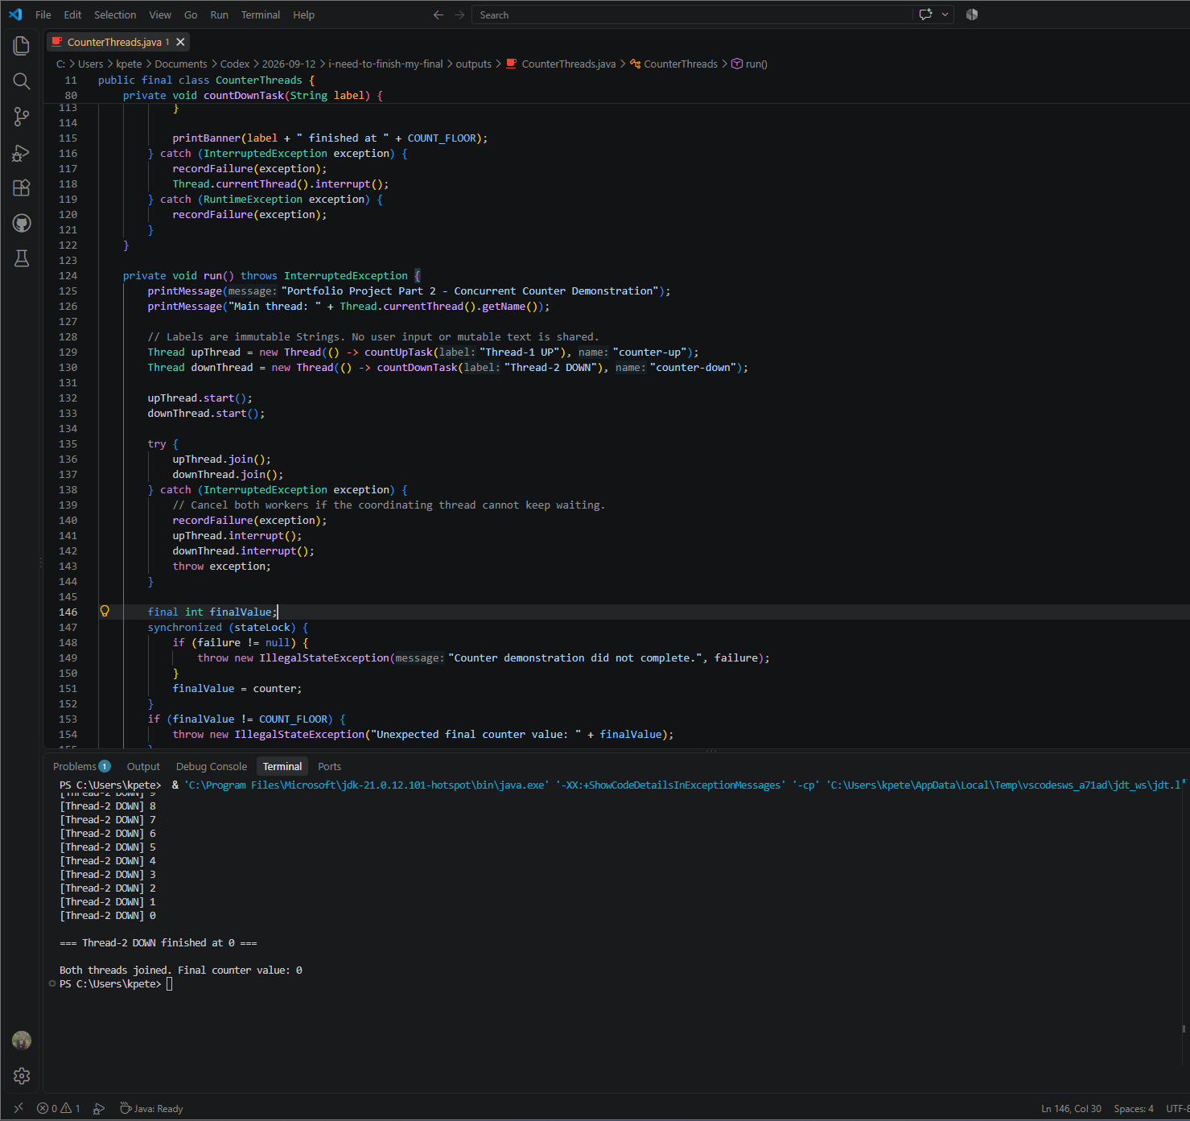
Note. The terminal shows the final countdown values, the completion banner, and a final shared counter value of zero after both threads join. The full output is reproduced on the following page.

Program Output
Compile: javac -Xlint:all CounterThreads.java
Run: java CounterThreads
Verified with Java 21: compilation, ordered output, interruption, and early notification.
Portfolio Project Part 2 - Concurrent Counter Demonstration
Main thread: main

=== Thread-1 UP starting: counting up to 20 ===
[Thread-1 UP] 1
[Thread-1 UP] 2
[Thread-1 UP] 3
[Thread-1 UP] 4
[Thread-1 UP] 5
[Thread-1 UP] 6
[Thread-1 UP] 7
[Thread-1 UP] 8
[Thread-1 UP] 9
[Thread-1 UP] 10
[Thread-1 UP] 11
[Thread-1 UP] 12
[Thread-1 UP] 13
[Thread-1 UP] 14
[Thread-1 UP] 15
[Thread-1 UP] 16
[Thread-1 UP] 17
[Thread-1 UP] 18
[Thread-1 UP] 19
[Thread-1 UP] 20

=== Thread-1 UP finished at 20 ===

=== Thread-2 DOWN starting: counting down to 0 ===
[Thread-2 DOWN] 20
[Thread-2 DOWN] 19
[Thread-2 DOWN] 18
[Thread-2 DOWN] 17
[Thread-2 DOWN] 16
[Thread-2 DOWN] 15
[Thread-2 DOWN] 14
[Thread-2 DOWN] 13
[Thread-2 DOWN] 12
[Thread-2 DOWN] 11
[Thread-2 DOWN] 10
[Thread-2 DOWN] 9
[Thread-2 DOWN] 8
[Thread-2 DOWN] 7
[Thread-2 DOWN] 6
[Thread-2 DOWN] 5
[Thread-2 DOWN] 4
[Thread-2 DOWN] 3
[Thread-2 DOWN] 2
[Thread-2 DOWN] 1
[Thread-2 DOWN] 0

=== Thread-2 DOWN finished at 0 ===

Both threads joined. Final counter value: 0

Analysis and Comparison of Java and C++ Implementations

Performance Issues with Concurrency
The first performance concept common to the Java and C++ applications is the dependency between their counting phases. Each performs 20 upward iterations followed by 21 downward iterations. Java starts both workers at lines 132 and 133, but the predicate at line 87 prevents the countdown from proceeding early. The C++ condition-variable predicate at line 76 enforces the same dependency. Additional cores cannot make these counting phases overlap. Both implementations request 25 ms of sleep per iteration, totaling 1.025 seconds of deliberate pacing. That figure is calculated from the source; it is not a measured execution time.
The second concept is runtime overhead. Java's Thread constructors create platform threads, typically backed by operating-system threads with associated stack and scheduling resources (Oracle, n.d.-g). The native C++ executable also creates two workers. Java additionally incurs JVM startup and class-loading costs, while HotSpot can optimize executed methods through tiered compilation (Oracle, n.d.-d). This brief workload offers little work over which to spread startup costs. Garbage collection introduces further throughput and pause-time tradeoffs, although no collection event was measured here (Oracle, n.d.-c). C++ avoids JVM startup, but these demonstrations establish no numerical performance advantage.
A fair comparison would measure separate variants with identical counting work and with pacing and per-value output disabled. Repeated trials should record compiler settings, verify the final result, and separate whole-process startup from execution inside a running process. Java steady-state measurements would also require warmup. The current screenshot and transcript demonstrate ordering and completion; their console output and intentional delays prevent a defensible language-speed ranking.

Synchronization, Shared State, and Failure Handling
The handoff demonstrates the relationship between waiting and shared-state visibility. Java waits on stateLock at line 88, while C++ waits on a condition_variable with a unique_lock. Both release the lock while waiting and reacquire it before continuing. Both recheck their predicates after spurious wakeups (Oracle, n.d.-e; ISO/IEC JTC1/SC22/WG21, 2017, section 33.5.3). The completion flag also preserves an earlier notification. Monitor release and reacquisition establish visibility; sleep provides no synchronization guarantee (Oracle, n.d.-a).
Lock scope affects both performance and correctness. Java updates the counter under stateLock at lines 59 and 109, then releases that lock before printing or sleeping. C++ follows the same pattern. Neither implementation nests its state and output locks, avoiding a circular dependency between those application locks. C++ uses notify_one after unlocking; Java uses notifyAll while locked. With one waiting worker, both wake the intended thread. Java prints its completion banner before signaling, while C++ can display the countdown banner first because its completion banner follows notification.
Java adds a failure record that the C++ submission lacks. recordFailure preserves the first handled exception and wakes the waiter; the coordinator checks that record before announcing success. Worker interruption handlers restore interrupt status. Both programs join their workers, and destroying a joinable C++ std::thread would invoke terminate (ISO/IEC JTC1/SC22/WG21, 2017, section 33.3.2.3). Java's explicit failure propagation improves this implementation, although C++ could adopt it. Remaining Java limitations include untimed joins and incomplete cleanup after thread-start failure. Bounded waiting, shared cancellation, and startup cleanup would address those limitations.

Vulnerabilities Exhibited with the Use of Strings
The string concept most directly exercised by the two implementations is ownership. C++ passes each std::string label by value, giving its worker a separate string object. Java shares references to immutable String literals at lines 129 and 130; their contents cannot be changed through the String API (Oracle, n.d.-f). Both approaches protect the labels in the submitted programs. A future C++ revision that borrowed a destroyed string could create a dangling reference. Java's managed references remove that ordinary manual-lifetime obligation.
Immutability does not establish safe interpretation of text. Neither program accepts external input, so its fixed labels provide no current injection path. If labels became user-controlled, embedded newlines could forge apparent output records, while terminal control characters could change the display. MITRE (n.d.) identifies improper output neutralization as a log-forging weakness. An extension should restrict label length and permitted characters and encode text for its destination. Credentials should also remain outside these messages: an immutable String cannot be overwritten in place to satisfy an explicit erasure requirement.
String construction also affects resource use. Java constructs complete message values before calling printMessage, whereas C++ streams labels and integers under its output mutex. Java's temporary messages contribute allocation work; C++ strings manage storage through their object lifetimes. Unrestricted input or high-frequency logging would increase these modest allocation costs. Both protect worker output. Java routes its title and summary through the same helper; C++ safely prints those messages before worker creation and after the joins. Java centralizes that output protection.

Security of Data Types and Overall Assessment
Java int and C++ std::int32_t are signed, and both programs restrict the shared value to zero through 20. After printing zero, the local loop variable becomes negative one and the loop stops; the shared value remains zero. An unsigned C++ loop could instead wrap and continue indefinitely. Java signed overflow wraps, while C++ signed overflow produces undefined behavior (Oracle, n.d.-b; ISO/IEC JTC1/SC22/WG21, 2017, section 8). Current constants avoid overflow. Future runtime limits should be validated, with termination checked before an increment can exceed the type's maximum.
The second safeguard is coordinated access to mutable state. Java's int assignment is indivisible, but that property alone cannot coordinate counter, upPhaseDone, and failure. One monitor protects those fields, and the snapshot at line 93 must equal 20 before countdown. The coordinator checks zero after both joins. C++ similarly guards its counter and completion flag with one mutex. Its std::chrono::milliseconds also carries a duration unit in its type; Java relies on the STEP_DELAY_MILLIS name and sleep method contract. These protections address different risks and remain necessary alongside memory management.
Java can be considered less vulnerable to accidental memory-lifetime and mutable-string errors because managed references and immutable Strings reduce maintenance responsibilities. The C++ submission nevertheless uses appropriate string ownership and scoped locking, and these executions demonstrate no exploitable memory defect. Both applications have a small present attack surface because they accept no external input. Java provides a broader default memory-safety margin; correct bounds, synchronization, input handling, and failure policy remain essential in either language.

Git Repository
Java source and project repository:
CSC450_CT8 / CounterThreads.java
C++ milestone repository:
CSC450_CT7
The accompanying CounterThreads.java file contains the complete source without document line numbers. The C++ line references in the comparison refer to counter_threads.cpp as reproduced in the Module 7 submission.

References
ISO/IEC JTC1/SC22/WG21. (2017). Working draft, standard for programming language C++ (N4659). https://www.open-std.org/jtc1/sc22/wg21/docs/papers/2017/n4659.pdf
MITRE. (n.d.). CWE-117: Improper output neutralization for logs. https://cwe.mitre.org/data/definitions/117.html
Oracle. (n.d.-a). Chapter 17. Threads and locks. The Java Language Specification, Java SE 21 Edition. https://docs.oracle.com/javase/specs/jls/se21/html/jls-17.html
Oracle. (n.d.-b). Chapter 4. Types, values, and variables. The Java Language Specification, Java SE 21 Edition. https://docs.oracle.com/javase/specs/jls/se21/html/jls-4.html
Oracle. (n.d.-c). Introduction to garbage collection tuning. Java Platform, Standard Edition HotSpot Virtual Machine Garbage Collection Tuning Guide, Release 21. https://docs.oracle.com/en/java/javase/21/gctuning/introduction-garbage-collection-tuning.html
Oracle. (n.d.-d). Java HotSpot virtual machine performance enhancements. Java Platform, Standard Edition Java Virtual Machine Guide, Release 21. https://docs.oracle.com/en/java/javase/21/vm/java-hotspot-virtual-machine-performance-enhancements.html
Oracle. (n.d.-e). Object. Java Platform, Standard Edition 21 API Specification. https://docs.oracle.com/en/java/javase/21/docs/api/java.base/java/lang/Object.html
Oracle. (n.d.-f). String. Java Platform, Standard Edition 21 API Specification. https://docs.oracle.com/en/java/javase/21/docs/api/java.base/java/lang/String.html
Oracle. (n.d.-g). Thread. Java Platform, Standard Edition 21 API Specification. https://docs.oracle.com/en/java/javase/21/docs/api/java.base/java/lang/Thread.html

