1)
CODE :

<!DOCTYPE html>
<html>
<head>
<style>

</style>
<title> Question 1 :</title>
</head>

<body>

<table border="3" bordercolor="black">

<tr>
<td>
<h3>Nested Table 1</h3>
<table border="1" bordercolor="black">
<tr>
<td>Column 1</td>
<td>Column 2</td>
</tr>
<tr>
<td>col 1 data</td>
<td>col 2 data</td>
</tr>
</table>

</td>
<td>
<h3>Nested Table 2</h3>
<ol>
<li>List Object 1</li>
<li>List Object 2</li>
<li>List Object 3</li>
</ol>
</td>
</tr>
<tr>
<td>
<h3>Nested Table 3</h3>
<a href = 'new_pg.html' > click here</a>
</td>
<td>
<h3>Nested Table 4</h3>
<img src="./images/computer.jpg" alt="" width = 100 height="100"></td>
</tr>
</table>

</body>
</html>

- SCREENSHOT :
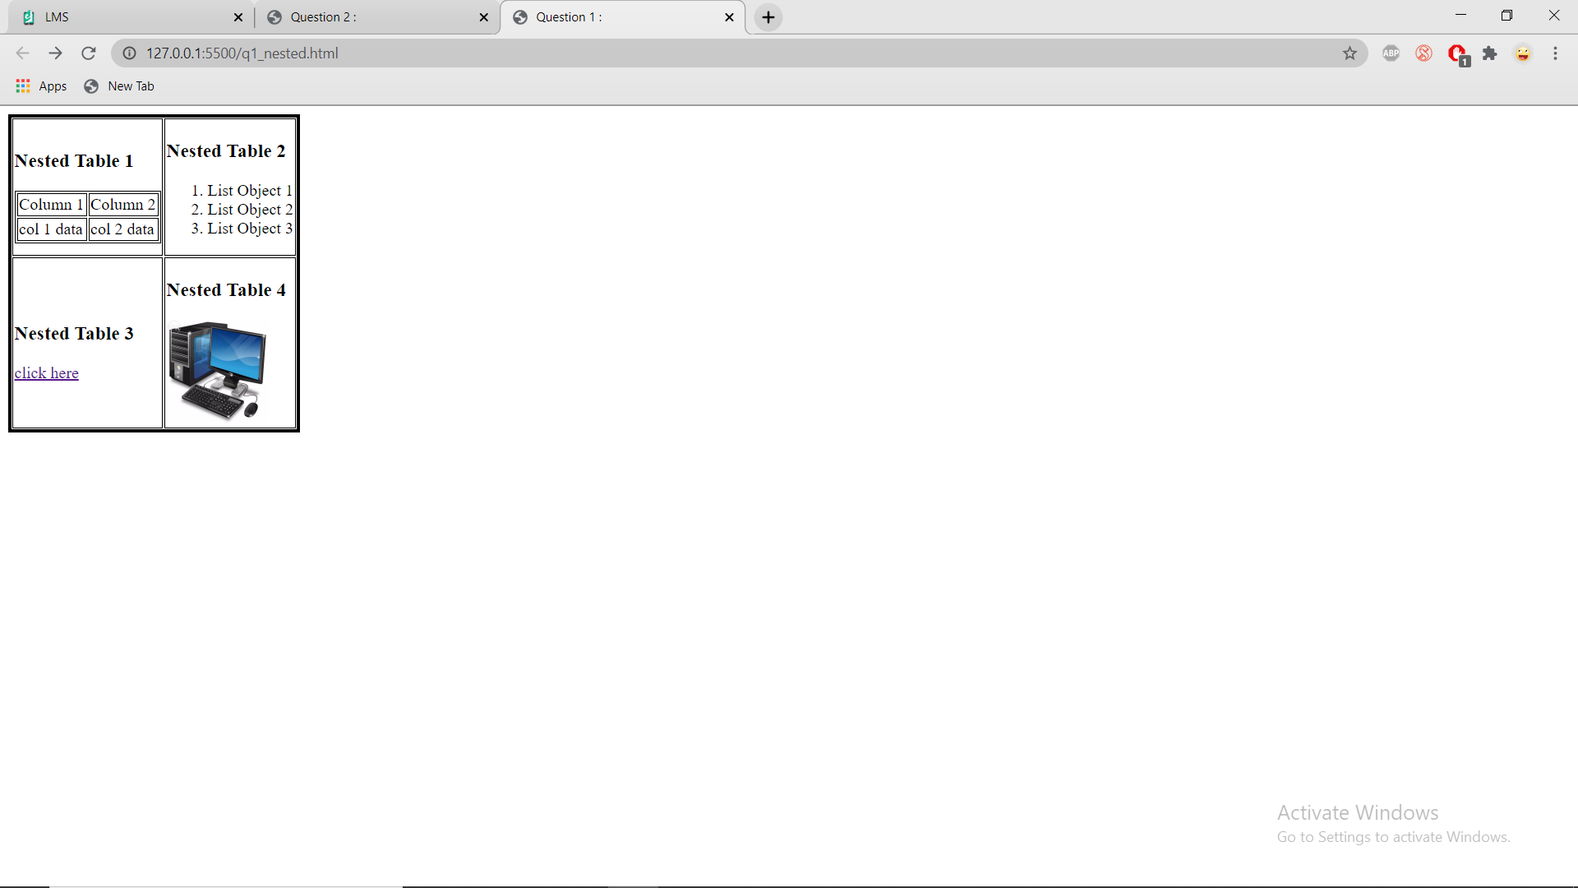

2 ) CODE :
<!DOCTYPE html>
<html lang="en">
<head>
<meta charset="UTF-8">
<meta name="viewport" content="width=device-width, initial-scale=1.0">
<title> Question 2 :</title>
</head>
<body>

<table border="3" bordercolor="black">

<tr>
<td> SLOTS : </td>
<td> SLOT 1 </td>
<td> SLOT 2 </td>
<td> SLOT 3 </td>
<td> SLOT 4</td>
<td> SLOT 5 </td>
<td> SLOT 6 </td>
<td> SLOT 7 </td>
<td> SLOT 8</td>
</tr>

<tr>
<td> TIMING :</td>
<td> 9.00AM to 10.00AM </td>
<td> 10.00AM to 11.00AM </td>
<td> 11.00AM to 12.00PM</td>
<td> 12.00PM to 1.00PM</td>
<td> 1.00PM to 2.00PM </td>
<td> 2.00PM to 3.00PM </td>
<td> 3.00PM to 4.00PM</td>
<td> 4.00PM to 5.00PM</td>
</tr>

<tr>
<td>MONDAY</td>
<td>Maths</td>
<td>Physics</td>
<td>Free</td>
<td>Physics</td>
<td>LUNCH</td>
<td>Programming</td>
<td>Free</td>
<td>Free</td>

</tr>

<tr>
<td>TUESDAY</td>
<td>Chemistry</td>
<td>Maths</td>
<td>Physics</td>
<td>Programmin</td>
<td>LUNCH</td>
<td>Chemistry</td>
<td>Maths</td>
<td>Programming</td>
</tr>

<tr>
<td>WEDNESDAY</td>
<td>Maths</td>
<td>Chemistry</td>
<td>Programming</td>
<td>Maths</td>
<td>LUNCH</td>
<td>Physics</td>
<td>Maths</td>
<td>Physics</td>
</tr>

<tr>
<td>THURSDAY</td>
<td>Maths</td>
<td>Maths</td>
<td>Physics</td>
<td>Chemistry</td>
<td>LUNCH</td>
<td>Free</td>
<td>Maths</td>
<td>Maths</td>
</tr>

<tr>
<td>FRIDAY</td>
<td>Physics</td>
<td>Programming</td>
<td>Chemistry</td>
<td>Maths</td>
<td>LUNCH</td>
<td>Chemistry</td>
<td>Maths</td>
<td>Physics</td>
</tr>

</table>

</body>

</html>

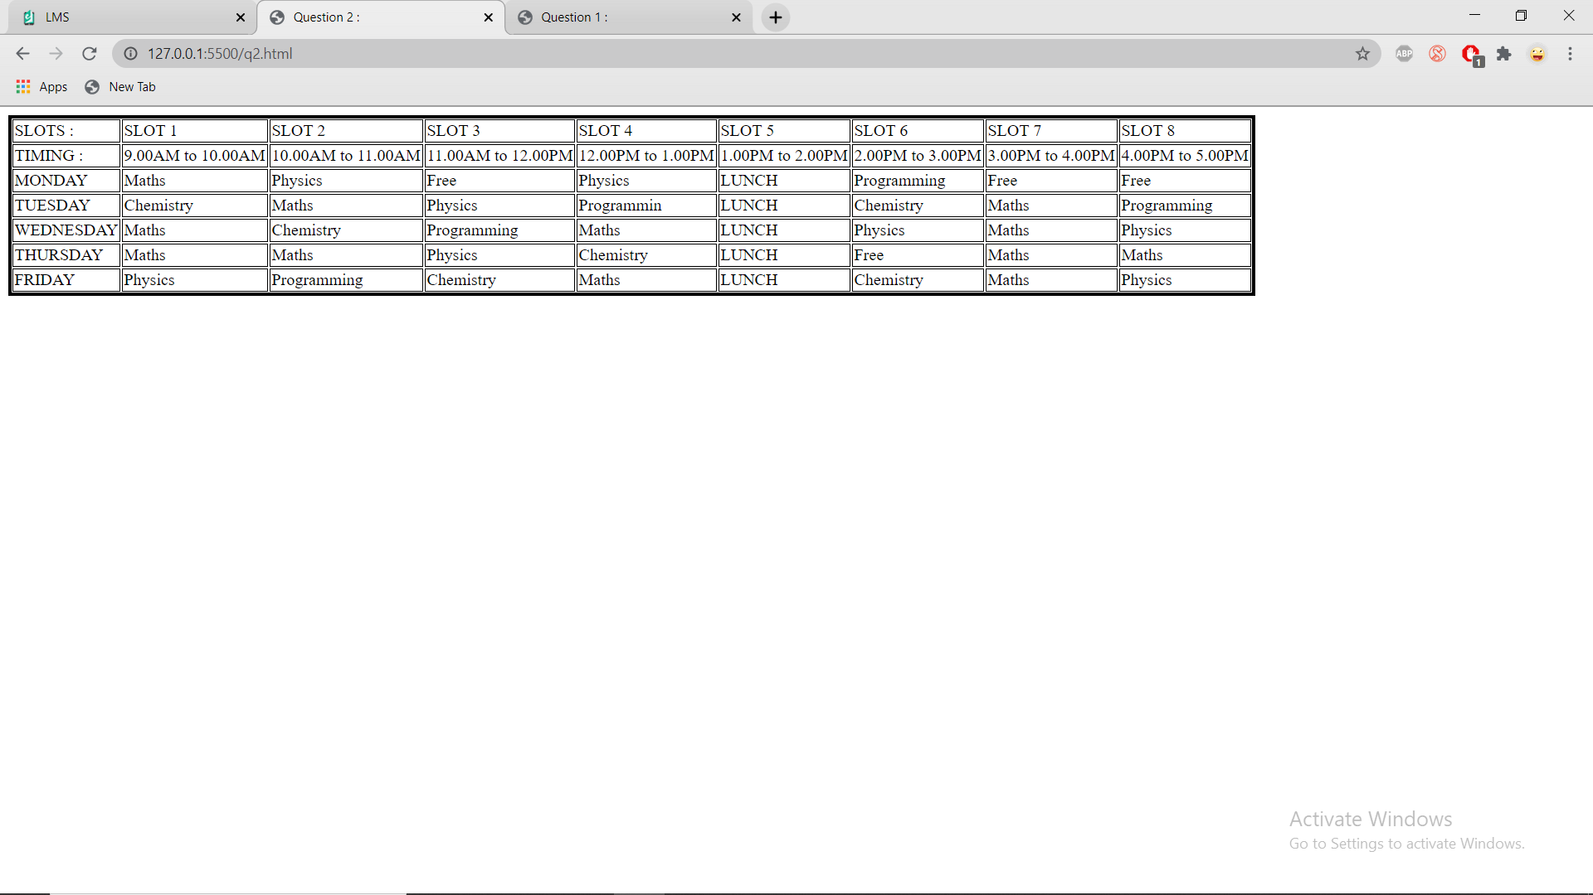

4)CODE :

Q4.html :
<!DOCTYPE html>
<HTML>
<HEAD>
<TITLE>Forms and frames</TITLE>
</HEAD>
<FRAMESET cols="50%, 50%">
<FRAMESET rows="400, 400">
<FRAME src="frame3.html">
<FRAME src="frame1.html">
</FRAMESET>
<FRAME src="frame2.html">
<NOFRAMES>
<P>This frameset document contains:
<UL>
<LI><A href="frame1.html">Some neat contents</A>
<LI><IMG src="frame2.gif" alt="A neat image">
<LI><A href="frame3.html">Some other neat contents</A>
</UL>
</NOFRAMES>
</FRAMESET>
</HTML>

Frame1.html :
<!DOCTYPE html>
<title>
<head> Application Form !!</head>
</title>

<body >
<div>
<h1 style = "text-align: center;">Personal Information !!!</h1>
<br><br>
<form>
<label for="fname">First name:</label>
<input type="text" id="fname" name="fname" placeholder="Enter First name" required>
<br>
<br>
<br>
<label for="mname">Middle name:</label>
<input type="text" id="mname" name="mname" placeholder="Enter Middle name" required><br><br>
<br>
<br>

<label for="lname">Last name:</label>
<input type="text" id="lname" name="lname" placeholder="Enter Last name" required><br><br>
<br>
<br>

<label for="email">Email ID:</label>
<input type="email" id="email" name="email" placeholder="Enter email id" required><br><br>
<br>
<br>

</form>
</div><br>

</body>
</html>

Frame2.html :
<!DOCTYPE html>

</style>
<body>
<div>
<h1 style = "text-align: center;">Information regarding the Job !!!</h1>
<form>
<label for="Position">Departmental Roles in the Comapany ! </label>
<br>
<br>
<div class="dropdown" style = "border-radius: 8px;">
<select id="role" name ="choice">
<option value="Database Manager">Database Manager</option>
<option value="Android Developer">Android Developer</option>
<option value="Analyst">Analyst</option>
</select>
<br><br>
</div>
<label for = "Food Allowances !">Food Allowances</label>
<input type="number" id="wage" name="wage" required><br><br>
<label for = "Date of Joining">Joining Data</label>
<input type="date" id="date" name="date" required>
<br>
<br>
<label for = "Weekly Hours">Weekly Hours</label>
<input type="number" id="hours" name="hours" required><br><br>

</form>
</div>
</body>
</html>

Frame3.html:
<!DOCTYPE html>
<body>
<div>
<h1 style = "text-align: center;">Educational Qualification !!!</h1>
<br><br>
<form>
<label for="sname">Institution Name </label>
<input type="text" id="iname" name="iname" placeholder="Enter Name of the Institution" required>
<br>
<br>

<label for="pers">10th %</label>
<input type="number" id="tenmark" name="tenmark" placeholder="Enter score in 10th" required>
<br>
<br>

<label for="ssname">12th %</label>
<input type="number" id="twemark" name="twemark" placeholder="Enter score in 12th" required>
<br>
<br>

<label for="email">Enter the hobbies:</label>
<input type="text" id="email" name="email" placeholder="Enter the hobbies:" padding: 20%;>
<br>
<br>
<br>

<input type = "submit" value = "submit" >

</form>
</div><br>

</body>
</html>

4) SCREENSHOT :
