Design review

Peer and Message Class

Shaonan Wang

Swarm Team

Package Diagram

Listener

Generator

Sender

Chat

Peer

Swarm

Parser

UI

Class Diagram

Peer class

Holds information of a peer (a machine) and interfaces for other teams.

MessageGenerator class

Make different types of XML messages for other classes.

Such as messages for updating swarm, chatting, set master and backup, etc.

MessageParser class

Parse different types of XML messages for other classes.

When a message coming, it will find out what is the message type and do proper operations.

Public Interface

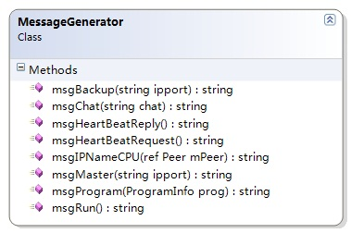

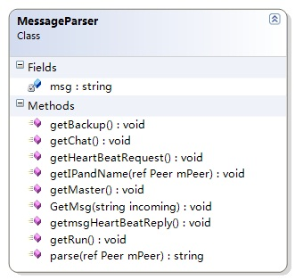

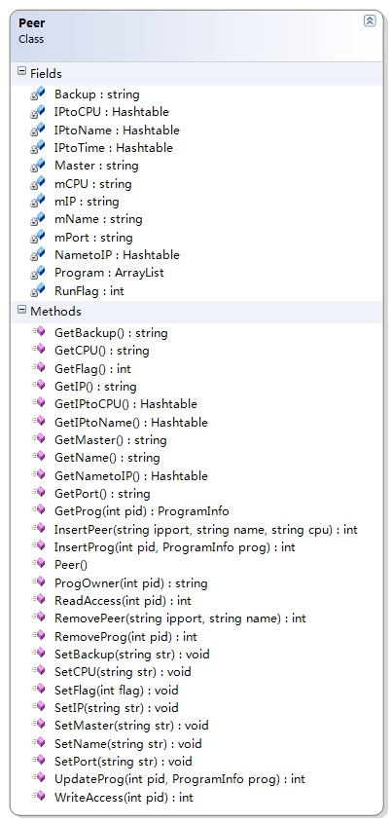

Current Status

*Completed:*

Peer class;

Define messages protocol;

Generate and parse messages for update peer class between different machines;

Generate and parse messages for chatting;

Generate and parse messages for broadcasting Master and Backup machine;

Generate and parse messages for heart beating;

*Not completed:*

Generate and parse messages for swarm;

Program Info class;