Report View:

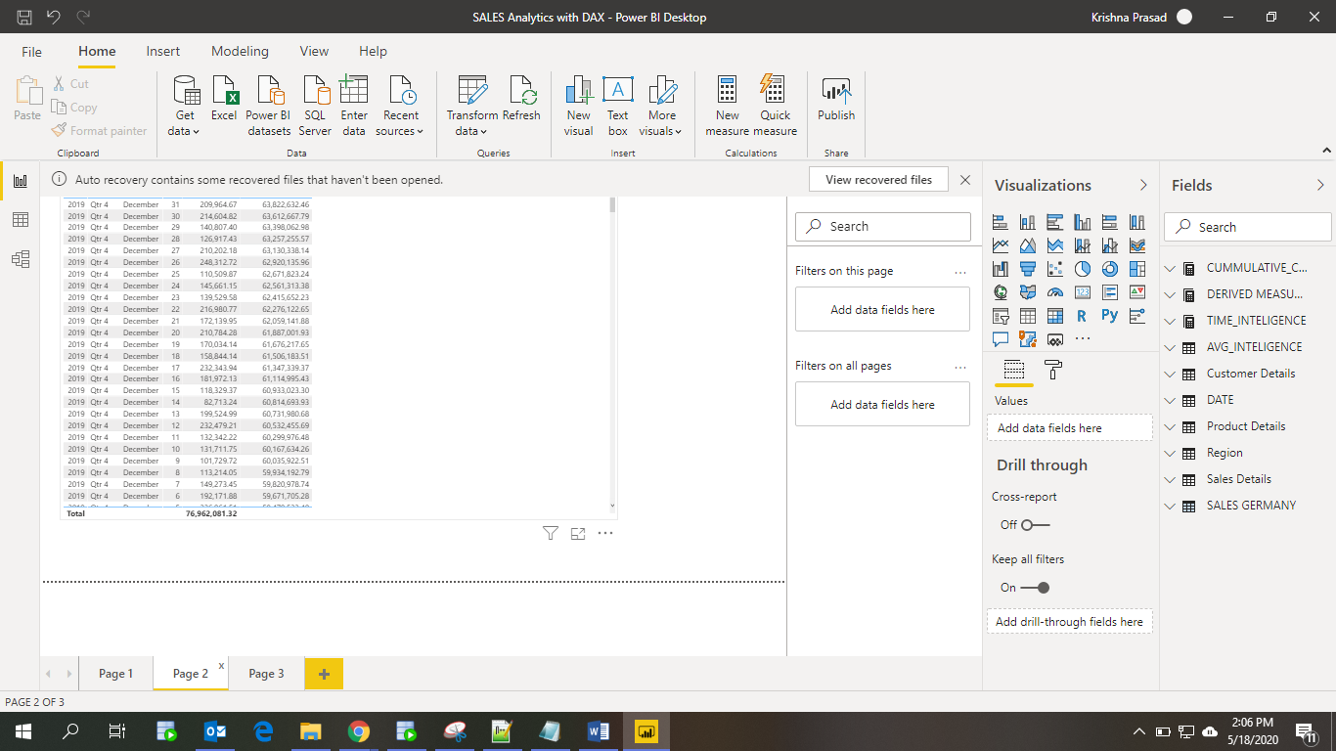

Data View:

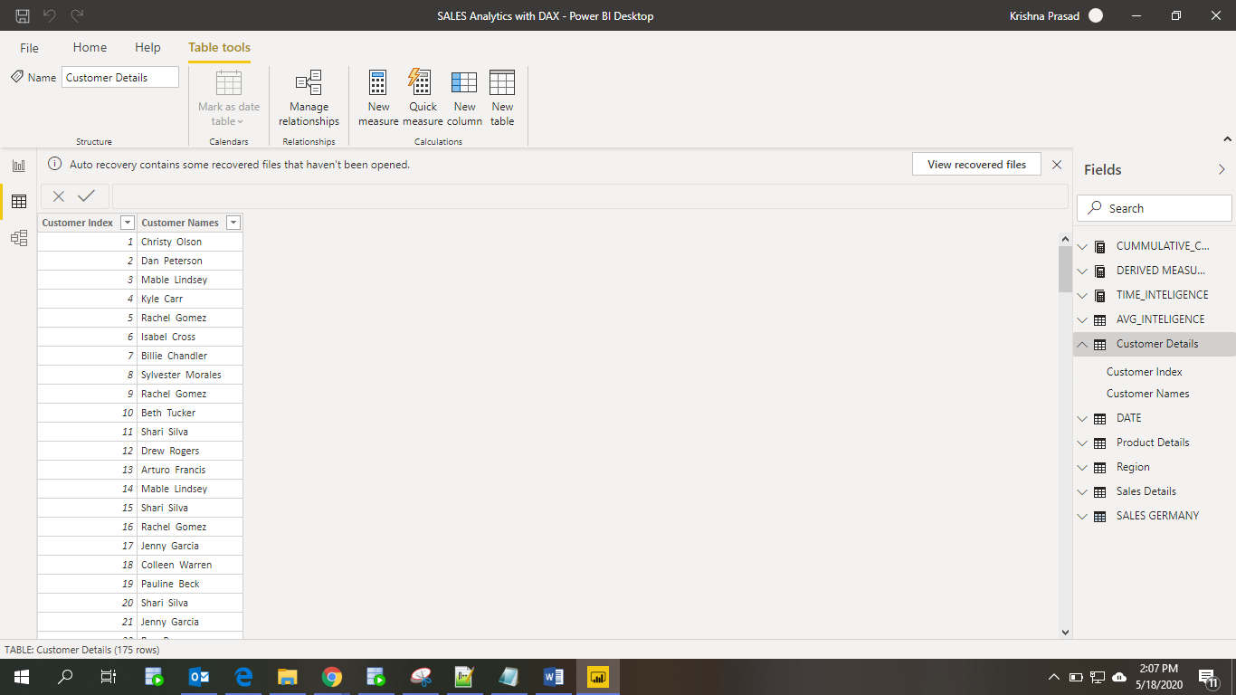

Model View:

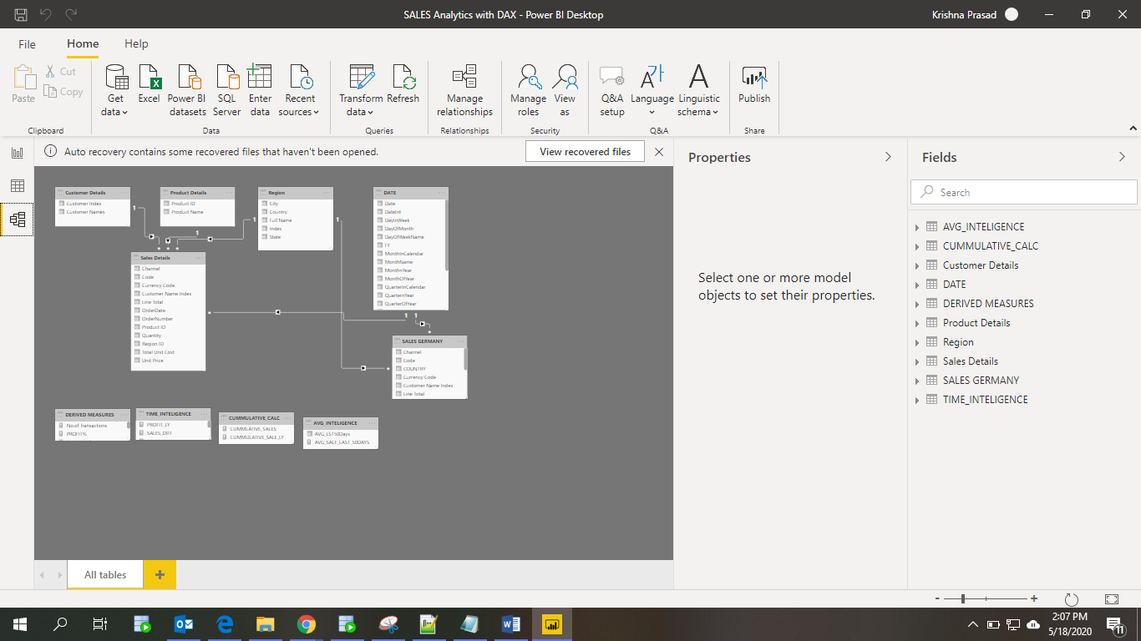

Power Query Editor:

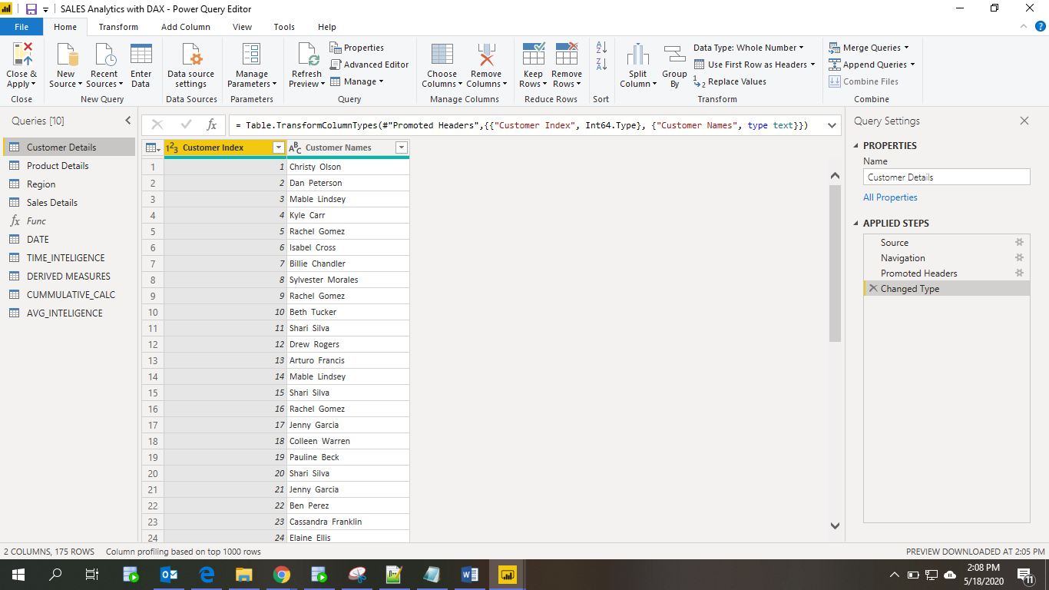

Advance Editor:

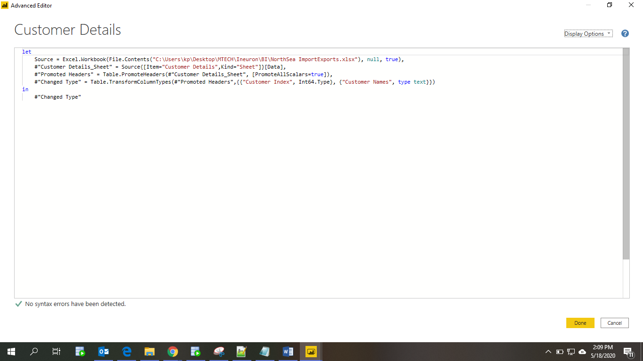

**Prepare a document with details of the following along with their price**

* **Power BI Desktop**: This offering is free to any single user and includes data cleaning and preparation, custom visualizations and the ability to publish to the Power BI service.
* **Power BI Pro**: The Pro plan costs $9.99/user/month. It includes data collaboration, data governance, building dashboards with a 360-degree real-time view and the ability to publish reports anywhere. Users can try it a free trial for 60 days before purchasing the subscription.
* **Power BI Premium:** The Premium plan starts at $4,995 a month per dedicated cloud compute and storage resource.