**Work through the following materials this week, making sure that you can do the given activities. This unit is a more extended treatment of the material on database modeling covered in CS 262.**

1. **Read Chapter 3.**
   1. **Compare and contrast the database and the software design processes. Are agile modeling practices applicable to database design as well?**In the agile process you start with the initial requirements and expand on them when it is needed. The agile process is applicable.
   2. **Explain the following terms: *entities*, *relationships* (including cardinality and participation constraints), *attributes* (simple, composite, multi-valued and derived).  
      Entities:** a thing or object in the real world with an independent existence. **Relationships:** defines a set of associations or a relationship set among entities form these entity types.  **Relationships cardinality restraint:** similar to every person has only one mother, or every document must have at least an author but possibly many. **Relationships participation restraint:** whether the existence of an entity depends on its being related to another entity via the relationship space. Minimum cardinality constraint. **Attributes:** specifies type of data of any object.   
      **Attributes Composite vs Simple:** simple cannot be divided. Composite can be made up using a hierarchy. **Attributes Multi-valued vs Single Valued:** single value for entity. Ex. age. **Multivalued:** Multiple values for entity. Ex. Degrees.  
      **Attributes Stored vs Derived:** derived ex. Age from birthdate.
   3. **Explain *weak entities* and *identifying relationships*.  
      Weak entities:** does not have a key attribute. Uses foreign keys to identify itself. Can olny exist if something else exists.  
      **Identifying relationships:** child table cannot be uniquely identified without the parent.
   4. **Model a person-household database (from class 2) using an ERD.**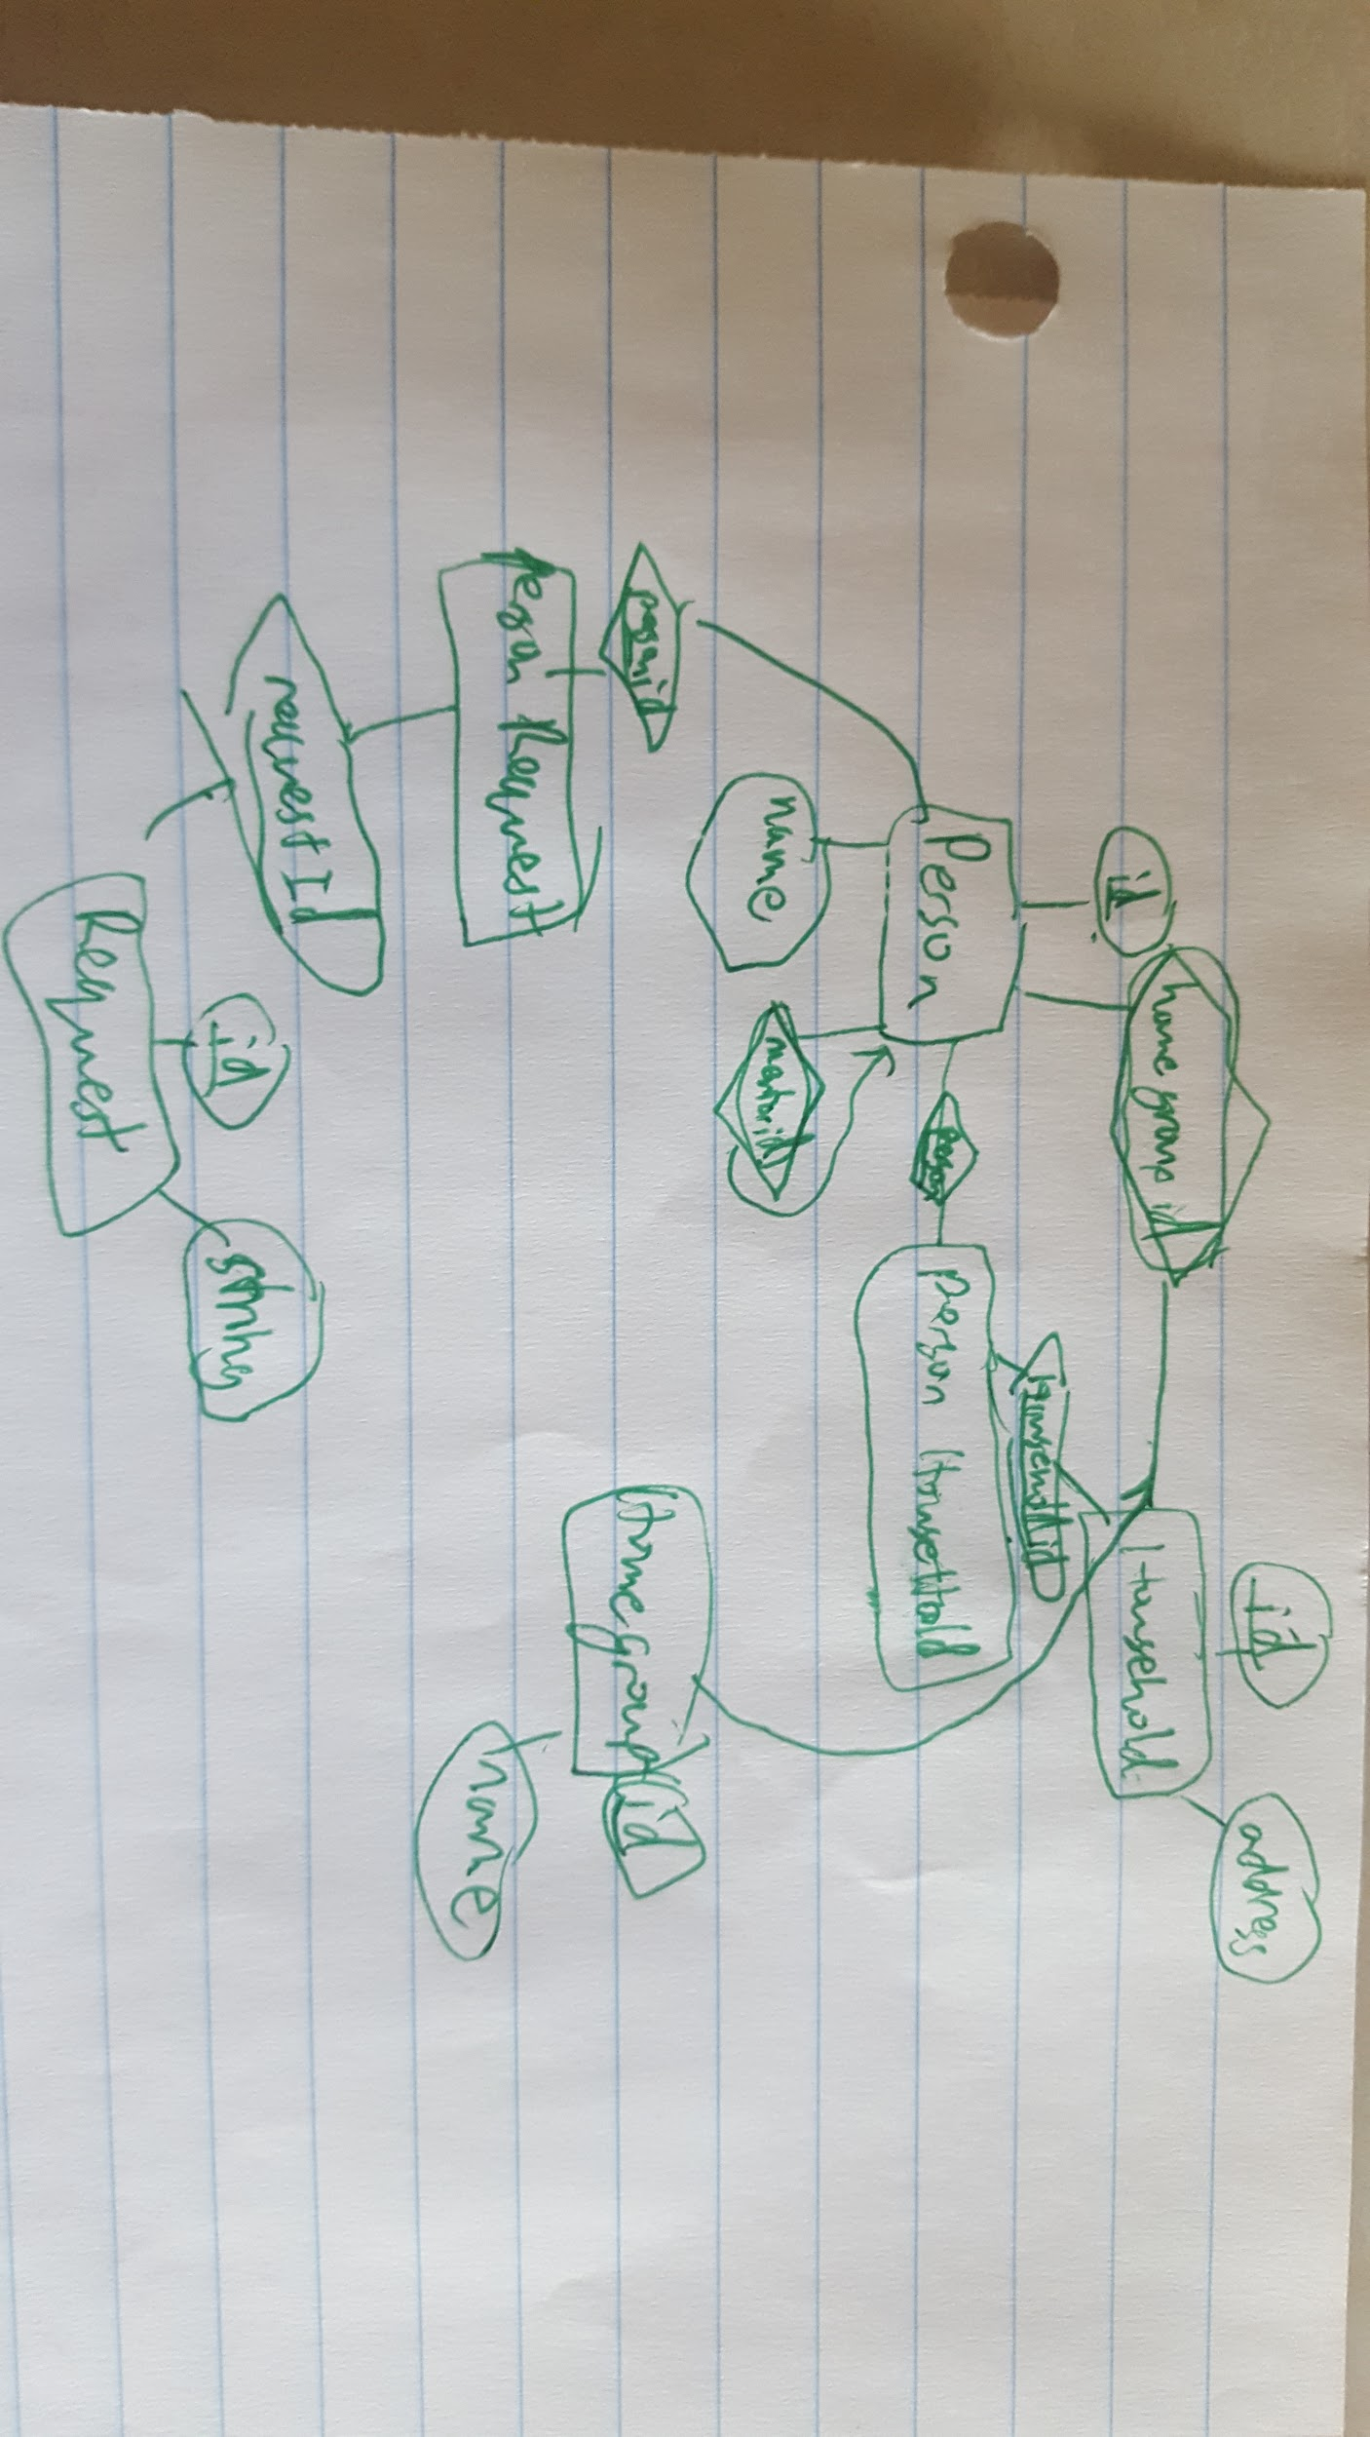
   5. **Skim the material in Section 3.8 on UML diagrams; we won’t use it here but we have addressed it in CS 262 and will review it in unit 11.**
2. **Note the ERD reference sheet in Figure 3.14.**
3. **Read Chapter 9.**
   1. **Map the ERD model from above to a relational database model.**Person(id, firstName, lastName, mentorId, homeGroupId)  
      PersonHouseHold(personId, houseHoldId);  
      HouseHold(id, address);  
      PersonRequest(personId, requestId);  
      Request(id, requestString);  
      HomeGroup(id, name);
   2. **Explain how to map from a UML model to a relational database model. We will address this issue more carefully in a later unit (on object-relational mapping).**From a UML model you can use software to automatically translate a UML to a relational database model. You can also translate it yourself.