Using an Arduino protoshield for a CAN interface for OpenLCB

by Tim Hatch

To get started using the Arduino, download the software for a basic OpenLCB node from the OpenLCB code repository. Build it within the Arduino Integrated Development Environment. The software can be run on any Arduino compatible board, but to communicate with others you need to have the Controller Area Network (“CAN”) hardware attached. To complete a fully operational basic OpenLCB node it is a must to have a CAN bus.
An Arduino compatible board usually does not come with a CAN interface. However, it is not difficult to construct one on a prototype shield, while still leaving lots of space for other functions.
As stated in the OpenLCB web site, there are several versions of CAN hardware available or under development for the Arduino. All of these use the Microchip MCP2515/MCP2551 chip set, and are compatible with the standard CAN library. This article will explain how to use the Arduino protoshield #A000024. It lends itself to an easy CAN shield for the Arduino development boards. The article will lead you step by step to completion of the board for just the CAN interface. There will be more to come for the Button LED consumer, producer with Blue/Gold LED and buttons.

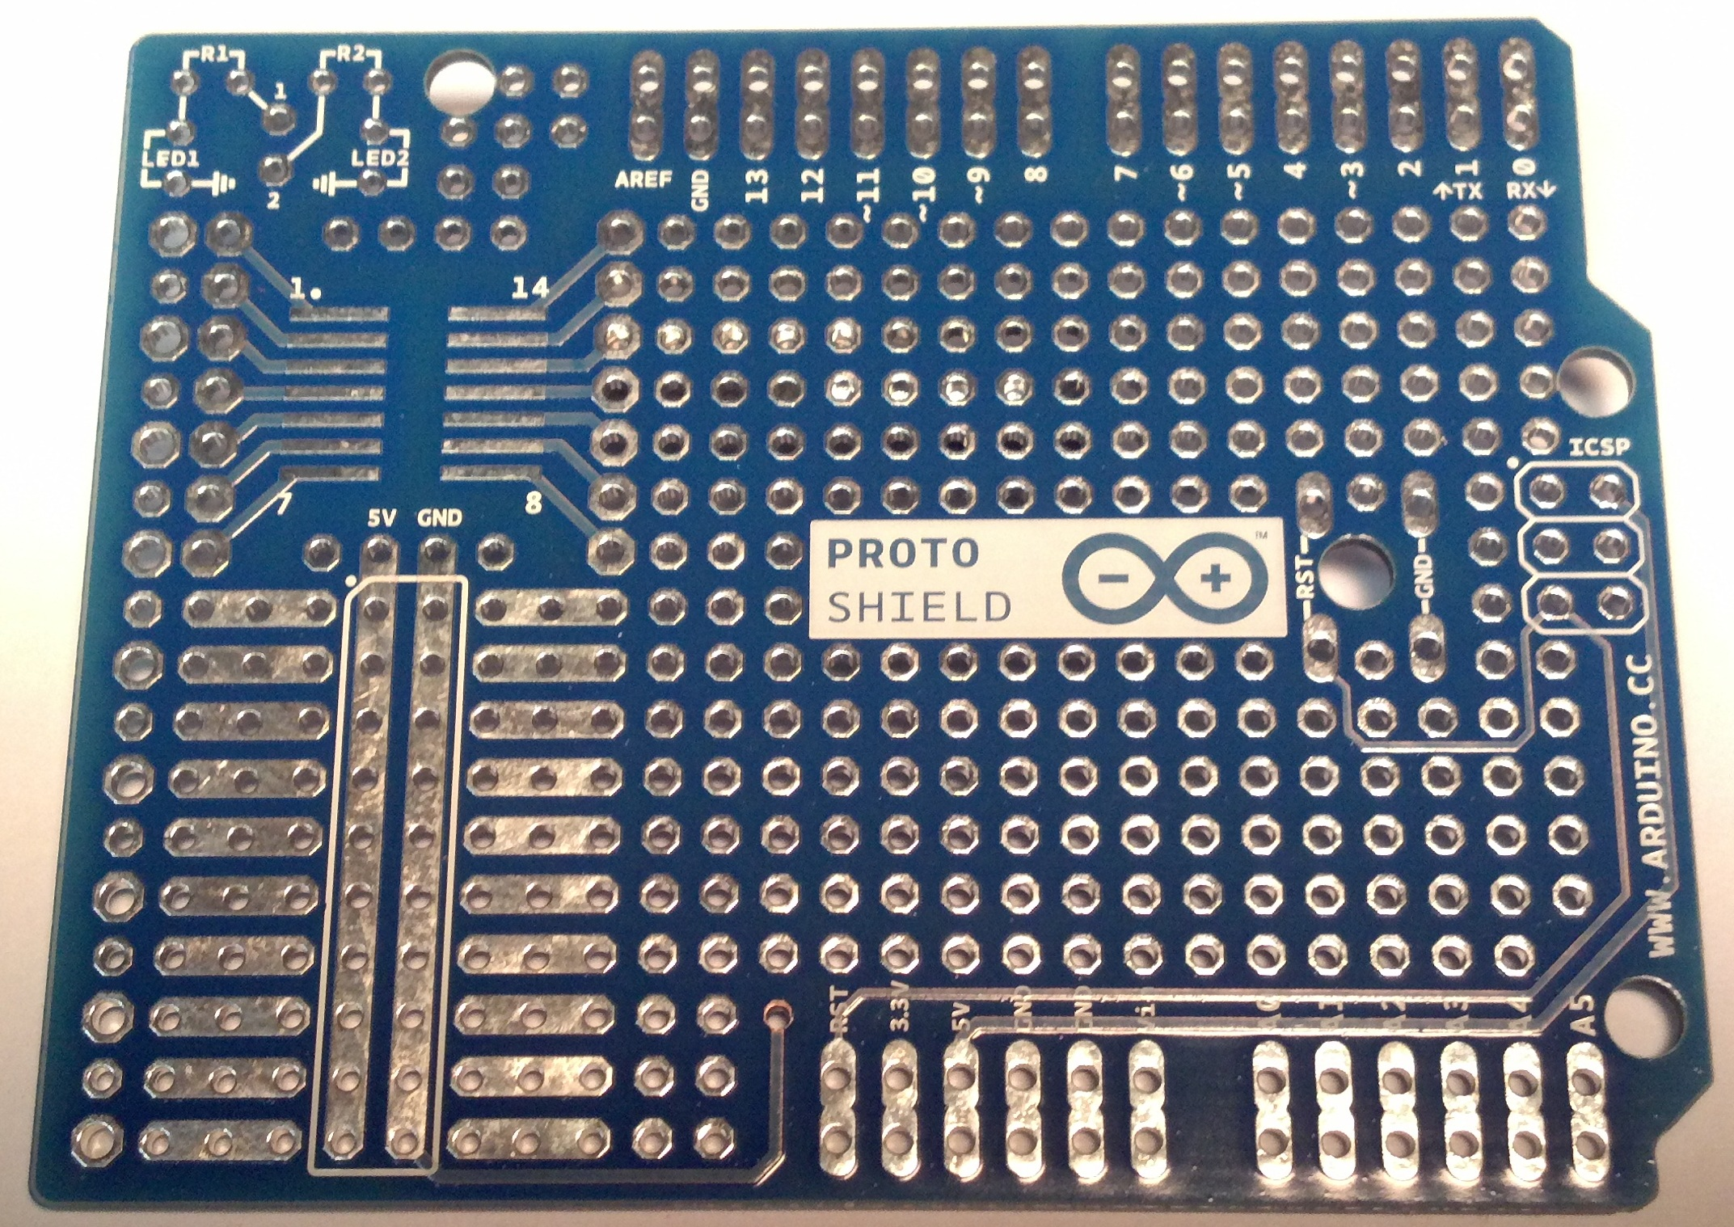

Parts list

Starting out with the soldering of the MCP2551 SOIC surface mount IC. Observing the picture below.

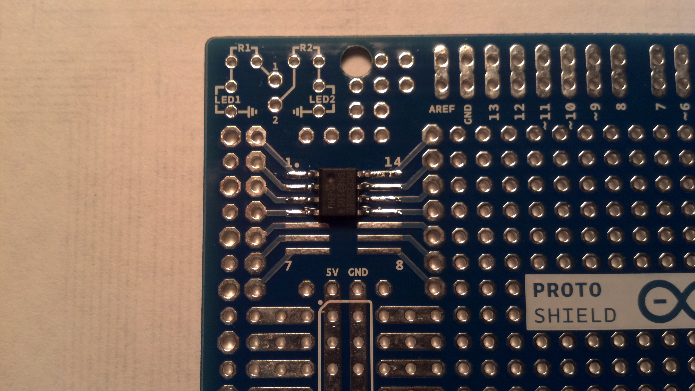
Next install the 18 pin socket for the MCP2551 IC and the 10k resistor between pin 18 and 17. Also install the 100k pin 8 and ground for the MCP2515 IC.

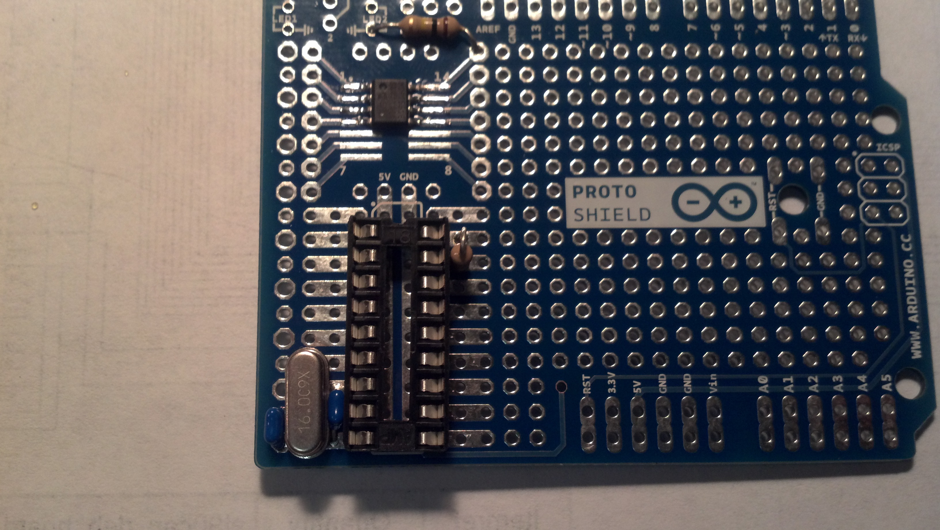
Installing the crystal and the 18 pf capacitors is a little tricky. The crystal is installed to pin 7 and 8. The two 18pf capacitors go between pins 7 and 9 and pins 8 and 9.

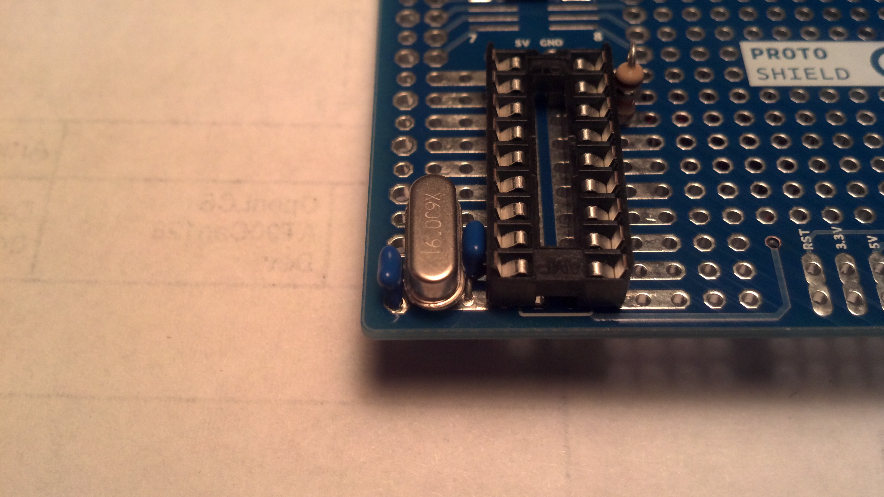
On the bottom of the board solder a jumper wire between the ground pad and pin 10.

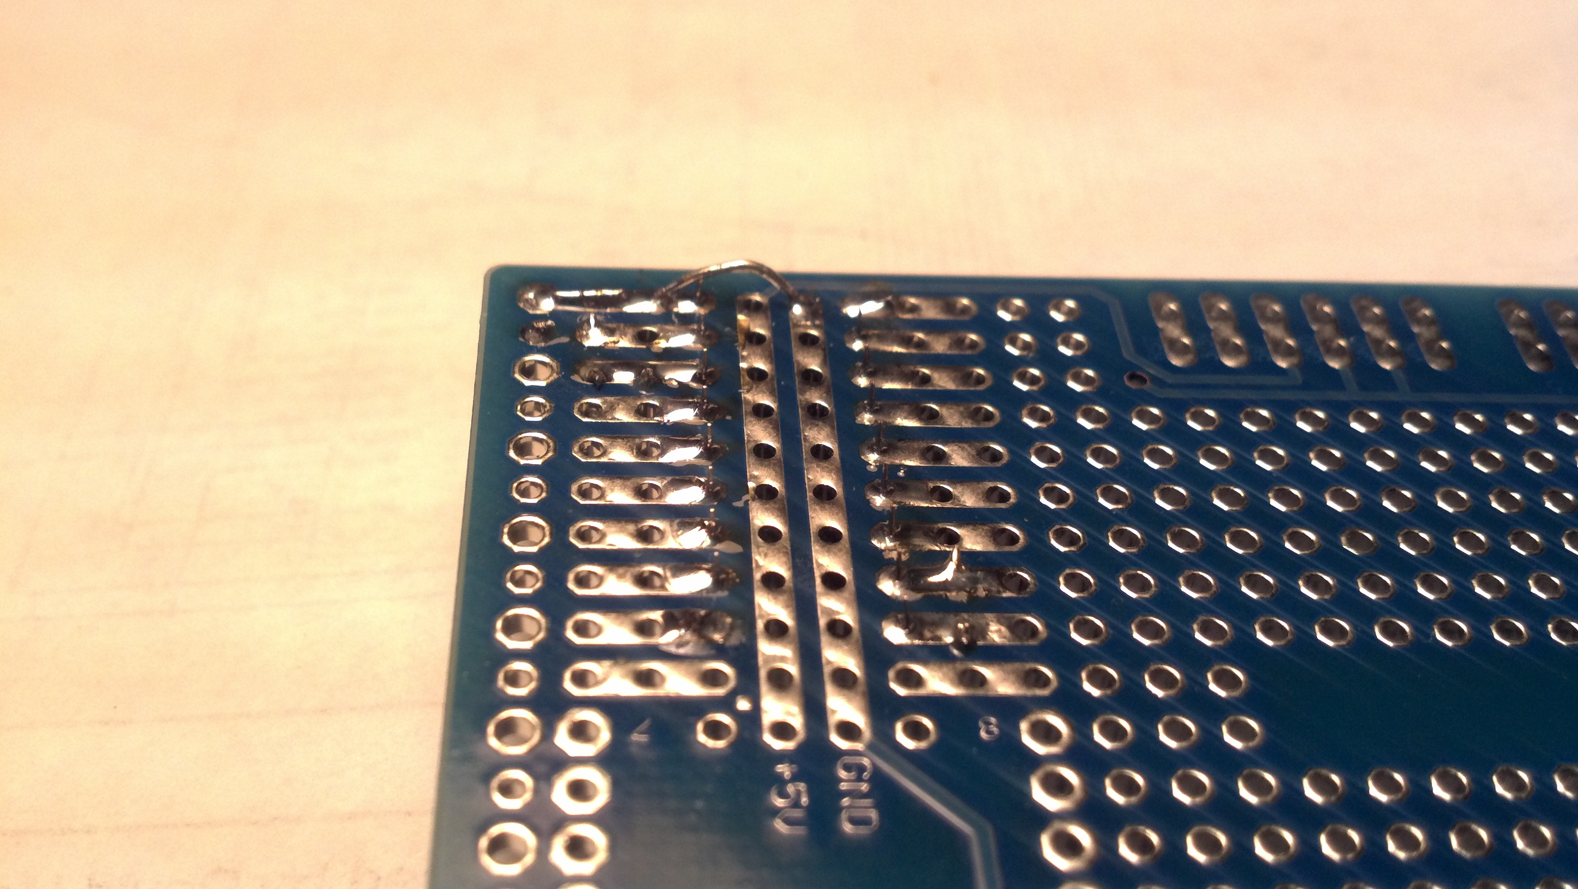

Now it is time to use the #30 wire wrap. Solder a piece of blue wire to pin 16 of the MCP2515 to the Arduino shield pin #10.

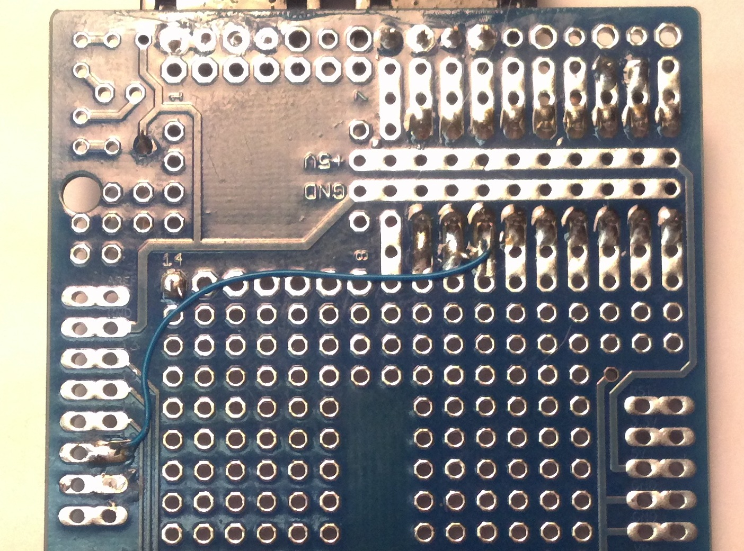
Solder a blue wire to pin 15 of the MCP2515 to the Arduino shield #12.

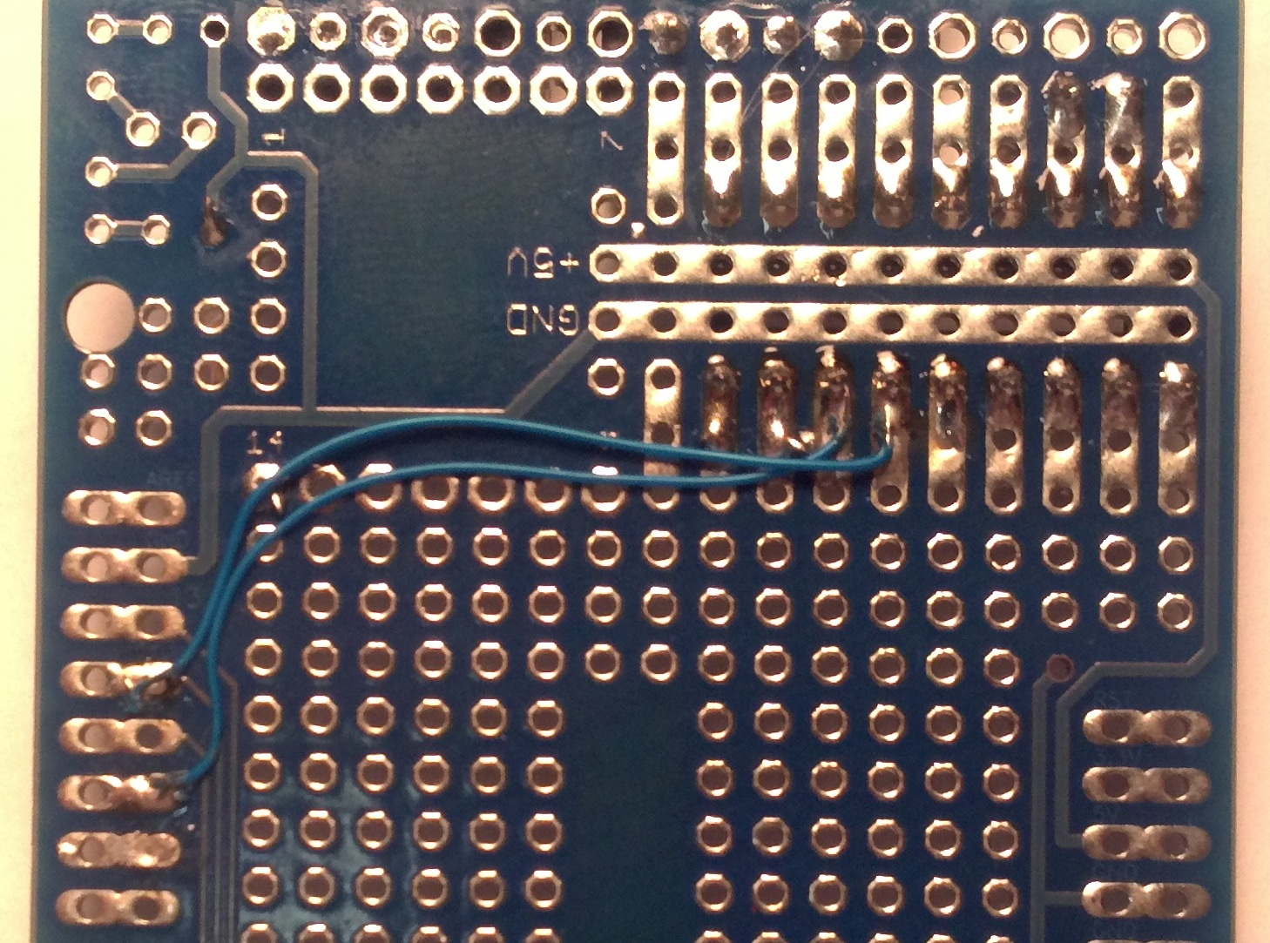

Pin 14 of the MCP2515 to Arduino shield #11

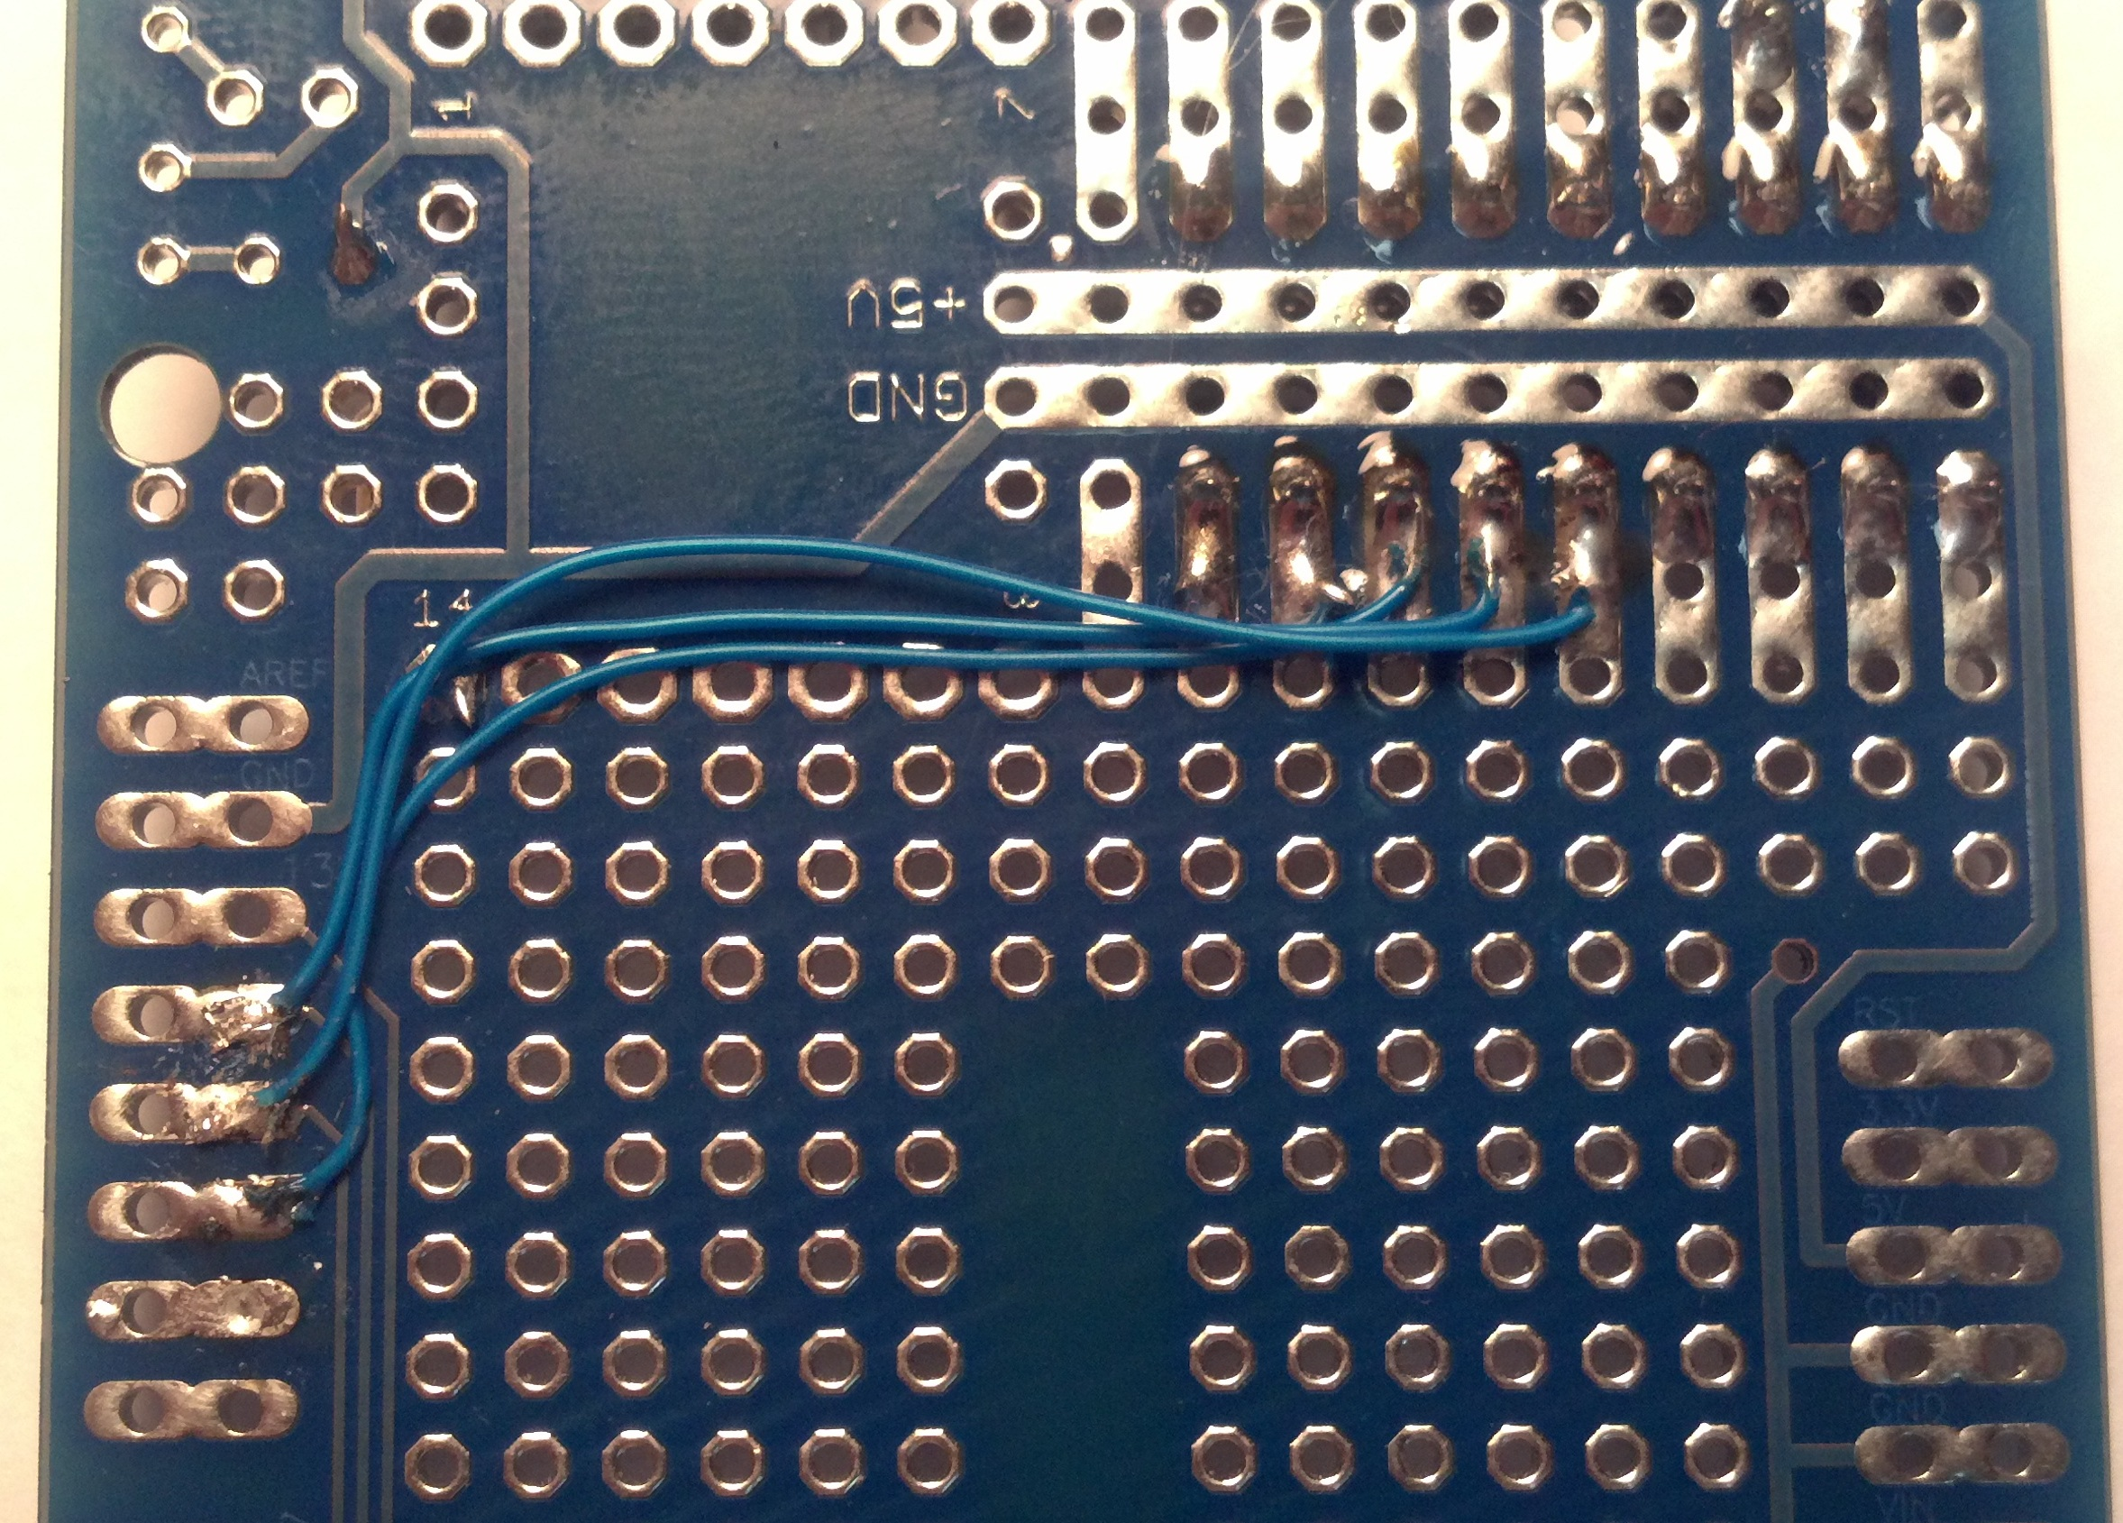
Pin 13 of the MCP2515 to Arduino shield #13.

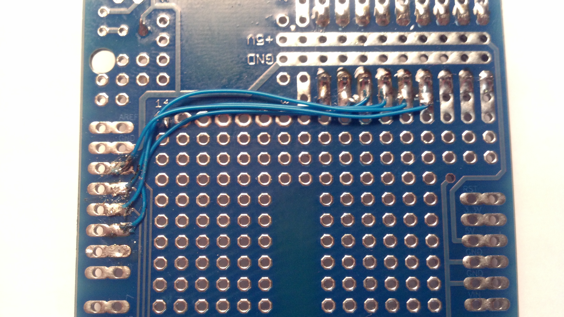
Solder Pin 12 of the MCP2515 to Arduino shield #3.

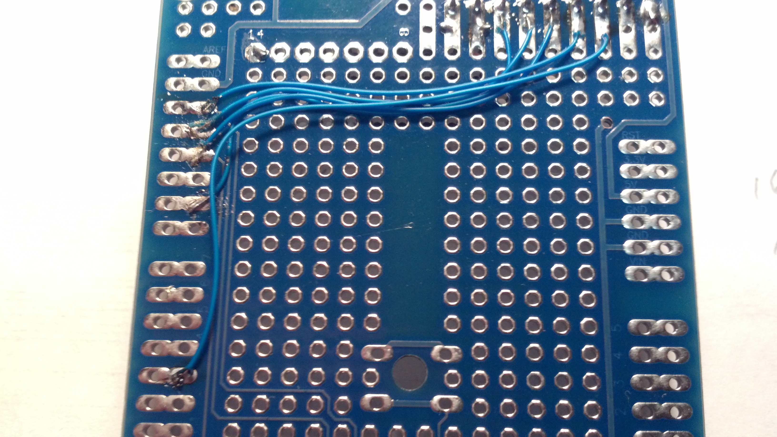
Solder Blue wire to Pin 1 on the MCP2515 DIP to pin 1 on the MCP2551 SOIC. Then blue wire to Pin 2 on the MCP2515 DIP to Pin 4 on the MCP2551 SOIC. Solder a red wire on +5 v Pad to pin 3 on the MCP2551 SOIC. Solder a red wire on pin 1 of the MCP2515 to +5 v Pad. Solder a black wire on pin 2of the MCP2515 to the ground pad.

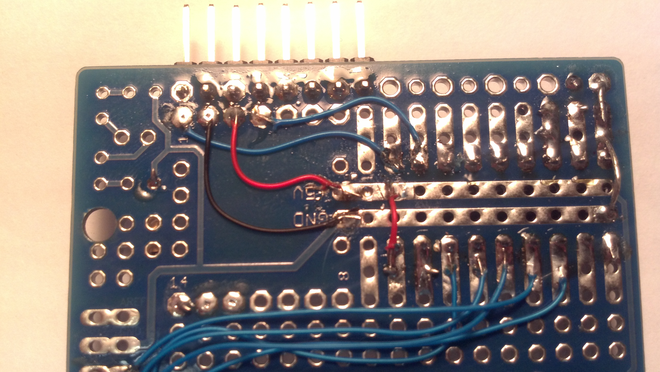
There are two ways that have been used to connect the MCP2551 CAN transceiver to the bus. Two RJ-45 jacks with the front 4 pins bent up and cut off. Using pins 1,3,5 and 7.

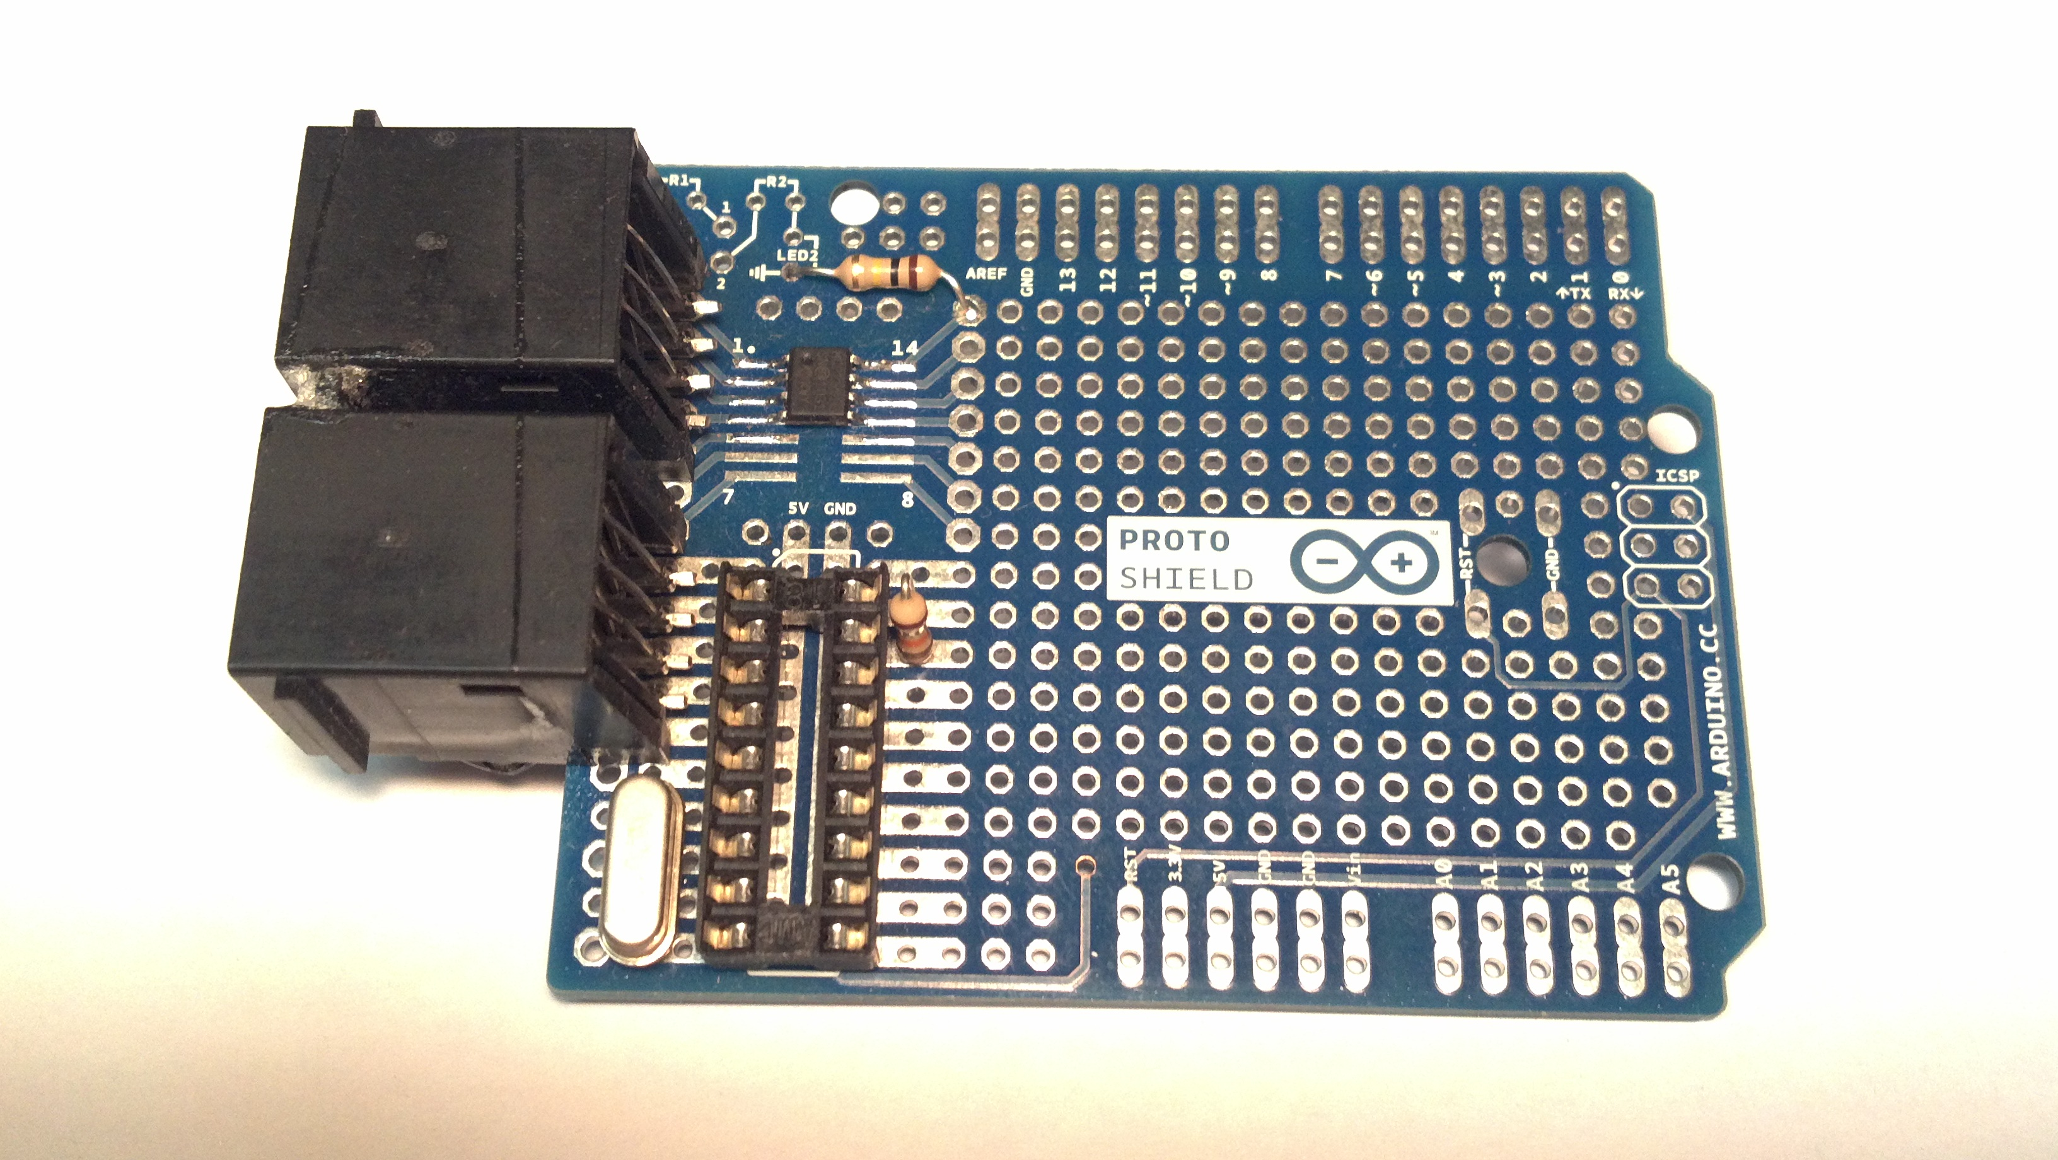
Using a right angle .1 header.

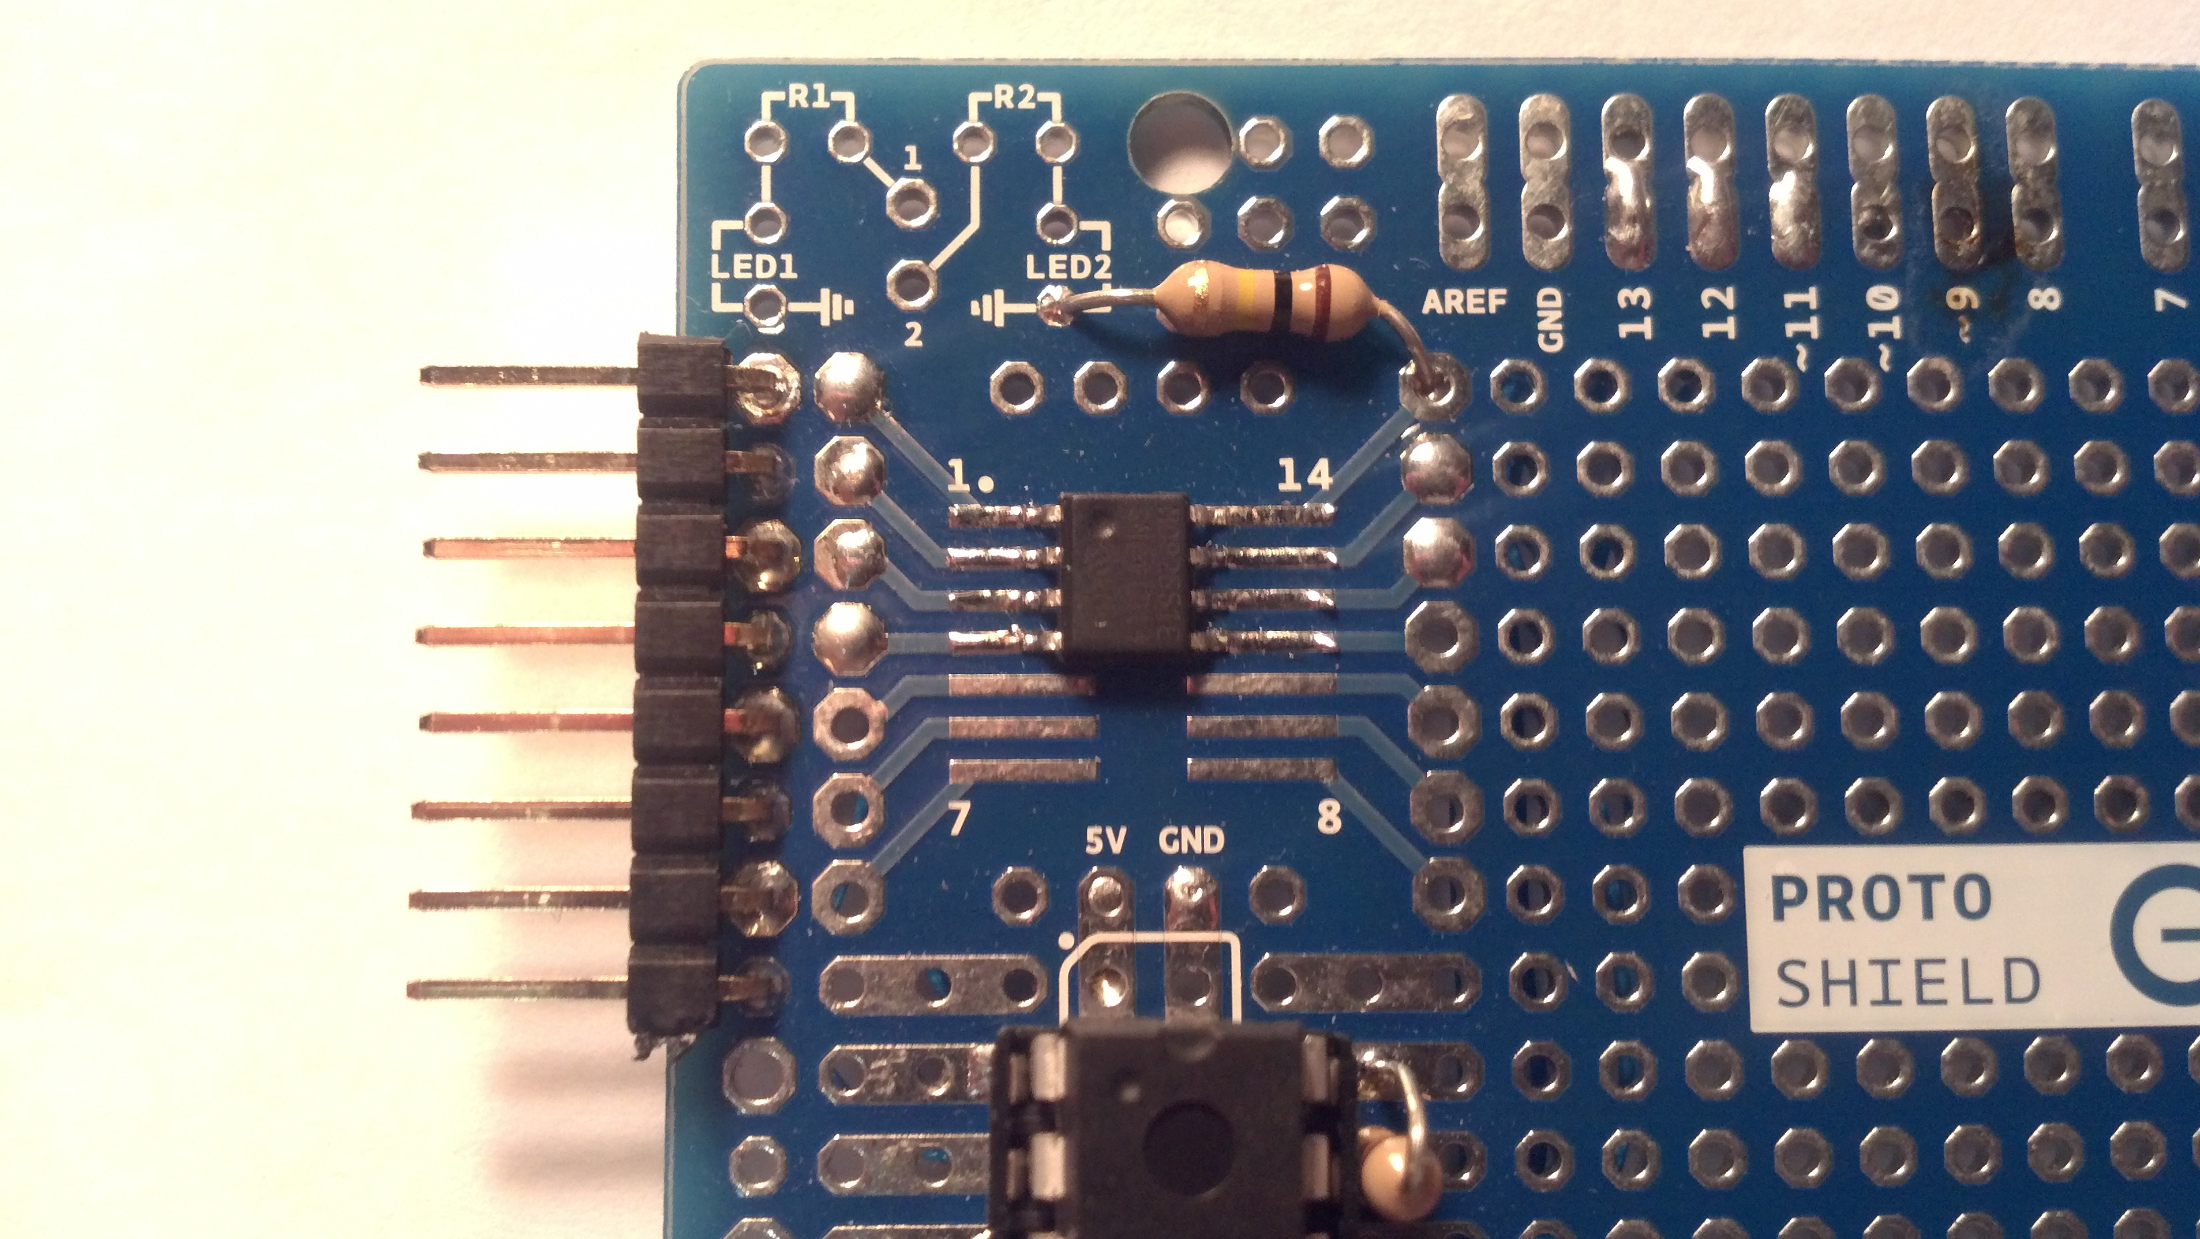
Connections to the jacks can be just two wires to other OpenLCB nodes just like this one. Other connections can be +5 volts and ground. The author has chosen to use the four wire approach with the CAN high, CAN low, +5 volts and ground connected the RJ-45 jacks. This is one of the first the author constructed. A little bit of super glue has been applied to keep the jacks stable because the front half of the pins on the jack have be remove and the back four are use to connect the CAN high, CAN low to the MCP2551 SOIC and power. The tabs on the RJ-45 to the left have been remove to clear the USB port on the Arduino.
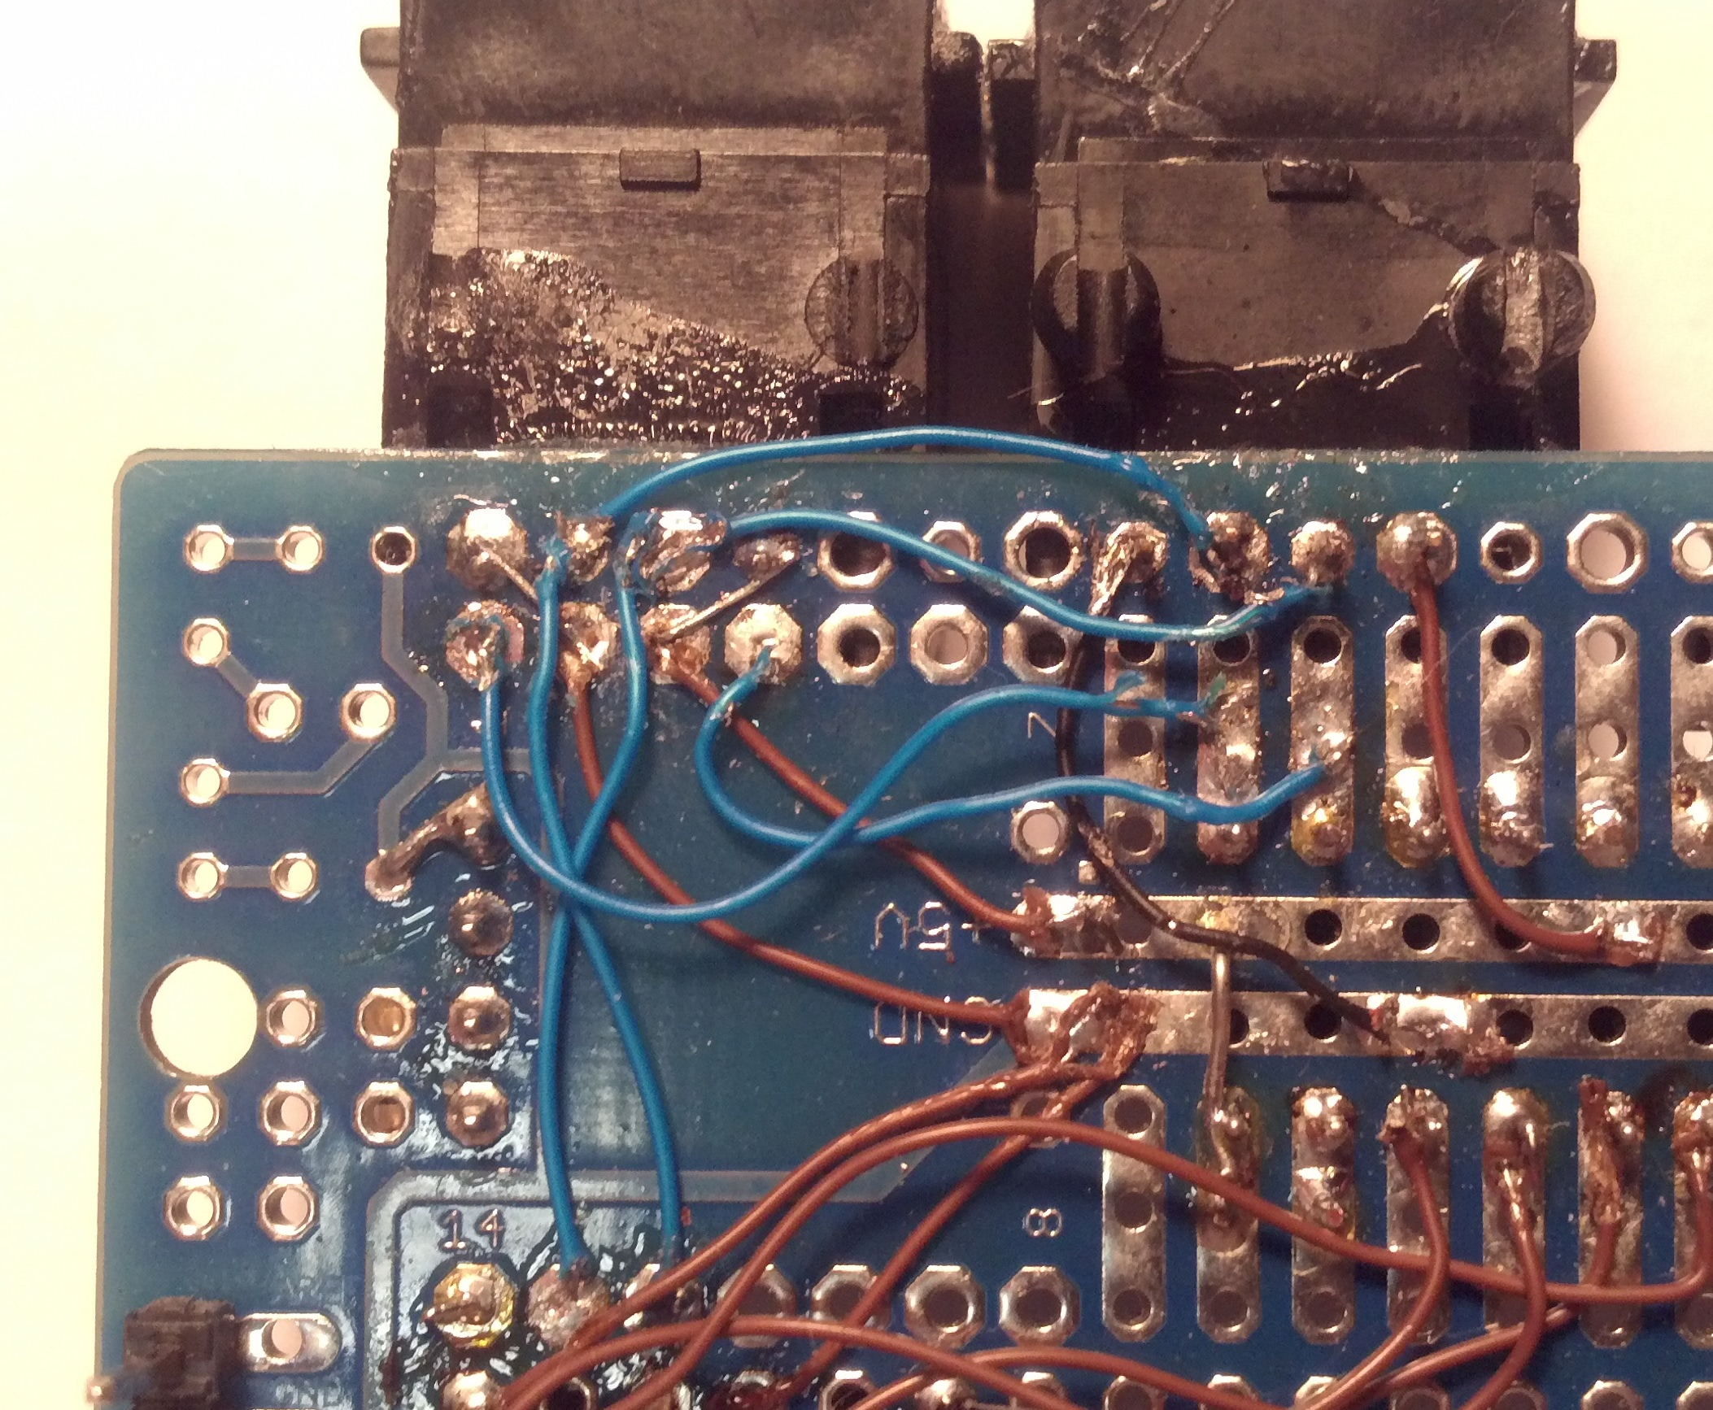
Pins used on the RJ-45 are 1,3,5,7. Two RJ-45 jacks are connected in parrallel.

RJ-45 MCP2551 SOIC

1 = Ground Pin 2

3 = CAN High Pin 7

5 = CAN Low Pin 6

7 = +5 volts Pin 3
The completed protoshield. Plenty of room to add Buttons, LEDs, and other components.

More to come.

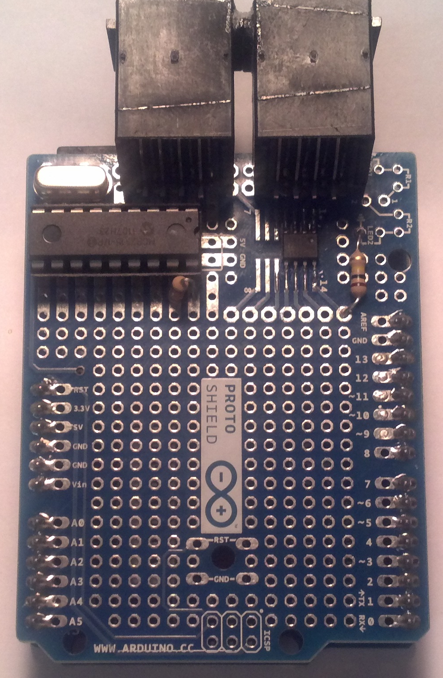

Thanks for reading.


