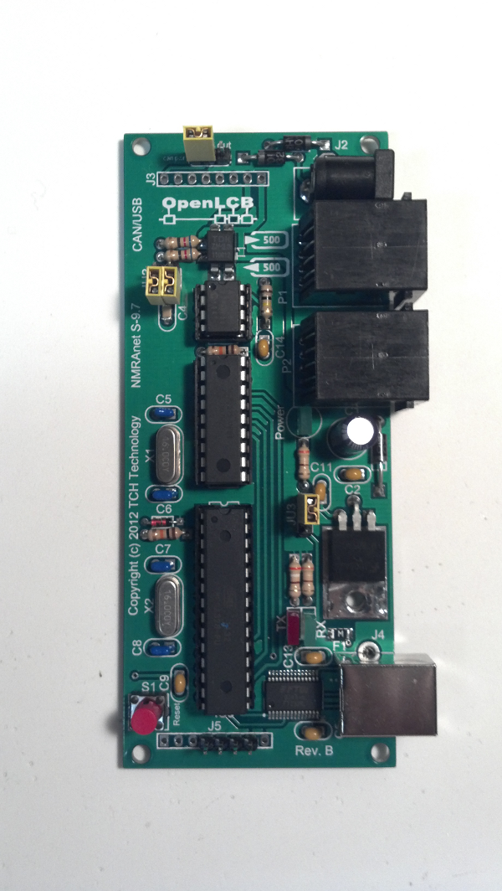
DC Power
Jack
RJ-45 Jack
CAN
USB
Connector
Power select
USB or Power Jack
Power in/out
selection
Termination
selection
Reset
Button
Baud rate
selection

