DevKit
Manual
v0.1

<openlcb logo>
<railstars logo>
<nmranet logo>

Welcome to the OpenLCB / RailStars / NMRAnet DevKit. This kit is meant to allow you to quickly use it to solve a problem on your model railroad. This manual will help you with that task.

Contents:

- Four Io version 1.0 nodes;
- One USB-serial programming cable;
- One manual (this);
- A assortment of connectors:
- Two 10-position screw-terminals;
- Four shouded 2x5 headers;
- Seven strips of pinheaders;
- Four strips of 1x6 right-angle pinheader;

Please check to make sure you have these.

You will also need to supply a power-supply from 8-15VDC with a centre-positive barrel connector.

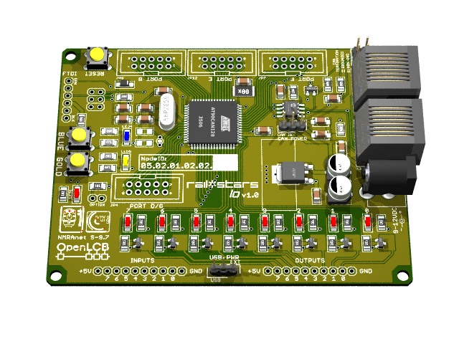
The Node as it appears out of the box.
Blue / Gold
Buttons and LEDs
Termination
Options
Optional I/O
Connectors
Reset Button
Output Connector
Position
Ouptut LEDs
Input Connector
Position
Power
Connector
Power
Options
LCB / CAN
Connectors
CAN Power
Options
Power
Indicator
Blue / Gold
Buttons and LEDs
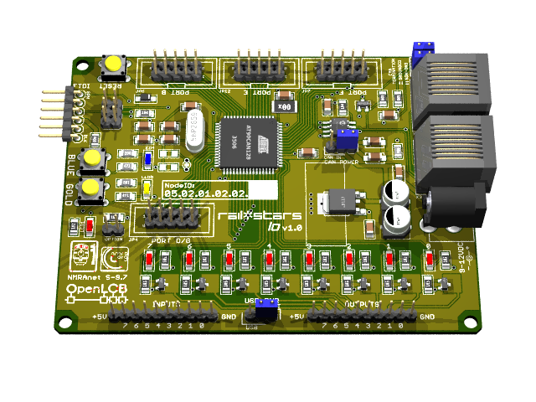
Power:

The nodes can be supplied from three sources:
- Externally from the 2mm Barrel connector. This requires 7-15VDC positive to inside. The USB Power Selector link needs to be set to “EXT”.
- Externally through the Serial Connector. The USB Power Selector link needs to set to “USB”.
- From the CAN / LCB bus. This requires the CAN Power Selector to be set to “CAN IN”.
Illustration 1: USB Power Selector
Illustration 2: The CAN Power Selector.

In addition, if the nodes are externally powered then they can provide power to the LCB / CAN bus , and other nodes, by setting the CAN Power Option link to the “CAN OUT” position.

.....

Output Connectors

As from the box.

Pinheaders installed.

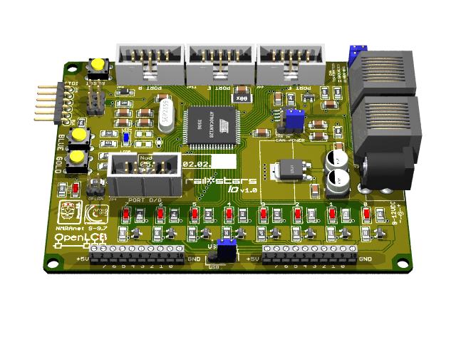

Screw-terminals installed.

......

