The FTDI FT232R USB UART and using Python
By Tim Hatch

Test setup:

Using an FT232R usb uart and interfacing it with an OpenLCB CAN bus.
TCH Technology CAN/USB interface or,
LEDuino programmed for a CAN/USB interface or,
Railstars “Io” using a FTDI FT232R usb uart

OpenLCB node
Railstars “Io” or,
TCH Technology 16 input producer/24 output consumer

The problem/issue:

Can not transmit (write/send) from a “Python script NMRAnet/OpenLCB Conformance Test Suite” to an OpenLCB node under test.

A work around to the issue was determined by setting a delay before the Python script is started. This would allow the Python test script to begin. Without the delay, the test will not transmit (write/send) to the node subjected to the test. My investigation revealed that each time the FTDI FT232R was accessed it would reset the atmega328p-pu chip used as the controller for the interface. This reset was caused by the DTR output pin of the FT232R chip connected to the reset pin of the atmega328p-pu via a .1uf capacitor. Each time this reset would occur the controller chip would send frames back to the Python script, in which the program would immediately reject, and the test would fail. Further investigation revealed that disconnecting the .1 uf capacitor connected to the reset pin on the atmega328p-pu would eliminate the problem. However, doing so would make the Arduino IDE programmer cease to function. That was determined not to be an option. Looking into the programing of the FTDI became the next step into determining the problem. I found that in the programing of the FTDI using the FTDI “FT Prog” there are options under the Hardware menu that would allow inverting the settings of the RS-232 DTR pin.

Procedure:

Inverting the DTR pin on the FTDI FT232R chip using the FTDI “FT Prog”.

Opening the program gives you the following:

See graphic

Make sure that you have a usb cable connected to the computer to the USB device, then click on the magnifying glass to load the EEPROM for the FT-232R.
Continue to next page.
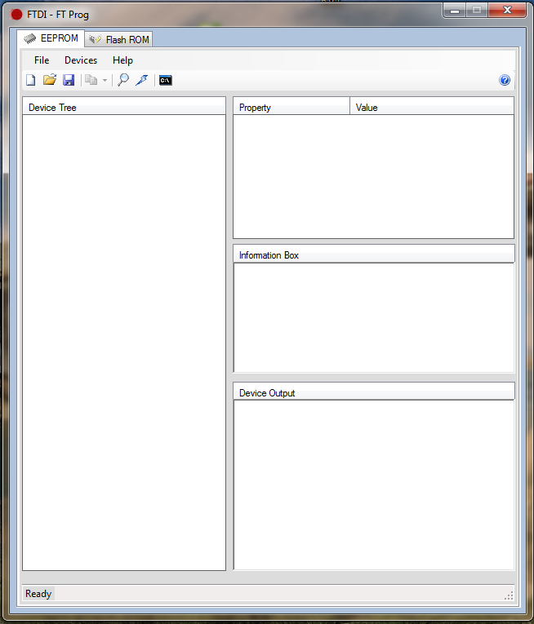

After reading the device your screen should look like the screen shot below.

Continue, to next page.
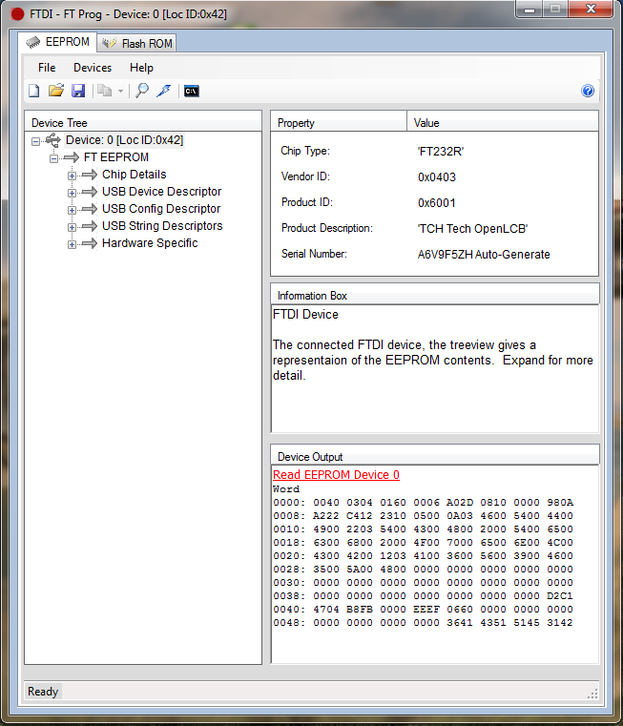

Clicking on the “Invert RS232 Signals” you should see the following page. Click on the Invert DTR# box. Then click on the button next to the right of the magnifying glass (small lightning bolt) This will program the FT-232R. Now the Python program will run with out the delay setting. Also the Auduino IDE will still perform as expected.
