We Rate Dogs Retweets and Favorites

The “We Rate Dogs” twitter feed is silly feed that takes pictures of dogs and rates them out of 10 but typically the rating is over 10. One of the ways to determine the success of a twitter feed is the number of times a tweet is retweeted or marked as a favorite. As such, I have looked at some of the features that seem to increase the retweet and favorite counts.

**Dogtionary Terms**

“We Rate Dogs” has created a dogtionary with a number of silly terms in it. Looking at the data, it appears that adding one or more of these terms increase the retweet and favorite counts. On average, the retweet and favorite counts have a statistically significant increase (at alpha level 0.05). A histogram of this data is difficult to display as the numbers can differ on an order of magnitude. Taking the natural log of the data does allow for a visualization with the order of magnitude normalized. In each case the normal curve for the tweets with a dogtionary term in it is further to the right than the general tweets and tweets without the terms (note the bar at the beginning of the favorites is for 0 favorites).

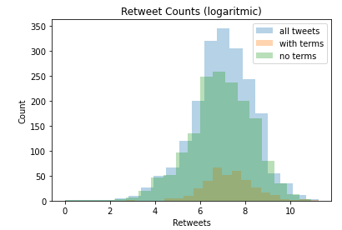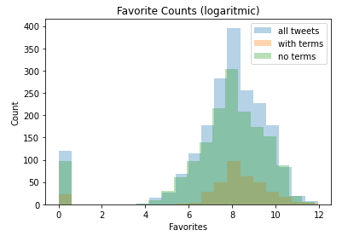

**Dog Breeds**

I looked into weather the dog breed affected the retweet and favorite counts. There does appear to be a good deal of difference in the minimum, mean, and maximum counts for the different breeds. Unfortunately, for many of the breeds there are only a handful of pictures. The way to look into this further, similar breeds could be combined into overarching groups. I do not have the knowledge to group similar dog breeds together, so I left the results as a csv titles “breed.csv” (included in the folder).

**Ratings**

In the “We Rate Dogs” feed, each dog in an image a rating out of 10, usually a number greater than 10. The feed then adds both the numerator together which, while mathematically incorrect, does give an average rating for the dogs in the image (because the denominators are all the same). As such, these ratings could be compared by converting these ratings into decimals. Creating a scatter plot, it appear that there is a positive correlation between the rating and both the retweet and favorite counts as shown (note, most of the data is in vertical bars because most of the rating are out of 10).

