Abstract

With the advancement of the technology and new invasions today world, Day to day work load can done effectively and efficient way. Human uses those technologies to provide better services to mankind. This project, Driver Fault Detection and Management System for Police is basically made for providing the middle ware for the police department to keep the day today works of their traffic section smoothly. The problem can be identified by difficulties that are met by the traffic police when they locating their officers to find the wrongful drivers. With the development of the technologies it will very useful for police department if they have a system to predict the locations where drivers break road rules constantly. Machine learning technology will provide a better support for the prediction problems. It can take a large bundle of data and give a prediction by analyzing those data. In this problem the system can analyze the data collected by police officers by using machine learning algorithms and give predictions about the location where the wrongful driving done by drivers. MySQL Relational Database Management Systems have used for implementing the database. When implementing the web application HTML, JSP, CSS and bootstrap.

**Chapter 1**

**Introduction**

* 1. **Introduction**

In modern society, there occurs many road accident because of the careless driving of the drivers and the wrongful behaviors that they carry as habits. There are many rules that have to be adhere by the drivers when they are driving. They are known as the driving laws. Some of the driving laws are as following.

* Seat Belt Laws
* Drinking and Driving
* Must have clear documents
* Speed Limits

The speed limits for Sri Lanka are as follows:

Open roads: 72 km/h

In Town: 56 km/h

Motorway/Highway 120 km/h

* Minimum Driving Age
* Child Safety Rules
* Insurance
* Rules of the Road

Standard international driving laws apply with one or two exceptions.

Many drivers completely ignore road rules so drive with caution

Fully tinted windows are illegal

Sri Lanka drives on the left

* Towing Regulations
* Speed Cameras
* Using Mobile Phones when driving
* Parking

So the traffic police is tend to charge fine from the drivers who are breaching the rules when they driving or using the vehicles. The drivers who are breaching the rules have to pay fine according to the offence that they have done or they might sent in front of the courts. As per the manual system that use by Sri Lankan traffic police at present if someone get caught to the traffic police by breaching the road rules, the police will take their driving licence card and issuing a and issuing a temporary licence until the driver pay the fine. So the driver has to pay the fine to the post office and get the receipt issuing by the post office. After that he have to forward that receipt and get the licence card from the respective police station which the driver got caught.

When drivers have to go on such process to get their licence back, the government thinking that the offences on road will be reduced in to some amount. But when looking at the offences done by the drivers on the road we can see that it haven’t been reduced. So we have to look at a new method to reduce the road accidents. If we have a method to find the drivers who are doing offences frequently the police can take an action against then by cancelling their driving licence or by giving some other punishment to wrongful drivers.

The proposed system is specially designed system to the traffic police to get the data of the wrongful drivers and analyze their character. Even the insurance companies which used to insure the vehicles can use this system to analyse about their customers who are claiming frequently. Here when a driver get caught to a policemen by doing an offence the policemen can update the system online by entering the licence card number of the driver to the system and entering the offence done by the driver. The system can predict bout the drivers’ quality after a period of time.

This system will be very useful for the police to find out the locations and time where drivers doing offences constantly. The policeman can first login to the system by making an user account by giving his e-mail address and some other information. After he login to the system the user interface shows the information to be entered about the wrongful drivers the locations and the times.

The system can learn about the past incidents by using machine learning algorithms and give the predictions to the future about the locations where drivers may do wrongful driving constantly. And the system can give predictions about the drivers who are doing wrongful things constantly. The system can predict about the drivers and give results about the drivers that which offence that they will going o do in the next time.

* 1. **Background and Motivation**

In each and every field in the world, they are use modernize or computerize system to perform their day to day activities. There is no any separation between government section and private section, both of them are hurry to use more powerful options to perform their task much better than the other one.

As a government organization of police department still working with manual base system. But world is running with machines and people are working with machines. The number of vehicles that are running on roads in these days are very higher than earlier times. So many drivers are driving and most of them are doing wrongful things while driving in several locations. Because of these reasons traffic police should also have some method to take some decisions in the future by looking at the recent incidents.

* 1. **Problem in Brief**

At present in Sri Lanka, there are many vehicles are running on roads. So the number of drivers and the vehicles are very higher than the past times. Because of this the breaching of road rules and the road accidents can see frequently on the road. Police department have to do a massive work to reduce these things. Normally traffic police officers are staying in some areas of the roads and checking the wrongful drivers. Those records are not insert into computerized systems and the do not have a way to analyze those records. The police do not have a method to get predictions about the locations where drivers are doing offences constantly. Because there is no centralized system to analyze the data collected by different police officers.

* 1. **Aim and Objectives**

**1.4.1 Aim**

The aim of this project is to develop a system to improve efficiency of the traffic police and give predictions about the locations where drivers breach road rules constantly.

**1.4.2 Objectives**

Build a system to enter and store the data of the wrongful drivers when they caught to traffic police on the road.

Personal user accounts for traffic police officers.

Analyze data and give predictions about the locations where drivers will break road rules continuously.

Analyze data and generate reports.

**1.5 Software Solution for the Identified Problems**

To overcome constraints proposed system will be introduced by using Machine Learning technology. The algorithmic way will define how the system will give predictions from the system. It will made time consuming and efficient way to inspection process with proposed system.

This proposed system architecture with the interface which is developed by using PHP and Java Script insertion windows to insert the data of the drivers and the locations.

There is a MySql database database with the proposed system to store the data collected by traffic police officers. The system will do the predictions using machine learning algorithms with weka libraries and java.

* 1. **Users**

The traffic police department of Sri Lanka Police will be the users of this proposed system.

* 1. **Input and Output**

Inputs of the system should be done manually by traffic police officers. The data about the wrongful drivers should be entered on the spot where drivers got caught.

Output of the system will be the predicted result of the locations given by the system.

* 1. **Process**

The users (Traffic Police Officers) can sing up to the system by creating a user account. Then the users can login to the system by using their e-mail address and the password. Then user can login to home page and insert the data about drivers who got caught to the police. Different police officers can insert data about different drivers from different locations. After a period of time the system can take a training data set and a test data set from the data base and train the system and predict the locations where will drivers do offences frequently by using machine learning algorithms.

* 1. **Technologies used**

Machine Learning

HTML

PHP

Java Script

Boostrap

CSS

* 1. **Summery**

Within this chapter, the introduction to the project including the background of problem domain, aim and objectives, and a brief account on solution is mentioned. The chapter 2 is on existing solutions to the problem domain by comparing those to the solution provided by this system. Chapter 3 discuss the technologies used for the system. It will follow up chapter 4 which describes the approach to the problem identified. A detailed description on the analysis and design is included in chapter5. The project implementation is included within the chapter 6. A discussion about the final outcome and interpretation of results obtained is stated in chapter 7. Finally, the report includes the references and a collection of appendixes.

**Literature Review**

This chapter is about a literature review on the topic Driver Fault Detection and Management System for Police. This chapter describes about the existing systems which are relevant to this project and the technologies that we can use for this system.

In modern society, there occurs many road accident because of the careless driving of the drivers. There are many rules that have to be adhere by the drivers when they are driving. They are known as the driving laws. Some of the driving laws are as following.[1]

* Seat Belt Laws
* Drinking and Driving
* Must have clear documents
* Speed Limits

The speed limits for Sri Lanka are as follows:

Open roads: 72 km/h

In Town: 56 km/h

Motorway/Highway 120 km/h

* Minimum Driving Age
* Child Safety Rules
* Insurance
* Rules of the Road

Standard international driving laws apply with one or two exceptions.

Many drivers completely ignore road rules so drive with caution

Fully tinted windows are illegal

Sri Lanka drives on the left

* Towing Regulations
* Speed Cameras
* Using Mobile Phones when driving
* Parking

So the traffic police is tend to charge fine from the drivers who are breaching the rules when they driving or using the vehicles.[2] The drivers who are breaching the rules have to pay fine according to the offence that they have done or they might sent in front of the courts. As per the manual system that use by Sri Lankan traffic police at present if someone get caught to the traffic police by breaching the road rules, the police will take their driving licence card and issuing a and issuing a temporary licence until the driver pay the fine. So the driver has to pay the fine to the post office and get the receipt issuing by the post office. After that he have to forward that receipt and get the licence card from the respective police station which the driver got caught.

The current system is a method which is very tough to the drivers. Because they have to take their licence from the respective police station. If the driver is from a very far area, he have to again come to the respective police station to collect his licence.[3] So this is very difficult to the people who having very busy life in this present society. But this is an act of a parliament which have been granted to reduce the faults done by the drivers. When drivers have to go on such process to get their licence back, the government thinking that the offences on road will be reduced in to some amount. But when looking at the offences done by the drivers on the road we can see that it haven’t been reduced. So we have to look at a new method to reduce the road accidents. If we have a method to find the drivers who are doing offences and the locations where they doing offences frequently. That will be very useful to the traffic police. From those results the traffic police can pay more attention to those areas where that was predicted by the system.

The proposed system is specially designed system to the traffic police to get the data of the wrongful drivers and analyze their character and predict locations where drivers tend to do wrongful driving continuously [4] .From this the police can take a report automatically at the end of a time period and the system will automatically the locations and judge the quality of the driver. Here when a driver get caught to a policemen by doing an offence the policemen can update the system online by entering the licence card number of the driver to the system and entering the offence done by the driver, current location and some other details. So the at the end of the time period the system will decide the locations to pay more attention when checking the vehicles by analyzing former details.

In Sri Lanka the number of the road accidents are increasing day by day. This is because of the careless driving of the drivers and breaching the road rules. When looking at the statics of previous years we can get to know how they have increased with the time.[5]



When we are looking at these statics we can understand that how the number of accidents increased with the time. As an example when we look at the motor cycles and the Three- Wheelers there is considerable increase.

So the traffic police is doing a great job to decrease these accidents and fine the wrongful drivers.

In following images it is shown an image of a valid driving licence in Sri Lanka and the permit issued by a police officer in a lieu of the driving licence.

 

A valid Driving Licence Card The permit issued by police

in a lieu of the driving licence

Following procedure is normally using by a driver to get the driving licence back after getting caught to the traffic police.[3]

**Step 1:** The Driver breaks a traffic rule(s)

**Step 2:** Police confiscates drivers [driving license](http://www.gic.gov.lk/gic/index.php?option=com_info&id=390&task=info&back=0&pid=475&lang=en).

**Step 3:** Police issue a spot fine statement

**Step 4:** Driver goes to office and receives a fine payment form from the traffic division.

**Step 5:** Driver goes to post office and pays fine for which he/she receives a receipt.

**Step 6:** Driver goes to police station, shows receipt and police return [driving license](http://www.gic.gov.lk/gic/index.php?option=com_info&id=390&task=info&back=0&pid=475&lang=en).

**Note 1:** If driver didn’t pay the fine he/she will be submitted to court

**Note 2:** If driver hasn’t [driving license](http://www.gic.gov.lk/gic/index.php?option=com_info&id=390&task=info&back=0&pid=475&lang=en). Police issue another permit (police 405- Code of criminal Procedure Section 109(6) Act, No. 15 of 1979)

This manual system is only available system for the fine paying system at present for Sri Lanka. Making all the things to online is a difficult task in Sri Lanka. Because there are many driver who do not having idea about online payments and drivers who do not use credit cards. Online traffic fine payment is available in some foreign countries but it is not available still in Sri Lanka.[6]

A driver improvement points system where motorists would have their driving licences cancelled on points accumulated for traffic offences, will be in place before year end. The proposal initially made more than two years back. Points regarding other offences have also been determined, but will be implemented only in the second phase. The Motor Traffic Department will collect data from police stations and courts on a monthly basis to update their records. The records will be available to police stations through a card reading system or a mobile application, where police can check on the points accumulated to date. But this system is still not implemented to the police stations.

In this system it will give points to the offences done by the drivers when they using vehicles. The points will be added in following method.[7]

|  |  |
| --- | --- |
| Offence | Driver Improvement Points |
| Reckless Driving and Accidents |  |
| Failing to such action on road to prevent an accident | 06 Points |
| Driving a motor vehicle on a road recklessly or in a dangerous manner at a dangerous speed. | 08 Points |
| Driving a motor vehicle negligently or without reasonable consideration | 08 Points |
| Failing to stop after accident on road and furnish relevant information | 10 Points |
| Failing to report an accident forthwith to the nearest police station | 04 Points |
|  | |
| Speeding |  |
| Exceeding the prescribed speed limit on a road | 06 Points |
|  | |
| Road Rules |  |
| Failing to, | |
| 1. Keep left or nearside of the road |  |
| 1. Allow a motor vehicle being overtaken by the traffic |  |
| 1. Overtake other traffic without a clear view of the road ahead. |  |
| 1. Overtake other traffic without keeping to the right. |  |
| 1. Drive alongside of or overtake, other traffic proceeding in the same direction, in such manner as to obstruct any traffic proceeding in the opposite direction. |  |
| 1. Cross or commence to cross road or turn in a road in such manner without, obstructing any traffic on the road. |  |
| 1. Proceed from a place which is not a road in to a road or from a road to a place which is not a road in such a manner without obstructing the traffic on the road |  |
| 1. Proceed from one road without obstructing the traffic on the other road. |  |
| 1. Turn in to or cross a main road without obstructing the traffic on the road. | 04 Points |
| 1. Give way to the traffic coming on right side of the junction |  |
| 1. Give way to the vehicles approaching a narrow road |  |
| 1. Give way to the vehicles approaching each other on a narrow road. |  |
| 1. Turn right without violating the correct maneuvering procedure |  |
| 1. Stop and proceed from any place to a road before entering such roads where stop lines are painted. |  |
| Reversing or permitting the vehicle to travel backwards on a road for a long distance | 04 Points |
| Failing to comply with prohibitory, restrictive, mandatory or priority signs | 06 Points |
|  | |
| Signaling |  |
| Failing to comply with the oral directions or hand signals given by a police officer or a traffic warden. | 06 Points |
|  | |
| Pollution |  |
| Driving a motor vehicle which has above the prescribed standards. | 04 Points |
| Using or permitting to use amplifying equipment in a volume of sound above the prescribed standards. | 04 Points |
| Using a vehicle the noise of the engine and the horn of which exceed the prescribed standards. | 04 Points |
|  | |
| Construction and Use of Vehicle |  |
| Driving a vehicle the condition of which causes or is likely to course danger or harm any person, property or vehicle on or adjoining the road. | 10 Points |
|  | |
| Safety |  |
| Driver failing to wear the seat belt or failing to ensure the front passenger wears seat belt. | 03 Points |
| Failing to stop before the give way line of a zebra i crossing while pedestrian is at a pedestrian crossing. | 06 Points |
| Ride of a motor cycle carrying more than one person or falling to wear a safety helmet. | 04 Points |
| Using hand held communication equipment while driving | 04 Points |

The proposed system is somewhat different than this system. It is a system that can predict about the drivers intelligently. And the system will predict the location where drivers might do offences continuously.[8], [9]. We can train data sets according to some patterns and after that we can easily find the drivers who should be nominated to reject list and we can predict about them by seen their past records.

Machine learning will solve the problems that are in the real world by building model that that is good and useful approximation to the data. The study of Machine learning has grown from the efforts of exploring whether computers could learn to mimic the human brain, and a field of statistics to a broad discipline that has produced fundamental statistical computational theories of learning processes. In machine learning it advanced the algorithm in with in the general areas of supervised learning and unsupervised learning. At present the adaptive programing is consists in machine learning where those programs are capable of recognizing patterns, learning from experience, getting new information from the collected data and optimizing the accuracy and efficiency of the processing of output result. [10]

Today the machine learning algorithms have been developed to a high standard level. They are not as the machine learning algorithms which were there previously. Because of these developments the the machine learning has the ability to apply complex mathematical calculations very faster. [11]

**Machine Learning Model**

The learning process in the machine learning model is divided in to two parts as training and testing[12][13].

* Training
* Testing

In data training process in machine learning, samples of training data are taken as input in which features are learned by learning algorithm or learner and build the learning model. In the testing process, learning model uses the execution engine to make the prediction for the test or production data. Output of the learning model is tagged data it gives the final prediction or classified data.

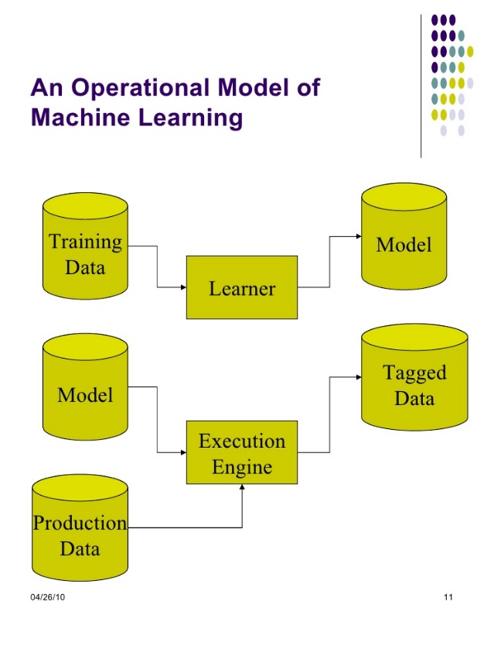

Operational model of machine learning

In machine learning there are machine learning techniques[14]. They can be categorized in to several categories as.

* Supervised Learning.
* Unsupervised learning.
* Semi Supervised Learning.
* Reinforcement Learning.

Supervised Learning

Supervised learning is a technique that which is using labeled examples. That means when entering data we know the desired output. Supervised learning provides set of data which consists of both features and labels. The task or the objective of the supervised learning is to construct an estimator which is able to predict the label of an object given the set of features. Along with the corresponding correct outputs, the supervised learning algorithm receives a set of features as inputs. To find the errors the learning algorithm compares the actual output with the correct output. By this process the algorithm can learn about the data. The algorithm modifies the model accordingly after learning the pattern. This supervised learning method is not needed as long as the inputs are available. But if some input values are missing it will not able to infer anything about the outputs. Supervised learning is commonly used in applications where historical data predicts likely future events. Tasks of supervised learning are divided in to two parts. They are,

1. Classification
2. Regression

In classification part the label is discrete and in regression part the label is continuous.

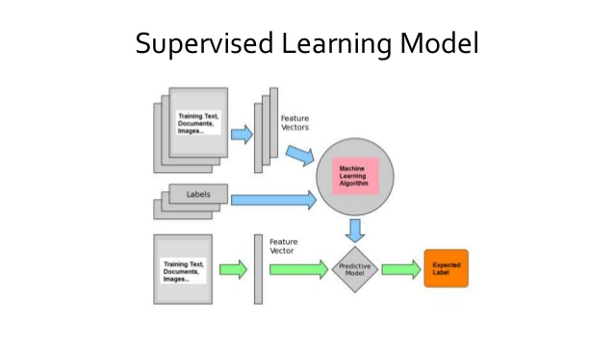

Supervised Learning Model

Unsupervised Learning

In unsupervised learning it is used the data that do not have historical labels. In unsupervised learning the goal is to explore and finding similarities between the objects. That is the method of finding labels of the data from itself. This works well on transactional data as identify segments of customers with similar attributes who can then be treated similarly in marketing campaigns.

There are some other unsupervised problems. They are,

* Given detailed observations of distant galaxies –

This determines the features or combinations of the features that are very much important in distinguishing between galaxies.

* Given a mixture of two sound sources for example

A song playing with the music and voice is a good example for this. A human voice and an instrumental voice is there. The separation of these two sounds is called as blind source separation.

* Given a video

Isolating a moving object in a video and matching and categorizing with other moving objects which can be seen.

Clustering is a typical unsupervised learning task and it is divided into groups. Not as in classification, those groups are not known before. Popular unsupervised learning techniques are include,

- Self-organizing maps

- Nearest-neighbor mapping

- k-means clustering

- Singular value decomposition

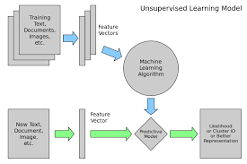

Unsupervised Learning Model

Semi-supervised Learning

Semi-supervised learning is used for the same applications as supervised learning but it uses both labeled and unlabeled data for training. In semi-supervised learning there is a desired prediction problem but the model must learn the structures to organize the data as well as make predictions.

This type can be used with the method like classification, regression and prediction.

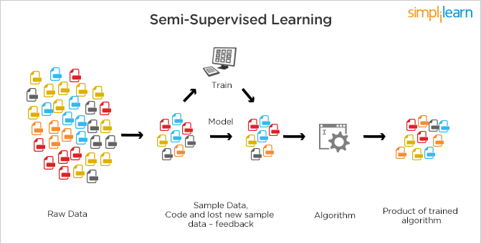

Semi-supervised Learning

Reinforcement Learning

The reinforcement learning method can be used in the areas like robotics, gaming and navigation. Reinforcement learning is the learning technique which interacts with a dynamic environment in and it perform a certain goal without a teacher explicitly telling it whether it has come close to its goal. In reinforcement learning method it identifying the trial and the errors. It will benefited to get more rewards when working with it.

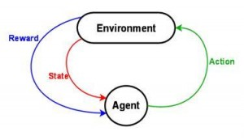

Reinforcement Learning

MAHINE LEARNING ALGORITHMS

To build machine learning models and to implement iterative machine learning process there are set of machine learning algorithms that are developed by the various researchers. Those algorithms can be classified according to the learning style of them. Those algorithms are as follows.

1. Regression algorithms

Regression is the ability an algorithm of predicting the value of a continuously varying variable such as a price, a temperature if given some input variables like features and regressor . Most commonly used regression algorithms are,

* Ordinary Least Squares Regression (OLSR)
* Linear Regression
* Logistic Regression
* Stepwise Regression
* Multivariate Adaptive Regression Splines (MARS)
* Locally Estimated Scatterplot Smoothing (LOESS)

1. Instance-based Algorithms

This method also called a lazy learner method. In this algorithm it takes less time in training and more time in prediction. This builds a data base of training data and typically compare with the test data and looking about best match and make a prediction[15]. Common types of Instance-based algorithms are,

* k-Nearest Neighbour (kNN)
* Learning Vector Quantization (LVQ)
* Self-Organizing Map (SOM)
* Locally Weighted Learning (LWL)

1. Decision Tree Algorithms

In the decision tree algorithm it uses a tree as the predictive model. The tree can match observations about an item to conclusions about its target value. In tree models the target variable can get finite set of values. That is known as classification trees. In decision tree structures branches represent conjunctions and the leaves represent class labels. These are fast and accurate algorithms.[16] Most common decision tree algorithms are,

* Classification and Regression Tree (CART)
* Iterative Dichotomiser 3 (ID3)
* C4.5 and C5.0 (different versions of a powerful approach)
* Chi-squared Automatic Interaction Detection(CHAID)
* Decision Stump
* M5
* Conditional Decision Trees

1. Bayesian Algorithms

These Bayesian algorithms are based on the probability theory. Machine learning is a hybrid product of statistics and algorithmic computer science. Statics is about managing and quantifying of uncertainty. Most commonly used Bayesian algorithms are,

* Naive Bayes
* Gaussian Naive Bayes
* Multinomial Naive Bayes
* Averaged One-Dependence Estimators (AODE)
* Bayesian Belief Network (BBN)
* Bayesian Network (BN)

1. Clustering Algorithms

Clustering is the method of classifying objects in to groups. Clustering algorithms are classifying the data in to subsets or the clusters. Clustering methods are classified as hierarchical clustering and partitional clustering. K-means is partional clustering algorithms which uses centroid-based approach[17].

* k-Means
* k-Medians
* Expectation Maximisation (EM)
* Hierarchical Clustering

1. Association Rule Learning Algorithms

This extracts the best rules. Explains the observed relationships between variables of data. The common algorithm types are,

* Apriori algorithm
* Eclat algorithm

1. Artificial Neural Network Algorithms

Artificial neural networks are used in the supervised learning and those neural networks are constructed by considering the structure of biological neural networks[18], [19]. These are consisted with artificial neurons and they are learned by tuning the connection weights to perform parallel distributed processing. Most common artificial neural network algorithms are,

* Perceptron
* Back-Propagation
* Hopfield Network
* Radial Basis Function Network (RBFN)

1. Deep Learning Algorithms

Deep learning algorithms are the modified or updated version of artificial neural networks. They are concerned with building much larger and much complicated neural networks[20]. Some common deep learning algorithms are,

* Deep Boltzmann Machine (DBM)
* Deep Belief Networks (DBN)
* Convolutional Neural Network (CNN)
* Stacked Auto-Encoders

1. Dimensionality Reduction Algorithms

These dimensionality reduction algorithms are a good solution to the problem course with the dimensionality. When number of dimensions and increases the volume of the space increase faster and available data become sparse. In dimensionality reduction it it reducing the number of dimensions that describes an object. Its objective is to remove the irrelevant and redundant data to reduce the computational cost[21]. Some dimensionality reduction algorithms are as follows.

* Principal Component Analysis (PCA)
* Principal Component Regression (PCR)
* Partial Least Squares Regression (PLSR)
* Sammon Mapping
* Multidimensional Scaling (MDS)
* Projection Pursuit
* Linear Discriminant Analysis (LDA)
* Mixture Discriminant Analysis (MDA)
* Quadratic Discriminant Analysis (QDA)
* Flexible Discriminant Analysis (FDA)

1. Ensemble Algorithms

Ensemble algorithms are the methods based on unsupervised learning. Ensemble algorithm divides the training data into number of subsets of data for which independent learning models are constructed. All learning models are combined to make correct hypothesis. This is a very powerful and very much common technique[22]. Some common algorithms are follow.

* Boosting
* Bagging
* Bootstrapped Aggregation
* AdaBoost
* Stacked Generalization (blending)
* Gradient Boosting Machines (GBM)
* Gradient Boosted Regression Trees (GBRT)
* Random Forest

After considering the factors which are described in this chapter, we can get a better idea about the current systems used by the traffic police at present. And we can get an idea about what are the technologies and algorithms that we can used when implementing this driver faut detection nd prediction system.

**REFERENCES**

[1] “Motor traffic act no 08.pdf.” .

[2] “Traffic Police.” [Online]. Available: http://www.police.lk/index.php/traffic-police. [Accessed: Mar-2017].

[3] “The Government Information Center.” [Online]. Available: http://www.gic.gov.lk/gic/index.php?option=com_info&id=475&task=info&lang=en. [Accessed: Mar-2017].

[4] “Open & independent forum of Sri Lanka,” *Open & independent forum of Sri Lanka*. [Online]. Available: https://www.lankafb.com/forums/. [Accessed: Mar-2017].

[5] “Statistics.” [Online]. Available: http://www.transport.gov.lk/web/index.php?option=com_content&view=article&id=279&Itemid=171&lang=en. [Accessed: Mar-2017].

[6] “Pay traffic fines online | Traffic fines | Parking in County Clare | Roads and Transport | Clare County Council.” [Online]. Available: https://www.clarecoco.ie/roads-and-transport/parking-facilities/traffic-fines/pay-traffic-fines-online/. [Accessed: Mar-2017].

[7] “Points system for motorists to improve road discipline | The Sunday Times Sri Lanka.” .

[8] S. B. Kotsiantis, I. D. Zaharakis, and P. E. Pintelas, “Machine learning: a review of classification and combining techniques,” *Artif. Intell. Rev.*, vol. 26, no. 3, pp. 159–190, Nov. 2006.

[9] S. B. Kotsiantis, I. Zaharakis, and P. Pintelas, *Supervised machine learning: A review of classification techniques*. 2007.

[10] “1459926027_06-04-2016.pdf.” .

[11] P. Domingos, “A few useful things to know about machine learning,” *Commun. ACM*, vol. 55, no. 10, pp. 78–87, 2012.

[12] E. Alpaydin, *Introduction to machine learning*. MIT press, 2014.

[13] Q. Wei and R. L. Dunbrack, “The Role of Balanced Training and Testing Data Sets for Binary Classifiers in Bioinformatics,” *PLoS ONE*, vol. 8, no. 7, p. e67863, Jul. 2013.

[14] K. P. Murphy, *Machine learning: a probabilistic perspective*. MIT press, 2012.

[15] H. Brighton and C. Mellish, “Advances in instance selection for instance-based learning algorithms,” *Data Min. Knowl. Discov.*, vol. 6, no. 2, pp. 153–172, 2002.

[16] J. Su and H. Zhang, “A fast decision tree learning algorithm,” in *AAAI*, 2006, vol. 6, pp. 500–505.

[17] T. Kanungo, D. M. Mount, N. S. Netanyahu, C. D. Piatko, R. Silverman, and A. Y. Wu, “An efficient k-means clustering algorithm: Analysis and implementation,” *IEEE Trans. Pattern Anal. Mach. Intell.*, vol. 24, no. 7, pp. 881–892, 2002.

[18] J. F. Elder IV, “Machine Learning, Neural, and Statistical Classification,” *J. Am. Stat. Assoc.*, vol. 91, no. 433, pp. 436–439, 1996.

[19] D. Michie, D. J. Spiegelhalter, and C. C. Taylor, Eds., *Machine learning, neural and statistical classification*. New York: Ellis Horwood, 1994.

[20] T. Sigma, “A Survey of Selected Papers on Deep Learning at ICML 2016,” *Two Sigma*. [Online]. Available: https://www.twosigma.com/insights/a-survey-of-selected-papers-on-deep-learning-at-icml-2016. [Accessed: 26-Mar-2017].

[21] V. A. Kumar and N. Elavarasan, “A Survey on Dimensionality Reduction.”

[22] A. Zimek, R. J. Campello, and J. Sander, “Ensembles for unsupervised outlier detection: challenges and research questions a position paper,” *Acm Sigkdd Explor. Newsl.*, vol. 15, no. 1, pp. 11–22, 2014.

**Summary**

The purpose of this chapter is to take an idea about the field of Driver Fault Detection and Management System and have a study about the researches so far done in this field. Have a good through about Importance, challenges, benefits, opportunities and the future works regarding the Driver Fault Detection and Management System for the police department. Not only had that, to ember sized this knowledge for the bettermance of the future works.

**Chapter 3**

**Technology and Development**

**3.1 Introduction**

In this chapter we hope to discuss about the technical perspective of the entire system development. It states how and why those technologies used are important. By paved an important notation to decide technologies to use because, before any programming could be done, the technologies which are interested to use should be clearly identified and stated. It was found that various types of technologies and different views have been taken into usage when developing those prediction systems for locations on Google map. As a prediction system this system has mainly used machine learning algorithms. To achieve accurate results project should be developed with standard technologies.

**3.2 Technology considerations**

The machine learning part of the proposed system is mainly running on Java and it use Weka libraries for machine learning part. Weka is a collection of machine learning algorithms for data mining tasks. The algorithms can either be applied directly to a dataset or called from our own Java code. The machine learning part can be further developed to analyse about the drivers and make predictions about them. Weka contains tools for data pre-processing, classification, regression, clustering, association rules, and visualization. It is also well-suited for developing new machine learning schemes. The machine learning part can be further developed to analyze about the drivers and make predictions about them. Web application is developed by using HTML, PHP and Java Script mainly. To get the results with minimum errors some of the following things should be considered.

I. Efficiency and high Performance

Then proposed system need to be time saving and less resources consumption to make the prediction process quickly. All the used algorithms need to be taking less time to generate the location output and it need to be accurate locations where the drivers may do offences continuously.

II. Re-usability and flexibility

The system can reuse the locations which was taken to do predictions previous times to do new predictions. Then the outputs also may more accurate. The system can be flexible enough to develop to predict about the drivers other than locations.

III. User Friendly development

For making the higher interactivity with the system to the users there should be considered the user interfaces. So this system also provided the user interactive functions and simple interface to the users.

**3.3 Technical Specification**

The technologies which are used to implement the system are:

I. Prediction part will be developed using Java and Weka libraries.

II. Java API.

III. HTML.

IV. PHP

V. Java Script

VI. MySQL

**3.4 Usability Requirements**

Following are the usability requirements of the proposed system.

I. System develop for the use of windows base environment (Windows 2000, XP, 7,8,10)

II. User friendly interface to interact with user.

III. Test and Training data should be very accurate.

IV. Should predict locations separately.

**3.5 Summary**

Technology is a key area that should select when developing a software project. So In this chapter it has been described about the technological perspective of the proposed software solution. In here it has been included the details about developing tools, Language to be used development infrastructures and also the technical and the usability requirements.

# Chapter 4

# Approach

## 4.1 Introduction

Chapter 3, discusses about the literature review and the identified problem and proposed solution. In this chapter, the approach will be taken to solve the identified problems. This includes the hypothesis, inputs, outputs, process related to the system, users of the system and the features of system will be described.

## 4.2 Hypothesis

By using Driver fault detection and management system, the traffic police can make their job much accurate and they can get a clear idea about the wrongful drivers and the locations that the drivers doing offences frequently.

## 4.3 Users

There will be many users who are using this application. Those are the traffic police officers who are recommended to use this.

## 4.4 The Features

### 4.4.1 Functional Requirements

* The system should be able to detect the locations that drivers doing offences frequently.
* The system should able to store the all data regarding wrongful drivers.

### 4.4.2 Non- Functional Requirements

* The system should be reliable
* The system should provide user friendly interface with the all the needed option.
* The system should be efficient.

### 4.4.3 Technological Requirements

* Mobile or PC with an internet access.

## 4.5 Inputs

The main inputs of the system is the details of the wrongful drivers, their vehicles and he locations which they have done the offences.

## 4.6 Outputs

The output of the system is the details about the drivers who are doing offences constantly and the locations that the traffic police should pay more attention when checking the vehicles.

## 4.7 Process

Main steps will be as follows

* User can log in to the system by providing their email address and the password to the system. A new user can sign up and create a new account.
* User can enter the details about the wrongful drivers and their vehicles to the system.
* System will gather the information about the drivers for a period of time.
* System will learn about the wrongful drivers and the locations that drivers doing offences constantly using machine learning techniques.
* After a period of time the system will be given the drivers whose driving license should be cancelled and the locations and the time that the police should pay more attention when checking the vehicles.

## 4.8 Features

Key Features will be as follows,

* Ability to predict the locations which drivers may doing wrongful driving often.
* Ability to compare the results with users expectation

## 

## 4.9 Summary

This chapter presented the hypothesis, input, output, features, users and process of the proposed solution. In particular I have explained the input processing concerning with the system. The outputs from the system are emotion recognized in the system. The overall features of the new system also have been pointed out at the end of the approach section.

The next chapter will present the design of the proposed system.

# 

# 5.0 ANALYSIS AND DESIGN

## 5.1 Introduction

This chapter elaborates on the analysis and design of the system. Firstly, this chapter presents the analysis of the project domain and the second section concludes with the proposed design of the solution. The analysis section describes on the data gathering protocols, how the data was analysed, and the overall summary of the data analysed. The design section describes the design of the developed system with using different UML diagrams and architecture diagrams. The components and modules of the system and their relationships have been elaborated using use case diagrams. And here discuss about what each component does in the system.

## 5.2 Analysis

### 5.2.1 Data Collection Protocols

The data was collected from the main users of the system. Mainly the data which was gathered by the traffic polce officers will be stored in a data base. These data points will be gathered first.

The data which will stored by the user are as follows

* DATE : Date that driver got caught by doing a offence on road .
* TIME : The time driver got caught
* Registered Province : Vehicle registerd province
* Vehicle Type
* Drivers’ Licen NO: License card number of the driver
* Offence : Type of offence that drver did
* Location : The location that driver got caught
* Police Station: The police station which that traffic police officer belongs.
* PC SVC No : Service number of the Police officer.
* Amount Of Fine : Amount of fine to be charged.

## 5.3 Overall System Architecture

Architectural design is the first illustration of the overall structure and the main components of this proposed system. The total structure is based on how it would suit the software architecture and how to integrate that with users and the database. Overall system will be split in to three layers’ names as presentation layer, application layer and data layer. Overall system architecture of the proposed system is given below.

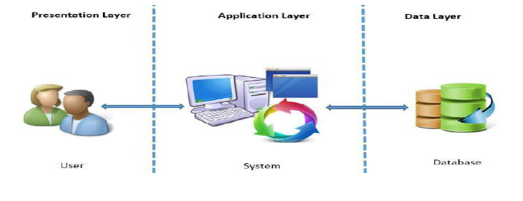

Figure 1: Overall System Architecture

## 5.4 UML Model of Proposed System

The main purpose of using UML to design was to identify the user requirement in as clearly as possible. The UML modelling depicts the correct user interaction with the system and the process flow. And also, the entities and relationships between them. The UML diagram types selected in analysing the business requirement is as follows,

* Use Case Diagram
* Sequence Diagram
* Activity Diagram

### 5.4.1 Use Case of System

Use case diagrams are considered for high level requirement analysis of a system. So, when the requirements of a system are analysed the functionalities are captured in use cases**. Use case diagrams** are usually referred to as [behaviour diagrams](http://www.uml-diagrams.org/uml-25-diagrams.html#behavior-diagram) used to describe a set of actions ([use cases](http://www.uml-diagrams.org/use-case.html)) that some system or systems ([subject](http://www.uml-diagrams.org/use-case-subject.html)) should or can perform in collaboration with one or more **external users** of the system ([actors](http://www.uml-diagrams.org/use-case-actor.html)). Each use case should provide some observable and valuable result to the actors or other stakeholders of the system.

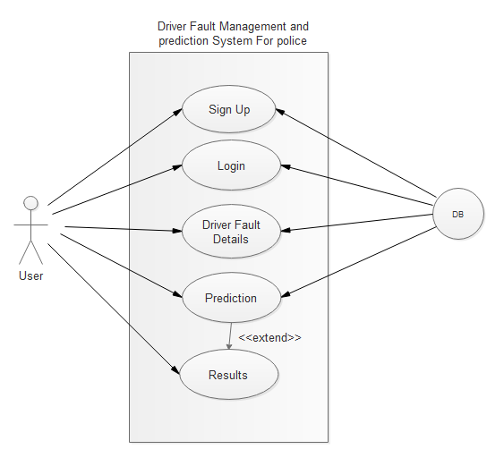

Figure 1: High level Use case for proposed system

#### 5.4.1.1 Scenarios of the use case by the side of User

**5.4.1.1.1 Sign Up**

|  |  |
| --- | --- |
| Use Case | Sign Up |
| Pre-condition | User should have the internet connection |
| Flow of events | User can go to the Login page by using the internet browser.  As a new user he must sign up as new user to the system. |
| Alternative Path | * System provide an error message for these reasons,   1. User must give a valid e-mail address   * If a user gives valid e-mail address, password and other related details he will be recognized as a valid user |
| Post Condition | User can enter to the login page after registered in the system successfully. |

**5.4.1.1.2 Login**

|  |  |
| --- | --- |
| Use Case | Login |
| Pre-condition | User should go to the login page. |
| Flow of events | 1 User can enter the e-mail address and the password to login  2. System will check with the user table and recognise the user |
| Alternative Path | * If user is a new user he can press the “New User” user button and go to the Sign Up page. |
| Post Condition | After log in properly the user can go the home page of the data base. |

**5.4.1.1.3 Driver Fault Details**

|  |  |
| --- | --- |
| Use Case | Driver Fault Details |
| Pre-condition | Details of the drivers who getting caught to the police by doing traffic offences should be recorded. |
| Flow of events | User can enter the details in form which contains in the home page. |
| Post Condition | Return to home page again after user submittec the details to the data base. |

**5.4.1.1.4 Prediction**

|  |  |
| --- | --- |
| Use Case | Prediction |
| Pre-condition | User can go to the prediction page. |
| Flow of events | 1. User can train the existing data by pressing the predict button. |
| Alternative Path | * User can go back and add more data. |
| Post Condition | The system will generate prediction results. |

**‘**

### 5.3.2 Sequence Diagram of System

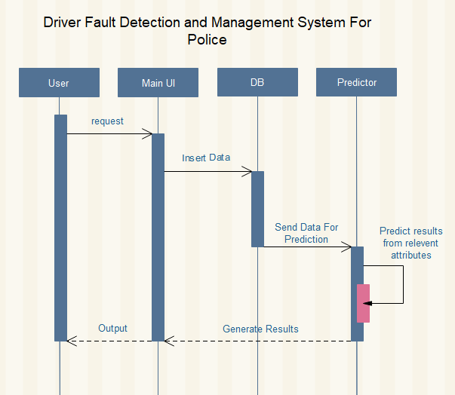

Figure 2: Sequence Diagram the system

### 5.3.3 Activity Diagram of System

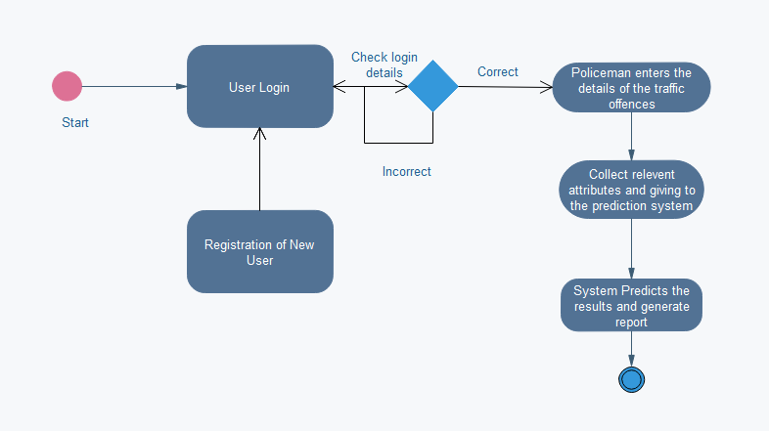

Figure 4: Diagram for process activities

## 5.4 Interface Design

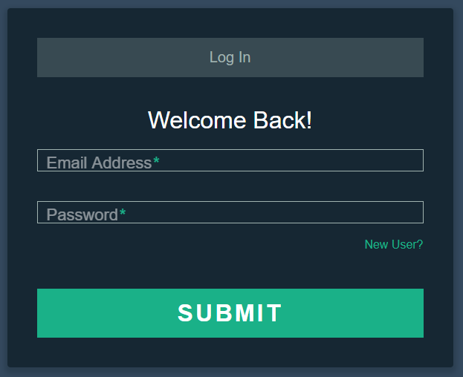

Figure 5: Login Page

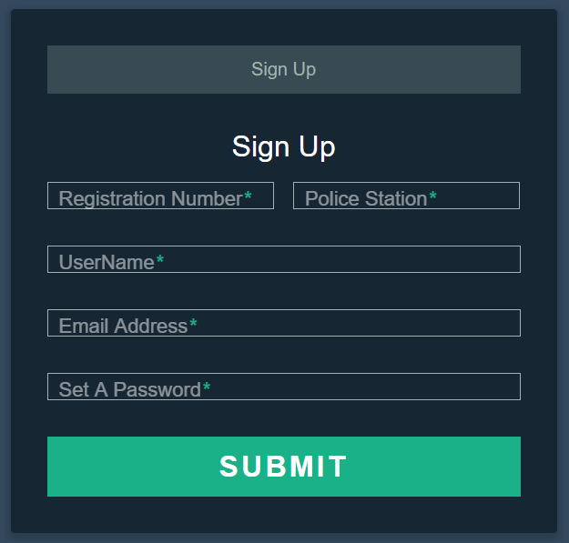

Figure 6: Sign Up page

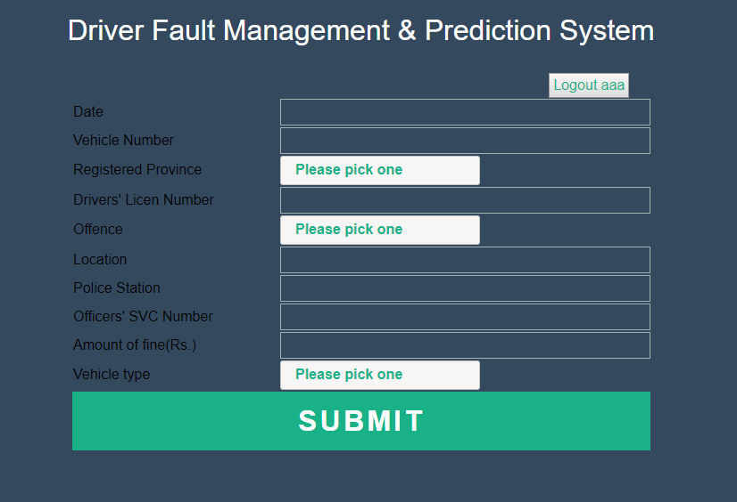

Figure 7: Home page