

**General Sir John Kotelawala Defence University**

**Faculty of Computing**

**Department of Information Technology**

**Approach and Design Chapters**

**Emotion Detection through Voice**

**Approach, , Design** Chapters of the Software Engineering Project undertaken in partial fulfillment of the requirements for the Bachelor of Science (Hons)

in Information Technology Degree program

By

K.W.T Harshani

ICT/14/018

Under the supervision of

Major R. M. M. Pradeep

Contents

4.0 APPROACH 3

4.1 Introduction 3

4.2 Hypothesis 3

4.3 Users 3

4.4 The Features 3

4.4.1 Functional Requirements 3

4.4.2 Non- Functional Requirements 3

4.4.3 Technological Requirements 4

4.5 Inputs 4

4.6 Outputs 4

4.7 Process 4

4.8 Features 4

4.9 Summary 4

5.0 ANALYSIS AND DESIGN 5

5.1 Introduction 5

5.2 Analysis 5

5.2.1 Data Collection Protocols 5

5.3 Overall System Architecture 6

5.4 UML Model of Proposed System 6

5.4.1 Use Case of System 7

5.3.2 Sequence Diagram of System 9

5.3.3 Activity Diagram of System 10

5.4 Interface Design 11

Table of figures

Figure 1: Overall System Architecture

Figure 2: High level Use case for proposed system

Figure 3: Sequence Diagram the system

Figure 4: Diagram for process activities

Figure 5: Home UI

Figure 6: Recording Interface

# 4.0 APPROACH

## 4.1 Introduction

Chapter 3, discusses about the literature review and the identified problem and proposed solution. In this chapter, the approach will be taken to solve the identified problems. This includes the hypothesis, inputs, outputs, process related to the system, users of the system and the features of system will be described.

## 4.2 Hypothesis

By using reliable emotion detector in an android app will provide more functional real time analysis in emotion detection of a user.

## 4.3 Users

There will be mainly one user in the system. That user is the owner of the app.

## 4.4 **The Features**

### 4.4.1 Functional Requirements

* The new system must be able to identify the user by voice or user name and password.
* The system should capture the speech of the user
* The system must provide the accurate emotion according to the voice
* The system should be able to confirm its decision by user input.
* The system should provide facilities to the user according to his emotion.

### 4.4.2 Non- Functional Requirements

* The system should contain quick and easy access.
* The performance must be in well-organized manner which will help the system to perform its tasks in an efficient way.
* The system should provide reliable and accurate results.
* The user interfaces must be interactive and attractive to gain the user’s attention.
* The system must provide confidentiality to the user
* The system must not evade the personal space unnecessarily.

### 4.4.3 Technological Requirements

* Mobile with android application compatibility
* Efficient microphone embedded in a mobile

## 4.5 Inputs

The main input of the system is the user’s voice, it must be audible and it must be at a frequency level which can be captured by the modern devices.

## 4.6 Outputs

The output of the system is the user’s emotion displayed in the screen.

## 4.7 Process

Main steps will be as follows

* User turn on the app
* User utter some words or a sentence
* System will capture the characteristics as frequency.
* System will determine the emotion after the data been sent to the database
* Emotion generated by the DB processing will be displayed.

## 4.8 Features

Key Features will be as follows,

* Ability to recognize the emotion by a small sentence
* Ability to compare the results with users expectation
* Ability to recognize the emotion in an personalized way

## 4.9 Summary

This chapter presented the hypothesis, input, output, features, users and process of the proposed solution. In particular I have explained the input processing concerning with the system. The outputs from the system are emotion recognized in the system. The overall features of the new system also have been pointed out at the end of the approach section.

The next chapter will present the design of the proposed system.

# 5.0 ANALYSIS AND DESIGN

## 5.1 Introduction

This chapter elaborates on the analysis and design of the system. Firstly, this chapter presents the analysis of the project domain and the second section concludes with the proposed design of the solution. The analysis section describes on the data gathering protocols, how the data was analyzed, and the overall summary of the data analyzed. The design section describes the design of the developed system with using different UML diagrams and architecture diagrams. The components and modules of the system and their relationships have been elaborated using use case diagrams. And here discuss about what each component does in the system.

## 5.2 Analysis

### 5.2.1 Data Collection Protocols

The data was collected from the main user of the system. Mainly the data was collected by an app which provides the functionality to gather data with the aid of different parameters.

It has the parameters such as

* LAF - A-frequency weighted and fast time weighted (125ms) sound level.
* LAS- A-frequency weighted and slow time weighted (1s) sound level.
* LAI - A-frequency weighted and Impulse time weighted (35/1500ms) sound level.
* LCF - C-frequency weighted and fast time weighted (125ms) sound level.
* LCS - C-frequency weighted and slow time weighted (1s) sound level.
* LCI - C-frequency weighted and Impulse time weighted (35/1500ms) sound level.
* LZF - Z-frequency weighted (Lin) and fast time weighted (125ms) sound level.
* LZS- Z-frequency weighted (Lin) and slow time weighted (1s) sound level.
* LZI - Z-frequency weighted (Lin) and Impulse time weighted (35/1500ms) sound level
* LAeq – Equivalent A- frequency weighted continuous sound level.
* LCeq– Equivalent C- frequency weighted continuous sound level.
* LZeq – Equivalent Z- frequency weighted (Lin) continuous sound level.
* LAE – A- frequency weighted sound exposure level.
* LCE – C- frequency weighted sound exposure level.
* LZE – Z- frequency weighted (Lin) sound exposure level.

## 5.3 Overall System Architecture

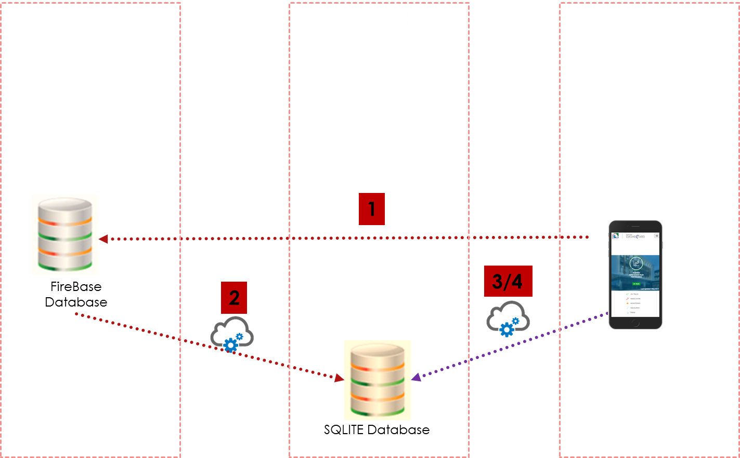

Figure 1: Overall System Architecture

## 5.4 UML Model of Proposed System

The main purpose of using UML to design was to identify the user requirement in as clearly as possible. The UML modelling depicts the correct user interaction with the system and the process flow. And also, the entities and relationships between them. The UML diagram types selected in analysing the business requirement is as follows,

* Use Case Diagram
* Sequence Diagram
* Activity Diagram

### 

### 5.4.1 Use Case of System

Use case diagrams are considered for high level requirement analysis of a system. So, when the requirements of a system are analysed the functionalities are captured in use cases.

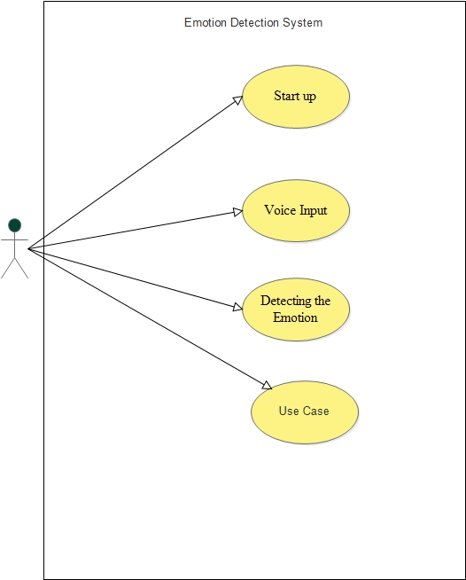

Figure 2: High level Use case for proposed system

#### 5.4.1.1 Scenarios of the use case by the side of User

**5.4.1.1.1 Start Up**

|  |  |
| --- | --- |
| Use Case | Start up |
| Pre-condition | User should have the app |
| Flow of events | 1. User install the app  2. Press start button |
| Alternative Path | * System provide an error message for these reasons,   1. A user cannot have a low version of android   * If a user install and launch the app user can successfully access. |
| Post Condition | User can enter to the home page successfully. Then user can carry-out the process. |

**5.4.1.1.2 Input the voice**

|  |  |
| --- | --- |
| Use Case | Voice Input |
| Pre-condition | Customer should launch the app |
| Flow of events | 1 User can press start button  2. the system will record the user input |
| Alternative Path | * Customer can click rec button to make voice recording * Can listen to the voice in the recorder folder * Customer can click back button to make choice reverse |
| Post Condition | After the recording the user can move into the emotion detection |

**5.4.1.1.3 Emotion Detection**

|  |  |
| --- | --- |
| Use Case | Detecting the Emotion |
| Pre-condition | Voice input must be well recorded |
| Flow of events | Customer will get a splash screen of the detected emotion |
| Alternative Path | Customer can click back button to make choice reverse |
| Post Condition | Return to home page, if customer needs more predictions |

### 5.3.2 Sequence Diagram of System

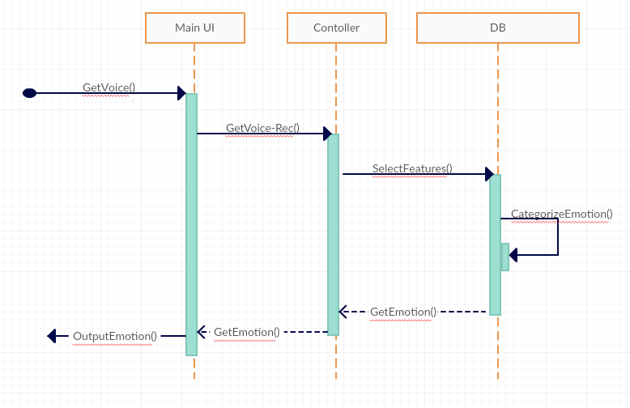

Figure 3: Sequence Diagram the system

### 5.3.3 Activity Diagram of System

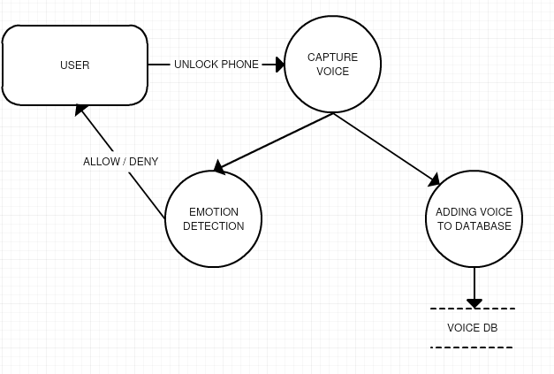

Figure 4: Diagram for process activities

## 5.4 Interface Design

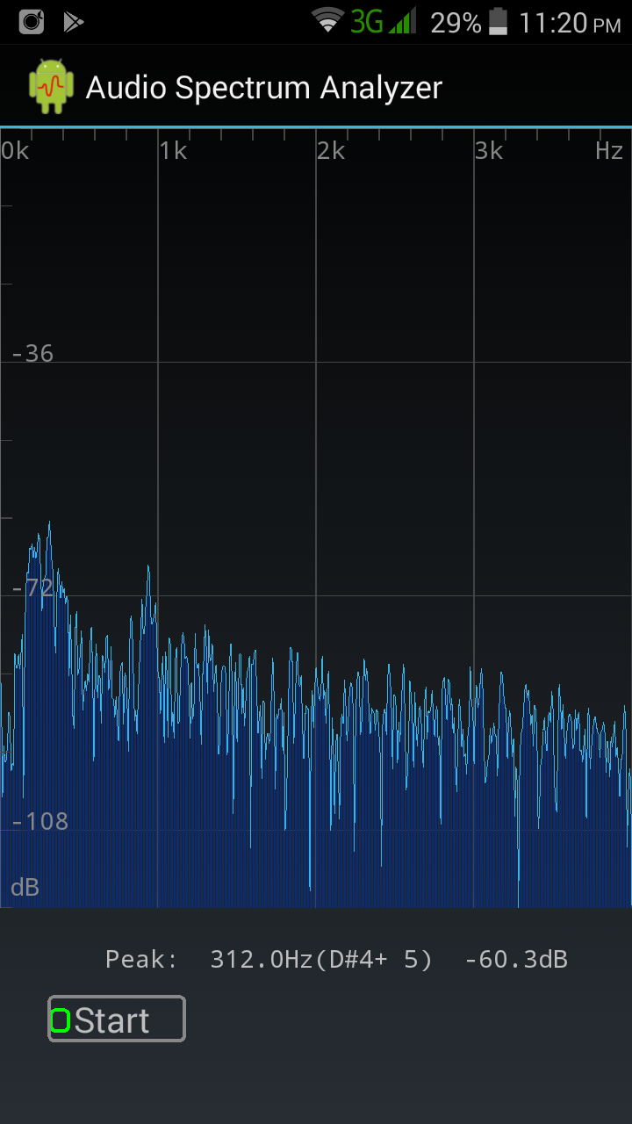

Figure 5: Home UI

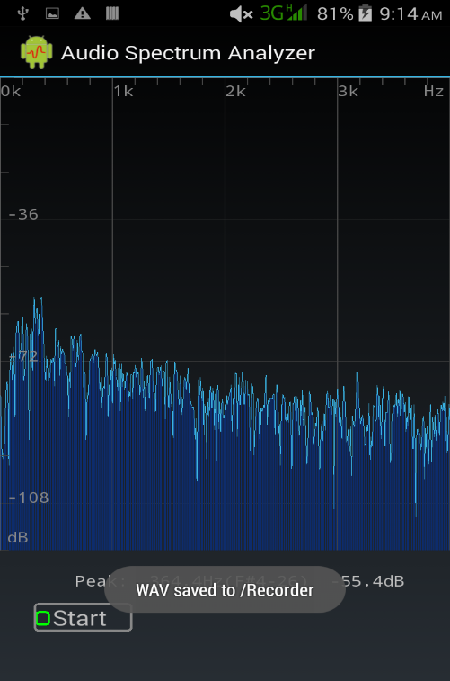

Figure 6: Recording Interface