**Lost in the Sauce: The Effects of Nutrient and Silica concentration on Cell Density of *Chaetoceros calcitrans***

by

Nicholas Fantin and Kyle Hudson

A report submitted in partial fulfilment of the requirements of

DIRECTED STUDIES IN MARINE SCIENCE AND APPLIED DATA ANALYSIS

at

Bamfield Marine Sciences Centre

Instructors: Dr. Garth Covernton and Paul van Dam Bates

Teaching Assistant: Gina Nickoloff

© Nicholas Fantin, 12/2022

Home University: University of British Columbia – Okanagan

© Kyle Hudson, 12/2022

Home University: University of Alberta

**ABSTRACT**

The search for sustainable food sources is a critical area of research; as our population continues to grow and our fisheries decline, aquaculture has stood out as a promising solution. We applied standard microalgae cultivation methods created for diatoms like *Chaetoceros calcitrans* while changing the amounts and ratios of the two standard diatom growth nutrients. *Chaetoceros calcitrans* is an important food for farmed oysters, as it contains all the essential nutrients that an oyster needs. It is especially critical to young oysters due to its small size. These algae are grown in either large bioreactor tanks or in batch systems filled with different nutrients that the algae need to grow. However, these nutrients' most efficient amounts and ratios are still not completely understood. We aimed to test dozens of different combinations and concentrations in a factorial system of the two essential growth nutrients, F/2 algal growth media and Silica Dioxide. This was done to try and determine a golden ratio of the two nutrients, resulting in the highest efficiency of plankton growth, with the highest output of oyster food. We found that altering Silica dioxide to approximately 190% of the industry standard resulted in the highest densities, meaning it may be the limiting nutrient.

**KEYWORDS**

Aquaculture, Diatom, F/2, Water glass, Frustule, Pediveliger, Spat, Bioreactor.

**INTRODUCTION**

With the global need to feed an increasing population of people, advances in food production are critical research areas. As the demand for seafood increases and coastal fisheries are declining (Jackson et al., 2001), aquaculture has become a promising solution to this problem (deFur & Rader, 1995). Aquaculture is one of the fastest-growing food industries providing large amounts of sustainable food to people worldwide (Troell et al., 2009). While studies have shown that aquaculture can cause disturbances in native fish populations, these issues have been primarily linked to finfish aquaculture (Naylor et al., 2000). Alternatively, bivalve aquaculture has been shown to be highly sustainable as they filter-feed from the water column, which can even help prevent algal blooms (Shumway et al., 2003). Aquaculture of the *Crassostrea sp.* oysters was valued as a 7-billion-dollar industry in 2017, making up almost 25% of the total aquaculture product sold globally (Omont et al., 2021). Aquaculture is practical in any coastal city and can be done with land-based facilities (Troell et al., 2009).

*Crassostrea gigas* is the most commonly farmed mollusk in the world (Omont et al., 2021). These oyster farmers are generally farming *C. gigas* from their spat stage of life to their full adult size that then gets sold for consumption. Oyster spat is a post-metamorphosis juvenile oyster (Dégremont et al., 2007). This oyster spat is referred to as oyster seed in the mollusk aquaculture industry (Dégremont et al., 2007). Like traditional farming, aquaculture of mollusks requires these oyster seeds to begin farming, and unless you have an established aquaculture business producing brood stock, farmers need the oyster seed to establish their farmed population. This oyster seed is provided by hatcheries like Nova Harvest (Bamfield B.C. Canada) that keep brood stock of the oysters. Oysters are metamorphic animals that live as free-swimming pediveliger larvae until they are ready to metamorphose; then, they find a rigid substrate to attach to before they can change to oyster spat. In the aquaculture industry, companies like Nova Harvest create this oyster seed by tumbling the pediveliger larvae with sand, allowing the larvae to attach to a grain of sand instead of a hard substrate. This allows the oysters to be farmed easily as they grow free floating so that they can be more easily grown and harvested (NOVA Harvest, personal communication, November 22, 2022). This type of growth makes them more appealing than wild oysters to the food industry because the shell can grow into a uniform cup shape (Wang et al., 2022).

Oysters are very efficient filter feeders, pulling organic debris out of the water column. A single adult male *C. gigas* is capable of filtering up to 200 litres of water in a single day (Chávez-Villalba et al., 2007). Therefore, Hatcheries like Nova Harvest spend lots of resources replicating the complex diet these oysters need to grow. Cultivating microalgae as feed for *Crassostrea sp*. is the most expensive and unpredictable step in the oyster aquaculture process (Carboni et al., 2016; Tanyaros & Chuseingjaw, 2016). While a diversity of algal species is fed to growing oysters, the algae we are specifically interested in is *Chaetoceros calcitrans* (CC). CC is a critical species as it is commonly used, and clean cultures are readily available. CC is a small-sized diatom crucial for oysters' early development (Kaspar et al., 2014; Ragg et al., 2010). CC is one of the only diatoms that early veliger-stage oysters can eat (Ragg et al., 2010), and continues to be an essential food for the oysters all the way into their settled spat stage (Kaspar et al., 2014). Extending past bivalves, CC is a nutritionally important microalgae to other filter-feeding aquaculture animals, like clams (Tredici et al., 2009). This further strengthens the need to be able to grow CC in an efficient way, as it would apply to several other aquaculture species.

CC are commonly grown in both large, automated bioreactors, which act as a flow-through system, and in static batch cultures of sterile sea water with two standard growth nutrients (Kaspar et al., 2014). The first nutrient is a typical algal growth solution called F/2, which is made with all the essential nutrients like nitrogen, phosphorus, sodium, and trace metals (Table 1). Second, a soluble silica solution called 'water glass' (sodium silicate) which is a key ingredient in diatoms silica-based cell walls called frustules. We aim to find the concentrations of the two standard nutrients that result in optimal algal growth to increase the efficiency of both resources and time for aquaculture companies that rely on CC as feed. To find this optimal concentration, we varied both nutrients in a factorial system based on the current local standards to incubate CC (NOVA Harvest, personal communication, November 22, 2022). Our growth will be done in static flask systems most similar to batch culture growth, with inferences also extending to what would be expected in large-scale bioreactors. Growth will be measured by comparing initial to final cell densities after one week of incubation. We hypothesize that cell densities will increase with both F/2 and water glass density and that increasing both together will have the most significant effect (i.e., there will be an interaction effect).

**MATERIALS AND METHODS**

Treatment Preparation

In advance of inoculation, we labelled and prepared 84 125ml Erlenmeyer flasks. We added 50ml of filtered and UV sterilized sea water pre-mixed with Trisaminomethane, a standard pH buffer used to maintain pH in a biologically safe range (Stone-Weiss et al., 2021). We varied our Silica dioxide and F/2 concentrations based on standard concentrations (1 : 1 : 2000 ratio of F/2 : water glass : sea water) (NOVA Harvest, personal communication, November 22, 2022), which we refer to as 100% concentration. Initial F/2 and water glass solutions were also as per standard of NOVA harvest (Table 1). We tested 70-220% concentration in 30% increments of each nutrient in a factorial system, as well as combinations of 300 and 600% with both nutrients increasing and with one held at 100% to further extend our inferences of concentration effects (Figure 3). We used a 0.5mL micropipette accurate to 0.1μL to add the Silica Dioxide and F/2 solutions and added tinfoil covers to all flasks. To guarantee initial sterility of the solution we autoclaved all flasks at 119°C for 45 minutes. Once the flasks cooled, we used a 0.025mL hemocytometer to measure cell density of a single uniform CC culture also supplied by NOVA harvest and inoculated every flask in a saved randomized order using a 1ml micropipette accurate to 1 μL with 2ml each of the CC culture. During inoculation we used sterile technique to keep cultures pure, including flaming the mouth of flasks prior to and after opening any of them, working near a flame to maintain a sterile environment, and using autoclaved pipette tips.

Incubation

All inoculated flasks were set on the same lab bench in a new random order in a 12x7 grid with two full spectrum bulbs on two opposing long sides (Figure 1). Every 12 hours we swirled the flasks to reoxygenate the cultures and flasks were rotated systematically towards one side to give them all the same amount of light exposure (Figure 1). The lab that the cultures were incubated in had an average temperature of 20.6°C, over the trial, with a minimum temperature of 17.4°C and a maximum of 26.9°C, we measured this with a HOBO temperature logger that was placed in the middle of the flask grid. Throughout the incubation period the grow lights stayed on the entire time.

Measurement

After 7 days we measured cell density of the cultures in the same order they were inoculated to keep growth time as consistent as possible. Before each measurement we swirled the flask vigorously to create a homogeneous density across the culture. Cell density was measured using a 0.025mL hemocytometer and converted to cells per mL.

Analysis

Initially we ran a multiple linear regression model including water glass and F/2 as main effects and an interaction effect on the cell densities. The extreme trials (300 and 600% concentration flasks) had high leverage on the effect and were removed from the analysis. The initial linear model failed to meet the assumptions tested in a residual analysis, to solve this we logged the response which satisfied all assumptions tested in our residual analysis. All models were fit in the program R (R Core Team, 2021), and linear relationships were visualized with the ggeffects package (Lüdecke, 2018). We ran the model again without an interaction effect and compared the models using an ANOVA to choose the one that best describes the data. Our threshold for significance of all predictor coefficients is 0.05 (α = 0.05).

**RESULTS**

We ran a log linear model with both main effects and an interaction effect and found that the interaction coefficient was insignificant. We ran another log linear model with only additive effects and compared the two models with an ANOVA. We found that the interaction model did not do a better job of explaining the data (F = 1.94, p = 0.17), therefore we chose to use the simplified additive model for our analysis. Consistent with this, no clear interaction trend was visual in a density map (Figure 3). Because we are interpreting our coefficients on the log scale and received small values, our coefficients can be interpreted as percent increase in the response. Using our additive model, we estimate a 0.18% increase in cell density for every percent increase from standard concentration of water glass (Mean; Lower 95% Confidence Interval-Upper 95% confidence interval) (0.0018; 0.0007-0.0028) (Table 2, Figure 2B). Contrary to our predictions we did not find a significant effect of F/2 concentration on cell density (0.0001; -0.001-0.0012) (Table 2, Figure 2A).

**DISCUSSION**

Water glass

The water glass concentration showed a positive relationship to cell density, predicting a 0.18% increase in density for every percent increase from standard in water glass concentration (Table 2). This supports our hypothesis that one of the two nutrient solutions would have an effect on the cell densities. Cultures that had the lowest water glass concentrations of 70% also showed the lowest average cell density of any flasks (Figure 2B). While cultures with a water glass concentration of 190% showed the highest average cell density of any flask (Figure 3). Water glass being the limiting step of the CC growth rate is not surprising however, diatoms need large amounts of bio-available silica to form the new frustules during cell division (Arasuna & Okuno, 2018). The highest overall cell density of any culture was the flask with the highest concentration of water glass and F/2 at 600% the normal concentrations (Figure 3), however these were outlier values with high leverage effects and were omitted from the analysis.

Shortcomings in growth understanding

Contrary to our predictions we did not see a change cell density with a change in F/2 concentration (Table 2, Figure 2A) or any interaction effects between the water glass and F/2 (Table 2, Figure 3). One limiting factor to our ability to detect change may have been that we only checked density after the 7-day incubation period. Growth of unicellular cultures such as diatoms tends to follow an S-shaped growth curve with initial exponential growth and then an asymptote as resources are used up (González et al., 2021). It is possible that higher nutrient concentration flasks had higher initial growth rates and reached their maximum cell density before our measurement period. Future studies with regular density measurements across the incubation period could give further insight to cell growth rates and could make valuable inferences for flow through systems such as Bioreactors. However, maintaining sterility while doing this could be troublesome as 9 out of 84 cultures crashed due to contamination. For even better inferences for bioreactors similar studies could be done in actual flow through systems, though this requires more resources than simple static systems.

Sources of error

Our laboratory environment was not held precisely at the optimal growth temperature and light. The lighting setup could have been rearranged with more lights, where we could have placed each flask an equal distance away from the growth light. While flask order was randomized to remove possible trends with light as a predictor, having even lighting on all flasks at all times in their incubation period could reduce variation in flask growth. Cultures grow in a S-shaped growth curve and depending how close they are to the light while their growth rate slope is the largest (González et al., 2021), some flasks may have produced smaller densities than they would have if they were a constant distance. The optimal temperature for growth for CC is around 30oC (Krichnavaruk et al., 2005). Better growth conditions would leave nutrient concentrations as the limiting factor and could yield more precise inferences on the effects of nutrient concentration. Additional sources of error could include the lack of recent calibration on our pipettes for nutrient and CC measurements for the cultures.

Implications

Our findings suggest that the current standard concentration of water glass should be increased to maximize CC growth. 190% of the standard concentration (1.9 : 2000 water glass: water of 120g/L waterglass solution) would give the highest increase in cell density we estimate. Due to the lack of significant effects of F/2 concentration change, however it would be inefficient to increase the concentration of F/2 in a static growth system of CC, we assume these inferences could be extended to bioreactors as well.

Future research

We only ran this study with *Chaetoceros calcitrans* (CC), which are vital to the growth of young bivalves (Kaspar et al., 2014; Ragg et al., 2010) it is important to note that this is just one species in a slurry that these oysters require to grow. Rato *et al*. (2019) concluded that the best diets for *Crassotrea gigas* need to include one diatom and at least one flagellate. Similar studies with other commercially valuable diatoms would further increase the efficiency of diatom cultivation for aquaculture. New techniques such as blending macro algae to a specific size may even make CC redundant as an important feed (Carboni et al., 2016; Omont et al., 2021). However further research is needed to test the effectiveness of this technique.

Additional further research could include the makeup of F/2 itself. F/2 is a semi-standard mixture which may yield better results if individual ingredients are optimized for different diatom species.

**Acknowledgments**

First, we would like to thank Olivia and the whole NOVA harvest crew for their input, ideas, and generosity with lending equipment and supplies. Thanks to Dr. Patrick Martone and Elliot Procher for making us fall in love with life that wasn’t an animal. Thanks to Dr. Sally Leys and Carter Burtlake for letting us explore the intertidal region and driving us to follow our passions without restriction. Thanks to Dr. Stephanie Green and Kyle Shanebeck for introducing us to R and giving us the fundamental skills to make these figures. Thanks to Keith Johnstone for helping us attain all the glassware and pipettes we needed to pull this experiment off. Thanks to Tao Eastham for assisting us in the lab. Thanks to Dr. Garth Covernton and Paul van Dam Bates and Gina Nickoloff for helping with design plan and statistical analysis. Thanks to Olive the dog for being the emotional support animal we all needed when times were tough. Finally, thanks to Alexis Palmer, Tong Zhang, Madeline Thompson, Brittany Welsh, and Shay Marks for helping with the experiment.

**References**

Arasuna, A., & Okuno, M. (2018). Structural change of the frustule of diatom by thermal treatment. *Geoscience Letters*, *5*(1), 1. https://doi.org/10.1186/s40562-018-0101-3

Carboni, S., Clegg, S. H., & Hughes, A. D. (2016). The use of biorefinery by-products and natural detritus as feed sources for oysters (Crassostrea gigas) juveniles. *Aquaculture*, *464*, 392–398. https://doi.org/10.1016/j.aquaculture.2016.07.021

Chávez-Villalba, J., Villelas-Ávila, R., & Cáceres-Martínez, C. (2007). Reproduction, condition and mortality of the Pacific oyster *Crassostrea gigas* (Thunberg) in Sonora, México: Reproduction, condition, and mortality of *C. gigas*. *Aquaculture Research*, *38*(3), 268–278. https://doi.org/10.1111/j.1365-2109.2007.01662.x

deFur, P. L., & Rader, D. N. (1995). Aquaculture in Estuaries: Feast or Famine? *Estuaries*, *18*(1), 2. https://doi.org/10.2307/1352278

Dégremont, L., Ernande, B., Bédier, E., & Boudry, P. (2007). Summer mortality of hatchery-produced Pacific oyster spat (Crassostrea gigas). I. Estimation of genetic parameters for survival and growth. *Aquaculture*, *262*(1), 41–53. https://doi.org/10.1016/j.aquaculture.2006.10.025

González, J. F., Cuello, T. B., Calderón, A. J., Calderón, M., González, J., & Carmona, D. (2021). Cultivation of Autochthonous Microalgae for Biomass Feedstock: Growth Curves and Biomass Characterization for Their Use in Biorefinery Products. *Energies*, *14*(15), 4567. https://doi.org/10.3390/en14154567

Jackson, J. B. C., Kirby, M. X., Berger, W. H., Bjorndal, K. A., Botsford, L. W., Bourque, B. J., Bradbury, R. H., Cooke, R., Erlandson, J., Estes, J. A., Hughes, T. P., Kidwell, S., Lange, C. B., Lenihan, H. S., Pandolfi, J. M., Peterson, C. H., Steneck, R. S., Tegner, M. J., & Warner, R. R. (2001). Historical Overfishing and the Recent Collapse of Coastal Ecosystems. *Science*, *293*(5530), 629–637. https://doi.org/10.1126/science.1059199

Kaspar, H. F., Keys, E. F., King, N., Smith, K. F., Kesarcodi-Watson, A., & Miller, M. R. (2014). Continuous production of Chaetoceros calcitrans in a system suitable for commercial hatcheries. *Aquaculture*, *420–421*, 1–9. https://doi.org/10.1016/j.aquaculture.2013.10.021

Krichnavaruk, S., Loataweesup, W., Powtongsook, S., & Pavasant, P. (2005). Optimal growth conditions and the cultivation of Chaetoceros calcitrans in airlift photobioreactor. *Chemical Engineering Journal*, *105*(3), 91–98. https://doi.org/10.1016/j.cej.2004.10.002

Lüdecke, D. (2018). *ggeffects: Tidy Data Frames of Marginal Effects from Regression Models*. https://doi.org/10.21105/joss.00772

Naylor, R. L., Goldburg, R. J., Primavera, J. H., Kautsky, N., Beveridge, M. C. M., Clay, J., Folke, C., Lubchenco, J., Mooney, H., & Troell, M. (2000). Effect of aquaculture on world fish supplies. *Nature*, *405*(6790), 1017–1024. https://doi.org/10.1038/35016500

NOVA Harvest. (2022, November 22). [Personal Communication].

Omont, A., Py, C., Gamboa-Delgado, J., Nolasco-Soria, H., Spanopoulos-Zarco, M., & Peña-Rodríguez, A. (2021). Nutritional contribution of seaweed Ulva lactuca single-cell detritus and microalgae Chaetoceros calcitrans to the growth of the Pacific oyster Crassostrea gigas. *Aquaculture*, *541*, 736835. https://doi.org/10.1016/j.aquaculture.2021.736835

R Core Team. (2021). *R: A language and environment for statistical computing. R Foundation for Statistical Computing, Vienna, Austria.* https://www.R-project.org/.

Ragg, N. L. C., King, N., Watts, E., & Morrish, J. (2010). Optimising the delivery of the key dietary diatom Chaetoceros calcitrans to intensively cultured GreenshellTM mussel larvae, Perna canaliculus. *Aquaculture*, *306*(1–4), 270–280. https://doi.org/10.1016/j.aquaculture.2010.05.010

Rato, A., Pereira, L. F., Joaquim, S., Gomes, R., Afonso, C., Cardoso, C., Machado, J., Gonçalves, J. F. M., Vaz-Pires, P., Magnoni, L. J., Matias, A. M., Matias, D., Bandarra, N. M., & Ozório, R. O. A. (2019). Fatty Acid Profile of Pacific Oyster, Crassostrea gigas, Fed Different Ratios of Dietary Seaweed and Microalgae during Broodstock Conditioning. *Lipids*, *54*(9), 531–542. https://doi.org/10.1002/lipd.12177

Shumway, S. E., Davis, C., Downey, R., Karney, R., Kraeuter, J., Rheault, R., & Wikfors, G. (2003). *Shellfish aquaculture—In praise of sustainable economies and environments*. 4.

Stone-Weiss, N., Smith, N. J., Youngman, R. E., Pierce, E. M., & Goel, A. (2021). Dissolution kinetics of a sodium borosilicate glass in Tris buffer solutions: Impact of Tris concentration and acid (HCl/HNO 3 ) identity. *Physical Chemistry Chemical Physics*, *23*(30), 16165–16179. https://doi.org/10.1039/D0CP06425D

Tanyaros, S., & Chuseingjaw, S. (2016). A partial substitution of microalgae with single cell detritus produced from seaweed ( *Porphyra haitanensis* ) for the nursery culture of tropical oyster ( *Crassostrea belcheri* ). *Aquaculture Research*, *47*(7), 2080–2088. https://doi.org/10.1111/are.12662

Tredici, M. R., Biondi, N., Ponis, E., Rodolfi, L., & Chini Zittelli, G. (2009). Advances in microalgal culture for aquaculture feed and other uses. In *New Technologies in Aquaculture* (pp. 610–676). Elsevier. https://doi.org/10.1533/9781845696474.3.610

Troell, M., Joyce, A., Chopin, T., Neori, A., Buschmann, A. H., & Fang, J.-G. (2009). Ecological engineering in aquaculture—Potential for integrated multi-trophic aquaculture (IMTA) in marine offshore systems. *Aquaculture*, *297*(1–4), 1–9. https://doi.org/10.1016/j.aquaculture.2009.09.010

Wang, Q., Sun, C., Chen, L., Shi, H., Xue, C., & Li, Z. (2022). Evaluation of microalgae diets on flavor characteristics of Pacific oysters (Crassostrea gigas) during fattening. *Food Chemistry*, *391*, 133191. https://doi.org/10.1016/j.foodchem.2022.133191

**Tables and Figures**

**Table 1.** Nutrient concentrations breakdown of the F/2 solution used in our experiments as well as the water glass solution concentration.

|  |  |  |
| --- | --- | --- |
| Chemical | Ingredients | Grams per L |
| F/2 | EDTA | 17.44 |
|  | Sodium Nitrate | 300 |
|  | Dissolved Iron | 20 |
|  | Sodium Phosphate | 20 |
|  | Trace metal solution | 4 |
|  | F/2 total | **361.44** |
| Water Glass | Silica Dioxide | **120** |

**Table 2.** Summary Statistics for the coefficients of each predictor variable. Values were interpreted from the log linear additive model and are reported on the log scale. The standard error is reported as ‘Std. Error’, and the last two columns show the confidence interval. The predictors are not scaled and therefor inferences should not be made from the intercept.

**Fig 1.** Incubation set up. Numbers represent the random starting position for each flask (42 different treatments, each with two replicates gave 84 flasks) in the grid. The arrows show the direction the flasks were rotated in a conveyor belt style. Lights along each long side of the incubation grid.

**Fig 2**. A: Cell density plotted against nutrient concentration. B: Cell density plotted against water glass concentration. Each line is fitted values of the model with the respective predictor with a 95% confidence interval. Black dots are observations, each line is fitted values of the predictor with the other continuous variable held at its mean, grey bands show the respective 95% confidence interval.

**B**

**A**

**Fig 3**. A density heat map with each manipulated variable on the axis and colour saturation representing average cell density of each treatment.

**APPENDIX:**

**B**

**A**

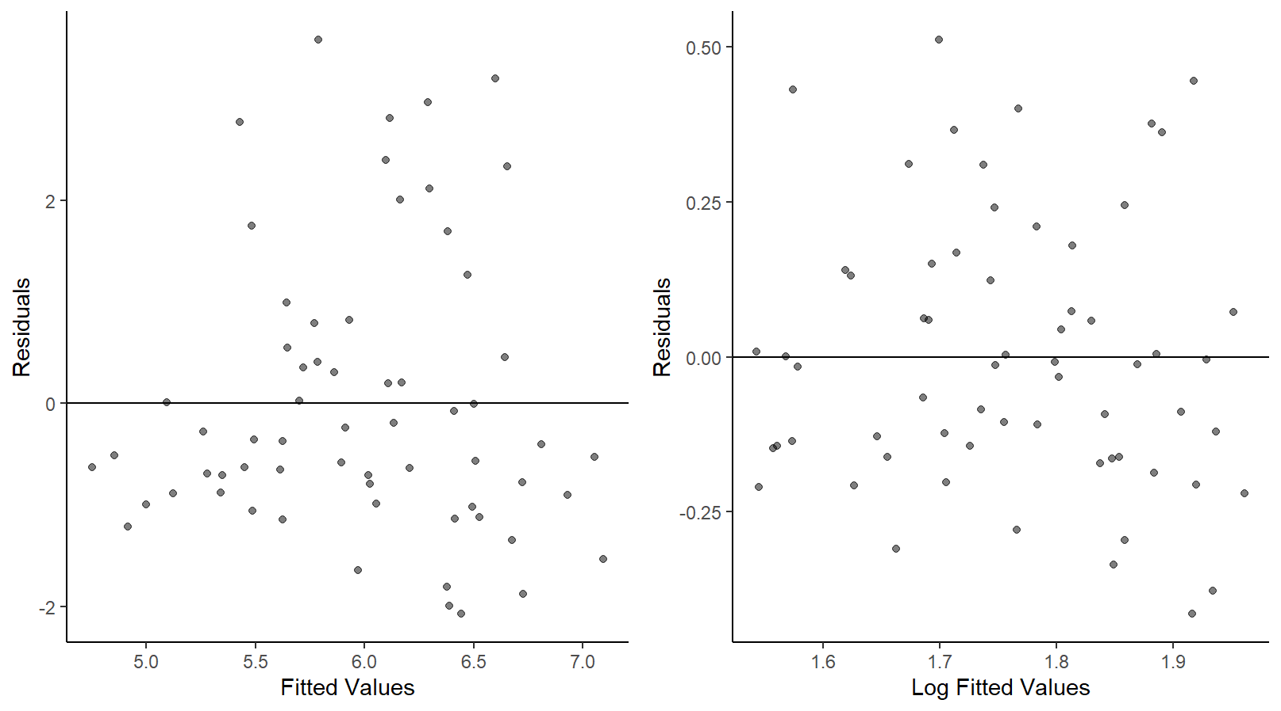

**Fig A. 1**. Residuals plotted against fitted values. A: initial model with no transformations or removal of high leverage points. B: The model with the log transformed output and the extreme predictor values removed.

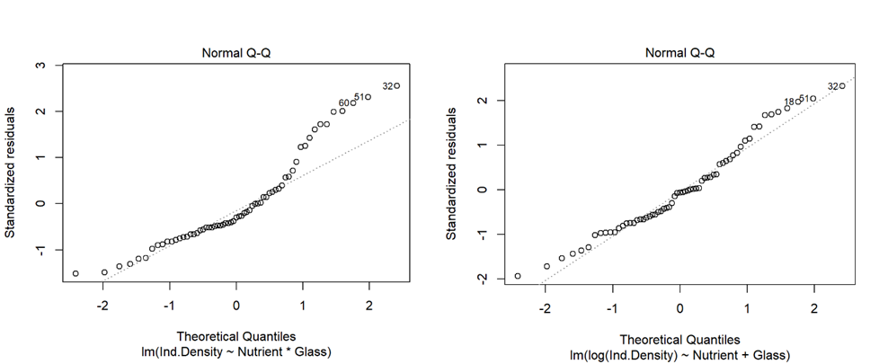

**B**

**A**

**Fig A. 2.** QQ plots to check normality of residuals. A: initial model with no transformations or removal of high leverage points. B: The model with the log transformed output and the extreme predictor values removed.

After running the initial linear model, we did a residual analysis to check if they met the model assumptions. The densities on the real scale showed a non-linear trend and inconstant variance (Figure A. 1A, Figure A 2A). To solve this, we fitted cell density on the natural log scale and saw much better results. On the log scale we saw homoscedasticity of variance in the residuals (Figure A. 1B) and a QQ plot that followed a much more linear trend (Figure A. 2B). Thanks to the nature of our experimental design all random effect variables were applied equally to all treatments and therefor the assumption of no multicollinearity is met. After the residual analysis of the log transformed densities, we removed the 12 extreme treatment results from the analysis. We removed these because of their high leverage on regression and sporadic extreme outlier values.