markymark

katherine piatti

2/7/2021

R markdown documents are good for creating sharable reports of you work. to generate the report from this markdown file click the knit button at the top.

# Headings

to create headings, subheadings, and sub-sub headings, etc. use hashes

# Heading 1

## Heading 2

### Heading 3

### Heading 4

make sure to add a space after the hashes.

# bold and italics

you can make text bold and ital using astricks.

**i want to make this bold** *i want to make this italics*

# bullets

to add bullet points use dashes.

* bullet 1
* bullet 2
* bullet 3

don’t forget to put a space after the dash.

# quotes

to make nicely formatted quotations use >

“there definitely are stupid questions.” -katherine piatti, rladies sydney learner

# links

to add links to you report put text label for link in square brackets and url in round brakets. [here](https://rladiessydney.org/courses/ryouwithme/04-markymark-1/) is the link.

# pictures/gifs/tweets

you can easily add additional types of content to your markdown report.

### pictures

the image file needs to be in the same .proj directory as your markdown file. use square brackets for the label you want on the image. put the image file name in round brackets.

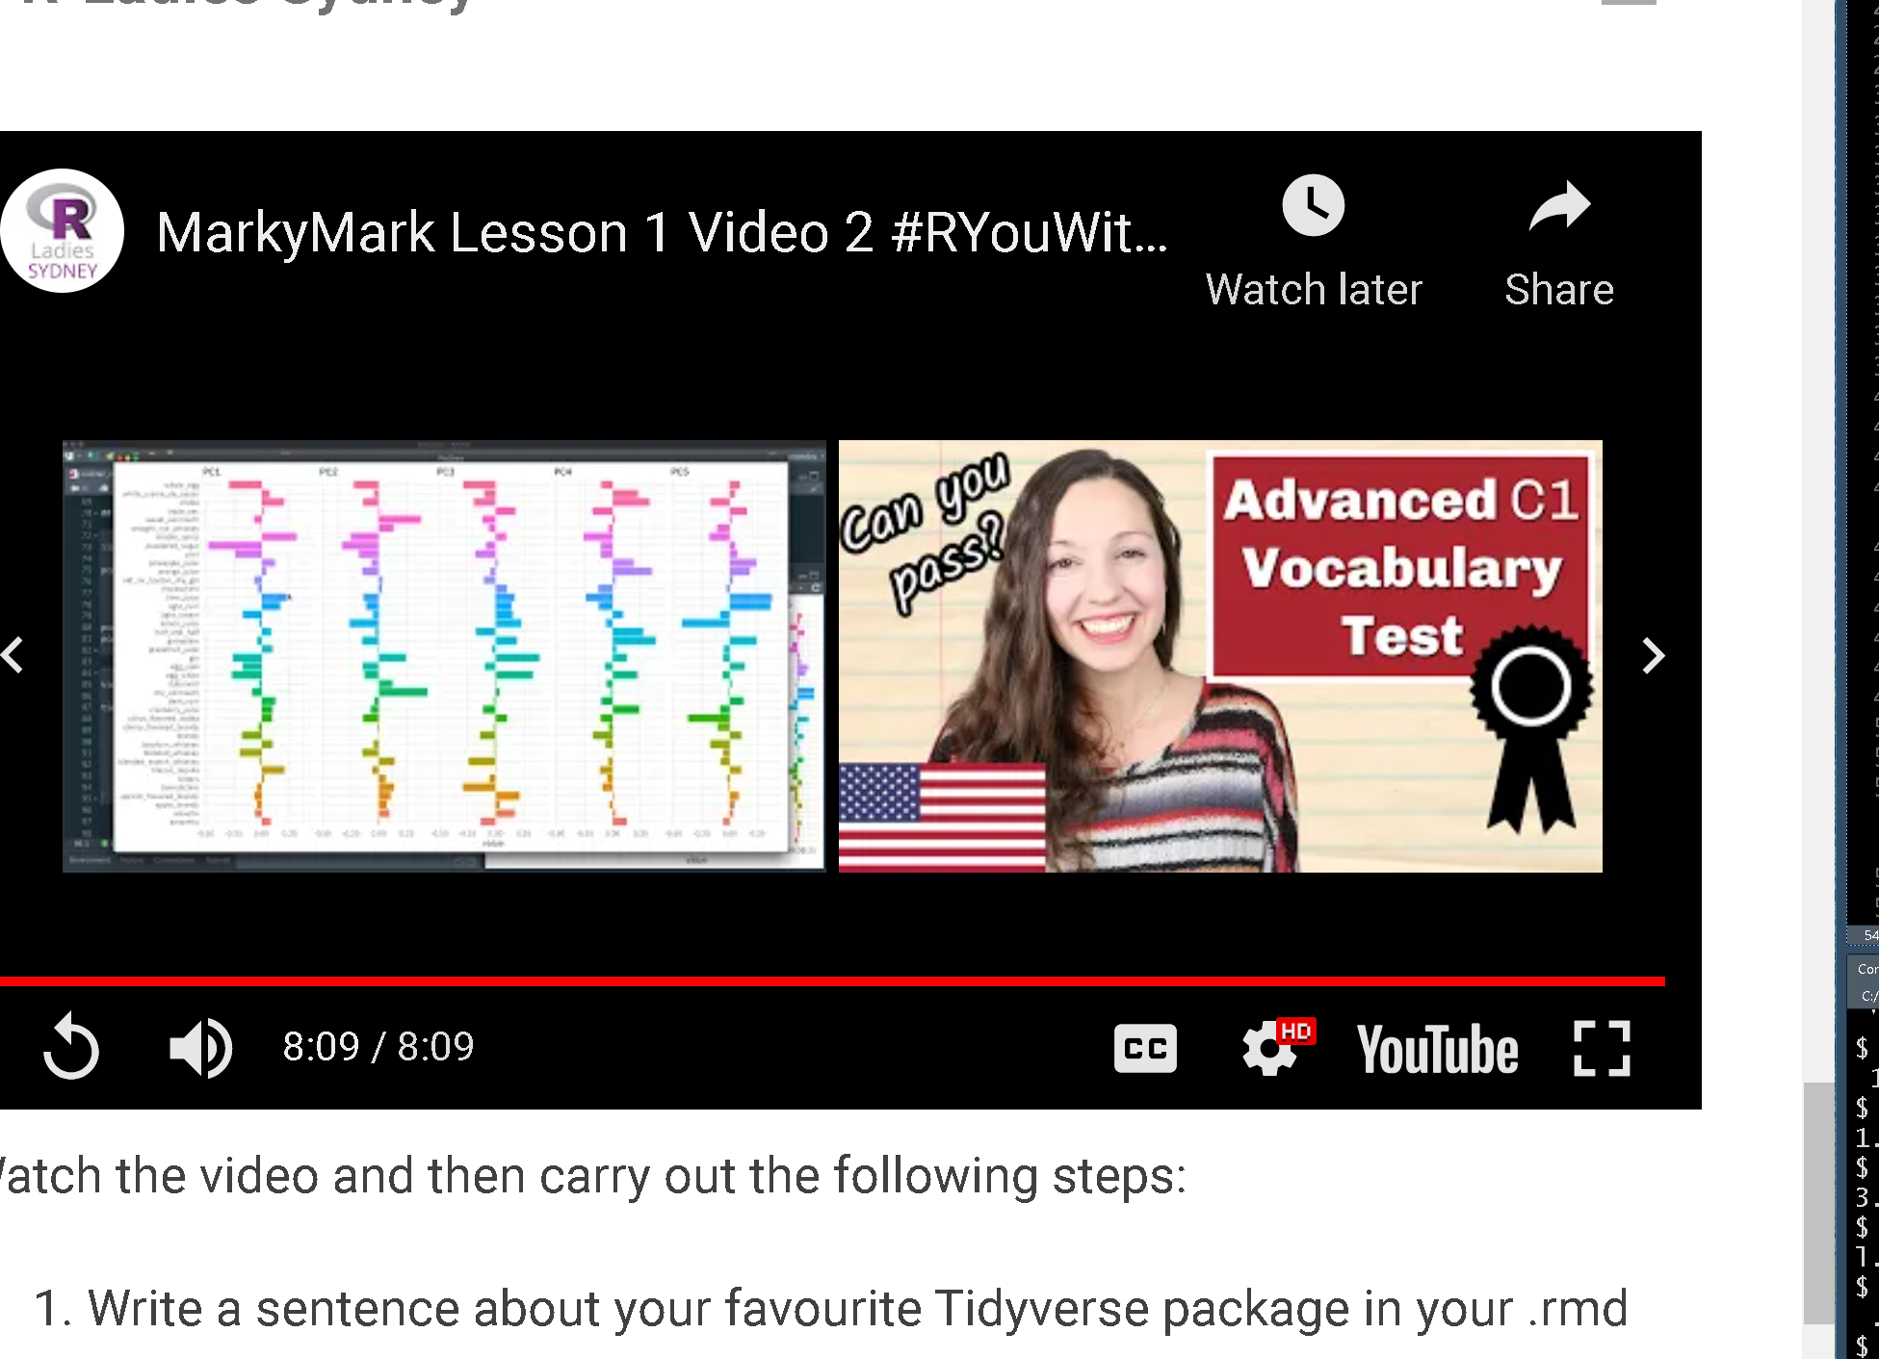

text to explain image

### tweets/gifs/other media

copy and paste the embed code from the media website into your markdown report

use single tick mark around text[]if you want it printed as a command

# insert code

to power of markdown is that you can insert and execute code chucks, and control what output does or does not appear in the final report. - to insert a code chunk use button at top or keyboard shortcut ctrl+ alt+I - to execute code chunk press green arrow at end of chunk or ctrl+enter - to control what output appears in your report add parameters to {r}

#### load pkgs

if some of output is included (can add warnings and more verbose output to report)

library(tidyverse)

## -- Attaching packages --------------------------------------- tidyverse 1.3.0 --

## v ggplot2 3.3.3 v purrr 0.3.4  
## v tibble 3.0.5 v dplyr 1.0.3  
## v tidyr 1.1.2 v stringr 1.4.0  
## v readr 1.4.0 v forcats 0.5.1

## -- Conflicts ------------------------------------------ tidyverse_conflicts() --  
## x dplyr::filter() masks stats::filter()  
## x dplyr::lag() masks stats::lag()

if all output is removed from showing up in your report

library(readr)  
library(here)

#### read in data

beaches <- read.csv(here("Data", "cleanbeaches.csv"))

#### plot mean number of bugs at each beach

beaches %>%   
 group_by(site) %>%   
 summarise(meanbugs = mean(beachbugs, na.rm = TRUE)) %>%   
 ggplot(aes(x = site, y = meanbugs)) +  
 geom_col() +  
 coord_flip()

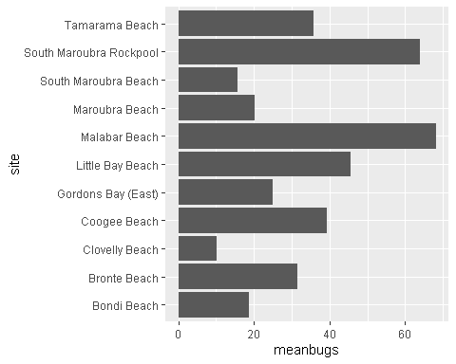

# other export formats

by default your markdown report will export as html, but you can also choose to export as word doc or pdf by clicking down arrow next to knit button and changing the output specified in your header.