**UNC – Charlotte – Data Analyst Visualization – Project II**

**Team members:** Heba Mohsen, Karine Piccoli & Sashi Devulapalli

**Project Proposal**

**Overview**: Visualize the trends related to food & travel and analyze COVID -19 impacts on people food & travel related searches in U.S.

**Data source:** Google trends (<https://trends.google.com/trends/?geo=US>)

**Data range:** 01/01/2018 to present.

**Region:** USA, States and Cities

**Data set 1:** Recipes, Restaurants, Delivery and Bar

**Data set 2:** Airline, Vacation & Car Rental

**Data Visualization Approach**: Using Python, extract CSV datasets obtained from Google Trends, load them in Postgres SQL & import to Tableau for data visualization and Analysis.

**Link to Git Hub:** <https://github.com/kpiccoli/Project_Two.git>

**Graphical View(s).**

Food data:

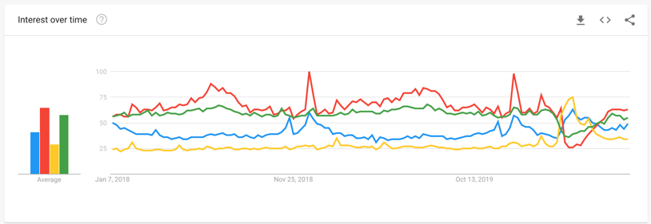

Travel data

