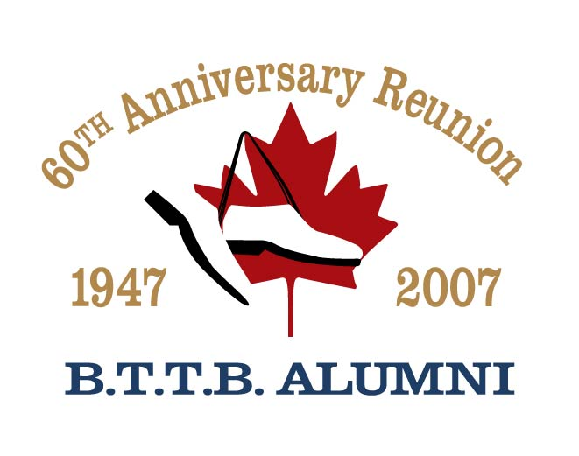 | 2026-11-07 | Submit completed order form to:
 | 2026-11-07 | Burlington Teen Tour Band  P.O. Box 5013  Burlington, ON  L7R 3Z6  Fax: (905) 333-0859  Or email to payments@bttbalumni.ca

Contact Information |  |  |  |  | Payment Information
Name |  |  |  |  |  | Cheque, payable to:
Guest Names |  |  |  |  |  | BTTBB Inc. (60th Anniversary Alumni)
Street
 |  |  |  |  |  | Visa
City |  | Prov/  State |  |  |  | Mastercard
Country |  | PC/  Zip |  |  |  | Card #:
Phone |  |  |  |  |  | Exp: | mm | / | yy
Email |  |  |  |  |  | Signature:

11 | 0\* | Qty | Regular | Subtotal | Shirt Size(s)
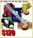 | Pride of Burlington  Social + Parade + Homecoming + Uniform + Souvenir + Lunch | 0 | $120 | $ 0.00
 | Strike Up The Band  Social + Parade + Uniform + Souvenir | 0 | $75 | $ 0.00
 | The Sound of Music  Social + Homecoming + Souvenir + Lunch | 0 | $60 | $ 0.00
 | We Are Family  Social + Homecoming + Hat + Lunch | 0 | $80 | $ 0.00
 | Friday Social (Alumni) | 0 | $20 | $ 0.00
 | Friday Social (Guest) | 0 | $20 | $ 0.00
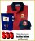 | Parade + Uniform + Souvenir | 0 | $55 | $ 0.00
 | Saturday Homecoming | 0 | $40 | $ 0.00
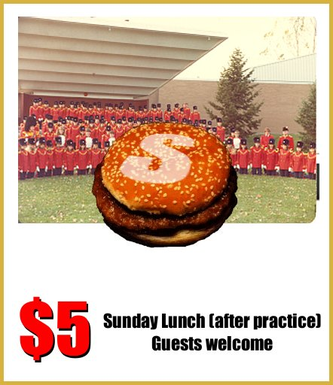 | Sunday Lunch | 0 | $5 | $ 0.00
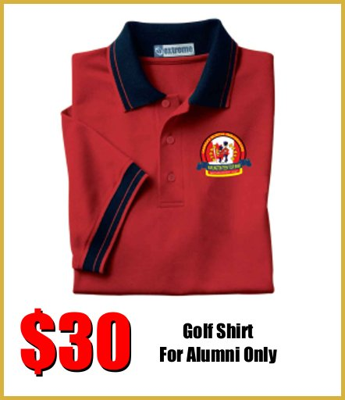 | Shirt | 0 | $30 | $ 0.00
 | Hat | 0 | $15 | $ 0.00
 |  | Total |  | $ 0.00
Specify shirt size(s) desired where applicable. Available sizes are S, M, L, XL, and XXL (all Men’s sizes).

