Package Deals
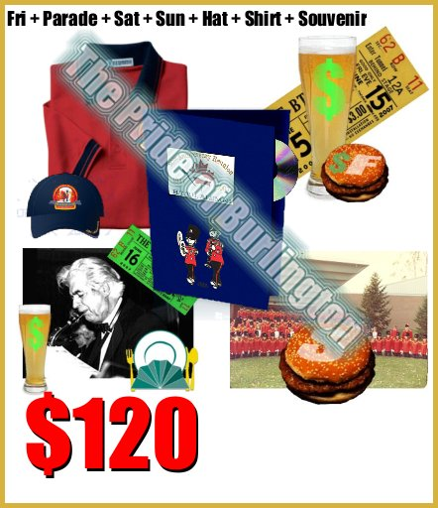 |  | 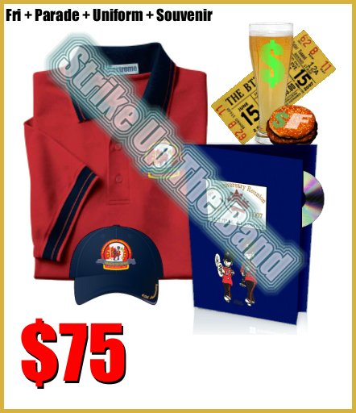
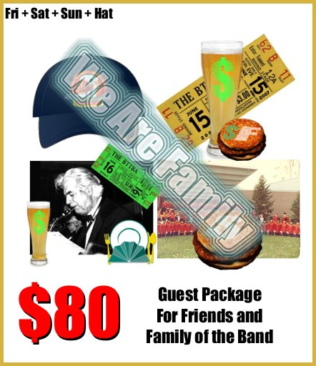 |  | 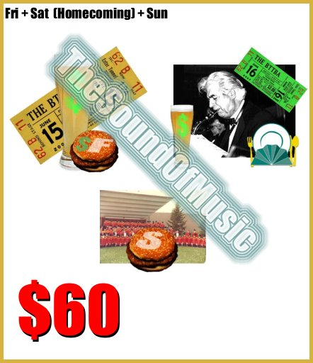
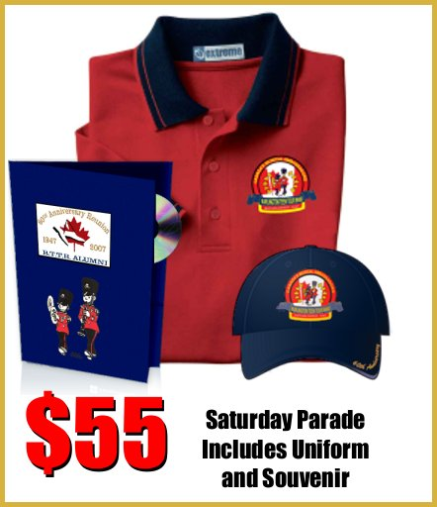 | 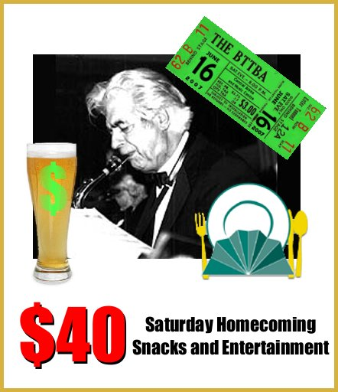 |  | 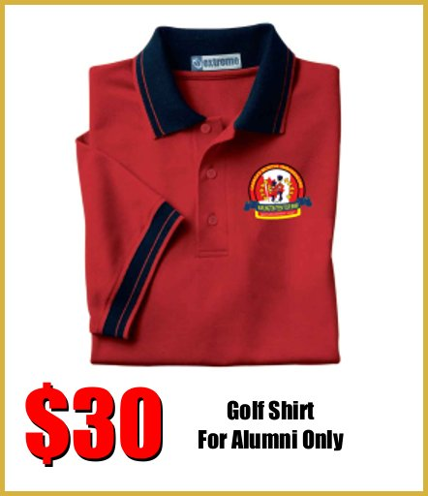
Dust off the instrument, or just tag along (flatbed float available for those who would rather ride) for the annual Sound of Music Parade in the special 60th Anniversary Alumni Band. Everyone in the parade will need a uniform, and don’t forget the practice Friday evening at 7 p.m. at the Music Centre! | The 60th Anniversary Party – A Homecoming Celebration, featuring live entertainment of various types and featuring the Eddie Graf Band. Enjoy gourmet finger food, cash bar, some special presentations celebrating our 60 years and a guest performance by the guests of honour – the 2007 BTTB! |  | Can’t make the parade but want to get into the spirit? This is a high quality golf shirt with the band logo on it. We’d like to keep this exclusive to the alumni as numbers are limited but keep an eye out after the celebration!
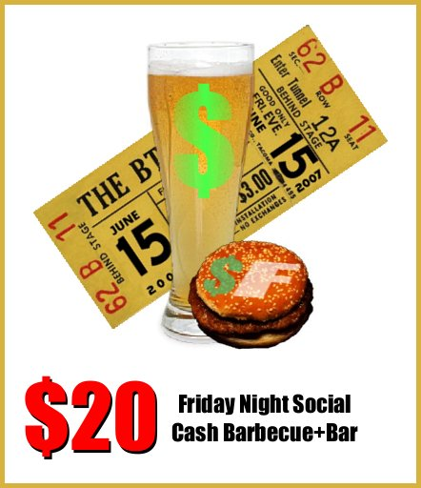 | 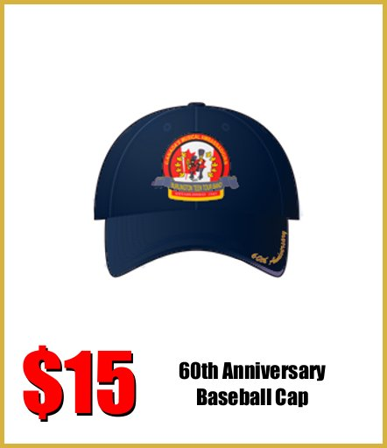 |  | 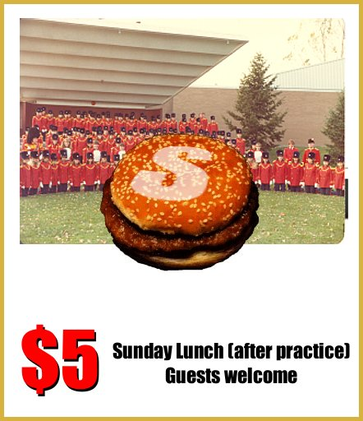
A great start to the weekend in familiar territory. Pick up your registration package at the Music Centre or Central Arena, enjoy a Band Booster barbecue (not included in price of admission), socialize with old friends, cash bar, and browse through the collection of band memorabilia. | A lasting souvenir for you to take home. High quality cap with the logo on the front and “60th Anniversary” stitched into the bill. |  | Bring your entire family for a BBQ Lunch in front of the Music Centre. Sit back, relax (unless you're playing) and enjoy the BTTB and Alumni for a concert in the park. Order individual tickets for your family if you've purchased a package for yourself.

