





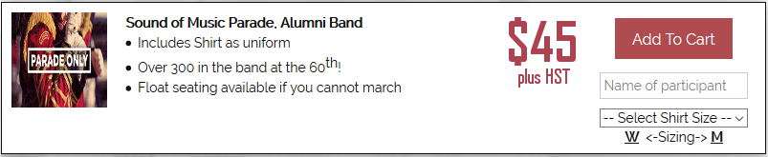



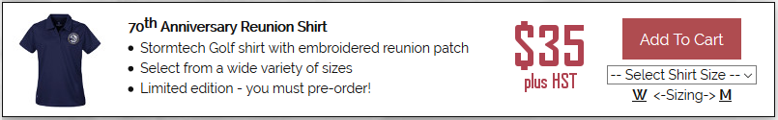

***Go to our website to order now!***

<http://bttbalumni.ca/#store2017>











***Go to our website to order now!***

<http://bttbalumni.ca/#golf2017>