{% extends "base.html" %} {% block body %}



*Create an account for you*

*and your families*

*Check out your health*

*condition in your profile*

**Monitor your most cares**

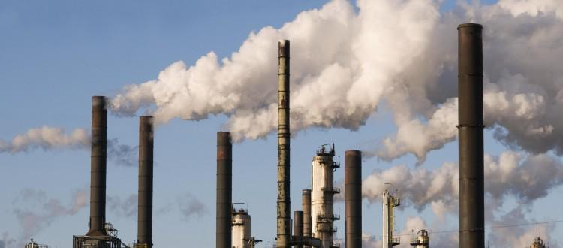

*Find your place on the map*

*and search for nearby hazards*

*Avoid dangerous zone that*

*threatens your health*

**Avoid nearby Hazards**

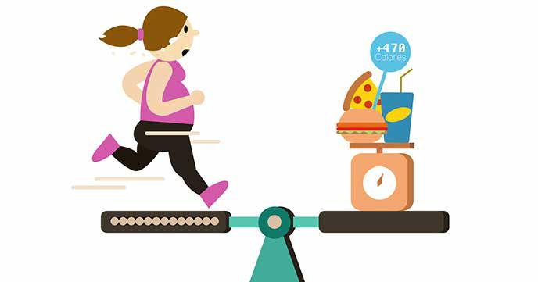

*Find how many exercise*

*you have done thesedays*

*Calories consumption will*

*also be provided for your*

*convenience*

**Record your energy consumption**



*How to improve your*

*health?*

*Don't worry, we have a*

*plan for you*

**Getting Advice**

{% endblock %}