Unit 3-4.5

Outcome of collaborative working, archiving the work

Once I have completed my work, I will want to store the work where I can access it at a later date, I may also wish to e-nail that work to a collogue, to accomplish this I shall store the data/work in different types of folders.

Folder
In windows a document is stored in File explorer, the document is stored in a folder
[directory], depending on the amount of related data/documents the user requires to store, he file may be copied to a sub folder and so on.

Zip Folder
when transferring large amounts of data/documents via e-mail, it is wiser to embed your work in zip folder, this zips or presses the data into a tighter entity, and therefore easier to transfer through the internet process.
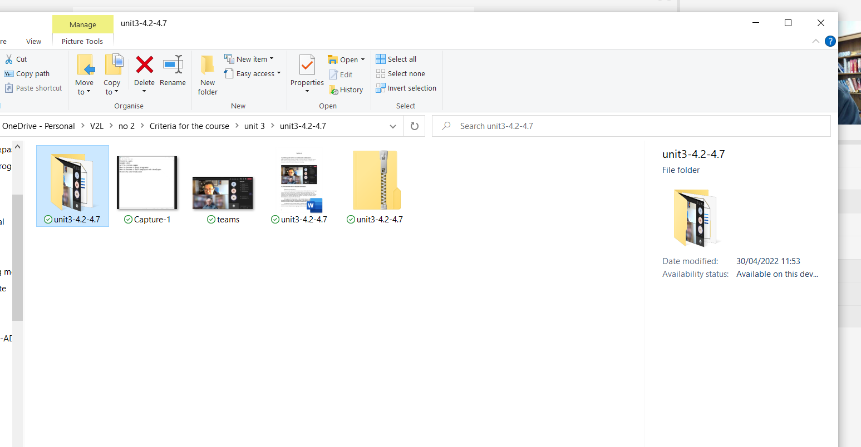
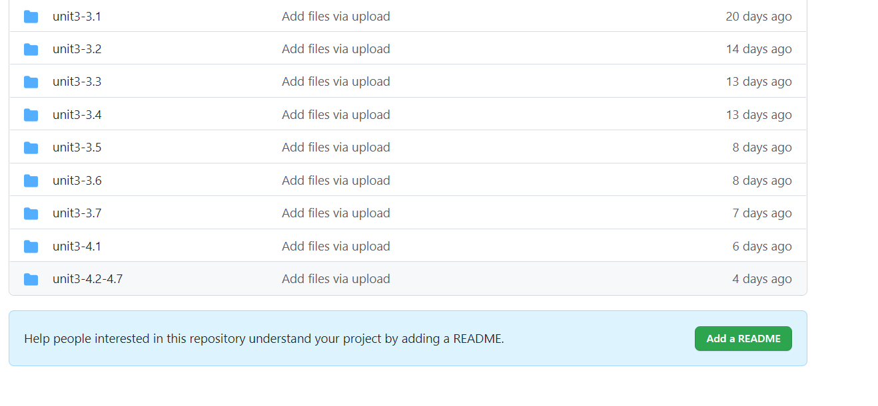
This screenshot shows a directory file and a zipped file, both have the same data, the zipped file for e-mail and the directory file for GitHub and simpler storage.

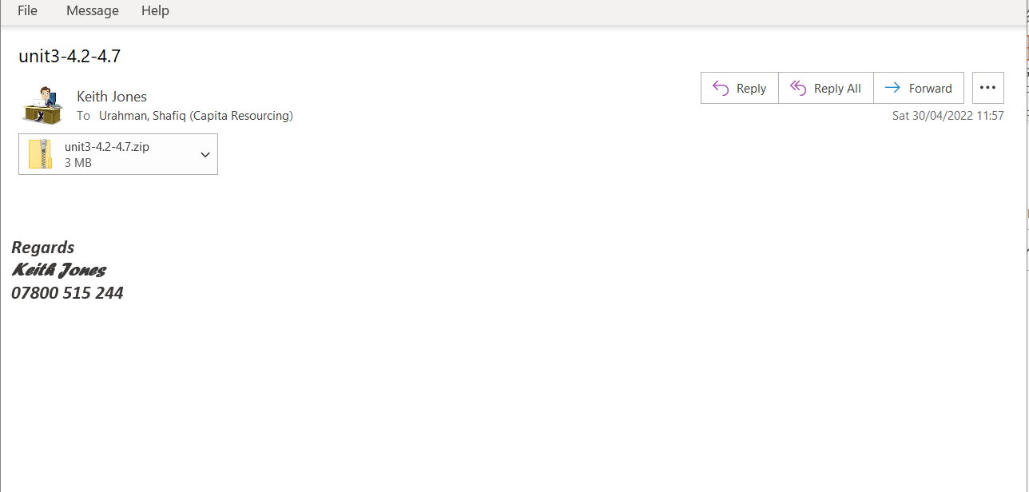
GitHub email

