Unit33-3.5

A Working Development Project

When the developer begins a project, their first task would be to plan the procedure, by writing a gantt chart, the developer would be able to list the tasks that need to be undertaken, assign them a timeline, which would include the tasks position in the overall procedure, the tasks time scale, and list different stages of a projeccts intended path.
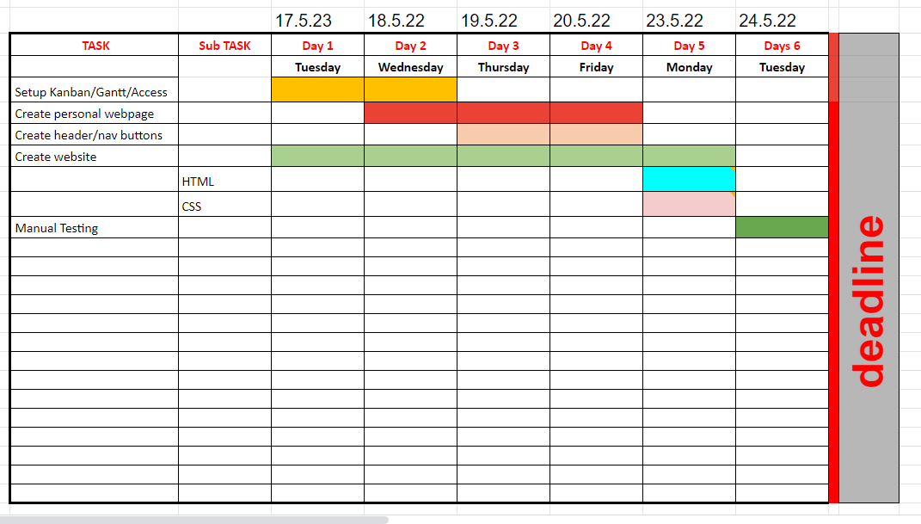
A gantt chart follows a simular downward path to a waterfall method development plan, where each task is marked as complete and the next task is excuted, the gantt chart can also be used as a progress chart, informing the developer off the tasks complete and if the project is following the intended time scale, thus proving the procedure is on budget.

The developer can also use a Project Plan template, where a proven list of tasks is consigned to an excel sheet, the developer can alter the tasks to suit individual projects, ensuring that the tasks are planned, delegated and the staus of each tasks is registered.

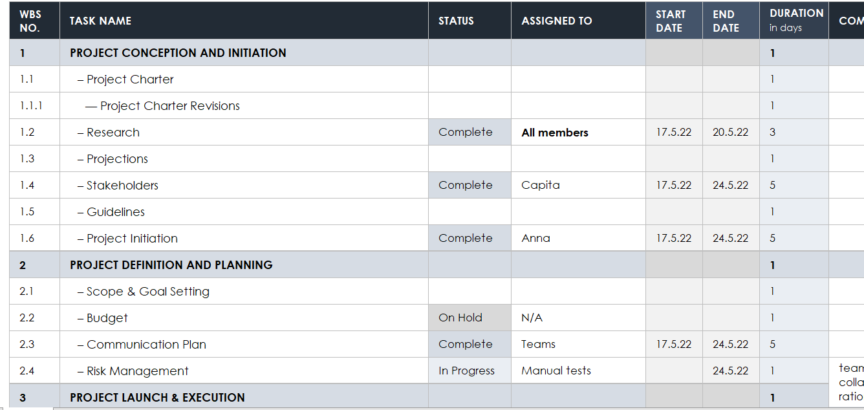
For the plannig of the project concerning Unit33-1.5, the team working as collabrotive group, decided to use Microsft teams as the main collabration communication application, meetings were planned, and tasks delegated to members, we were each agreed with time line deadlines and by using google docs, and Visual Studio, we each able to write our own code for our individual page, which contributed to the web site.

The tools we decided to use were;
- Teams- communication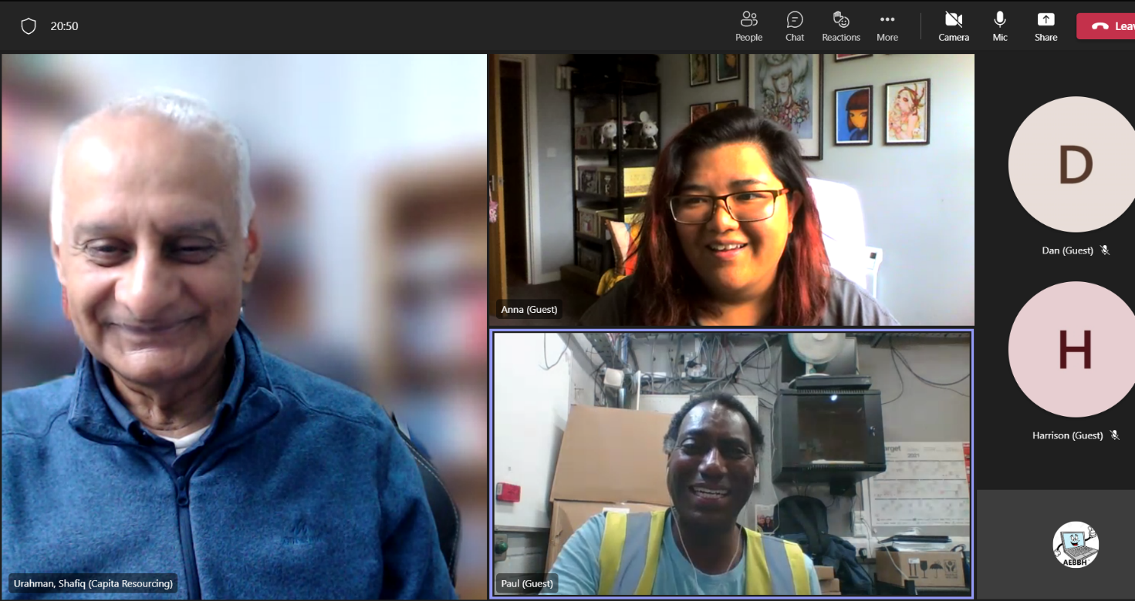
- Trello- 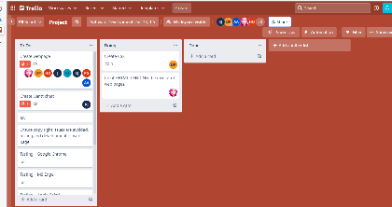task 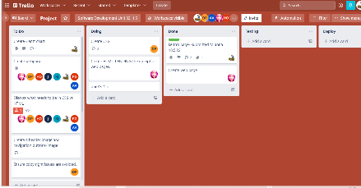delegation and valuation

- Gannt chart- planning and executing the progress
- Visual Studio- HTML & CSS code writing software to build web pages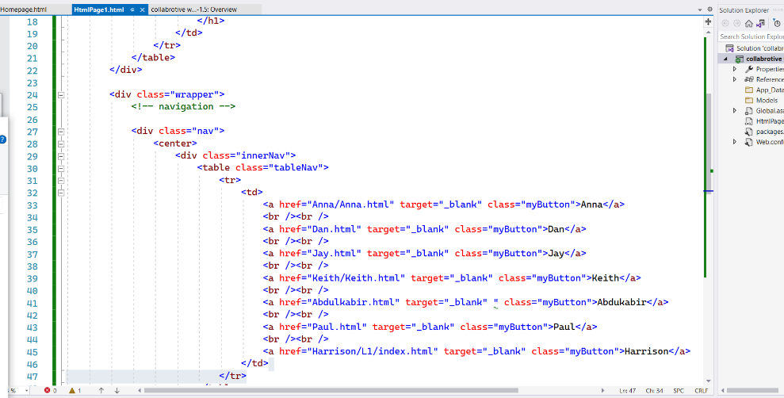
- Manual testing- using a written sheet, detailing test stages and tasks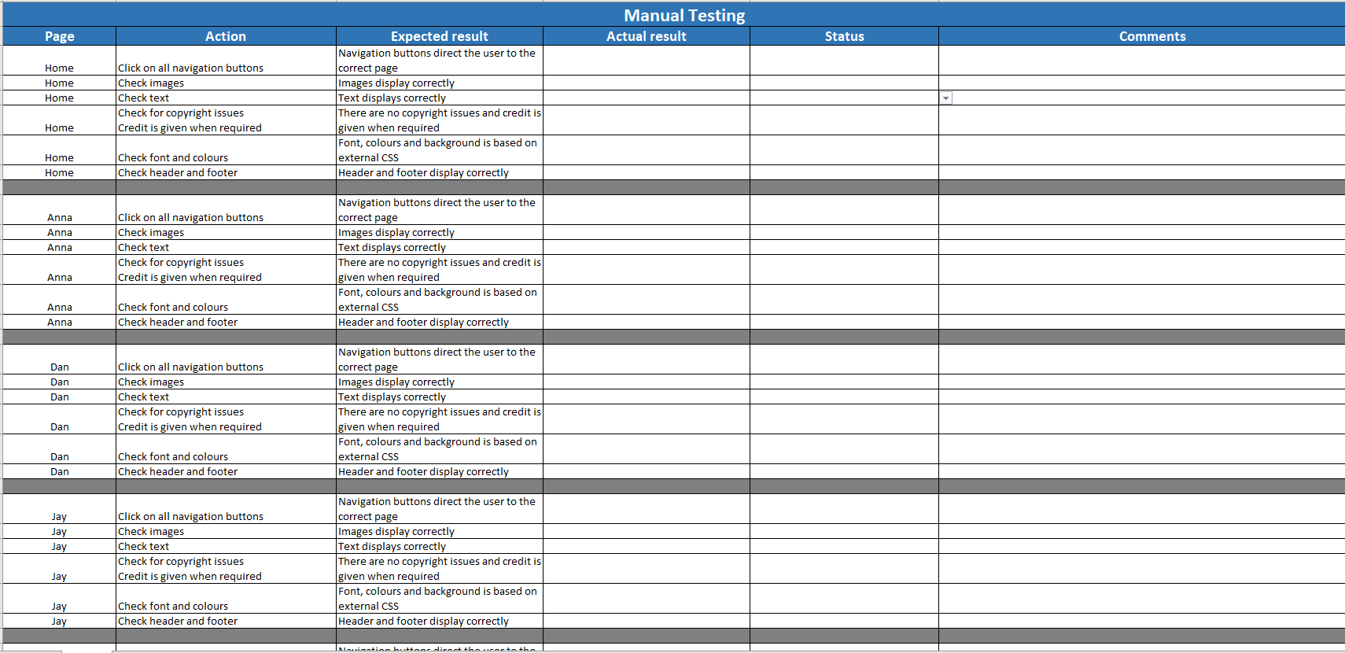
- Validication software- check code for bugs and errors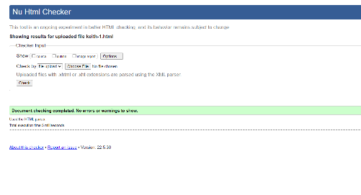
- Deploy- using a service host provider

Trello is based on the Agile methodology
Not necessary for the exercise 33-1.5

