# Testing

Checking the HTMl before publishing, the developer needs to test if the code is valid and accessible to web page servers, ensuring the web page can be clearly understood as intended by the developer.

## Manual testing

* Analyse the requirements required
* Create a test plan
  + Draw the layout of your web page
    - Header
      * Title
      * logo
    - Navigation bar
      * Links to other pages
      * Links to related web sites
    - Main content
      * Text, message, information
    - Article
      * Advert
      * Supporting image
    - Aside
      * Supporting text or link,image
    - Footer
      * Date, author, platform, copyright

## Automation testing

Web sites offer to test your code on your behalf, in a professional manner that usually requires a fee.

Tests for bugs,defects and other issues that can arise during the development stage. It can offer updates of your code compared to earlier testing to identify the improvement in the web page visual content.

## Blackbox testing

A method of software testing which examines the functionality of code without peering into its internal structures.

## Whitebox testing

Tests the internal structures of an application, not its functionality. Tests the application paths[1] between units.

## Why test

HTML and CSS require developers to test their code to ensure it works properly before the web page is published to the web. If web pages include unidentified bugs in the code, the web page may falter in the developers required visual effects.

Developers should use different platforms to see how their pages are displayed on different servers, they can use a validation application which will highlight most errors.

## Debugging

A step by step process of finding faults with code, locate where the ‘bug’ is, and correct using your applications ***advising element!![2].***

### Recall due to bugs

If there are bugs in your website code, because you not tested thoroughly[3], then your site will not run correctly and if your site is aimed at future customers, then the site would need to be taken down of the internet and fixed, this will cause you lost business and lose income as well as demoting the reputation of the web site and possibly your business!

## Correct software

Developers need a reliable editor app, validator app, domain and established host, during the development process they would also need collaboration software, a development methodology application to initiate,plan and monitor a team's progress in developing a software product from start to finish.

* Visual Studio
* Nova
* W3C validator
* GoDaddy
* Teams
* Github
* Trello
* GitOps

## Requirements

Requirements for development methodologies include the capability and compatibility of the relationship between your hardware and the software you propose to use to complete your development process.

Developers need to target the client and end users wants and needs when acquiring your product, prioritise the importance, urgency and convenience of the elements needed by developers to build the product **Discuss with product owners ther ongoing needs and wants, to ensue the product ,for the owner will be value and competitive in the market.**

*The need for developers and product owners to share ownership of the different flexible elements should ensure that the end product fulfils its expectations on delivery.*

*All necessary licences and laws are included in planning and again flexible adaptations are agreed during the process.*

* Hard Drive, Processor, Ram , Windows/mac
* Latest and forecast market competitive products
* Highest value to the product or most extensive to produce, or material availability

# 

# Project development

## Modular

The intent is to create an application that can be easily ported from one

project type to another with configuration alterations and style changes.

These alterations and changes will enable and disable web mapping site functionality and design layout.

## Component approach

Emphasises the [separation of concerns](https://en.wikipedia.org/wiki/Separation_of_concerns) with respect to the wide-ranging functionality available throughout a given [software system](https://en.wikipedia.org/wiki/Software_system). It is a reuse-based approach to defining, implementing and composing loosely coupled independent components into systems.

By using a trello board with the scrum methodology, a team might monitor its progress to a successful objective.

This practice aims to bring about an equally wide-ranging degree of benefits in both the short-term and the long-term for the software itself.

## 

## Microservices

### Monoliths

A network on a single server or PC, user interface, logic, data support exist in a single entity, when the files grow to giant databases the monoliths is slow and cannot react to external or wider audiences such as the internet,where users wish to extract information,

Replaced by microservices which use the cloud, and separate areas of information a monolith would hold, and call them containers each can run a service that would be easier for processors to read and download time faster.

### Virtual machine host

[4]Abstract and therefore **does not exis**t ?. They are computing instances created by a program running another machine.

The machine creating the Virtual machine [VM], is called the ‘host’, the VM’s are called the ‘guest’

### Hypervisor layer

### Crucial software that makes visualisation possible, separates CPU processors, RAM from the virtual software you make.

### Hardware

Virtual hardware, that uses the hosts system to generate the processors, RAM ect, for the VM’s to operate on a ‘guests’ PC.

Microservices run in **containers**

which run in **virtual machines**

which run on a **hypervisor**

Which runs on a **server**

**Which sits in the Uk/USA/japan ect**

**Which sits in** **data centre**

***Which is part of a network of data centres called the cloud[5]***

# 

# Teams working on projects

## Agile & Scrum

When a team is allocated a project, managers would introduce methods of monitoring the team's progress from planning to deploying [handover].

Known as development methodologies there are many different platforms to choose from , depending on the project and industry the team is participating in.

Agile methodology is for the process to be agile/flexible, so the project from start to finish can be monitored and adapted throughout the process.

Meaning earlier stages of a procedure can change to suit the clients wants and needs as the product is being manufactured, ensuring the end user is accepting a validated and competitive product, suitable to the required standards the market expects at the time of delivery.

Scrum is a method of a team's approach to an agile procedure, where the manager or scrum leader[6] ensures the team discusses the ongoing procedure daily, highlighting different parts[7] of the procedure past and present, ensuring the final deployment is going to be competitive for the client[8].

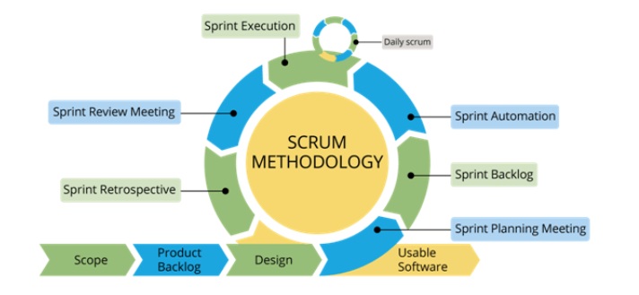

## 

## V model

A software development process, that is an extension of the waterfall methodology, where the waterfall stages downwards to completion, the v-model changes direction at the end of the coding phase and continues upwards during the testing and eventual deployment stage.

Therefore the stages are parallel to their related stage, ensuring there is a visual relationship between a stage and its testing.

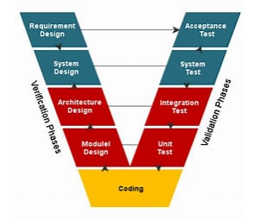

[(4) What are Microservices? - YouTube](https://www.youtube.com/watch?v=j3XufmvEMiM)

[What are microservices? A modular way to deliver apps | Dynatrace news](https://www.dynatrace.com/news/blog/what-are-microservices/)

1. Checks where the web page is going, which server and if the server can reproduce the intended effect of the web page as designed by the developer.
2. “*A term created by myself at the time of writing to try to explain, some apps give the user alternative code, that can be tested to see if it improves your code”*
3. A Validation app will test your code, to ensure the site will run correctly.
4. https://www.dnsstuff.com/how-to-set-up-and-configure-virtual-machine-server
5. There are many cloud servers available- Amazon, OneDrive, Google etc.
6. Known as a ScrumMaster
7. Known as sprints
8. Known as ProductOwner