Unit33-3.1

# *Effectiveness of different project management techniques*

Project management is vital for achieving a successful project, when a manager has to delegate team members to their tasks, the manager needs to introduce an effective schedule of procedures that will get the job done.

To help the teams progress a method of development is used to enable the members to identify issues that are either ongoing or have been planned to be a part of the procedure further along the project's timeline.

Waterfall and Agile are two such development methodologies, waterfall being an earlier version, and Agile has been introduced from experience of former projects carried out from different industry backgrounds.

### Waterfall

A sequential development process, where different elements of a project are completed and ***‘ticked off ‘*** has been deemed complete. The visual focus of the method is the completed elements cascading downwards toward the final deadline.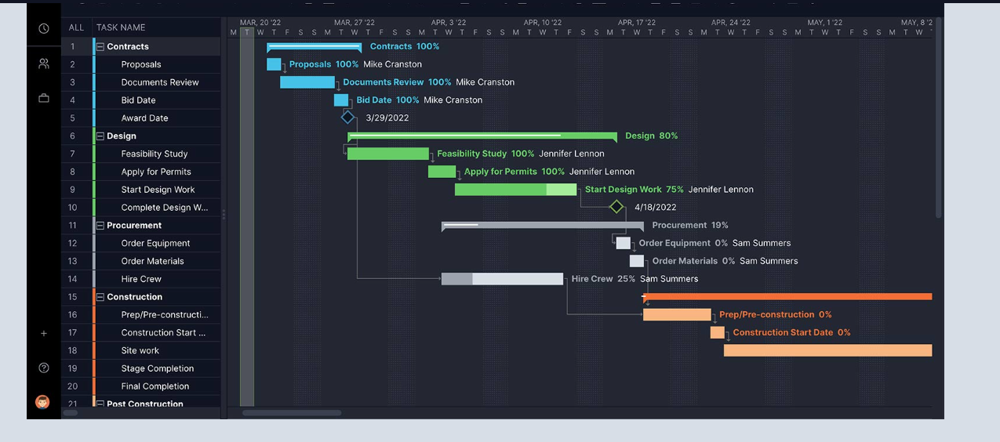

### 

### 

### 

### Agile

An iterative approach development, each iteration has a short time period to complete, but remains ‘agile’, and therefore each iteration is open for adaption, ensuring the end product is compatible with the latest specs and market value.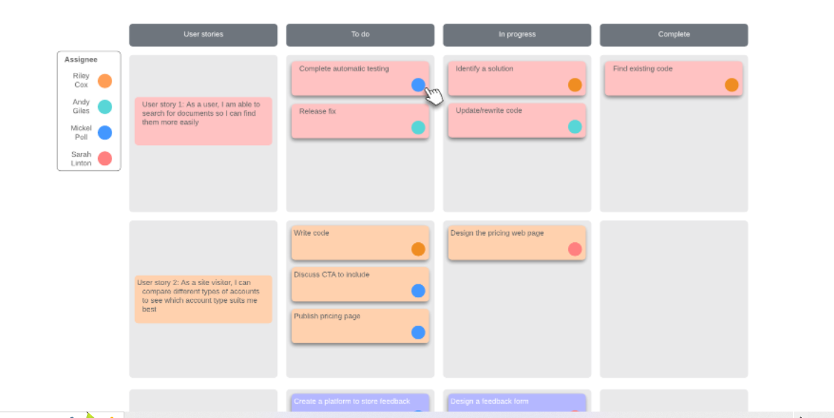

During Unit33-2.1-2.5

There were a number of issues,

* Communications
* Skill Sets
* Time convenience
* Experience
* Understanding

These were dealt with over a period of time that can only improve as the team uses development technologies further.