# Unit33**-3.4**

# **The effectiveness of tests & reflect on their purpose**

## Manual Testing

Known as ‘black box testing’, this method requires a tester to play the role of an end user to ensure the applications features are working as the developer had planned and fit for purpose.

To ensure all aspects of using a web page is working correctly, the tester would use a written test plan, to check if all the elements are correctly working, this would be in a waterfall method, i.e., working down one stage at a time to the last element and ticking the appropriate element off, deemed as correct.

**Unit33-1.5**

* ***Each member composed their own web page to form a collaborative web site***

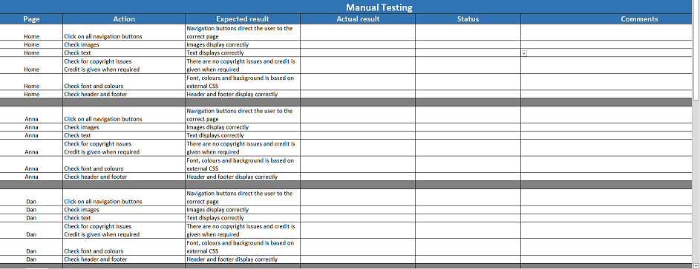

**A team member composed a test page for the team, to allow individual members to test their own pages, ensuring the pages were tested for the same operational procedure, therefore keeping the testing uniform.**

## Automation Testing

A software testing application, known as ‘white box testing’, uses a code compiled by professionals, and checks your code according to the rules laid down by the applications developer and product owner.

The software has a built -in comparison method where it identifies actual outcomes with predicted outcomes, of how your code and therefore your web page is fit for purpose and ready to deploy.

Automation testing can cover a lot more repetitive tasks and therefore, more accurate testing.

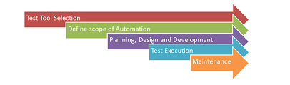*“A visualisation of how the automation application would perform”*

**Unit33-1.5**

**To test their code for bugs and errors, members also used the W3 validation application, to check individual web pages, prior to submitting them to the home page.**

## 

## V-Model purpose

A cycle methodology system, that checks for verification and then validation 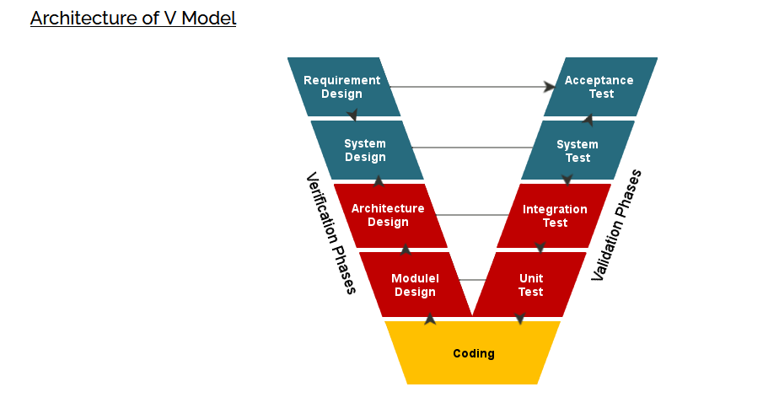

The model uses the verification process first in a waterfall method, then the validation method in an upward waterfall method, linking elements of the test, to ensure clarity of the test process.

**“Not used during unit33-5.1”**