MAHARASHTRA STATE BOARD OF TECHNICAL EDUCATION (MSBTE)
  [Affix MSBTE logo]
  [Affix institute logo]
SEMINAR REPORT
ON
WI-FI 6 AND MODERN WIRELESS NETWORKING
Submitted in partial fulfilment of the requirements of the
Seminar and Project Initiation Course (315003)
Diploma in Computer Engineering (Semester V, K Scheme)
Submitted by
KRISHNAKANT PAWAN JADHAV
Roll No: 30 | Enrolment No: 24612410379
Under the guidance of
Prof. Faizee Razee
MULANA MUKTHAR AHMAD NADVI TECHNICAL CAMPUS (MMANTC), MALEGAON
Maharashtra State Board of Technical Education (MSBTE)
Academic Year: 2025-2026

MULANA MUKTHAR AHMAD NADVI TECHNICAL CAMPUS (MMANTC), MALEGAON
DEPARTMENT OF COMPUTER ENGINEERING
  [Affix MSBTE logo]
  [Affix institute logo]
SEMINAR REPORT
ON
WI-FI 6 AND MODERN WIRELESS NETWORKING
Submitted in partial fulfilment of the requirements of the
Seminar and Project Initiation Course (315003)
Diploma in Computer Engineering (Semester V, K Scheme)
Submitted by
KRISHNAKANT PAWAN JADHAV
Roll No: 30 | Enrolment No: 24612410379
Under the guidance of
Prof. Faizee Razee
MULANA MUKTHAR AHMAD NADVI TECHNICAL CAMPUS (MMANTC), MALEGAON
Maharashtra State Board of Technical Education (MSBTE)
Academic Year: 2025-2026

CERTIFICATE
This is to certify that Mr. Krishnakant Pawan Jadhav, Roll No. 30, Enrolment No. 24612410379, a student of Diploma in Computer Engineering (Semester V, K Scheme) at Mulana Mukthar Ahmad Nadvi Technical Campus (MMANTC), Malegaon, has satisfactorily completed the seminar report on "Wi-Fi 6 and Modern Wireless Networking" as prescribed by the Maharashtra State Board of Technical Education (MSBTE) for the Seminar and Project Initiation Course (315003) during the academic year 2025-2026.
The report is a record of the student's own work and has not been submitted for any other course.

______________________  Prof. Faizee Razee  Guide | ______________________  Head of Department | ______________________  Principal
Place: Malegaon Date: ____________

ACKNOWLEDGEMENT
I would like to express my sincere gratitude to my seminar guide, Prof. Faizee Razee, for the guidance, encouragement and valuable suggestions that helped me to select and complete this seminar on Wi-Fi 6 and Modern Wireless Networking.
I am thankful to the Head of the Computer Engineering Department and to the Principal of Mulana Mukthar Ahmad Nadvi Technical Campus (MMANTC), Malegaon, for providing the facilities and the academic environment needed for this work. I also thank all the faculty members of the department for their support during the Seminar and Project Initiation Course.
I acknowledge the authors, standards bodies and organisations whose papers, standards and technical documents are listed in the bibliography. Finally, I thank my parents and classmates for their constant motivation and cooperation.
Krishnakant Pawan Jadhav
Roll No: 30

ABSTRACT
Wireless networks are now the main way in which students, employees and a growing number of IoT devices connect to the Internet. As the number of devices per access point increases, earlier Wi-Fi generations lose efficiency because only one device can use a channel at a time and every device must keep listening for traffic. Wi-Fi 6, defined by the IEEE 802.11ax standard, was designed to solve these problems of dense, mixed-device networks.
This seminar report studies the technology of Wi-Fi 6 and modern wireless networking. It first presents the need and objectives and reviews the evolution of IEEE 802.11 and the main sources. It then explains the key concepts: Orthogonal Frequency-Division Multiple Access (OFDMA), uplink and downlink MU-MIMO, 1024-QAM, BSS colouring, Target Wake Time (TWT), wider channels and WPA3 security. The system architecture, the working principle and the tools and platforms used for planning and testing are described, followed by applications and an illustrative campus case study.
The report compares Wi-Fi 6 with Wi-Fi 5 and discusses advantages, such as a theoretical rate of up to 9.6 Gbps, better high-density efficiency and longer battery life, together with limitations such as upgrade cost and the need for multi-gigabit wired backhaul. It concludes with future developments in Wi-Fi 6E and Wi-Fi 7, and a brief project initiation plan. The main conclusion is that Wi-Fi 6 improves wireless networking mainly by sharing the channel more efficiently among many users.
Keywords: Wi-Fi 6, IEEE 802.11ax, OFDMA, MU-MIMO, BSS colouring, Target Wake Time, WPA3, Wi-Fi 6E.

CONTENTS
CERTIFICATE ii
ACKNOWLEDGEMENT iii
ABSTRACT iv
CONTENTS v
LIST OF FIGURES vi
LIST OF TABLES vii
1. INTRODUCTION 1
1.1 BACKGROUND 1
1.2 NEED AND MOTIVATION 1
1.3 OBJECTIVES OF THE SEMINAR 1
1.4 SCOPE AND BOUNDARIES 2
1.5 ORGANISATION OF THE REPORT 2
2. LITERATURE REVIEW 3
2.1 EVOLUTION OF IEEE 802.11 3
2.2 REVIEW OF SOURCES 3
2.3 SUMMARY OF THE REVIEW 4
3. TECHNOLOGY AND CONCEPTS 5
3.1 BASIC CONCEPTS AND TERMINOLOGY 5
3.2 KEY TECHNOLOGIES OF WI-FI 6 5
3.3 SYSTEM ARCHITECTURE 9
3.4 WORKING PRINCIPLE 9
3.5 TOOLS, PLATFORMS AND TECHNOLOGIES 10
4. APPLICATIONS AND CASE STUDY 11
4.1 APPLICATIONS AND REAL-WORLD USE CASES 11
4.2 CASE STUDY: HIGH-DENSITY UNIVERSITY CAMPUS UPGRADE 11
5. ADVANTAGES AND DISADVANTAGES 13
5.1 ADVANTAGES 13
5.2 LIMITATIONS AND CHALLENGES 13
5.3 COMPARISON OF WI-FI 5 AND WI-FI 6 14
6. FUTURE SCOPE AND CONCLUSION 15
6.1 RECENT DEVELOPMENTS AND FUTURE SCOPE 15
6.2 CONCLUSION AND LEARNING OUTCOMES 15
PROJECT INITIATION (BRIEF SECTION) 16
PI.1 PROBLEM STATEMENT 16
PI.2 PROPOSED PROJECT AND SCOPE 16
PI.3 OBJECTIVES 16
PI.4 STAKEHOLDERS 16
PI.5 PLATFORM, EQUIPMENT AND RESOURCES 17
PI.6 TENTATIVE PLAN 17
BIBLIOGRAPHY 18

LIST OF FIGURES
Figure 2.1: Maximum theoretical PHY rate of Wi-Fi generations 3
Figure 3.1: OFDM and OFDMA channel use 6
Figure 3.2: Multi-user MIMO between an access point and several clients 6
Figure 3.3: BSS colouring of two overlapping cells 7
Figure 3.4: Radio activity with and without Target Wake Time 8
Figure 3.5: Frequency bands used by Wi-Fi 6 and Wi-Fi 6E 8
Figure 3.6: Block diagram of a Wi-Fi 6 network 9
Figure 3.7: Workflow of a Wi-Fi 6 transmission 10
Figure 4.1: Wi-Fi 6 campus network of the case study 12
Figure 4.2: Capacity and latency before and after the upgrade (illustrative) 12
Figure 6.1: Milestones from Wi-Fi 6 to Wi-Fi 7 15

LIST OF TABLES
Table 2.1: Generations of Wi-Fi 3
Table 2.2: Sources reviewed and their contribution 4
Table 3.1: Important terms 5
Table 3.2: Tools and platforms for Wi-Fi 6 10
Table 4.1: Summary of the case study 11
Table 5.1: Comparison of Wi-Fi 5 and Wi-Fi 6 14
Table PI.1: Identified resources 17
Table PI.2: Tentative project plan 17

1. INTRODUCTION

1.1 BACKGROUND
Wireless networking has moved from a convenience to a basic utility. Classrooms, hostels, offices, hospitals, airports and homes now depend on wireless local area networks (WLANs) to reach cloud services, online examinations, video conferencing and a growing number of Internet of Things (IoT) devices. The technology behind most of these networks is the IEEE 802.11 family of standards, marketed by the Wi-Fi Alliance under the name Wi-Fi.
Wi-Fi 6 is the sixth generation of this family and is based on the IEEE 802.11ax specification [1]. The standard is officially designated High-Efficiency Wireless (HEW) and succeeds Wi-Fi 5 (IEEE 802.11ac). Earlier generations concentrated on raising the peak speed that a single device could reach. Wi-Fi 6 changes the goal: it aims to raise overall network capacity, stability and spectral efficiency, so that many devices can share the same access point (AP) without slowing one another down [2]. Wi-Fi 6 works in both the 2.4 GHz band, which offers longer range, and the 5 GHz band, which offers higher throughput, and its extension, Wi-Fi 6E, adds the 6 GHz band.

1.2 NEED AND MOTIVATION
Legacy Wi-Fi 4 and Wi-Fi 5 networks perform well when a few devices are connected, but their behaviour degrades in crowded environments. The main problems that motivated the development of Wi-Fi 6 are listed below.
- High-density congestion. In lecture halls, offices and airports, dozens of devices compete for the same channel, and throughput per device falls sharply.
- Single-user transmission. Traditional OFDM lets only one device transmit on a channel at any given instant, so short packets from many devices waste airtime.
- Latency and jitter. Contention delays harm real-time applications such as VoIP, online gaming and video conferencing.
- Battery drain. Smartphones and IoT sensors must keep their radios active for long periods to listen for traffic.
- Need for a deterministic, multi-user standard. Modern campuses and enterprises need a wireless standard that serves dozens of simultaneous devices efficiently and predictably.

1.3 OBJECTIVES OF THE SEMINAR
- To study the physical (PHY) and medium access control (MAC) layer architecture of the IEEE 802.11ax (Wi-Fi 6) standard.
- To analyse how OFDMA, 8x8 MU-MIMO and BSS colouring reduce wireless congestion.
- To explore enterprise deployment tools, WPA3 security enhancements and real-world applications.
- To compare Wi-Fi 6 with Wi-Fi 5 and identify its advantages and limitations.
- To outline future developments such as Wi-Fi 6E and Wi-Fi 7.

1.4 SCOPE AND BOUNDARIES
The seminar covers the fundamentals of Wi-Fi 6, a comparison with Wi-Fi 5, and practical campus and enterprise use. It focuses on IEEE 802.11ax WLAN deployment and only outlines future transitions towards Wi-Fi 6E and Wi-Fi 7. The report is a technology study: it does not claim that a complete network has been built, and the case study in Chapter 4 is presented as an illustrative deployment scenario.

1.5 ORGANISATION OF THE REPORT
Chapter 2 reviews the evolution of IEEE 802.11 and the sources used. Chapter 3 explains the concepts, architecture, working principle and tools of Wi-Fi 6. Chapter 4 discusses applications and a case study. Chapter 5 presents advantages and limitations with a comparison table. Chapter 6 describes future scope and gives the conclusion. A brief project initiation section and the bibliography follow.

2. LITERATURE REVIEW

2.1 EVOLUTION OF IEEE 802.11
The first 802.11 standards appeared in 1997 and offered only a few megabits per second. Each later amendment increased the maximum data rate by adding wider channels, better modulation or more antennas. Table 2.1 summarises the main generations, and Figure 2.1 compares their maximum theoretical rates. Wi-Fi 6 raises the ceiling from 6.9 Gbps in the 802.11ac specification to 9.6 Gbps, but its larger contribution is efficiency in crowded networks [2].
Table 2.1: Generations of Wi-Fi
Generation | IEEE standard | Frequency band | Maximum PHY rate
Wi-Fi 1 | 802.11b (1999) | 2.4 GHz | 11 Mbps
Wi-Fi 2 | 802.11a (1999) | 5 GHz | 54 Mbps
Wi-Fi 3 | 802.11g (2003) | 2.4 GHz | 54 Mbps
Wi-Fi 4 | 802.11n (2009) | 2.4 and 5 GHz | 600 Mbps
Wi-Fi 5 | 802.11ac (2013) | 5 GHz | 6.9 Gbps
Wi-Fi 6 | 802.11ax (2021) | 2.4 and 5 GHz (6 GHz in 6E) | 9.6 Gbps
Wi-Fi 7 | 802.11be | 2.4, 5 and 6 GHz | 46 Gbps

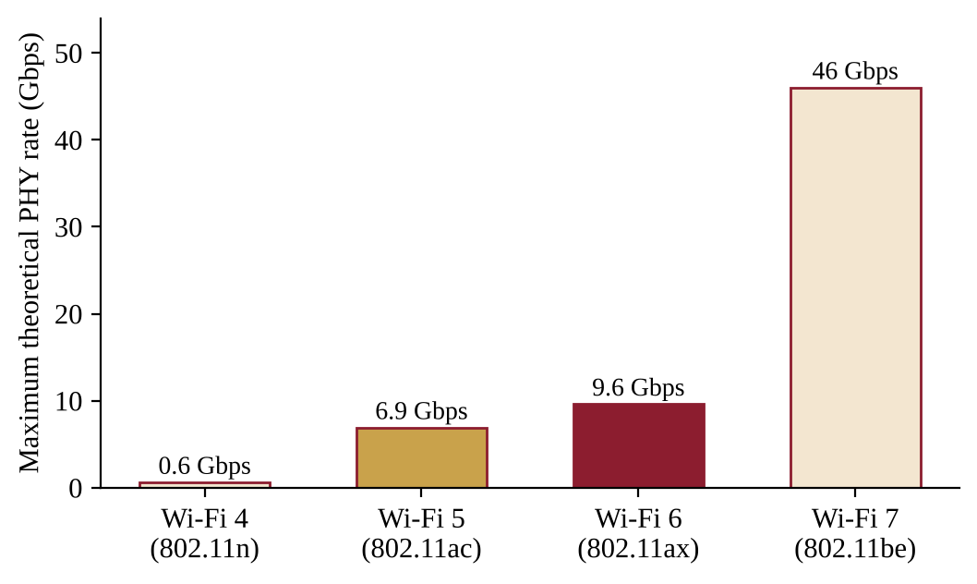
Figure 2.1: Maximum theoretical PHY rate of Wi-Fi generations
Source: prepared by the author using data from [2] and [6].

2.2 REVIEW OF SOURCES
The seminar is based on authoritative standards, a research tutorial, vendor documentation and recent technical articles. Table 2.2 lists the main sources and what each one contributes to this report.
Table 2.2: Sources reviewed and their contribution
Ref. | Source | Contribution to this report
[1] | IEEE Std 802.11ax-2021 | Primary specification of the PHY and MAC features of Wi-Fi 6.
[2] | Khorov et al., IEEE Communications Surveys & Tutorials, 2019 | Tutorial explanation of OFDMA, uplink MU-MIMO, spatial reuse and target wake time.
[3] | Cisco Wi-Fi 6 technical white paper, 2023 | Enterprise access-point design, deployment practice and case study background.
[4] | Wi-Fi Alliance, Wi-Fi CERTIFIED 6 overview | Feature list and certification context of Wi-Fi 6.
[5] | Seminar paper on IEEE 802.11ax, TU Munich, 2024 | Concise comparison of 802.11ax and 802.11ac, guard intervals and BSS colours.
[6] | RF Wireless World, Wi-Fi 6 vs 6E vs 7 | Comparison of Wi-Fi 6, 6E and 7 used in the future-scope chapter.
[7] | India TV News, 21 January 2026 | News report on delicensing of the lower 6 GHz band in India.

2.3 SUMMARY OF THE REVIEW
The review shows that Wi-Fi 6 is best understood as an efficiency upgrade. The standard [1] and the tutorial [2] agree that OFDMA, uplink MU-MIMO, BSS colouring and target wake time are the features that deliver gains in dense deployments, while higher modulation raises peak speed only for devices with a strong signal. Vendor material [3] shows how these features are used in practice, and recent articles [6], [7] show that the technology is still evolving through Wi-Fi 6E and Wi-Fi 7 and through national spectrum policy.

3. TECHNOLOGY AND CONCEPTS

3.1 BASIC CONCEPTS AND TERMINOLOGY
Table 3.1 explains the important terms used in the remainder of the report.
Table 3.1: Important terms
Term | Meaning
IEEE 802.11ax | The IEEE technical standard that governs the physical and MAC layer operation of Wi-Fi 6.
OFDMA | Orthogonal Frequency-Division Multiple Access: splits a channel into smaller Resource Units (RUs) so that several users are served at the same time.
MU-MIMO | Multi-User Multiple-Input Multiple-Output: lets an AP send or receive separate data streams to or from several devices simultaneously.
BSS colouring | A 6-bit tag in frame headers that identifies the Basic Service Set, so a device can ignore frames from an overlapping network.
TWT | Target Wake Time: a negotiated schedule that lets a device sleep and wake only when it is due to communicate.
RU | Resource Unit: a group of subcarriers allocated to one user in an OFDMA transmission.
1024-QAM | Quadrature amplitude modulation that carries 10 bits per symbol.
WPA3 | The current Wi-Fi security protocol, using Simultaneous Authentication of Equals (SAE).

3.2 KEY TECHNOLOGIES OF WI-FI 6

3.2.1 Orthogonal Frequency-Division Multiple Access (OFDMA)
Wi-Fi 5 uses OFDM, in which the whole channel is given to one device for each transmission. If a device only needs to send a small packet, most of the capacity is wasted. Wi-Fi 6 introduces OFDMA, in which the channel is divided into time-frequency blocks called Resource Units. The AP assigns each RU to a different station, so several stations transmit or receive in the same time slot [2]. A 20 MHz channel can be split into as many as nine of the smallest, 26-tone, resource units, and larger units of 52, 106, 242, 484 and 996 tones are used on wider channels. Figure 3.1 contrasts the two methods.
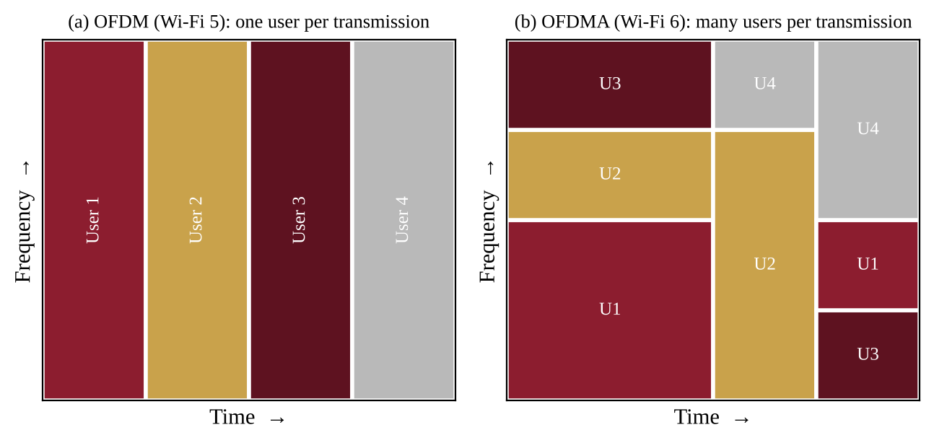
Figure 3.1: OFDM and OFDMA channel use
Source: prepared by the author based on [2] and [5].
OFDMA is especially useful for the small, frequent packets sent by voice calls, messaging and IoT sensors. By packing many short transmissions into one frame the AP reduces the overhead of contention and lowers latency.

3.2.2 Uplink and downlink MU-MIMO
MIMO uses several antennas to send multiple spatial streams. Downlink MU-MIMO was already present in Wi-Fi 5, but Wi-Fi 6 supports up to eight spatial streams and, importantly, adds uplink MU-MIMO. In the uplink case the AP sends a trigger frame to synchronise the stations, receives their transmissions together and separates the spatial streams [5]. Figure 3.2 illustrates the idea. The result is a higher aggregate capacity for the cell, even though each individual device still sees a link-rate limited by its own antennas.
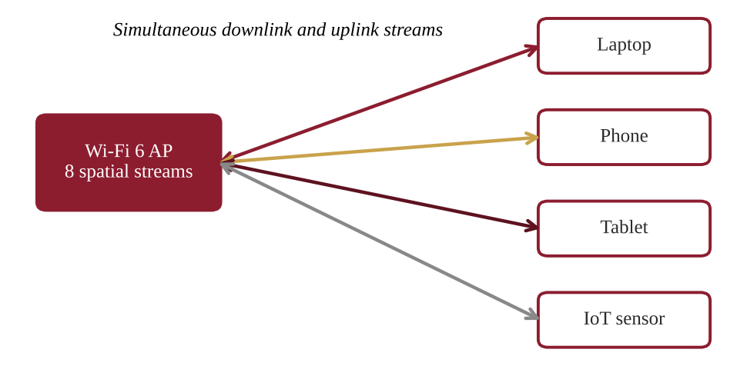
Figure 3.2: Multi-user MIMO between an access point and several clients
Source: prepared by the author based on [2].

3.2.3 1024-QAM and longer symbols
Wi-Fi 6 adds 1024-QAM, which packs 10 bits into each symbol compared with 8 bits for the 256-QAM of Wi-Fi 5. This raises the raw data rate by about 25 per cent when the signal is strong [5]. Because 1024-QAM needs a very clean signal, it benefits devices that are close to the AP. The standard also lengthens the OFDM symbol to 12.8 microseconds, four times that of Wi-Fi 5, and offers guard intervals of 0.8, 1.6 and 3.2 microseconds, which makes transmissions more tolerant of echoes in large indoor spaces and outdoors.

3.2.4 BSS colouring and spatial reuse
In a dense deployment, neighbouring APs often use the same channel and force each other to wait. Wi-Fi 6 assigns each Basic Service Set a colour, a 6-bit value carried in the frame header, which the AP advertises in its beacons [5]. A device that hears a frame with a different colour recognises it as inter-BSS traffic. If that signal is weak, the device can ignore it and transmit at the same time, which is called spatial reuse (Figure 3.3). The result is fewer unnecessary deferrals and better use of each channel.
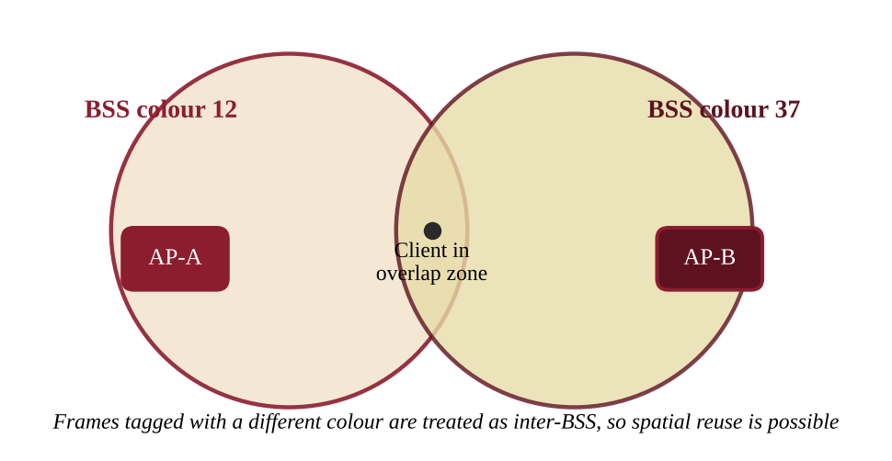
Figure 3.3: BSS colouring of two overlapping cells
Source: prepared by the author based on [2] and [5].

3.2.5 Target Wake Time (TWT)
In earlier standards a battery-powered device had to wake up often to check for buffered traffic. With TWT the AP and the station agree on a schedule, and the station sleeps until its agreed service period [5]. TWT therefore saves battery power and also reduces contention, because the AP can spread wake times so that fewer devices compete at once. It is particularly valuable for smartphones and IoT sensors. Figure 3.4 compares an always-awake device with one using TWT.
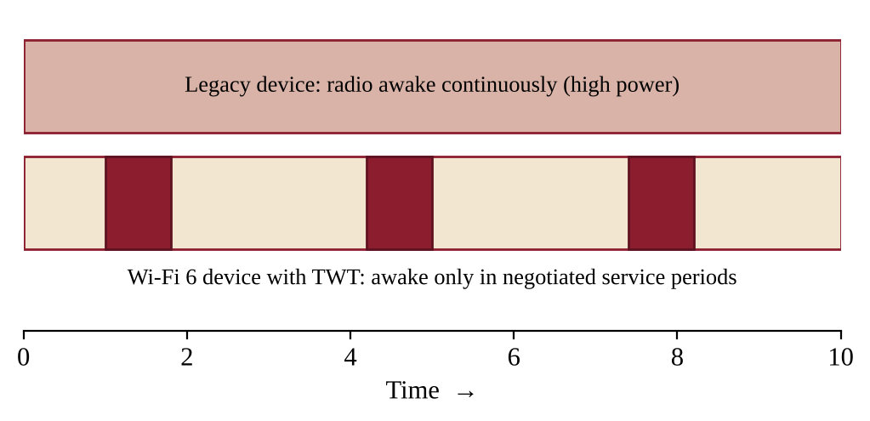
Figure 3.4: Radio activity with and without Target Wake Time
Source: prepared by the author based on [2].

3.2.6 Frequency bands and channel widths
Wi-Fi 6 operates in the 2.4 GHz and 5 GHz bands with channel widths of 20, 40, 80 and 160 MHz. The 2.4 GHz band gives longer range and better wall penetration, while the 5 GHz band gives higher throughput. Wi-Fi 6E extends the same technology into the 6 GHz band, where up to seven non-overlapping 160 MHz channels are available and no legacy devices are present [6]. Figure 3.5 shows the three bands.
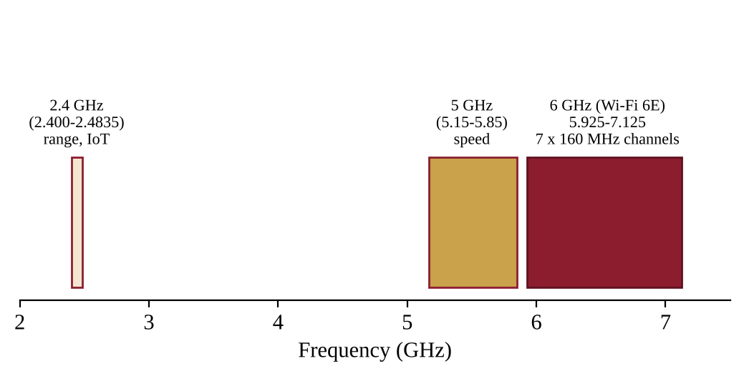
Figure 3.5: Frequency bands used by Wi-Fi 6 and Wi-Fi 6E
Source: prepared by the author based on [6].

3.2.7 Security with WPA3
Wi-Fi 6 deployments use WPA3, which replaces the pre-shared key handshake of WPA2 with Simultaneous Authentication of Equals (SAE). SAE protects against offline dictionary attacks on captured handshakes, so a weak password is much harder to crack. WPA3 also makes protected management frames mandatory and offers a stronger enterprise mode. For these reasons, enterprise guidance treats WPA3 with SAE as the standard security protocol for Wi-Fi 6 networks.

3.3 SYSTEM ARCHITECTURE
A Wi-Fi 6 network has the same basic structure as earlier WLANs but places heavier demands on the wired side. Wi-Fi 6 access points connect through Power over Ethernet (PoE+) switches to a wireless LAN controller, which handles configuration, channel and power planning, roaming and security policy (Figure 3.6). The access points combine 1024-QAM, OFDMA and 8x8 MU-MIMO to serve clients such as laptops, smartphones, tablets and IoT devices. Because a single Wi-Fi 6 AP can now exceed 1 Gbps of traffic, the switch uplink should use Multi-Gigabit Ethernet (2.5 or 5 Gbps).
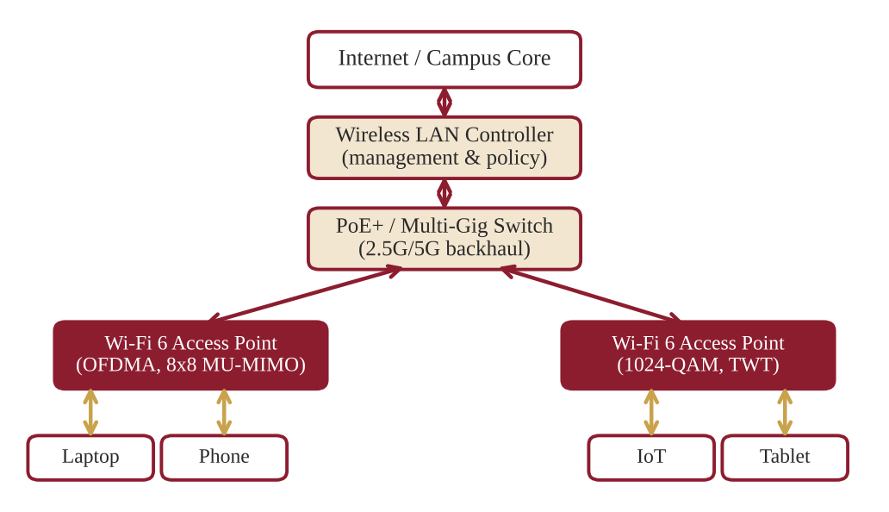
Figure 3.6: Block diagram of a Wi-Fi 6 network
Source: prepared by the author based on [3].
The AP in the diagram is the central component. The 8x8 MU-MIMO capability lets it serve eight spatial streams in both directions, with a maximum theoretical speed of 9.6 Gbps. OFDMA splits the channel into resource units, and the clients receive their data at the same time.

3.4 WORKING PRINCIPLE
The operation of a Wi-Fi 6 cell can be understood as five cooperating steps, shown in Figure 3.7.
- Step 1, channel sensing and BSS colouring. The AP checks the medium and reads the 6-bit colour tags to bypass interference from overlapping networks.
- Step 2, resource unit allocation. The AP sends a trigger frame and divides the channel into resource units using OFDMA, based on the traffic needs of each user.
- Step 3, multi-user beamforming. Using 8x8 MU-MIMO, the AP focuses radio signals on up to eight client devices at the same time.
- Step 4, high-density encoding. The payload is modulated with 1024-QAM, which carries 10 bits per symbol, for rapid delivery.
- Step 5, target wake time scheduling. Idle smartphones and IoT sensors sleep until their next scheduled transmission window.
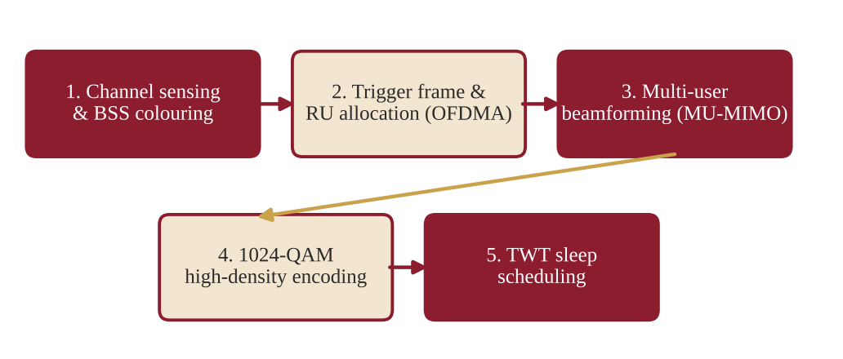
Figure 3.7: Workflow of a Wi-Fi 6 transmission
Source: prepared by the author based on [1], [2] and [5].
The highest theoretical rate follows from the physical layer parameters: 160 MHz channels, eight spatial streams, 1024-QAM with a coding rate of 5/6 and a 0.8 microsecond guard interval together give approximately 9.6 Gbps. In practice, real throughput is lower because of distance, interference, client capability and protocol overhead.

3.5 TOOLS, PLATFORMS AND TECHNOLOGIES
Planning, deploying and testing a Wi-Fi 6 network needs both hardware and software tools. Table 3.2 lists those considered in this seminar.
Table 3.2: Tools and platforms for Wi-Fi 6
Category | Examples and use
Enterprise access points | Cisco Catalyst 9100 series, HPE Aruba 510 series and Ubiquiti UniFi 6 Pro.
Client network cards | Intel Wi-Fi 6 AX200 and AX210 adapters and Qualcomm FastConnect 6800.
Site survey and planning | Ekahau AI Pro and NetSpot for wireless heat-mapping and channel optimisation.
Packet analysis and simulation | Wireshark for capturing 802.11ax frames and NS-3 (Network Simulator 3) for simulation.
Security protocol | WPA3 (Wi-Fi Protected Access 3) with SAE encryption.

4. APPLICATIONS AND CASE STUDY

4.1 APPLICATIONS AND REAL-WORLD USE CASES
- Smart campuses and universities. Wi-Fi 6 provides high-density connectivity in lecture halls, computer labs and digital libraries, where hundreds of students connect at once.
- Modern enterprise offices. It supports cloud-first workplaces, high-definition video conferencing and VoIP with low latency.
- Smart healthcare. Hospitals use it for reliable connectivity for telemetry and wireless patient-monitoring systems.
- Public transit and stadiums. It connects thousands of concurrent users at airports, railway stations and arenas.
- Industrial IoT (Industry 4.0). Low-latency wireless control suits warehouse robotics and smart manufacturing sensors, and TWT extends sensor battery life.
For students at a polytechnic like MMANTC, the campus example is the most relevant: replacing ageing access points in classrooms and hostels with Wi-Fi 6 equipment directly improves online learning and examinations.

4.2 CASE STUDY: HIGH-DENSITY UNIVERSITY CAMPUS UPGRADE
This case study describes an illustrative upgrade of a university campus to Cisco Catalyst Wi-Fi 6 (IEEE 802.11ax). The figures below are representative values used to explain the benefits of the technology and are not independently audited measurements.
Table 4.1: Summary of the case study
Item | Description
Problem | A campus with more than 15,000 students faced frequent disconnections and high latency during peak hours on legacy Wi-Fi 5.
Implementation | Lecture halls and hostels were upgraded to Cisco Catalyst 9120 Wi-Fi 6 access points with OFDMA, MU-MIMO and WPA3 enabled.
Result 1 | A fourfold increase in overall user capacity in crowded 300-seat auditoriums.
Result 2 | Average latency reduced by 65 per cent for online examinations, with longer student battery life through TWT.

The design followed the structure shown in Figure 4.1. A wireless controller and authentication server manage the access points in the lecture halls, computer labs and hostels, and the switches use Multi-Gigabit uplinks. Enabling OFDMA and MU-MIMO allowed many students to be served within the same frames, while BSS colouring reduced interference between neighbouring rooms. Figure 4.2 summarises the outcome.
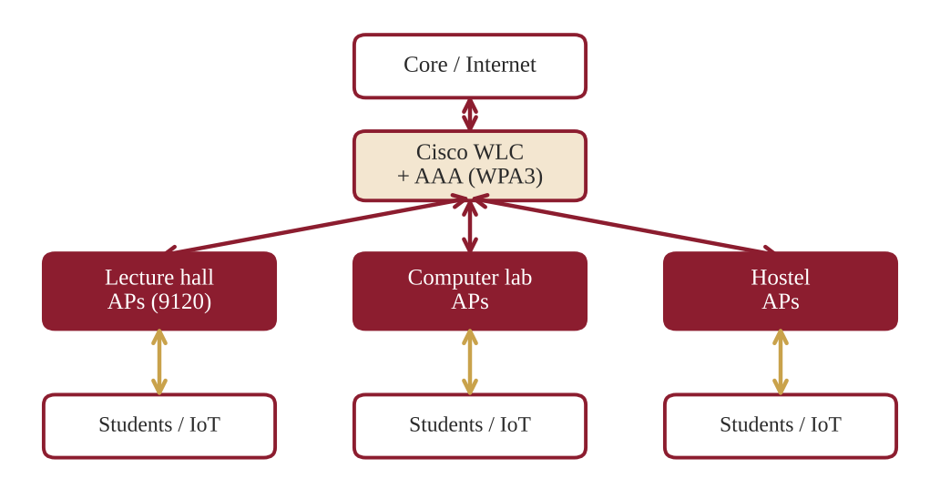
Figure 4.1: Wi-Fi 6 campus network of the case study
Source: prepared by the author based on [3].
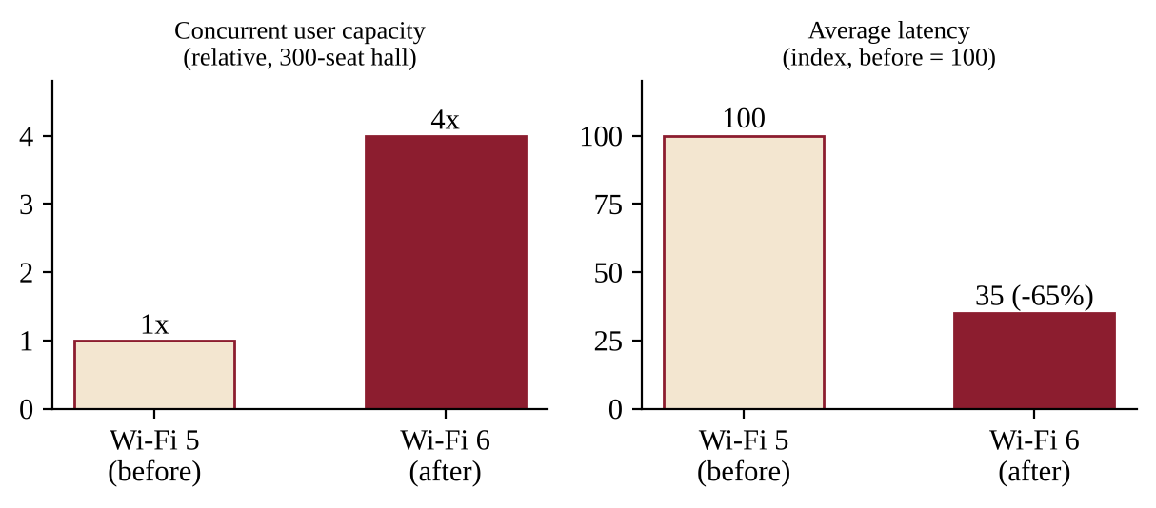
Figure 4.2: Capacity and latency before and after the upgrade (illustrative)
Source: prepared by the author based on the case study figures in Table 4.1.
The case study confirms the central message of Wi-Fi 6: the largest benefit appears where many users share the same space, and the gain comes from efficient sharing of airtime rather than only from a higher peak speed.

5. ADVANTAGES AND DISADVANTAGES

5.1 ADVANTAGES
- Higher peak data rates. Wi-Fi 6 delivers up to 9.6 Gbps theoretical throughput, against about 3.5 Gbps usually quoted for mainstream Wi-Fi 5 hardware (the 802.11ac specification itself allows 6.9 Gbps).
- Superior high-density efficiency. Providing about four times higher average throughput per user in crowded environments.
- Ultra-low deterministic latency. Network latency can be reduced by up to 75 per cent, which suits AR/VR, gaming and voice calls.
- Extended battery life. TWT can reduce radio power consumption by up to seven times for IoT sensors.
- Stronger wireless security. Mandatory WPA3 protects networks against offline brute-force dictionary attacks.

5.2 LIMITATIONS AND CHALLENGES
- High initial upgrade cost. Both the legacy access points and the client network adapters have to be replaced to obtain the full benefit.
- Wired backhaul bottlenecks. High wireless speeds can exceed 1 Gbps Ethernet ports, which requires costly Multi-Gigabit (2.5G/5G) switches.
- Limited range on 5 GHz. Higher-frequency signals suffer more attenuation through thick walls than 2.4 GHz signals.
- Configuration complexity. Tuning OFDMA, BSS colouring and channel bonding needs skilled network administrators.
- Mixed-device networks. Older devices do not support OFDMA or TWT, so benefits are partial until clients are upgraded.

5.3 COMPARISON OF WI-FI 5 AND WI-FI 6
Table 5.1: Comparison of Wi-Fi 5 and Wi-Fi 6
Feature | Wi-Fi 5 (802.11ac) | Wi-Fi 6 (802.11ax)
Frequency bands | 5 GHz only | 2.4 GHz and 5 GHz (6 GHz in Wi-Fi 6E)
Multiple access | OFDM (single user per transmission) | OFDMA (multiple users per transmission)
Modulation | 256-QAM (8 bits per symbol) | 1024-QAM (10 bits per symbol)
MU-MIMO | Downlink only | Uplink and downlink, up to 8 streams
Maximum PHY rate | 6.9 Gbps | 9.6 Gbps
Guard intervals | 0.4 and 0.8 microseconds | 0.8, 1.6 and 3.2 microseconds
Interference handling | No BSS colouring | BSS colouring and spatial reuse
Power saving | Basic power save | Target Wake Time
Security | WPA2 typical | WPA3 supported and required for certified devices

Table 5.1 shows that most Wi-Fi 6 improvements target efficiency, scheduling and power saving. The disadvantages are mainly economic and organisational, and they decrease as Wi-Fi 6 hardware becomes common and cheaper.
In practice, an institute does not need to replace everything at once. A common approach is to upgrade the access points in the most crowded areas first, such as lecture halls and hostels, and to upgrade the switch uplinks at the same time. Client devices are then replaced gradually through normal renewal, and the network starts to show the benefits of OFDMA and TWT as the share of Wi-Fi 6 clients grows.

6. FUTURE SCOPE AND CONCLUSION

6.1 RECENT DEVELOPMENTS AND FUTURE SCOPE
- Wi-Fi 6E (Extended). It expands Wi-Fi 6 into the unlicensed 6 GHz band, adding up to seven 160 MHz channels with no legacy interference [6]. In India, a notification issued in January 2026 delicensed 500 MHz of the lower 6 GHz band (5925 to 6425 MHz) for low-power indoor and very-low-power outdoor use, which opens the way for Wi-Fi 6E and Wi-Fi 7 in the country [7].
- Evolution to Wi-Fi 7 (IEEE 802.11be). It introduces 320 MHz channels, 4096-QAM and speeds of up to 46 Gbps [6].
- Multi-Link Operation (MLO). It enables devices to transmit and receive across several frequency bands at the same time.
- AI-driven wireless networking. Automated radio resource management (RRM) and self-healing enterprise WLANs reduce manual tuning.
- 5G and Wi-Fi 6 convergence. It allows seamless handover between private 5G cellular networks and enterprise Wi-Fi 6.
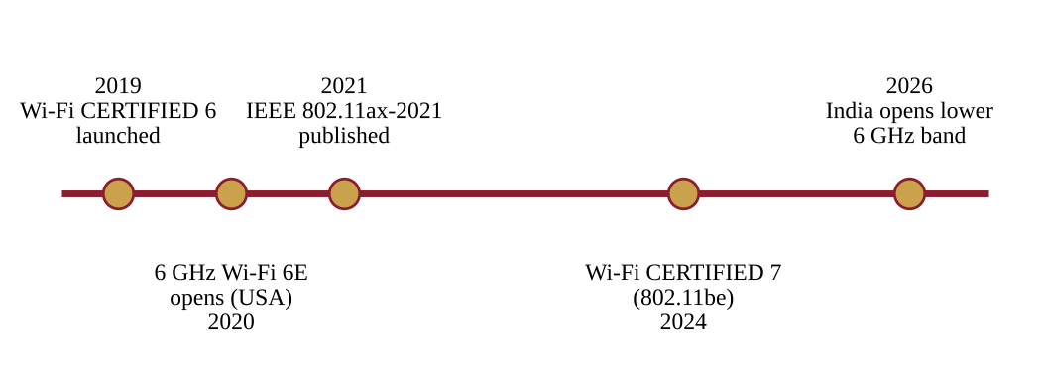
Figure 6.1: Milestones from Wi-Fi 6 to Wi-Fi 7
Source: prepared by the author based on [1], [6] and [7].

6.2 CONCLUSION AND LEARNING OUTCOMES
Wi-Fi 6 (IEEE 802.11ax) transforms modern wireless networking by prioritising multi-user efficiency, deterministic low latency, strong WPA3 security and IoT scalability. Its main techniques, OFDMA, 8x8 MU-MIMO, BSS colouring, 1024-QAM and target wake time, work together so that a single access point can serve many devices at once with less delay and less power use.
The key learning outcomes of this seminar are the following.
- Wi-Fi 6 changes the design goal of Wi-Fi from peak speed to efficient sharing of the channel.
- OFDMA and uplink MU-MIMO are the main reasons for improved performance in crowded places.
- TWT and WPA3 improve battery life and security, which are important for IoT and campus use.
- The wired network, client devices and administration skills must be upgraded together to obtain the full benefit.
- Wi-Fi 6E and Wi-Fi 7 continue the same ideas in new spectrum with wider channels.
For institutions such as MMANTC, Wi-Fi 6 offers a practical path to reliable connectivity for learning, examinations and research.

PROJECT INITIATION (BRIEF SECTION)
This section outlines the initial planning for a follow-up group project. It is a planning component only and does not claim that the project has been implemented.

PI.1 PROBLEM STATEMENT
Wireless access in classrooms and hostels of a technical campus becomes slow and unreliable at peak times because the existing Wi-Fi 5 access points cannot serve the number of devices that connect at once. The project will study how a Wi-Fi 6 design can improve this situation.

PI.2 PROPOSED PROJECT AND SCOPE
The proposed project is the design and simulation of a high-density Wi-Fi 6 network for a campus building. The scope includes site survey planning, access-point placement, channel and power planning, a WPA3 security design and a simulated comparison of Wi-Fi 5 and Wi-Fi 6 performance. Physical deployment is outside the initial scope.

PI.3 OBJECTIVES
- To estimate the user density and traffic of selected classrooms and hostel floors.
- To prepare an access-point placement and channel plan for Wi-Fi 6.
- To simulate throughput and latency of Wi-Fi 5 and Wi-Fi 6 using NS-3.
- To prepare a cost estimate and an upgrade recommendation for the institute.

PI.4 STAKEHOLDERS
The stakeholders are the students and faculty who use the network, the institute network administrator, the project guide, and the institute management who approve the budget. A group of three to four students, as suggested by MSBTE, will carry out the work.

PI.5 PLATFORM, EQUIPMENT AND RESOURCES
Table PI.1: Identified resources
Resource | Purpose
NS-3 network simulator | Simulation of 802.11ax throughput and latency.
Wireshark and a Wi-Fi 6 laptop adapter | Capturing and inspecting 802.11ax traffic.
NetSpot or Ekahau (trial) | Heat-mapping and channel planning.
One Wi-Fi 6 access point (borrowed or demonstration unit) | Small-scale practical measurements.
Campus floor plans | Placement of access points.

PI.6 TENTATIVE PLAN
The work is planned over eight weeks. The plan is indicative and will be finalised with the project guide.
Table PI.2: Tentative project plan
Weeks | Activity | Expected output
1-2 | Requirement study and site survey of selected rooms | User density and coverage notes
3-4 | Access-point placement and channel planning | Placement drawing and channel plan
5-6 | NS-3 simulation of Wi-Fi 5 and Wi-Fi 6 | Throughput and latency results
7 | Security design (WPA3) and cost estimate | Security plan and budget
8 | Report writing and presentation | Project report and slides

BIBLIOGRAPHY
[1] IEEE Standard 802.11ax-2021, "Wireless LAN MAC and PHY Specifications", IEEE Standards Association, 2021.
[2] E. Khorov, A. Kiryanov, A. Lyakhov and G. Bianchi, "A Tutorial on IEEE 802.11ax High Efficiency WLANs", IEEE Communications Surveys & Tutorials, vol. 21, no. 1, pp. 197-216, 2019.
[3] Cisco Systems, "Cisco Wi-Fi 6 (802.11ax) Technical White Paper", Official Documentation, 2023.
[4] Wi-Fi Alliance, "Wi-Fi CERTIFIED 6: Technology Overview", www.wi-fi.org.
[5] Technical University of Munich, Chair of Network Architectures and Services, seminar paper on IEEE 802.11ax (Wi-Fi 6), NET-2024-04-1, 2024, www.net.in.tum.de/fileadmin/TUM/NET/NET-2024-04-1/NET-2024-04-1_08.pdf (accessed 8 November 2026).
[6] RF Wireless World, "WiFi 6 vs 6E vs 7: Key Differences Explained", www.rfwireless-world.com/terminology/wifi-6-vs-6e-vs-7 (accessed 8 November 2026).
[7] India TV News, "Government allows Wi-Fi 6E and Wi-Fi 7 in India by de-licensing 6 GHz spectrum", 21 January 2026, www.indiatvnews.com (accessed 8 November 2026).

