**Project Objective:**

Interfacing DHT11 Sensor and controlling load using Relay using ESP32 and ESP RainMaker app.

**Hardware Requirement:**

* ESP32 Development Board (Wroom32 module)
* Temperature and humidity sensor (DHT11)
* Relay module(5v)
* Bulb with holder
* Wires (jumper wires and single stand wires)

**Software Requirement:**

* Arduino IDE
* ESP RainMaker app
* Amazon Alexa
* Google assistant

**Working:**

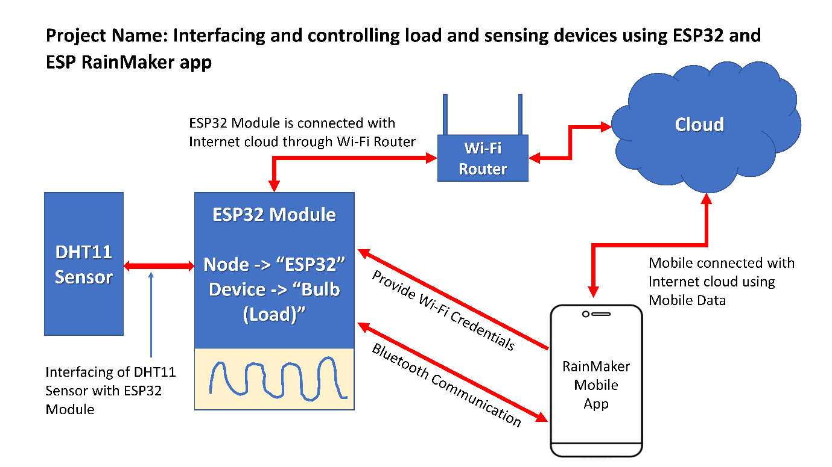

Figure 1 System Model

**Connection Diagram:**

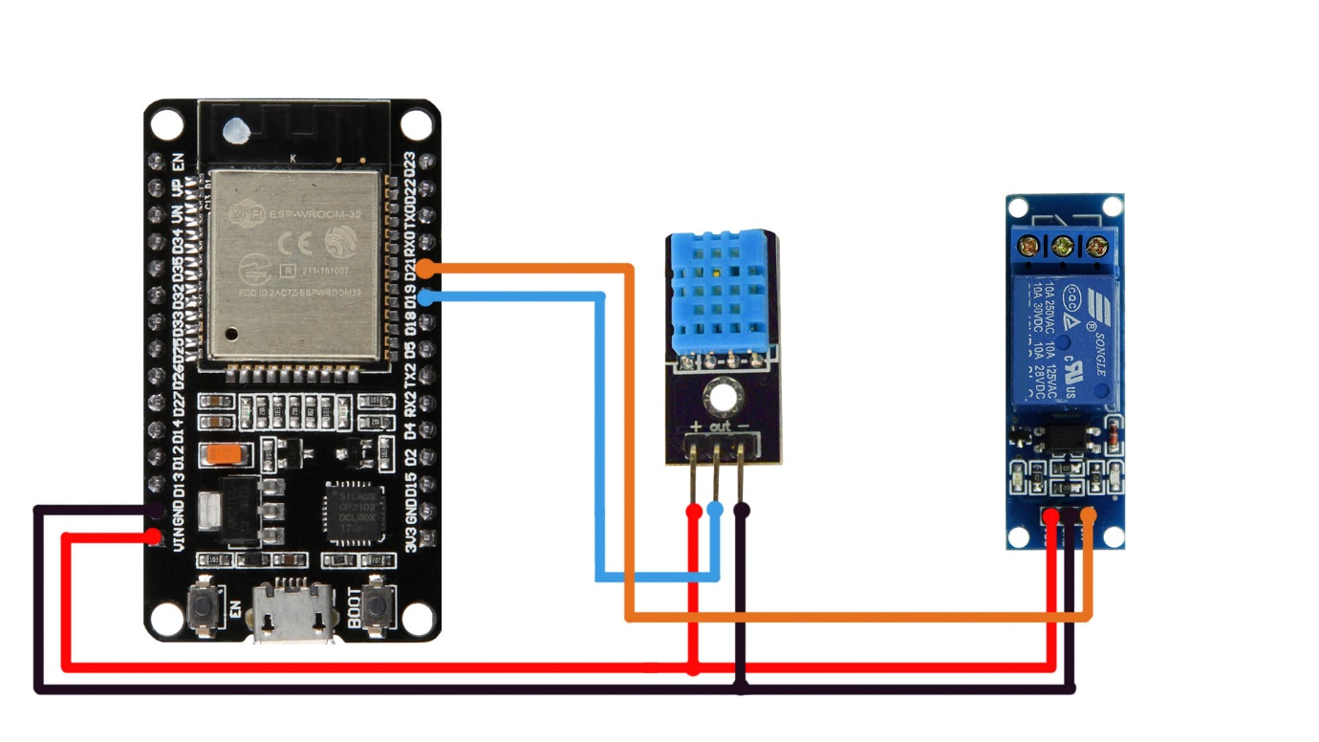

Figure 2 Connection Diagram

**Output and Source Code:**

|  |  |  |
| --- | --- | --- |
| **SN** | **Particular** | **Link** |
| 1 | Demonstration video (YouTube Video Link) | <https://www.youtube.com/watch?v=T7LkI_iex_k&feature=youtu.be> |
| 2 | Source Code (GitHub Repository Link) | <https://github.com/kpjadhav94/ESP32-RainMaker-Project.git> |

**Reference:**

|  |  |  |  |
| --- | --- | --- | --- |
| **SN** | **Topic** | **Type of Document** | **Link** |
| 1 | Espressif Systems ESP32-WROOM-32D-N4 Datasheet | Datasheet | <https://octopart.com/datasheet/esp32-wroom-32d-n4-espressif+systems-125126711> |
| 2 | DHT11–Temperature and Humidity Sensor Datasheet | Datasheet | <https://components101.com/sites/default/files/component_datasheet/DHT11-Temperature-Sensor.pdf> |
| 3 | ESP RainMaker | Information | <https://circuitdigest.com/microcontroller-projects/esp-rainmaker-tutorial-using-esp32-arduino-ide> |
| 4 | ESP Rainmaker — Arduino-ESP32 2.0.6 documentation | Library Document | <https://espressif-docs.readthedocs-hosted.com/projects/arduino-esp32/en/latest/api/rainmaker.html> |
| 5 | Wi-Fi API — Arduino-ESP32 2.0.6 documentation | Library Document | <https://espressif-docs.readthedocs-hosted.com/projects/arduino-esp32/en/latest/api/wifi.html> |
| 6 | Wi-Fi Provisioning - ESP32 | Library Document | <https://docs.espressif.com/projects/esp-idf/en/latest/esp32/api-reference/provisioning/wifi_provisioning.html> |
| 7 | DHT11 Sensor interfacing with ESP32 | Interfacing Document | <https://esp32io.com/tutorials/esp32-temperature-humidity-sensor> |
| 8 | ESP RainMaker Time Service | Information Document | <https://rainmaker.espressif.com/docs/time-service.html> |
| 9 | ESP RainMaker OTA Service | Information Document | <https://rainmaker.espressif.com/docs/ota.html> |
| 10 | Arduino Programming Tutorials | YouTube Playlist | <https://www.youtube.com/playlist?list=PLg2KtP8cgLjzNu5G2bQQLxFeBiqk8IO0s> |
| 11 | ESP32 and DHT11 Interfacing | YouTube Video | <https://www.youtube.com/watch?v=K98h51XuqBE> |
| 12 | ESP32 and Relay Interfacing | YouTube Video | <https://www.youtube.com/watch?v=Jl4O4bERVnw> |
| 13 | Project Reference Link | YouTube Video | <https://www.youtube.com/watch?v=651EoGQHWck&t=132s> |