Contents
1. Purpose of Learning MATLAB 1
1.1 Question: What is the role of MATLAB in Embedded Software Development? 1
1.1.1 Algorithm Design and Simulation 2
1.1.2 Automatic Code Generation 2
1.1.3 Hardware-in-the-Loop (HIL) Testing 2
1.1.4 Verification and Compliance 2
1.2 Question: Why Engineers choose MATLAB over alternatives? 2
1.2.1 The power of Simulink 2
1.2.2 Rigorous Safety Certification 2
1.2.3 Production-Ready Code Generation 3
1.2.4 When Other Tools Are Preferred 3
2. MATLAB Graphical Interface 3
2.1 Command Window: 3
2.2 Workspace 4
2.2.1 Core Purpose of the Workspace: 4
2.2.2 Types of Workspaces 4

Purpose of Learning MATLAB

Question: What is the role of MATLAB in Embedded Software Development?
- MATLAB acts as a model-based design and code generation platform.
- It allows engineers to automatically convert mathematical algorithms and system models into production-ready C/C++ code.
- It minimizes manual coding errors and accelerating the transition from theoretical algorithm design to hardware deployment.
The role of MATLAB in embedded software development can be broken down into the following key phases:

Algorithm Design and Simulation
- Engineers use MATLAB to develop and simulate algorithms for signal processing, control systems, and computer vision before writing actual code for microcontrollers.
- By simulating the system with mathematical rigor, developers can test edge cases and verify mathematical correctness without risking damage to physical hardware.

Automatic Code Generation
- Using tools like MATLAB Coder and Embedded Coder, MATLAB automatically generates optimized C/C++ code from your algorithms and Simulink block diagrams.
- The generated code can be deployed to mass-production embedded processors, such as ARM Cortex-M, SoCs, and FPGAs.

Hardware-in-the-Loop (HIL) Testing
- MATLAB bridges the gap between simulation and the real world through Processor-in-the-Loop (PIL) and Hardware-in-the-Loop (HIL) testing.
- Developers can run the compiled embedded code on physical hardware while MATLAB feeds vectors and monitors the output, validating real-time performance.

Verification and Compliance
- Through its companion tools like Polyspace, MATLAB tests embedded software to prove the absence of run-time errors and check for security vulnerabilities.
- MATLAB enforces coding rules and generates traceability reports to comply with stringent industry safety standards like ISO 26262 (Automotive)

Question: Why Engineers choose MATLAB over alternatives?
MATLAB dominates embedded development because it provides a fully integrated ecosystem that bridges high-level mathematical modeling with strict, safety-certified hardware code generation.
The core reasons are:

The power of Simulink
- Visual Modeling: Engineers can build multidomain system models visually rather than writing raw code.
- Closed-Loop Simulation: You can simulate the embedded software alongside a model of the physical hardware (the “plant”) to test system behavior before hardware exists.

Rigorous Safety Certification
- Industry Standards: MATLAB’s code generation tools are pre-certified for strict safety standards like ISO 26262 (Automotive), DO-178C (Aerospace), and IEC 61508 (Industrial Automation).
- Automated Qualification: Achieving these certifications manually with open-source tools requires expensive, time-consuming third-party audits.

Production-Ready Code Generation
- Target Optimization: Tools like MathWorks Embedded Coder generates C/C++ optimized for specific processor architectures (like ARM Cortex-M or TI C2000).
- Elimination of Human Error: Hand-coding complex differential equations into C often introduces bugs; automated generation ensures mathematical exactness.

When Other Tools Are Preferred
- Cost is a barrier: MATLAB licenses are highly expensive; startups often use Python for early algorithm prototyping.
- Building non-safety-critical systems: For basic IoT devices or smart appliances, writing direct C/C++ or using MicroPython is faster and cheaper.
- Pure Deep Learning: For advanced AI at the edge, developers frequently prefer framework-native tools like TensorFlow Lite or PyTorch over MATLAB.

MATLAB Graphical Interface
MATLAB features a modular, windowed graphical interface. By default, its layout includes three main panels: a large Command Window for running code, a Workspace to track variables, and a Current Folder browser to manage files.

Command Window:
The MATLAB Command Window serves as the primary interactive interface or “mission control” where you can communicate directly with MATLAB by entering individual lines of code and receiving immediate feedback.
Key uses of the Command Window:
- Immediate Code Execution
- Output and Error Display
- Running Scripts and Functions
- Workspace & Variable Management
- Directory Navigation
- Accessing Documentation
It looks like,
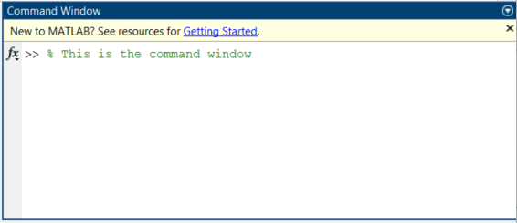

Workspace
In MATLAB, the workspace is your session’s temporary memory area where all created or imported variables are stored and managed. It serves as a scratchpad, allowing you to manipulate data, view variable size/types, and share information across your scripts.

Core Purpose of the Workspace:
- Data Storage: It holds the numbers, matrices, and structures you generate while running scripts or entering commands.
- Debugging and Inspection: You can double-click on any variable in the workspace panel to inspect its exact values and edit them on the fly.
- Data Persistence: While variables disappear when you close MATLAB, you can save the current workspace state to a ‘.mat’ file and reload it later.

Types of Workspaces
MATLAB isolates variables into different “scopes” to protect data integrity:
- Base Workspace: The main, global storage area where command-line and script variables are stored.
- Function Workspaces: Automatically created when you run a function; these are isolated from the base workspace to prevent variables from accidently overwriting one another.
- Model Workspace: Used specifically in Simulink to store parameters required for specific block simulations.
It looks like,
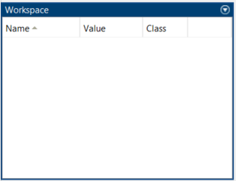

Current Folder
The current folder in MATLAB is your default working directory. It is primarily used as the primary location for saving scripts, loading data, and executing functions without needing to specify full file paths.
Why the Current Folder Matters
- Priority File Search
- File Management
- Data Access

Scratch Work:
Scientific notation example
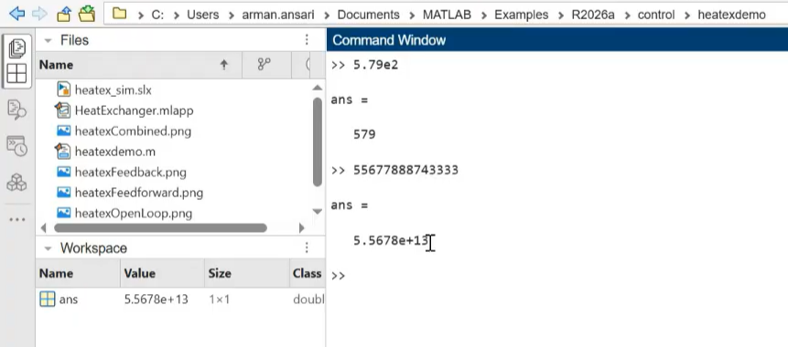
Script, how it works
Example
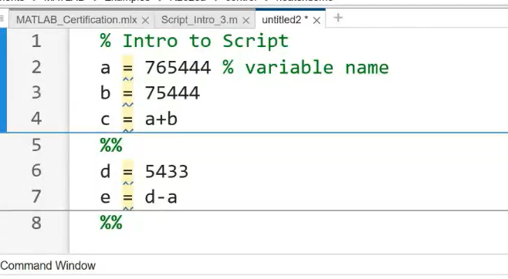
Save the above file with file format
Example 2: Script
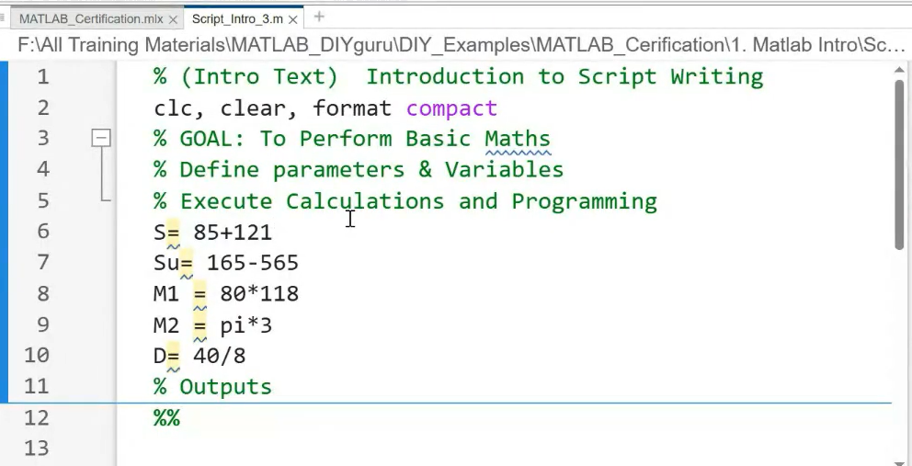
Shortcut in Script
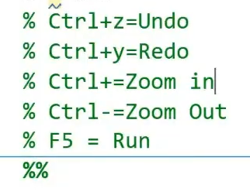
Example of Live Script:
