Purpose of Learning MATLAB

Question: What is the role of MATLAB in Embedded Software Development?
- MATLAB acts as a model-based design and code generation platform.
- It allows engineers to automatically convert mathematical algorithms and system models into production-ready C/C++ code.
- It minimizes manual coding errors and accelerating the transition from theoretical algorithm design to hardware deployment.
The role of MATLAB in embedded software development can be broken down into the following key phases:
- Algorithm Design and Simulation
- Engineers use MATLAB to develop and simulate algorithms for signal processing, control systems, and computer vision before writing actual code for microcontrollers.
- By simulating the system with mathematical rigor, developers can test edge cases and verify mathematical correctness without risking damage to physical hardware.
- Automatic Code Generation
- Using tools like MATLAB Coder and Embedded Coder, MATLAB automatically generates optimized C/C++ code from your algorithms and Simulink block diagrams.
- The generated code can be deployed to mass-production embedded processors, such as ARM Cortex-M, SoCs, and FPGAs.
- Hardware-in-the-Loop (HIL) Testing
- MATLAB bridges the gap between simulation and the real world through Processor-in-the-Loop (PIL) and Hardware-in-the-Loop (HIL) testing.
- Developers can run the compiled embedded code on physical hardware while MATLAB feeds vectors and monitors the output, validating real-time performace.
- Verification and Compliance
- Through its companion tools like Polyspace, MATLAB tests embedded software to prove the absence of run-time errors and check for security vulnerabilities.
- MATLAB enforces coding rules and generates traceability reports to comply with stringent industry safety standards like ISO 26262 (Automotive)

Question: Why Engineers choose MATLAB over alternatives?
MATLAB dominates embedded development because it provides a fully integrated ecosystem that bridges high-level mathematical modeling with strict, safety-certified hardware code generation.
The core reasons are:
- The power of Simulink
- Visual Modeling: Engineers can build multidomain system models visually rather than writing raw code.
- Closed-Loop Simulation: You can simulate the embedded software alongside a model of the physical hardware (the “plant”) to test system behavior before hardware exists.
- Rigorous Safety Certification
- Industry Standards: MATLAB’s code generation tools are pre-certified for strict safety standards like ISO 26262 (Automotive), DO-178C (Aerospace), and IEC 61508 (Industrial Automation).
- Automated Qualification: Achieving these certifications manually with open-source tools requires expensive, time-consuming third-party audits.
- Production-Ready Code Generation
- Target Optimization: Tools like MathWorks Embedded Coder generates C/C++ optimized for specific processor architectures (like ARM Cortex-M or TI C2000).
- Elimination of Human Error: Hand-coding complex differential equations into C often introduces bugs; automated generation ensures mathematical exactness.
- When Other Tools Are Preferred
- Cost is a barrier: MATLAB licenses are highly expensive; startups often use Python for early algorithm prototyping.
- Building non-safety-critical systems: For basic IoT devices or smart appliances, writing direct C/C++ or using MicroPython is faster and cheaper.
- Pure Deep Learning: For advanced AI at the edge, developers frequently prefer framework-native tools like TensorFlow Lite or PyTorch over MATLAB.

File Formats in MATLAB

Commands in MATLAB

clear Command
The clear command in MATLAB removes variables form your current workspace.

Clear Workspace Variables
Use following commands to manage data store in your active memory:
- clear: Removes all variables from the workspace.
- clear x: Removes only the specific variable named x.
- clear x y z: Removes multiple specific variables separated by spaces.
- clearvars -except x: Clears everything except the specified variable x.

Clear the Visual Interface
Use following commands if you want to visually clean up screen without deleting your data:
- clc: Clears all text from the command window to give you a clean screen. It does not delete your variables.
- clf: Clears the current active figure window.
- cla: Clears the current axes within a figure.
- close all: Closes all open figure windows.

plus Command
- The plus command in MATLAB is the functional equivalent of the + operator.
- It is primarily used to add numeric arrays, concatenate text, or join geometric shapes.
- Basic Syntax: C = plus(A, B), computes C = A + B

Numeric Addition
- It adds corresponding elements in two arrays
Example:
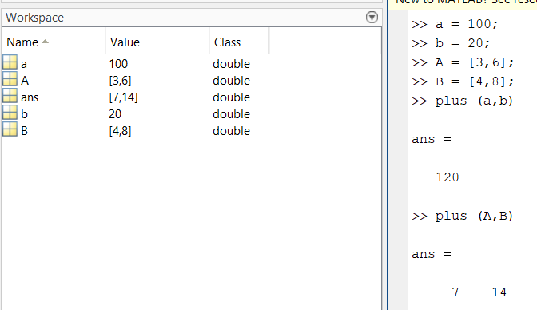

String Concatenation
- When used with strings, plus appends the text together
Example:
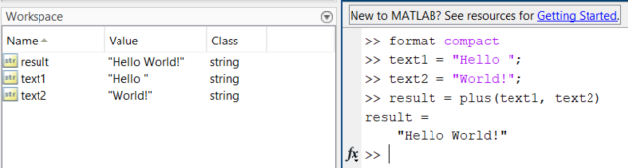

Object and Shape Joining
- In specialized toolboxes (like Antenna Toolbox), plus is used to combine shapes.
Example:
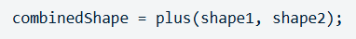

minus Command
- The minus command in MATLAB subtracts one array, matrix, or value from another.
- It is the functional equivalent of the standard minus operator ( - ), used for both numeric arrays and symbolic objects.
- Basic Syntax: C = minus(A, B), computes C = A – B
- Example: subtraction of corresponding elements in two arrays, or values

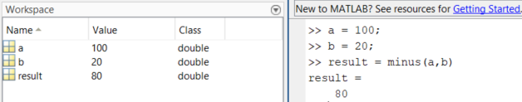
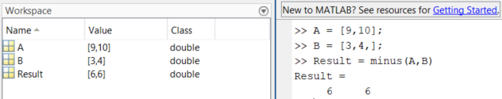

times Command
- In MATLAB, the times command ( .* ) performs element-by-element multiplication.
- It multiplies the corresponding elements of two arrays or matrices of the same size.
- Basic Syntax: C = times(A,B), computes C = A .* B
- Example: multiplication of corresponding elements in two arrays, or values

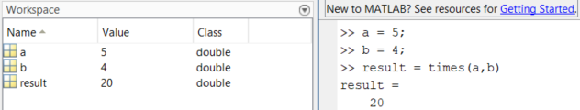
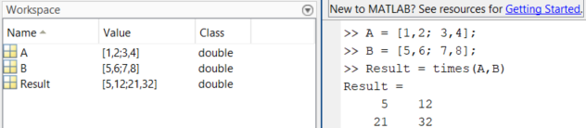

rdivide Command
- rdivide command executes element-wise right array division, dividing each element of one array by the corresponding element of another.
- It is the functional equivalent of the ./ operator (e.g., A./B)
- Basic syntax: result = rdivide(A, B)
Example 1:
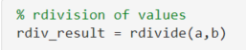

Example 2:
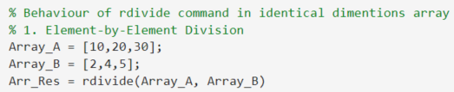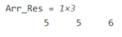

Example 3:
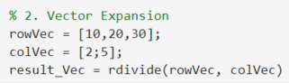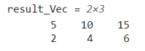

Important Note:
In rdivide command, the right-side element is considered as denominator i.e. divisor.

ldivide Command
- ldivide command performs element-by-element left division, dividing each element of one array by the corresponding element of another.
- Basic syntax: result = ldivide(A, B)
Example 1:

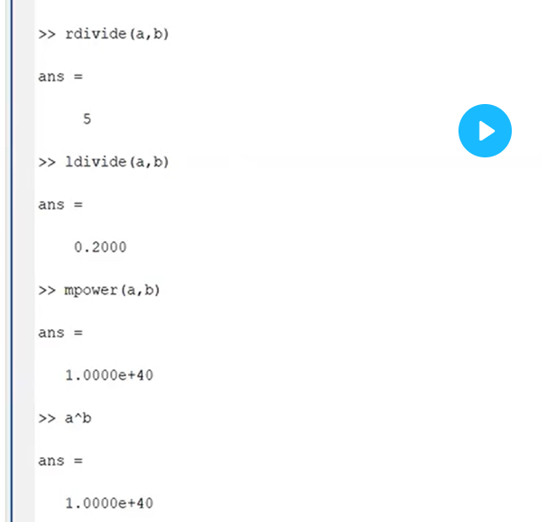
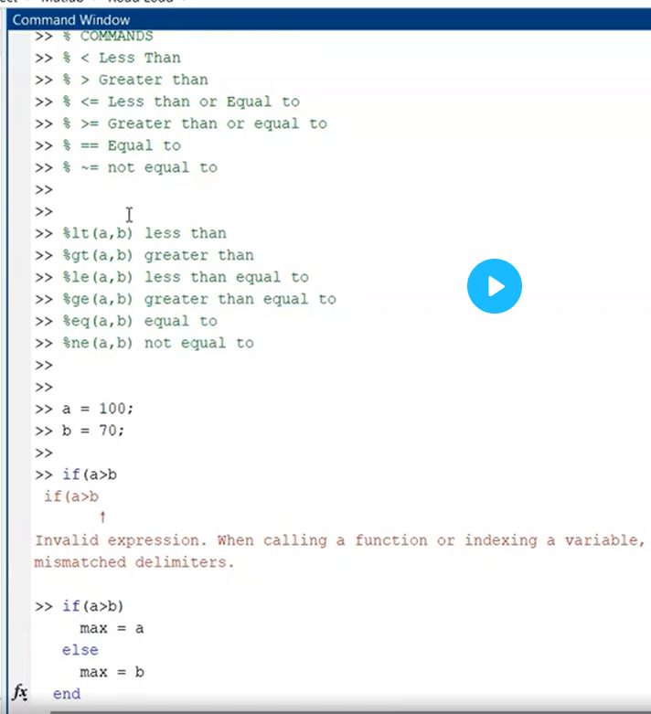
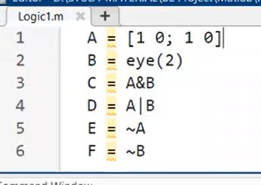
Short circuited AND and OR
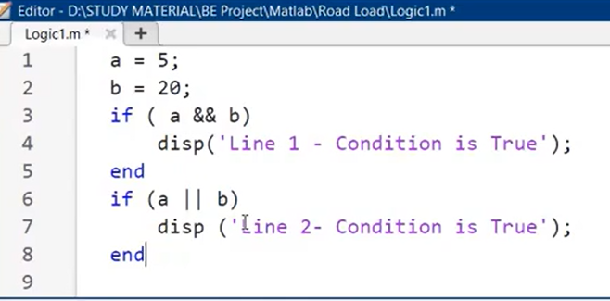
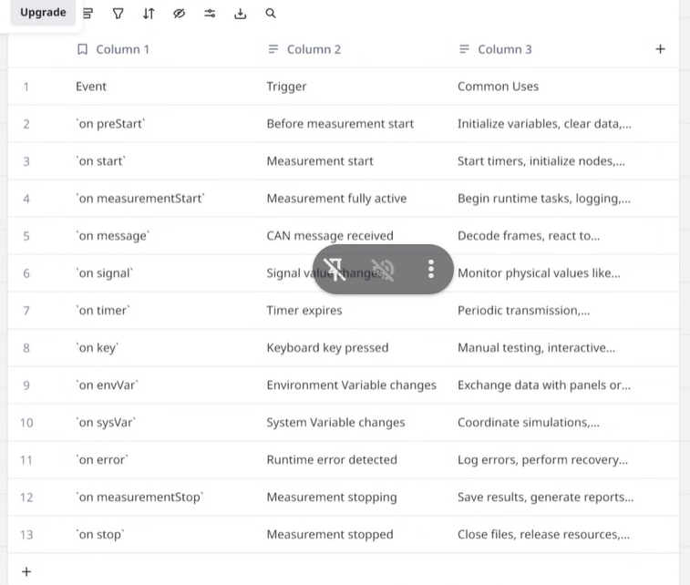
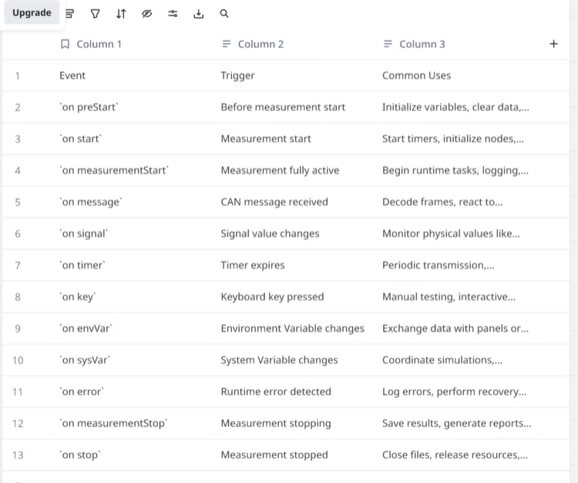
https://autodevpro.tech/tools/dbc-library/
https://www.csselectronics.com/pages/dbc-editor-can-bus-database

