Sample Input/Output:

Following are the list of tags that has been used while designing the bio-data using HTML.

* **List tag**: List tag has been used 2 times.

1. **To display the computer skills.**

Sample Input:

<ol>

<li>Basic Computer Skills (including Surfing Internet)</li>

<li>Hands on practice with MS-Office - 2003, 2007, 2010 (including Microsoft Word, Excel, Powerpoint)</li>

<li>Typing speed : 30 words/minute</li>

</ol>

Sample Output:

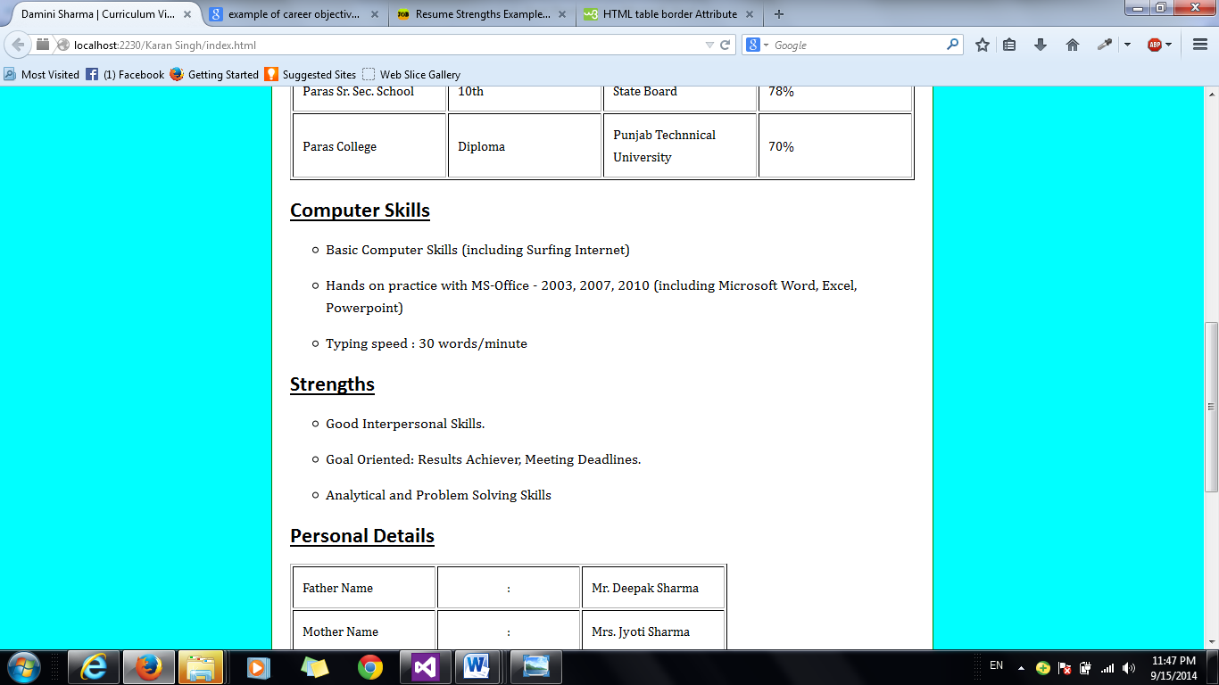

1. **To display the strength part.**

Sample Input:

<ol>

<li>Good Interpersonal Skills.</li>

<li>Goal Oriented: Results Achiever, Meeting Deadlines.</li>

<li>Analytical and Problem Solving Skills</li>

</ol>

Sample Output:

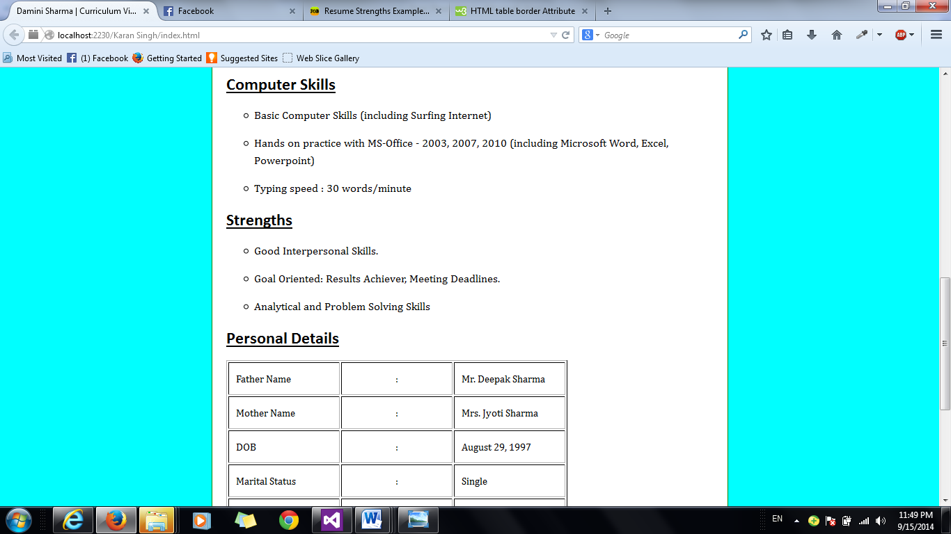

* **Table tag**: Table tag has been used 2 times.

1. **To display the Academic Qualification.**

Sample Input:

<table border="1">

<tr>

<td style="text-align: center;">Institution name</td>

<td style="text-align: center;">Qualification</td>

<td style="text-align: center;">Board of Education</td>

<td style="text-align: center;">Percentage Scored</td>

</tr>

<tr>

<td>Paras Sr. Sec. School</td>

<td>8th</td>

<td>State Board</td>

<td>91%</td>

</tr>

<tr>

<td>Paras Sr. Sec. School</td>

<td>10th</td>

<td>State Board</td>

<td>78%</td>

</tr>

<tr>

<td>Paras College</td>

<td>Diploma</td>

<td>Punjab Technnical University</td>

<td>70%</td>

</tr>

</table>

Sample Output:

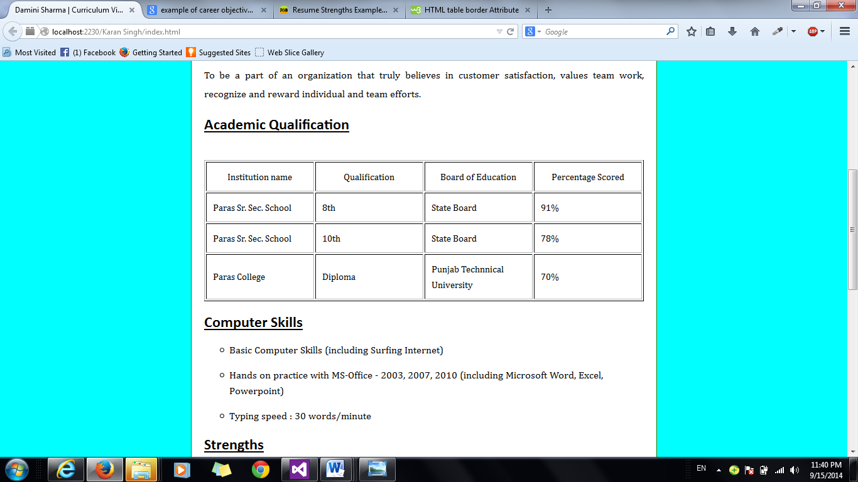

1. **To display personal details:**

Sample Input:

<table style="width: 80%">

<tr>

<td>Father Name</td>

<td style="text-align: center;">:</td>

<td>Mr. Deepak Sharma</td>

</tr>

<tr>

<td>Mother Name</td>

<td style="text-align: center;">:</td>

<td>Mrs. Jyoti Sharma</td>

</tr>

<tr>

<td>DOB</td>

<td style="text-align: center;">:</td>

<td>August 29, 1997</td>

</tr>

<tr>

<td>Marital Status</td>

<td style="text-align: center;">:</td>

<td>Single</td>

</tr>

<tr>

<td>Languages Known</td>

<td style="text-align: center;">:</td>

<td>English, Hindi</td>

</tr>

<tr>

<td>Nationality</td>

<td style="text-align: center;">:</td>

<td>Indian</td>

</tr>

</table>

Sample Output:

