Postman test results

1. Getting all employees

Endpoint:- <http://localhost:8081/getAllEmployees>

Request type:- Get

Accept:- json

Response body:-

[

    {

        "employeeId": 3,

        "employeeName": "nole",

        "department": "ec"

    },

    {

        "employeeId": 1,

        "employeeName": "roger",

        "department": "ec"

    },

    {

        "employeeId": 3,

        "employeeName": "nole",

        "department": "ec"

    },

    {

        "employeeId": 1,

        "employeeName": "roger",

        "department": "ec"

    },

    {

        "employeeId": 1,

        "employeeName": "roger",

        "department": "ec"

    },

    {

        "employeeId": 2,

        "employeeName": "rafa",

        "department": "ec"

    },

    {

        "employeeId": 3,

        "employeeName": "nole",

        "department": "ec"

    },

    {

        "employeeId": 1,

        "employeeName": "roger",

        "department": "ec"

    },

    {

        "employeeId": 1,

        "employeeName": "roger",

        "department": "ec"

    },

    {

        "employeeId": 2,

        "employeeName": "rafa",

        "department": "ec"

    },

    {

        "employeeId": 3,

        "employeeName": "nole",

        "department": "ec"

    },

    {

        "employeeId": 1,

        "employeeName": "roger",

        "department": "ec"

    },

    {

        "employeeId": 1,

        "employeeName": "roger",

        "department": "ec"

    },

    {

        "employeeId": 2,

        "employeeName": "rafa",

        "department": "ec"

    },

    {

        "employeeId": 3,

        "employeeName": "nole",

        "department": "ec"

    },

    {

        "employeeId": 1,

        "employeeName": "roger",

        "department": "ec"

    },

    {

        "employeeId": 1,

        "employeeName": "roger",

        "department": "ec"

    },

    {

        "employeeId": 2,

        "employeeName": "rafa",

        "department": "ec"

    },

    {

        "employeeId": 3,

        "employeeName": "nole",

        "department": "ec"

    }

]

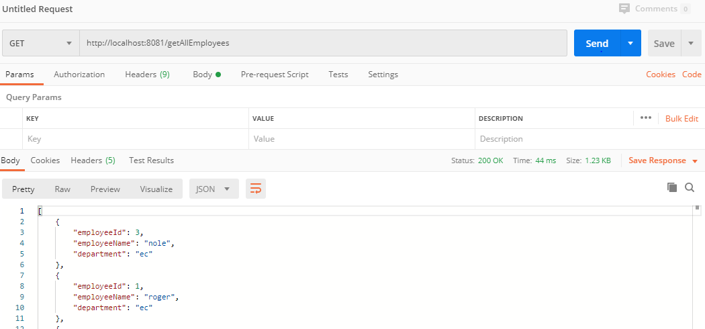

1. Get employee by name

Endpoint:- [http://localhost:8081/getEmployee/{employeename}](http://localhost:8081/getEmployee/%7bemployeename%7d)

Request type:- get

Accept:- json

Response body:-

{

    "employeeId": 3,

    "employeeName": "nole",

    "department": "ec"

}

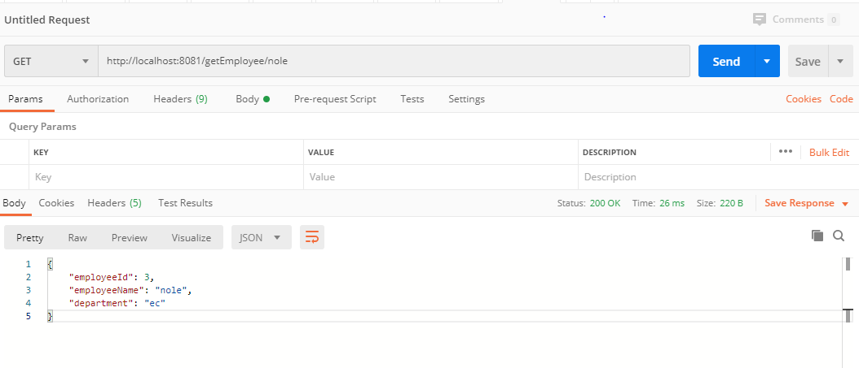

Status code- 200

1. Create an employee

Endpoint:- <http://localhost:8081/employee>

Request type: - POST

Content-type: JSON

Request body:-

{

        "employeeId": 2,

        "employeeName": "pradeep",

        "department": "medical"

    }

Status code: - 200

Response:- Employee saved sccesfully

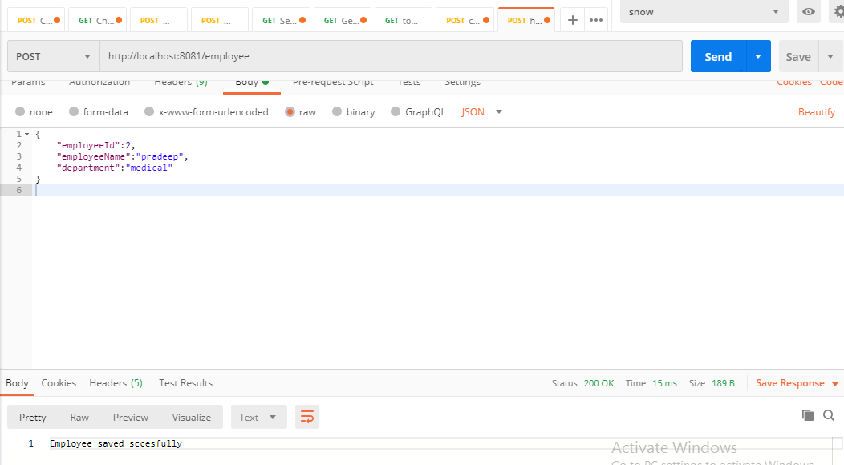

1. Create an employee with array

Endpoint:- http://localhost:8081//employee/createWithArray

Request type:- POST

Content type:- JSON

Request body:-

[

{

"employeeId":2,

"employeeName":"pradeep",

"department":"medical"

},

{

"employeeId":4,

"employeeName":"verdasco",

"department":"sports"

}

]

Response body:-

[

    {

        "employeeId": 2,

        "employeeName": "pradeep",

        "department": "medical"

    },

    {

        "employeeId": 4,

        "employeeName": "verdasco",

        "department": "sports"

    }

]

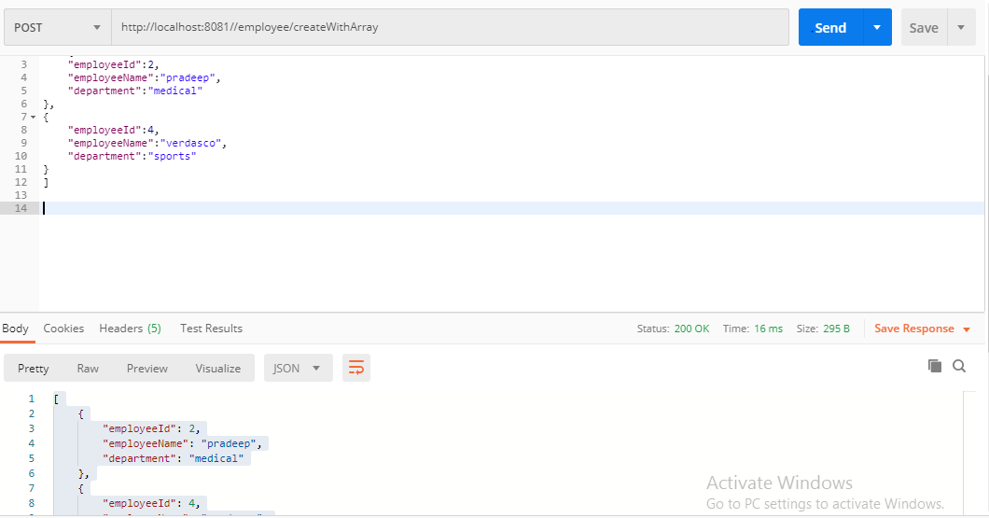

1. Create an employee with list

Endpoint:- <http://localhost:8081//employee/createWithArray>

Request type:- POST

Content-type:- JSON

Request body:-

[

{

"employeeId":2,

"employeeName":"pradeep",

"department":"medical"

},

{

"employeeId":4,

"employeeName":"verdasco",

"department":"sports"

}

]

Status code:- 200

Response body:-

[

    {

        "employeeId": 2,

        "employeeName": "pradeep",

        "department": "medical"

    },

    {

        "employeeId": 4,

        "employeeName": "verdasco",

        "department": "sports"

    }

]



1. Delete an employee

Endpoint:- [http://localhost:8081/deleteEmployee/{employeename}](http://localhost:8081/deleteEmployee/%7bemployeename%7d)

Request type:- delete

Response body:- employee has successfully ben deleted

